1. Find the titles of all movies that have no ratings.

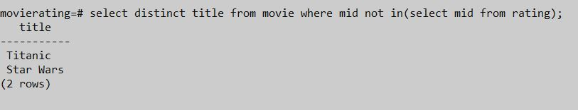

1. Find the difference between the average rating of movies released before 1980 and the average rating of movies released after 1980. (Make sure to calculate the average rating for each movie, then the average of those averages for movies before 1980 and movies after. Don't just calculate the overall average rating before and after 1980.)



1. Find all years that have a movie that received a rating of 4 or 5, and sort them in Descending order.

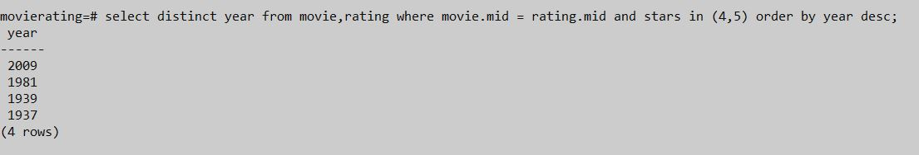

1. Some reviewers didn't provide a date with their rating. Find the names of all reviewers who have ratings with a null value for the date.

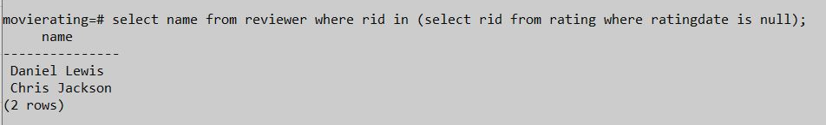

1. List movie titles and average ratings, from highest-rated to lowest-rated.

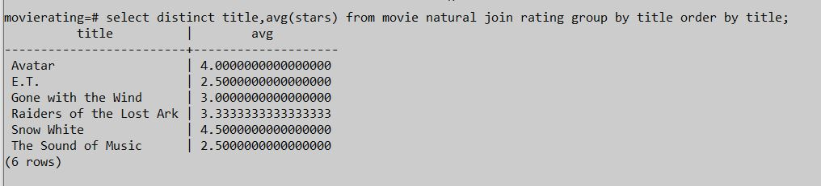

1. Find the names of all reviewers who have contributed three or more ratings.

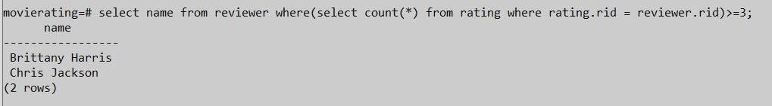

1. Return the movie name with minimum stars in the database.

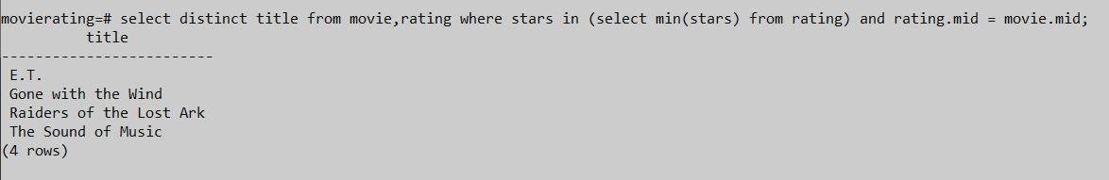

1. Find the average rating of the movie Gone with the Wind

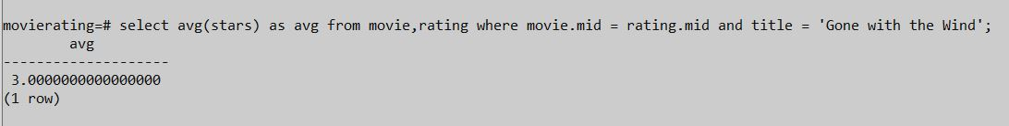

1. List movie titles and no of reviews given to each movie from highest-count to lowest-count.

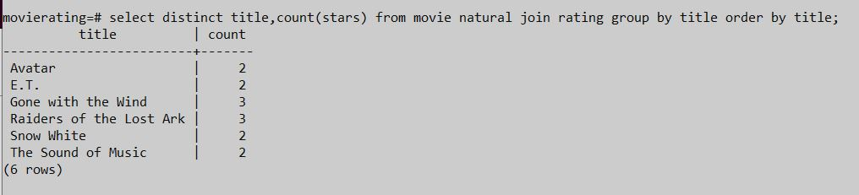

1. Find all the movie titles which are released in between 1964 and 1984(both years exclusive).

