HomeTask#2:

1. To get all the tables from the selected schema, passing % in table parameter.

execute spDatabaseStatistics 'TRN', 'hr', '%'

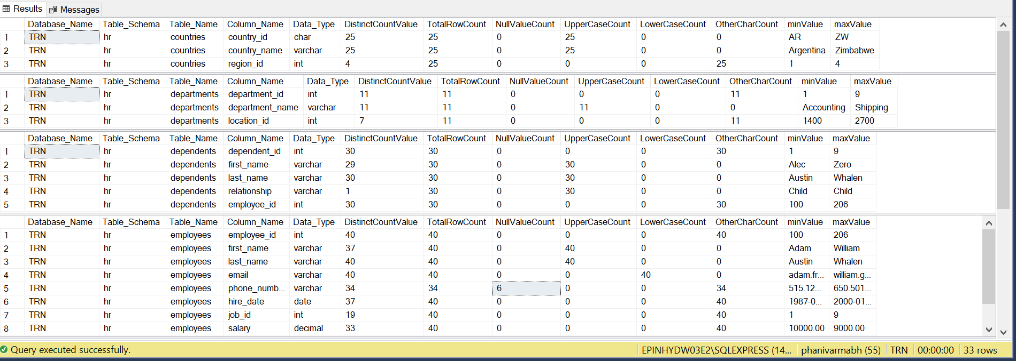

1. User have passed ‘reg’ instead of ‘regions’ in the table parameter.

