<https://docs.microsoft.com/en-us/azure/app-service/app-service-web-tutorial-dotnet-sqldatabase>

<https://stackoverflow.com/questions/47460039/vs-2017-git-local-commit-db-lock-error-on-every-commit/47472811>

git add without .vs folder

1. .vs folder should not be committed.
2. create a file with name ".gitignore" inside the projects git root directory.
3. Add the following line ".vs/" in ".gitignore" file.
4. Now commit your project.

[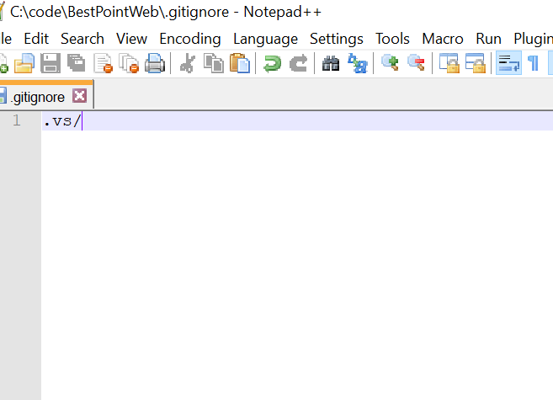](https://i.stack.imgur.com/ZRSg4.png)