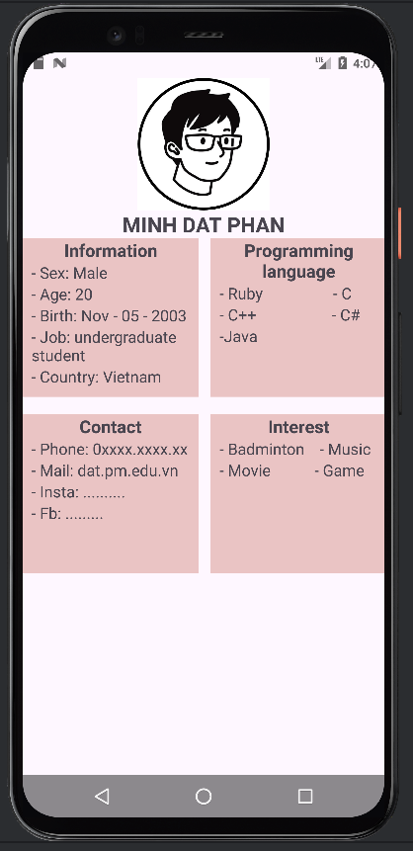

Figma: https://www.figma.com/file/WHzL6jwtFLqtQ2d99EhHFF/Untitled?type=design&node-id=1%3A2&mode=design&t=ntr3VqpJMk5TtM55-1