Office parser development fixture
Self-authored QA. Not a lecture, student work or held-out benchmark.

Networking
Native text before the embedded image: Networking
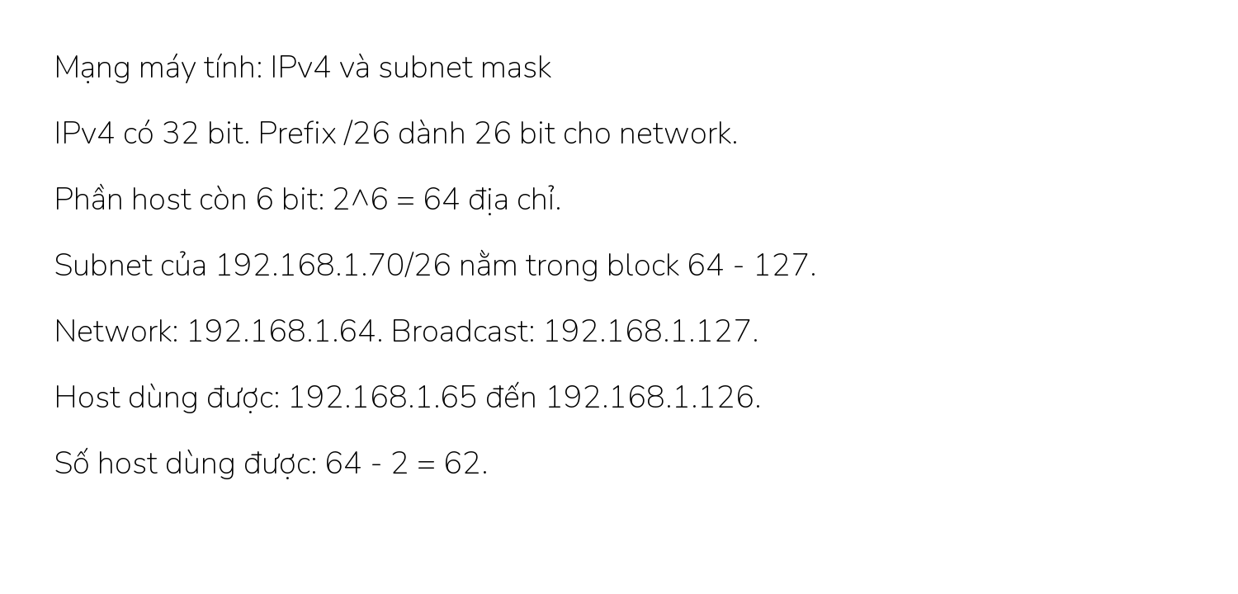
Native text after the embedded image: Networking

Calculus
Native text before the embedded image: Calculus
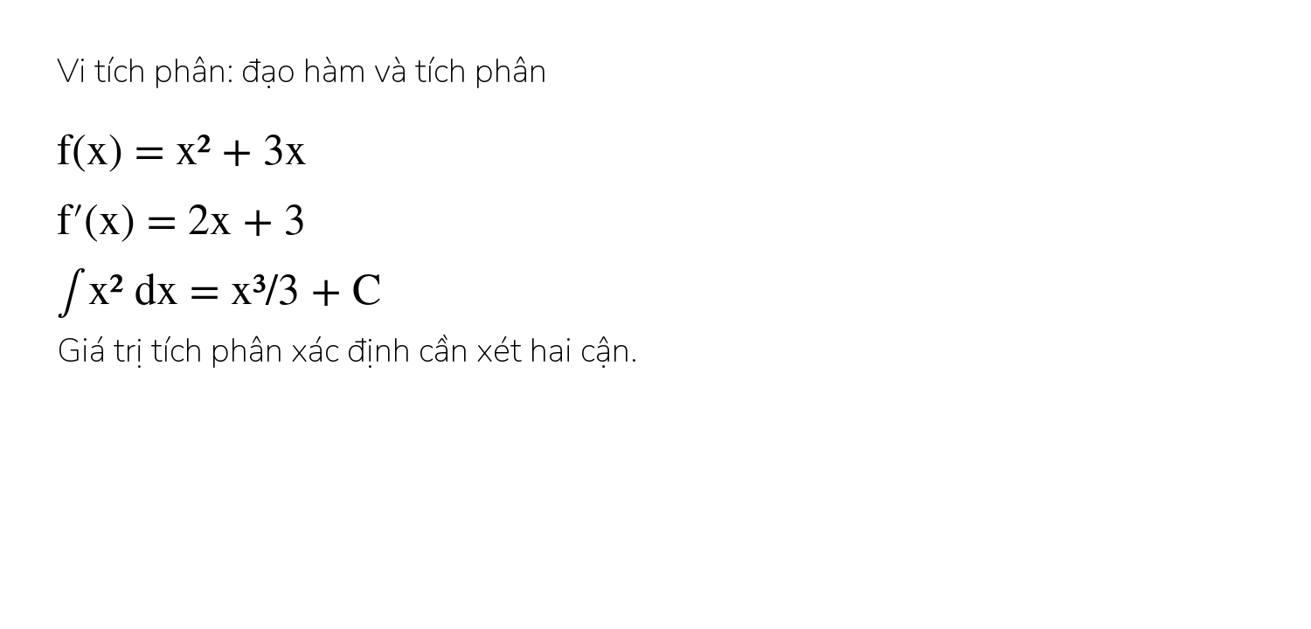
Native text after the embedded image: Calculus

Psychology
Native text before the embedded image: Psychology
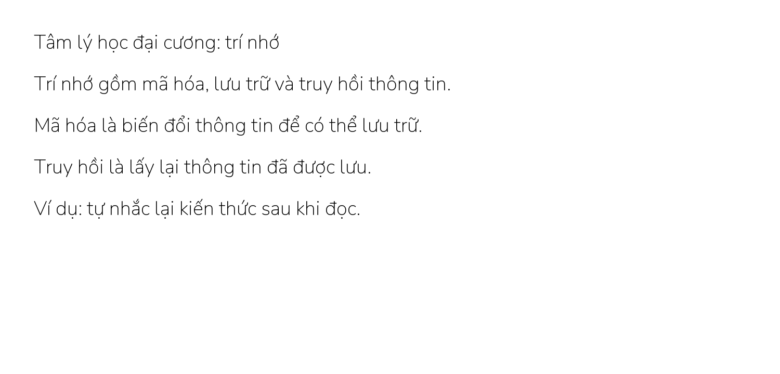
Native text after the embedded image: Psychology

Native Office Math
Exact native formula: $\int_{0}^{1}{x^{2}dx}=\frac{1}{3}$ end of native formula.

