A compact dot notation for designing multi operand parallel adders, multipliers and products adders

Luigi Dadda
Politecnico di Milano, Italy
ALaRI, University of Italian Switzerland at Lugano

Abstract - After having recalled the introduction of the "dot-notation" for an easy study of parallel binary adders and multipliers, a modified compact dot-notation is given, obtaining an easier application to arithmetic problems involving large numbers and many operands. This new notation, and some of its possible variations, is shown for the design of multi-operand parallel adders, multipliers and of adders of products. It is shown that a spreadsheet can be programmed as a design tool for obtaining dot schemes of complex arithmetic systems. This spreadsheet program gives also the total number of full and half adders and the number of stages of the compression process. The spreadsheet tools can be downloaded from the Web.
Keywords: parallel adders, parallel multipliers, dot notation, arithmetic arrays, spreadsheet as design tool in arithmetic.

Introduction
In [2,5] we have introduced a notation for representing an array of binary numbers for allowing an easy way in the design of parallel adders and multipliers. Fig. 1A represents a simple example for adders. In the notation a dot represents an unspecified binary digit, i.e. a bit. The column i (0<= i < n) in which it is placed is characterized by a weight 2^{i} since each row of an array in intended to represent a binary integer (fractional or mixed integer-fractional numbers can also be treated).

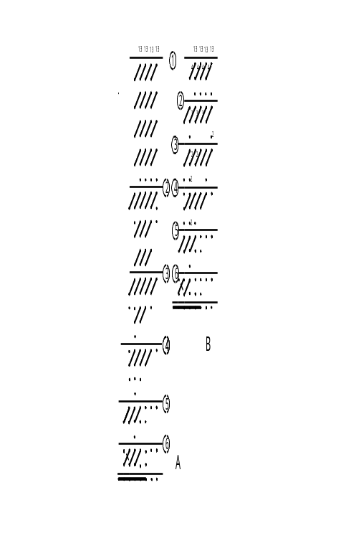

Fig.1: A:a parallel Adder of 13, 4 bits numbers, using the standard dot notation.
B: the same Adder, using the compact dot notation

The parallel multi-operands binary addition leads naturally to the concept of "parallel counters" if the addition algorithm in conceived in the way in which it is taught in primary schools, i.e. adding the digits of the leftmost column and writing the least significant digit in the same column, the others digits being written in the adjacent columns as carries, according to their weights.
It is possible to adopt the algorithm based on the addition of rows, i.e. of the single numbers to be added. This is obviously more tiring in hand addition. In parallel addition it leads to a binary tree of carry save adders for rows, as proposed by Wallace in [1]
The experience has shown that the easiest and faster counters are the full adders or FA's (i.e. the "3,2" parallel counters), due also to the fact that they have been well optimized, both in speed and area, in the design tools in common use today. Parallel counters with a higher number of inputs (e.g. (7,3) parallel counters, or composite counters, called also compressors, with inputs from two or more columns) are usually complex and relatively slow [5,7].
The representation of a FA in a dot array can be as simple as a segment joining the two output dots. The three inputs in the upper input level don’t need to be explicitly marked: it is implicitly assumed that they belong to the same column of the Sum output. It is important to stress that the dot scheme is not a wiring diagram, but an intermediate step in the design process, at a relatively high level of abstraction. Note that the equations or the truth tables of the FA are never used in this level.

The compact dot notation
The compact dot notation will be explained using as working examples Fig.1 and the Fig.2 schemes. Fig.1A is drawn according to the traditional method. Fig.1B is obtained using the new compact notation. Both figures represent the addition of 13 binary numbers of 4 digits each. The initial array of 13*4 dots is not shown for space reason; instead the number of digits (13) in each column is shown.
In Fig.1B we start e.g. from the rightmost 2⁰ column dividing by 3 the number of dots in the initial array and placing a single FA in the second array with the quotient ”4” close to it: this for signifying that, in the traditional scheme we have 4 distinct FA’s. The remainder, 1 , is represented in the third row by a dot. The same result is obtained for the remaining columns
Note that the 4 written close to each FA means that in the Sum and Carry columns there will be (see the traditional scheme) a corresponding number of dots.
Consider now the next mapping (obtaining the second array). In the first column of the first array we found 5 dots: three of them will enter a FA, the fourth and the fifth will not be processed, but simply transferred in the same first column in the second array, represented by a dot with a 2 close to it.
In the second column of first array we find 9 dots: they will enter three FA's represented by a single FA with a 3 close to it. The same is done for column 3 and 4.
In column 5 we find 4 dots: three of them will enter a full adder, the fourth will be represented by a dot in the 3rd row of column 5.
The above basic rules implement the compact array transforms.
It can be seen in Fig.1B that each stage is represented with only three dot rows, the first two being composed by a linear array of multiple FA or HA, while the third row is composed by single or double dots.
The two equivalent schemes of Fig.1 obtain the final 2-rows redundant sum with twodots for each column.
Additional rules can be added in order to obtain specific results, taking for instance into account the choice in using HA: we can decide to process a couple of dots in a column (obtaining two bits in adjacent columns), or transfer the dots in the next array without any processing.
A strategy can be to use a HA when in a column we have only two bits, all the columns at its right containing one bit only. This will obtain the final array composed by a number of the rightmost columns with a single dot, while those at the left have two bits. This will require a shorter parallel adder (often, for speed reasons, a carry look ahead adder).
In certain application we know in advance the length in bit of the final sum. As an example consider the case of adding decimal digits encoded as binary integers (BCD code). In adding, say 13 decimal BCD digits, the maximum value of the sum will be 117₁₀. In case we add 13 binary numbers of four bit the sum will be 13*15=195₁₀. Since 117<2⁷<195 <2⁸, 7 bits will suffice for decimal BCD digits, while 8 bit will be needed for 4 bit binary numbers. In fig.1 example the case of BCD digits requires simply to cut out the last stage of the final parallel adder. In other cases it might become necessary to "cut" in one or more of the last reduction stages. The cut can be done since we know that a carry will never be produced in a column. In case of cutting, only the sum output of a FA will be used. A more rational way is to use, in such a case, a two or three input XOR unit, as done in [10], for designing integer’s multipliers for product length smaller or equal to n.

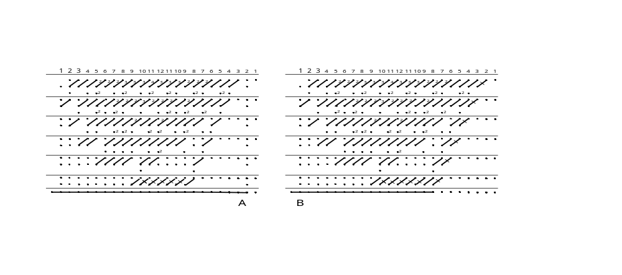
Fig2 : A: a 12*12 multiplier using only Full Adders in the compression stage .
B: a 12*12 multiplier generating 7 single l.s. bits in the last compression stage.

Two more examples of compact dot notation are given in Fig. 2, representing a binary multiplier for factors of 12 bits, obtained by adopting two different strategies. In the first scheme A we decide to use only FA, adding new stages until a stage is obtained containing no multiple FA. The last reduction stage, generating two rows, is obtained by adopting FA only in input columns with three dots. In columns containing 2 or 1, no processing is needed, unless required for specific reasons. This can certainly be done for a sequence of 2’s and 1’s in the leftmost least significant columns. Proceeding from the right we will reach a column valued 3: it will require a FA. The same will be done for the next column if valued 3. If a 2 in found instead, we will be obliged to apply a HA. For a sequence of 3 or 2 we will use a full or half adder respectively, until we find a 1: this will be left unchanged and will be associated with the carry of the FA, or HA, at its right. And so on up to the leftmost column. The algorithm leads to a minimal use of FA or HA in the last stage. The algorithm has been applied in constructing Fig.2A scheme
It is important to note that in all the preceding stages, where no HA is used, there is also a minimal use of FA. This can be seen by noting that a FA is a “saturated” parallel counter (in such counters the two output are both “1” when all the three inputs are “1”). This is not the case for a HA, where only one of the two outputs can be “1”. The dots used as inputs to FA’s are reduced in the following stage by the factor 2/3. Note that the in case of a non-zero remainder even in a single column, the corresponding dots reduction factor will be smaller then 2/3.
The strategy described before for obtaining a final result of the reduction process with some least significant bits fully computed has been used, obtaining 7 of the 24 product’s bits already known before entering the final parallel adder (which will be used for the remaining 17 bits). It can be verified that the first stage can produce two “final” 1’s using a HA in column 2¹. It can also be verified, see Fig.2A, that in each of the successive stages it is possible to “impose” a final HA. As shown in the figure, in the 10th stage a FA instead is necessary.
It must be stressed, however, that while we can produce a “final” new bit, the length of the products in each stage increases faster with n, so that the relative importance of the final bits of the products is diminishing. In Table A (obtained by using a multiplier synthesizer by means of a tool using a spreadsheet, see next chapter) are shown the results for multipliers of up to 68 bit factors.

Using spreadsheets
A variant of the compact dot notation is shown in Fig.3, representing the compact dot scheme for an Adder of 5, 4x4 products: it consists simply in placing the number attached to each FA to both of its two outputs. This is not only consistent with the intrinsic multiplicity of the output dots, but has been suggested in order to obtain an easier and systematic manual drawing procedure. As a matter of fact, drawing by hand a large dot array, and its various compression stages, is a very tedious task, prone to errors.
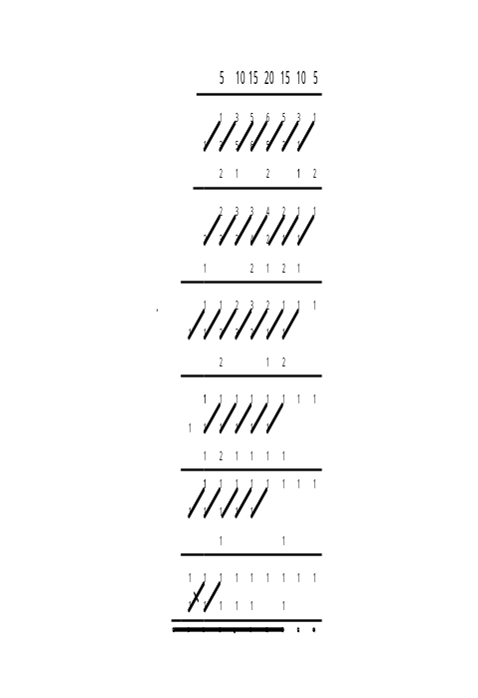
Fig. 3 -Adder of 5, 4*4 product. The multiplicity factors are written both at the Sum and Carry of the multiple Full Adders

Moreover, we could add to each stage a fourth line, for storing the sum of each column. This also contributes to an orderly procedure, avoiding the use of our “pattern recognition” capacity, the main source of errors.
This suggests naturally to search an automatic tool for obtaining the compression of a dot array. Such a tool has been envisioned in the spreadsheet, available in all personal computers and mostly used for administrative tasks.
It is important to underline that dot schemes are a first high level abstraction of the systems to be designed, requiring, as a next step, their translation into VHDL (or other similar languages) programs.
We are going to describe briefly the structure of some spreadsheet programs.
All the spreadsheet programs that we developed will be seen in the following through specific hyperlinks.

The design of Multi-Operand parallel Adders
It is the first spreadsheet program Multi Operabd Parallel Adders. It is a system obtaining the sum of N of n. bit length, N and n being given by the user.
We can note in such spreadsheet (implemented with Microsoft Excel) the following points:
- Row 1 contains a sequence of integers increasing from 1 in AM1 to n, the integer placed in cell AM2 to express the length in bits of the addends. Nulls are in all cells at the left of the last number in row 1.
- In AN1 we can place the addend’s number N , that must be smaller than the number in AO1. In such a case a YES appears in the alert cell AG2.
- The value of N appears in n cells starting from AM3: they represent the N rows array, to be compressed in the equivalent 2-rows to be added in a carry propagating parallel adder.
- The compression process is carried out by a sequence of stages, each represented by a group of 4 rows.
The first stage is composed by rows 4 to 7, with the following roles:
- Row 4 cells contain commands of the type “=ROUNDDOWN(J3/3,0)” obtaining the integer part of the quotient of J3/3, i.e. the number of FA necessary to process 12 input variables (or dots) of column J. In order to fully represent the FA’s in the same column, the number in cell J4 is written in cell I5 (in the column adjacent to column J at its left). This is obtained by the command “=J4” in I5.
- In Row’s 6 cells we place commands of the type “=MOD(J3,3)”, giving the remainder of the division J3/3. We could, instead, write in cell J6:=J3-3*J4. Row 6 contains the dots of the input array that are transferred in the output array of the stage with no processing.
- Row 7 is composed by the sums of the numbers in each column in the preceding three rows.
Row 7 is processed exactly in same way for producing the third array, equivalent to the original one, in row 11. In tsame way are obtained the following 15, 19, 23, 27, 31, 35,39, 43 rows.
Note also that in the proposed spreadsheet only full adders are used.
In the said Spreadsheet (MultiAdd2.xls) ten such stages have been provided.
Trough the first stage N will be reduced by a factor that (for a large N ) is slightly smaller than 2/3. Precisely, it will be 2/3 in case N is multiple of 3, smaller that 2/3 if the remainder of the division by 3 is 1 or 2 in some columns. The remainder is transferred to the following stage with no processing.
For N = 104 all the available 10 stages will be used: the output row of the 10th stage will contain numbers equal or smaller than 3 and consequently stage 10 will be marked with TRUE in column AO. For smaller N a number of stages smaller than the 10 available are needed: in such a case, the stage producing in its output row numbers equal or smaller than three will be marked with TRUE in column AO. The system will in any case operate with all the provided stages. For not too large N a number of stages among the last will produce equal outputs lines, usually composed by 1’s and 2’s. The content of such lines could be used as the final result, to be fed to a parallel adder. This is not an acceptable solution, due both to a number of components not providing any useful task and to the delay caused by the not useful stages.
The problem can be solved by choosing the output line of the first stage that generates an output row composed by 3’s, 2’s or1’s, representing an array of three rows only.
The chosen stage output is automatically transferred in the first row of the FINAL stage, at the bottom of the spreadsheet, whose output row is composed by 2’s, 1’s or 0’s, to be fed into a parallel adder.
The FINAL stage structure is different from the other stages. It is composed by Full Adders and Half Adders, and it works in such a way that a sequence of 2’s and 1’s is not processed, while sequences of 3’s and 2’s are processed by Full or Half adders. Processing a 2 following a 3 in needed in order to make room for the carry from the full adder fed by the 3, in order to obtain a final result composed only by 2 rows. The above sequences are recognized by corresponding sequences of 1’s and of 3’s in the row 44 placed at the bottom of the compression stages.
It is important to underline the most important capability of the proposed spreadsheet, i.e. the possibility of designing Multi Operand Adders for assigned n and N (smaller then the maximums implemented). This can be done by loading the desirable n and N and extracting the (compact) dot scheme from the non-empty cells.

Limits for n and N of a given spreadsheet program
It has been found difficult and impractical to express in mathematical formulas those limits: no matter of their complication, they could in any case be computed by suitable programs. .
We therefore decided to obtain the necessary controls by accepting the limit on the number of compression levels (it is an easy task to increase their number). Moreover we implemented a control on the length of the final result, i.e. the maximum number of output dots.
These checks are as a Yes or a NO in AG2 and AJ2 cells, respectively for N and for the overflow.
The term overflow is not to be intended in the usual numerical meaning. The described system does not simulate an addition: we obtain the scheme of an adder, where a dot represents an electrical terminal (the sum or the carry of a full or half adder). If the number of dots needed to represent the Sum is larger that the number of cells allotted in the spreadsheet, some most significant dots cannot be represented: we must then modify the spreadsheet program. This event could be called more correctly a "dot-overflow".
Another way to express the possibilities and the limits of this spreadsheet program is to say that it is not a simulation program, except in the case of operands composed by 1's and if only full adder are used. We can rather say that we simulate the design of an Adder. The real design of such systems can be obtained only by writing a corresponding program in a design language, such as VHDL, Verilog or SystemC.

The design of binary Parallel Multipliers
In relation to the two schemes of Fig.2 we have obtained two corresponding spreadsheets: Parallel Multipliers for n<68 (only FA) and Parallel Multipliers for n>68 (HA). Both can be used for multipliers for up to 67 bit factors.
Both spreadsheet differs from the one just illustrated for multi-operand addition only for the initial row containing the sequence of dot numbers in each column. Row 4 contains the sequence of integers from 0 (in column EE4) corresponding to the least significant bits (weight 2⁰) to134 (corresponding to the most significant bits of the 2-rows redundant product of a 68 factors bits).
In row 5 we have the sequence: 1,2,….n-1,n,n-1,….2,1,0,0,….0 of n-1 integers, representing the input array. Such sequence is generated automatically from the content of cell ED1, filled by the user with n. The following stages reduce the maximum number of the successive array, until the value 3 is reached. The stage producing such result is identified by the value TRUE in column EG and by a LAST in column EF.
The output of such LAST stage in transferred to the final stage at the bottom of the spreadsheet, as done as in the MultiAdd spreadsheet described previously.
In EH2 we found the total number of full and half adders (in EH1 the number of half adders).
In DY2 we get the number of the compression stages used.
The composition of each stage can be compared, for n = 12 with Fig.2A scheme.
The second Spreadsheet gives multipliers whose final 2-rows output gives a number of least significant dots in non-redundant 1-dot form, i.e. bits of the product. It has been shown in Fig. 2B the case of a 12 bits multiplier.
This spreadsheet obtains the result by introducing in each stage a half adder at its rightmost place.
In Appendix A is shown a table, obtained from the two above spreadsheets, showing for n from 3 to 68, the total number of compression stages, the total number of full and half adders and, from the second Spreadsheet, the "single dots" in the final result.
These data allow, for a prescribed technology giving the area and the delays of a full adder , of a half adder and of a carry-look-ahead final adder of prescribed length, an evaluation of the total multiplier area and delay. These are just "first evaluations", to be confirmed by a VHDL program of the same multiplier. It is important to note that in such a program the internal connections would be declared as local.

Asymmetric Multipliers
In application-specific systems we might have the problem of multiplying number with a different numbers of bits, i.e. an asymmetric multiplier. It is obviously possible to use a symmetric multiplier for factors of equal length, but it is more convenient (both in area and delay) to adopt a multiplier for factors matching in length the values required by the application.
A dot scheme for asymmetric multipliers can be easily obtained with the spreadsheet Asymmetric Multipliers. In this program it is assumed that the multiplicand length is the largest of the two lengths, n and m<= n, m being the length of the multiplier. Both parameters can be of up to 32 bits.
This program differs from the ones previously described essentially in the creation of the input line representing the multiplier array.

Obtaining Adders of Products
The addition of products is an elementary frequent operation in linear algebra and also in signal processing application (e.g. convolution).
In relation to the two schemes of Fig.2 we have obtained two corresponding spreadsheets, to be downloaded as Products Adders and Asymmetric Product Adders Both can be used for multipliers for up to 67 bit factors.
The first Spreadsheet differs from the multi-operand addition only for the initial row containing the sequence of dot number in each column. Row 4 contains the sequence of integers from 1 (in column EL) corresponding to the least significant bits (weight 2⁰ ).
In row 2 we have the sequence: 1,2,….n-1,n,n-1,….2,1,0,0,….0 of n-1 integers, representing the input array of a single product. Such sequence is generated automatically from the content of cell BN1, filled by the user. The number of product, p, is filed in BM2. Row4 is obtained from Row 2 by multiplication with p, and it is the input array of the compression stages.
The processing done by the compression stages reduces the maximum number of the successive arrays, until the MAX value 3 is reached. The stage producing such result is identified by the value TRUE in column BN.
The final stage obtains the result.
The second Spreadsheet handles asymmetric products. The input parameters are n, m and p: the first two for defining the products, the third their number.

A more compact version
The spreadsheets presented previously are “images” of the graphical schemes implementing the compact version of dots schemes, see e.g. Fig. 3. Each stage of the schemes is then represented (if some restrictions are accepted) by four rows: the first two for representing the Sum and the Carry outputs of an array of full adders, the third the remainder of the division by 3 of the preceding stage, the fourth the outputs of the array. The second row in each stage is clearly redundant, the equations of each cells of it being of the type: B5=C4: the second row is obtained from the first copying it with a displacement of one column to the left.
It is easy to hide the second row, by the command "hide", without erasing it
If we wish to omit entirely the second row we can do it provided that in the Sums row we replace the original equations, of the type: T7=SUM(T 6:T4), or : T7=T4+T5+T6, with the equation: T5=T4+T3+U3.
We could in principle omit also the Sum row, reducing to two rows each compression stage, but, besides the difficulties to obtain it, we think that for a designer it is desirable to monitor the compression process by looking to the Sums rows.

General comments and future work
The schemes chosen, particularly for multipliers, have been suggested both by the previous experience and by the adopted design methodology based on the compact dot notation. A general characteristic of the schemes is very easy to verify: the bulk of the needed full adders is concentrated in the first compression stages, the last ones requiring few full adders.
A question arises: is a more evenly distribution of the full adders desirable (e.g. for the complexity of the necessary connections)? The answer to this question cannot be derived from the dot schemes, but rather from the implementation schemes obtained via languages as VHDL and the final tools for obtaining the masks. The latter are beyond our reach.
It is in any case important to solve the problem of converting the dot schemes into languages such as VHDL.
We note also that the literature offers a large variety of compression strategies and related algorithms. It must be noted that their implementation with dot schemes can be, in principle, more or less difficult.
The further development of the work exposed in this paper can be seen along three parallel lines:
- Identification of computer intensive problems for which new solutions could be proposed. In signal processing we will consider operations like convolution.
- Implementation of an interface between spreadsheet and VHDL or similar languages in order to dispose of a new efficient design tools.
- Improving the readability of the spreadsheets schemes

References

[1] Wallace, C.S. A suggestion for a fast multiplier, IEEE Trans. n Electronic Computers, pp. 14-17,
Febr., 1964
[2] Dadda, L, Some schemes for parallel multipliers, Alta Frequenza, vol. 19, pp. 349-356, March,
1965
[3] Habibi, A., Wintz, P.A., Fast Multipliers, IEEE Trans on Computers, Febr. 1970
[4] Computer Design Development Principal Papers, E.E. Swartzlander, Editor, Hayden Book Co,
Rochelle Park, N.J., 1976
[5] Dadda, L. On parallel multipliers. Alta Frequenza, vol. 45 pp. 574-580, 1976
[6]Earl E. Swartzlander, Jr., Merged Arithmetic for Signal Processing:,, Proceedings of the 4th
Symposium on Computer Arithmetic, pp.239-244, 1978 A revised version (Merged Arithmetic)
is in IEEE Transaction on Computer Arithmetic, vol. C-29, 946-950, 1980
[7] Gajski, D.D., Parallel Compressors, IEEE Trans. on Computers, Vol. C-29, m.5, May 1980
[8] Muller, Jean-Michel, Arithmétique des ordinateurs,, Ed. Masson, Paris, 1989
[9] Koren, Israel, Computer Arithmetic Algorithms, Prentice Hall, Englewood Cliffs, 1993
[10}Gok,M., Schulte, M.J., Balzola. P. I., Efficient Integer Multiplication Overflow Detection Circuits, Proc.of the Thirty Fifth Asilomar Conference on Signal, Systems and Computers,
pp.1661-1665, 2001

Appendix
In the following table we show some parameters obtained by means of the files Mult68fa and Mult68ha for the synthesis of binary multipliers of up to 68 factors bits. For space reason we show an excerpt of the complete table: the reader could obtain the missing values by operating the same files, via the Web page DotNotation.doc .
In the first four column (from Mul68fa, using only full adders in the compression stages) we have: n, the factors bit number, stages, the number of the compression stages required (each stage is characterized by the delay of a full adder), fa,ha giving the total number of full adders and half adders, ha, the number of half adders.
In the following four columns (from Mult68ha, using a half adder in each compression stages) the last column single output dots gives the number of single dots (in the least significant part of the product).
It can be noted that:
- the number of required compression stages increases with n logarithmically.
- the number of half adders is rather small
- "single dots" in percentage of the product length 2*n decrease with n (due to the logarithmic increase of the required stages).

Mult68fa |  |  |  | Mult68ha
n | stages | fa+ha | ha | stages |  | fa+ha | ha | single  output dots
8 | 5 | 42 | 2 | 5 |  | 46 | 6 | 6 - 37.5%
9 | 5 | 56 | 3 | 5 |  | 60 | 7 | 6 - 33.3%
10 | 5 | 72 | 4 | 5 |  | 76 | 8 | 6 - 30.0%
11 | 6 | 90 | 4 | 6 |  | 95 | 9 | 7 - 31.8%
15 | 6 | 182 | 8 | 6 |  | 187 | 13 | 7 - 23.3%
16 | 7 | 210 | 8 | 7 |  | 216 | 14 | 8 - 25.0%
23 | 8 | 462 | 14 | 8 |  | 469 | 21 | 9 - 19.6%
27 | 8 | 650 | 18 | 8 |  | 657 | 25 | 9 - 16.7%
32 | 8 | 30 | 8 | 8 |  | 937 | 30 | 9 -14.1 %
33 | 9 | 992 | 23 | 9 |  | 1000 | 23 | 10 -15.2%
67 | 10 | 4290 | 56 | 10 |  | 4299 | 65 | 11 - 8.2%
68 | 11 | 4422 | 56 | 11 |  | 4432 | 66 | 12 - 8.82%

In case of a remainder = 2 we could process it through an Half Adder: it will produce in the following stage two variables placed in the same column of the two inputs (the Sum) and in the next to the left (the Carry) with no reduction in the number of variables treated. We choose in the case illustrated not to use Half Adders. In a successive case we will use it for obtaining specific effects.
The limit given in MultiAdd2.xsl,, AO1="<105" is conservative. It holds for n > 10, ten being the number of compression stages implemented. For n < 10 the limit for N is largest. For n = 5 it can be found, by "experimenting" with the said spreadsheet, that N can be up to 109. It can be seen from the spreadsheet that the maximum values in the stages outputs is drifting to the left. Note that two ALERT are given in row2: The left alert is NO when N is too large; the right alert is NO when the length of the final output in row50 cannot be accommodated in the same row.

