Shaun Coleman

Phansa Chaonpoj

TCSS372

Problem 4 Screenshots

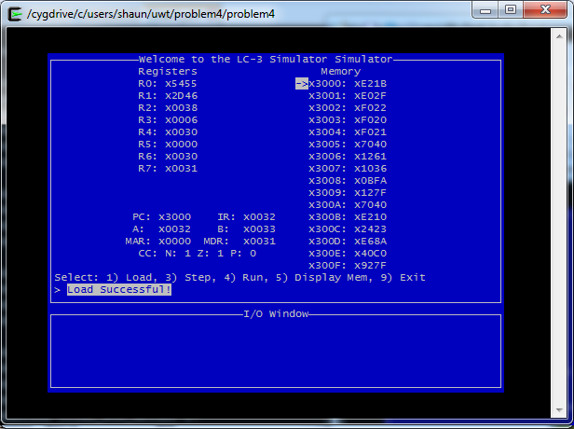

Fig. 1. Initital State of the Program

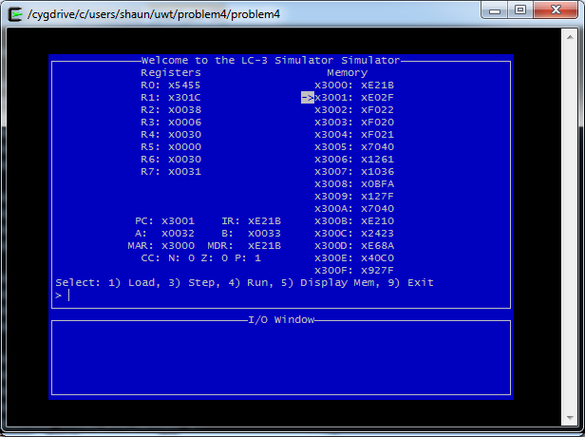

Fig. 2. Load R1 with the starting address of the string

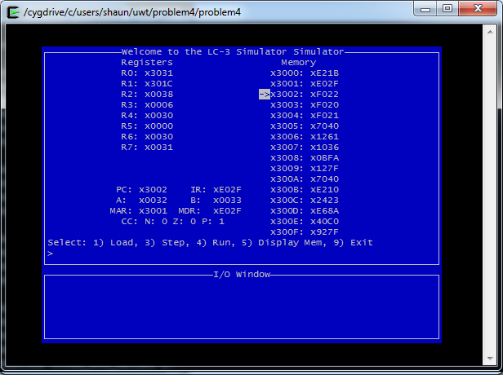

Fig. 3. Load R0 with starting address of “Enter First Name” prompt

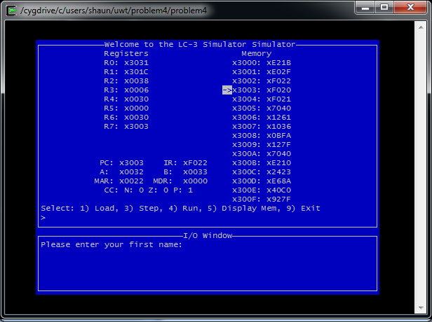

Fig. 4. Display Prompt

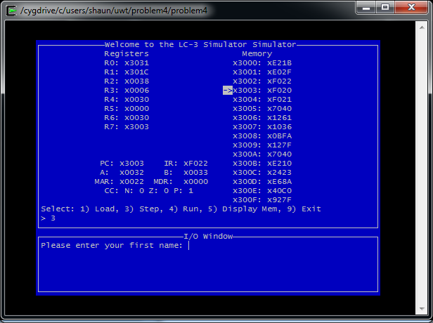

Fig. 5. Waiting for Getc (cursor in I/O Window)

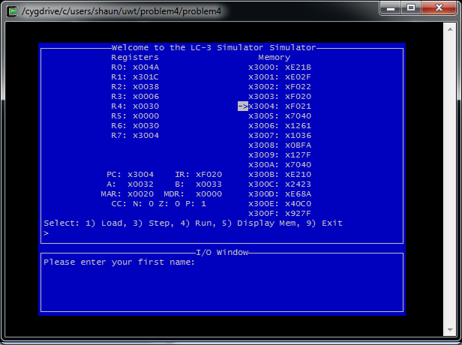

Fig. 6. User Pressed ‘J’

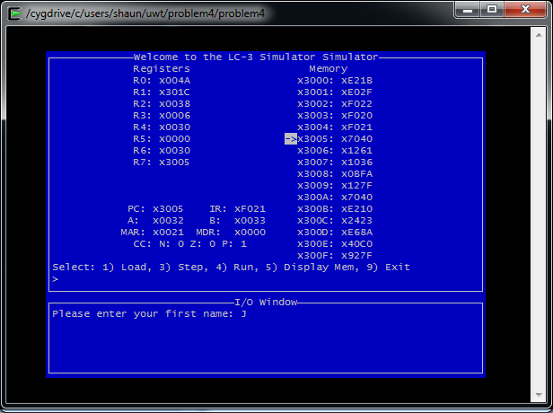

Fig. 7. OUT Trap called

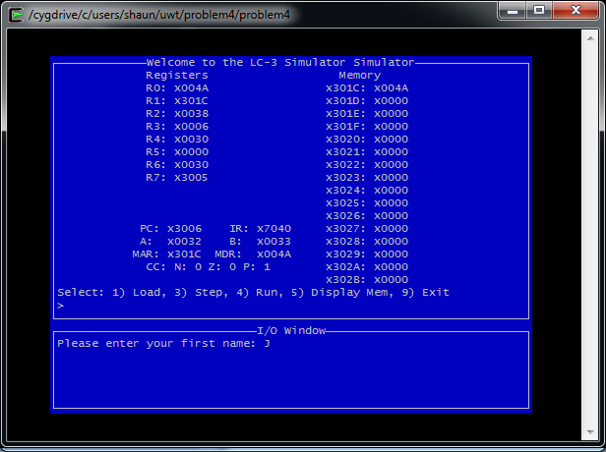

Fig. 8. Character stored in memory

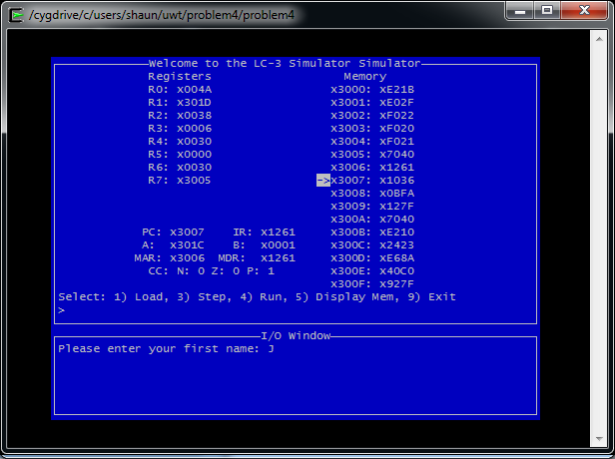

Fig. 9. R1 Incremented to next location in memory

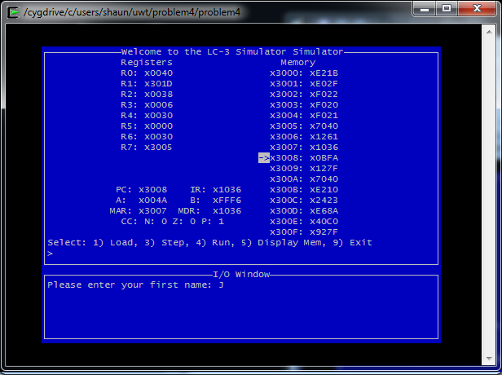

Fig. 10. Subtract 10 from R0

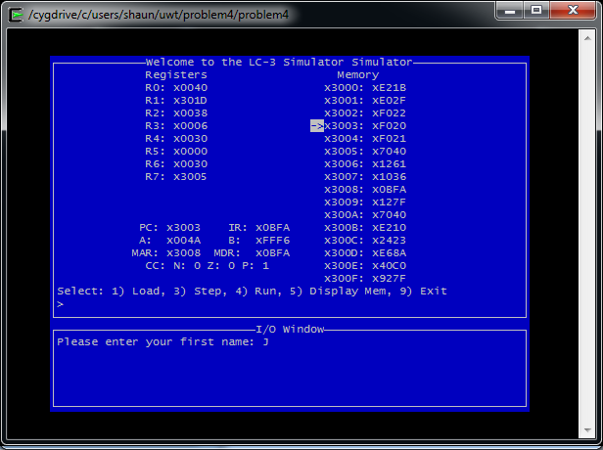

Fig. 11. Loop and repeat until R0 is 0 (new line character found)

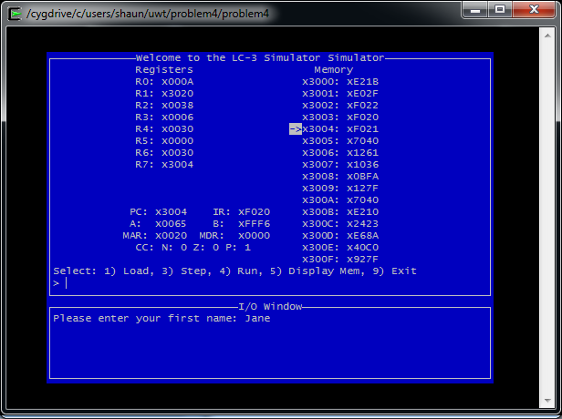

Fig. 12. User pressed enter to finish name prompt

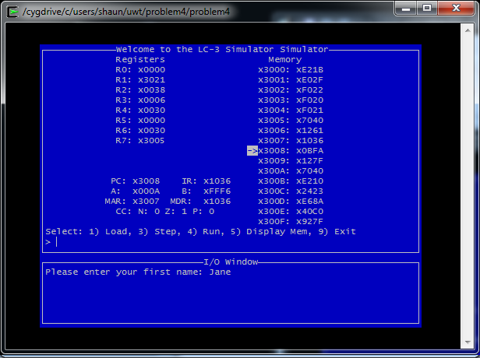

Fig. 13. Subtraction sets R0 to 0

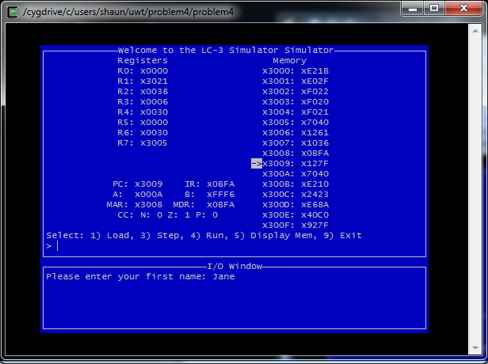

Fig. 14. Exited Loop

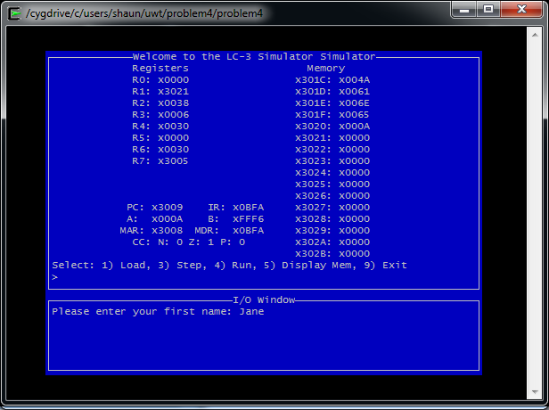

Fig. 15. String in memory post loop

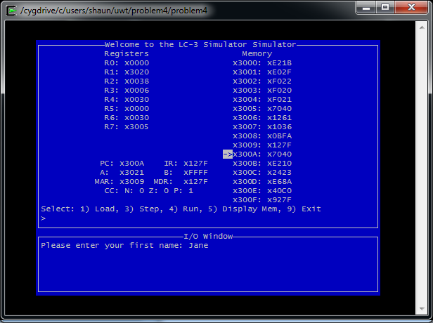

Fig. 16. Decrement R1

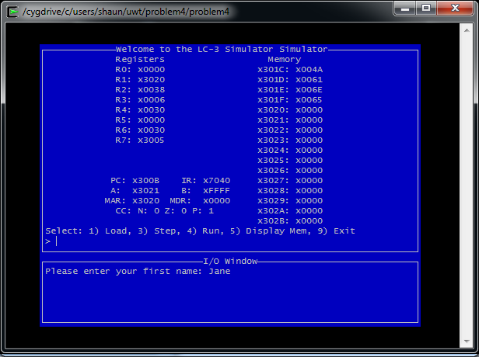

Fig. 17. Newline char in memory replaced with 0 to end string

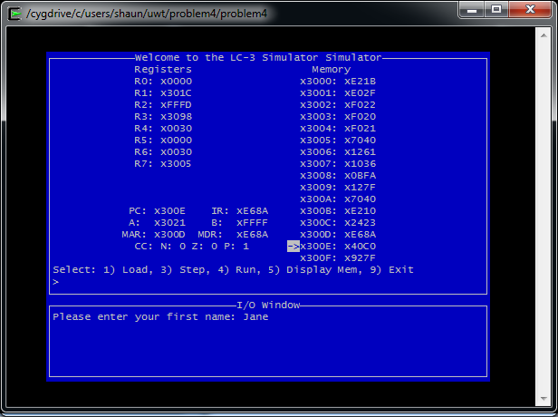

Fig. 18. R1 set to Start of String, R2 set to small constant from memory

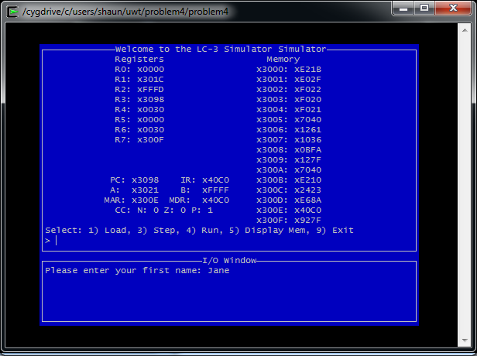

Fig. 19 JSRR Called

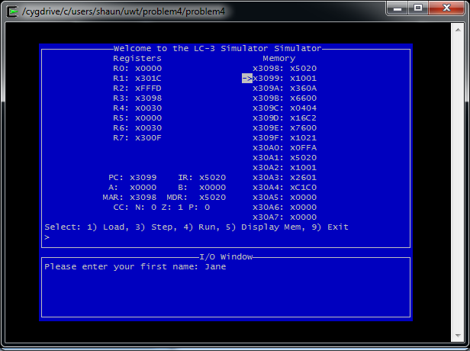

Fig. 20. R0 set to 0 (No effect here but done for safety)

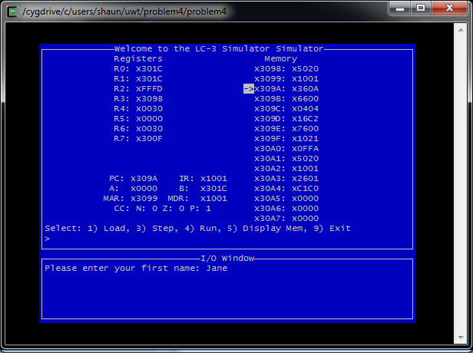

Fig. 21. R0 gets a copy of R1

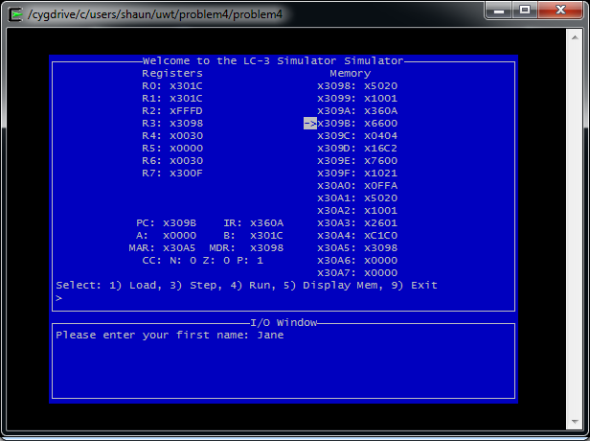

Fig. 22. R3 saved in memory (X30A5)

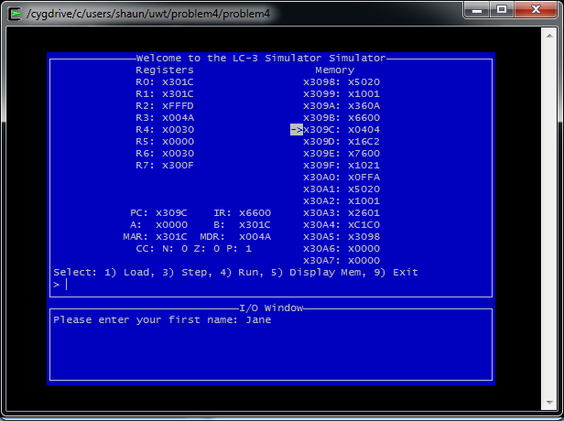

Fig. 23. First character’s value loaded into R3

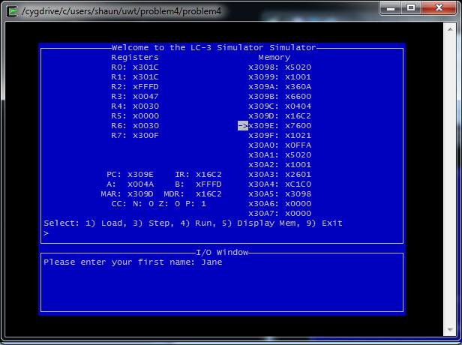

Fig. 24. Ignored Branch on 0 and set R3 to R3 – R2

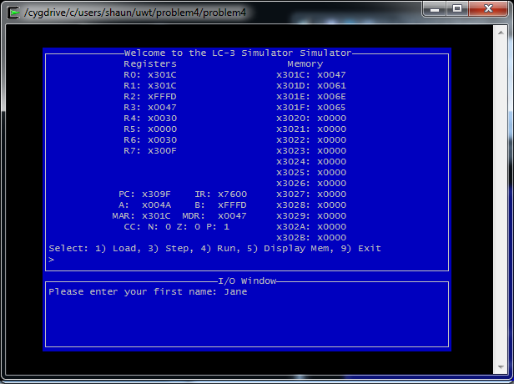

Fig. 25. New value for first character is saved over the old value

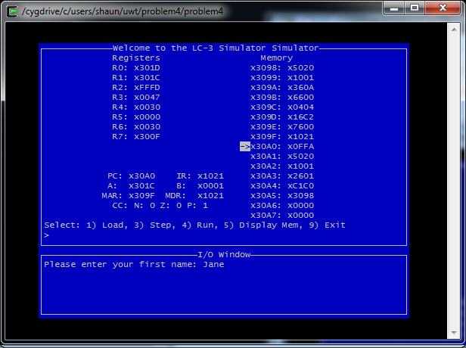

Fig. 26. Increment R0 to next location in memory

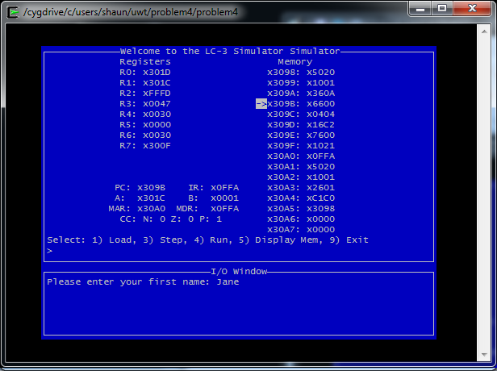Fig. 27. Return to top of loop and repeat until end of string is reached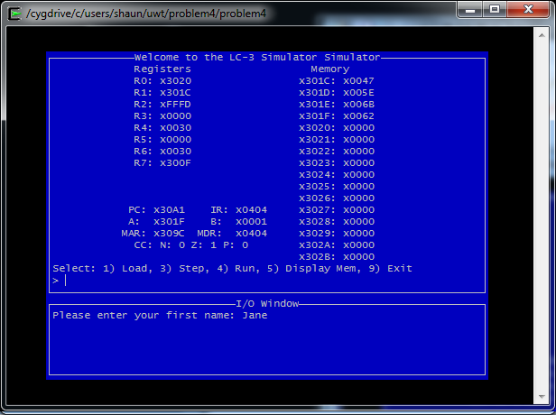

Fig. 28. String in memory after all iterations of the loop

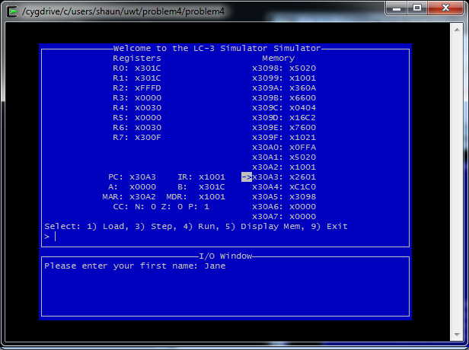

Fig. 29. Set R0 to R1 to return the starting address of the string for a successful run

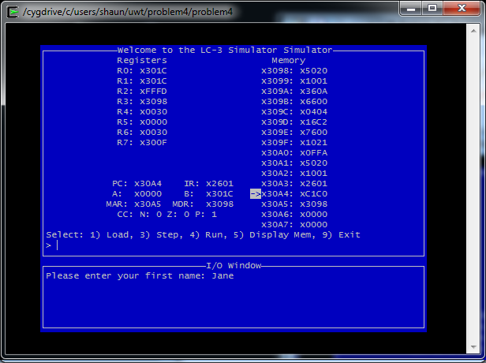

Fig. 30. Restore R3 using the saved R3 value in memory

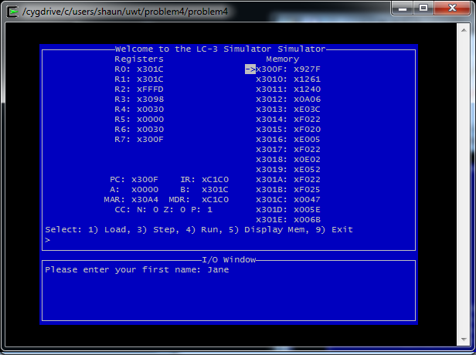

Fig. 31 Return to the mainline; PC is updated

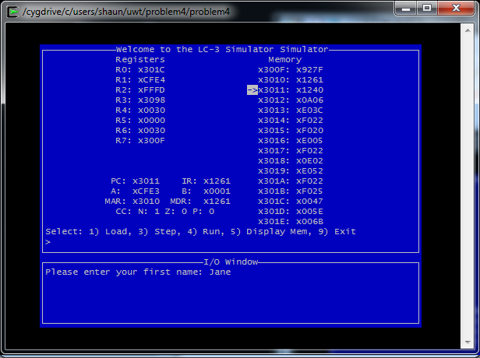

Fig. 32 Negate and increment R1 for two’s complement value

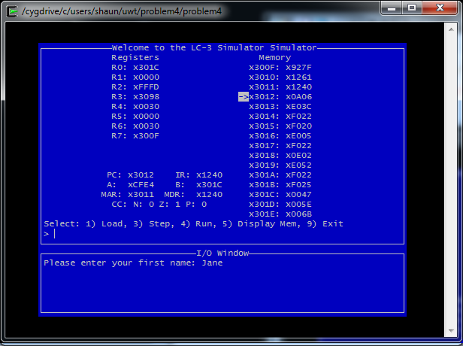

Fig. 33 Set R1 to R1 + R0 to check return status of Encrypt

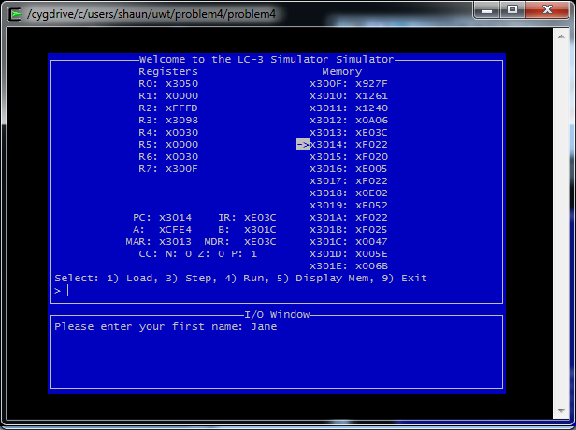

Fig. 34 Branch on zero and load R0 with “Press any key” prompt

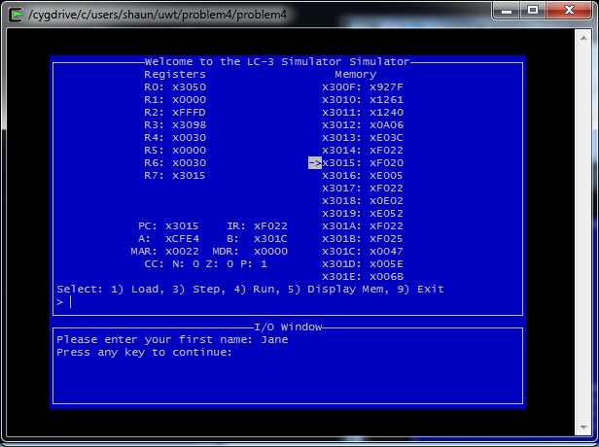

Fig. 35 Display Prompt and wait on user to press a key (getc)

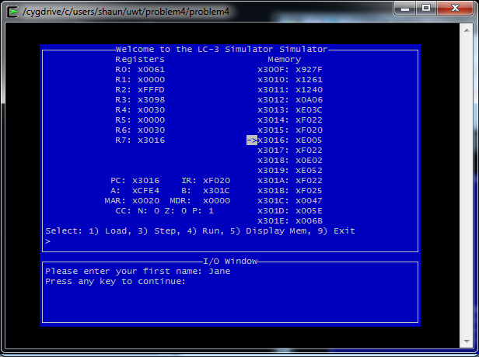

Fig. 36 User pressed ‘a’

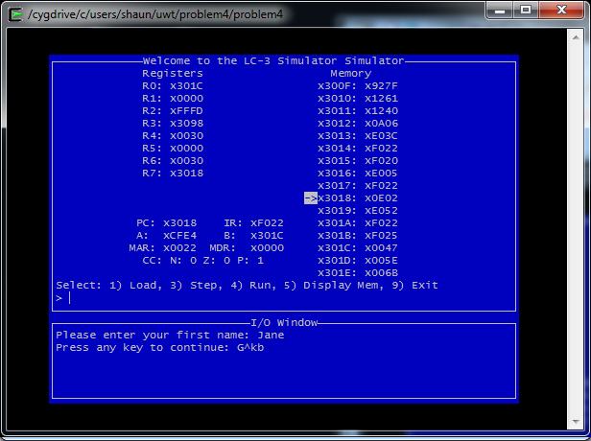

Fig. 37 Set R0 to starting address of string and display the encrypted string

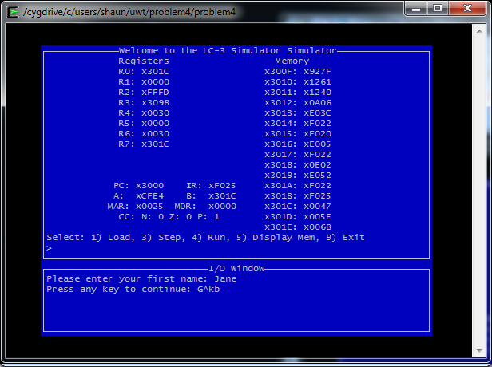

Fig. 38 End of program; Program halted.