Technical Report

 Interaction Design CA

Pia Hanslien

Word count

Summary: 81 | Main text: 1336

Table of Contents

1. Summery

2. Body

2.1 Introduction

2.2 Main section of report

2.3 Conclution

3. References

4. Acknowledgements

5. Appendices

**1. Summary**

This weeks CA was about collecting data from Hotjar and determine whether there was any aspects of the site that could cause problems for the user, and perform accessibility testing and improving the interactions for the users by using HTML, JavaScript and CSS.

It is so frustrating that I spent so much time trying to figure out what I am doing wrong in the forms, especially when it doesn´t pay off with finally getting it. But hopefully someone will tell me!

2. Body

Introduction

As mention, this CA we were asked to do a accessibility testing to ensure the accessibility is on point, and that there isn´t any issues.

Then we had to decide which areas we would focus on fixing and improving for the users.

I looked over the data collected from Hotjar and decided which part of the website that was in need of some change.

I´ve focused on the home page, navigation, the contact page as well as the checkout page. But I have also made some minor changes here and there.

Main section of report

**Research, user testing and Accessibility testing**

I´ve made a list of goals that I found appropriate and most likely goals the users would have:

**Goal 1:** Finding and buying a rain jacket for own use, because the one I got is broken

**Goa 2:** Finding and buying a rain jacket for the opposite gender (for a boyfriend/girlfriend, brother/sister etc.), for a Christmas gift

**Goal 3:** Contacting customer service for exchanging a product, ordered the wrong size

**Goal 4:** Learning more about Rainy Days, wanting to know what the company stands for before deciding whether or not to buy a jacket from Rainy Days

After spending some time figure out the users goals, I´ve asked some family, friends and co-workers to test the website, so I could get feedback on Hotjar (as well as some feedback from the testers).

I asked my brother (who is quite into technology and spends a lot of time on a computer), my mother (who is not good with technology at all) and four other who is in between these two to perform the testing. I asked them to perform the goals that they were given from me (I would make them navigate and do whatever, but since the website isn´t really that “professional”, I thought it would be better to ask them to perform specific goals.

And the result was:

**Goal 1:** The findings from Hotjar on goal 1 was that most of the testers could easy navigate through to the end, and the feedback

**Goal 2:** Same findings as goal 1

**Goal 3:** The testers could easily navigate, but some feedback was that it would be better to have a form

**Goal 4:** The testers could easily navigate to it, but some feedback i got was that it was to much text

**Accessibility testing**

I´ve used Colour Contrast Analyser, the program WAVE and just gone through manually (things I´ve learned throughout this school year).

**Home page**

In the feedback from HTML and CSS CA, I was told that the mobile navigation was well done and that it was ready to replace the checkbox hack with some JavaScript functionality, so this was the one of my main priority for the whole page, not only because of the feedback but was also one of the findings from Hotjar and accessibility testing. So now I have made a responsive hamburger menu using HTML, CSS and JavaScript, and will go more into detail further down.

I tried to have focus on the interaction design, and making sure the user´s goals were met. For example if the user´s goal was to find a rain jacket and purchase it, it would now be easier because it has better flow and easier to interact with the website than before. I have gotten rid off things that do not need to be there (empty buttons on the home page), upgraded the navigation by using JavaScript instead of the checkbox hack and just scaled back on unnecessarily things.

If we take a look at the header and navigation:



*The header/navigation before /desktop*



*The header/navigation now /desktop*

I got feedback from the HTML and CSS CA that the logo took up too much space on the screen, so i decided to make it smaller, but also inline with the navigation. Another thing i changed in the navigation is the icons, two of them were just empty links (and since I didn´t have the time to make the pages, i decided to delete them) and the shopping bag/cart I´ve moved and given it a function (will get into that further down).

And for the mobile/smaller screens:



*The header/navigation before /smaller screens*



*The header/navigation now /smaller screens*

I totally agree with the feedback I got regarding the logo, especially when it comes to smaller screens – it took up too much of the space so I am happy i decided to change that, and have also gotten feedback from the testers that it was much better this way. The hamburger menu is now also with JavaScript, which gives the navigation much better flow.  
As mention before, i got rid off some of the content on the home page because they didn´t do anything – which was

one of the feedback I got from using Hotjar.

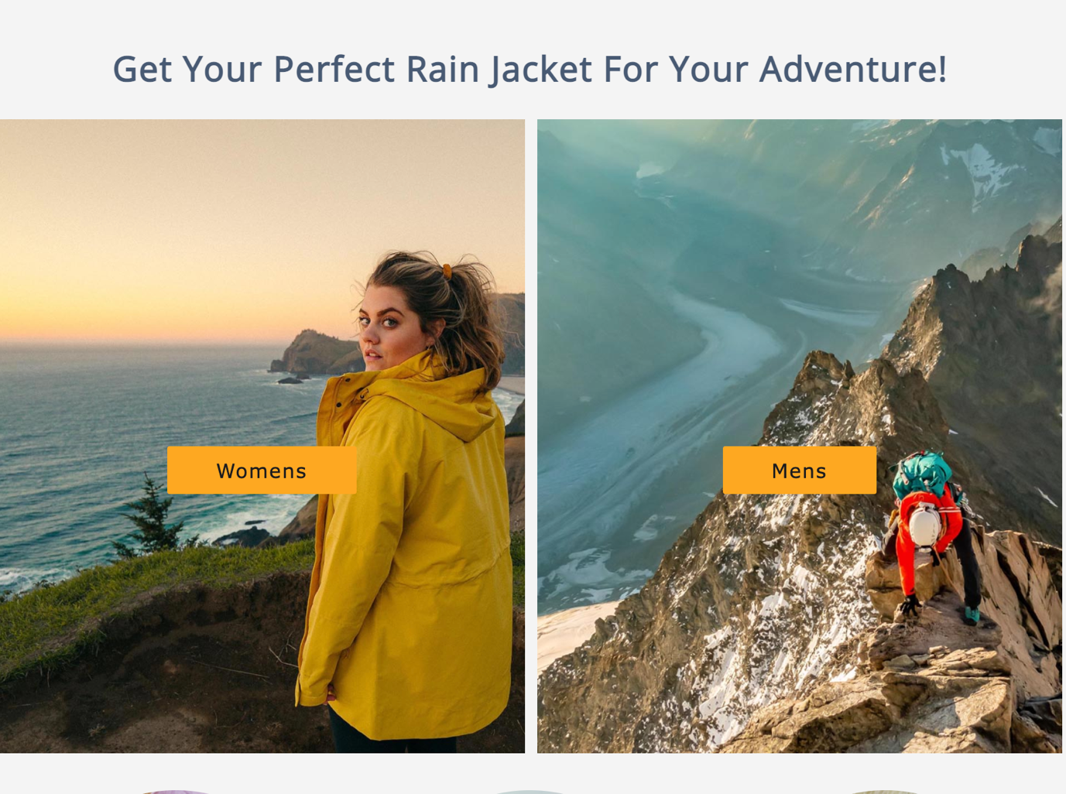

The home page is now much more cleaner and doesn´t have anything distracting the users with useless buttons and images. And last, as I mention before; I moved the shopping bag/cart to under the navigation instead. I was debating whether to have it in the navigation or under, and ended up putting it under because it would be hidden if it was inside the hamburger menu. Ideally, I would put it outside the navigation for smaller screens, and inside the navigation for desktop screens. But sadly I didn´t have the time for that now, but I think i choose the best option for now.

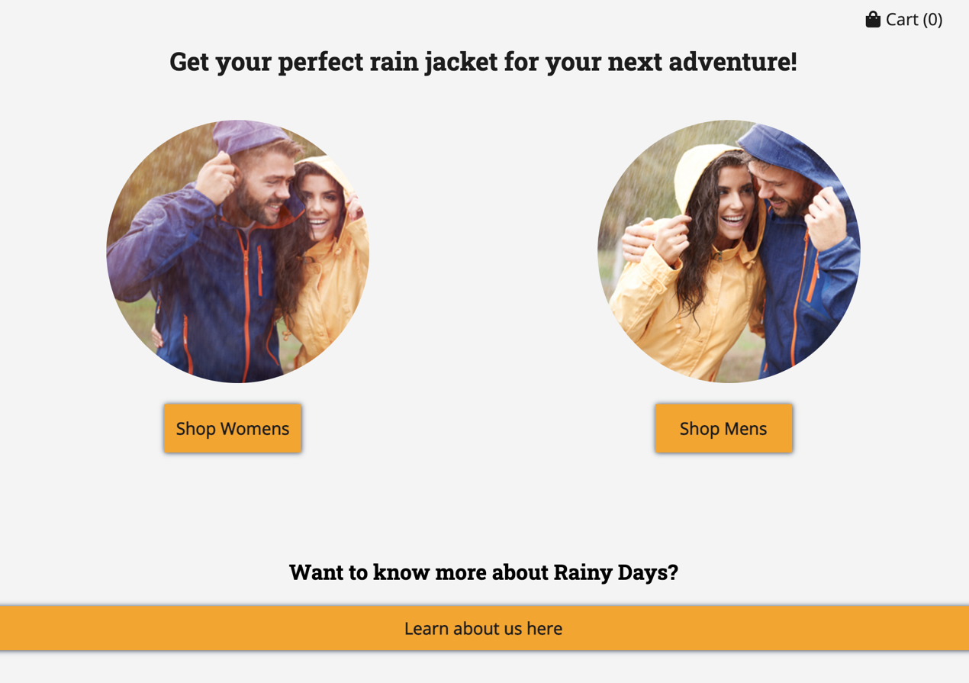

As you might have notice, I´ve change the blue color to a darker shade of blue – it was good enough contrast as it was, but I thought it would make it even better and give it a bit more contrast if I changed it to a darker shade, and as well as making the orange a bit stronger.





After the findings from Hotjar, accessibility testing and the feedback from the HTML and CSS CA, I´ve made a lot of changes on the home page.

More essential changes as mention over here, but also small changes like the font size in the footer, headings and making the buttons more 3D – as well as some other small changes. By doing small changes like this, it has given the website better accessibility score.

**Contact page**

Another change I´ve focused on was the contact page, which now has a form. I´ve used JavaScript, and when something is missing (example name), it gives the user a error message and has a simple and simple message, so the user knows what went wrong.

The one thing I can´t seem to get right is the part where sending the form after filling it out correctly, and I just don´t understand what I do wrong…

**Checkout page**

Here I´ve done the same as with the contact page and added a functional form.

**Specific jacket page (North 2.0 and Forrest 360)**I´ve changed the popup box, by using JavaScript instead of just HTML and CSS.

**About page**

Deleted the whole page, and decided that if I had time i would make tab-pages with the help of JavaScript instead of the solution it had – I didn´t make it i priority and wanted to focus on other parts of the website instead.

So I just used the same text more or less, and divided the text more so it didn’t have too long blocks of text and was easier to read.

**Women jackets/Men jackets**

These pages wasn´t really a priority and haven´t done much other than changing the images in women jackets-page, made the images smaller and some other minor changes.

And last I´ve added breadcrumbs, so now the users know where on the website they are.

Conclusion

I´ve spend a long time making the from and navigation this week, which gave me less time fixing other aspect of the website, and it is so so so annoying that I can´t seem to get the form correctly. But all in all I´ve learned so much and had so much fun using Hotjar and trying to take interaction design more under consideration.

3. References

Inspiration & tutorial:

<https://www.javascripttutorial.net/javascript-dom/javascript-form-validation/>

<https://www.codegrepper.com/code-examples/css/how+to+make+nav+bar+stay+on+screen+while+scrolling>

<https://www.youtube.com/watch?v=flItyHiDm7E>

4. Acknowledgements

Start writing here

5. Appendices

Start writing here