Brief Guide to Device Viewer App
Tong Zhang. 2020-10-12

Start App
Click Device Viewer app card on the App Launcher:
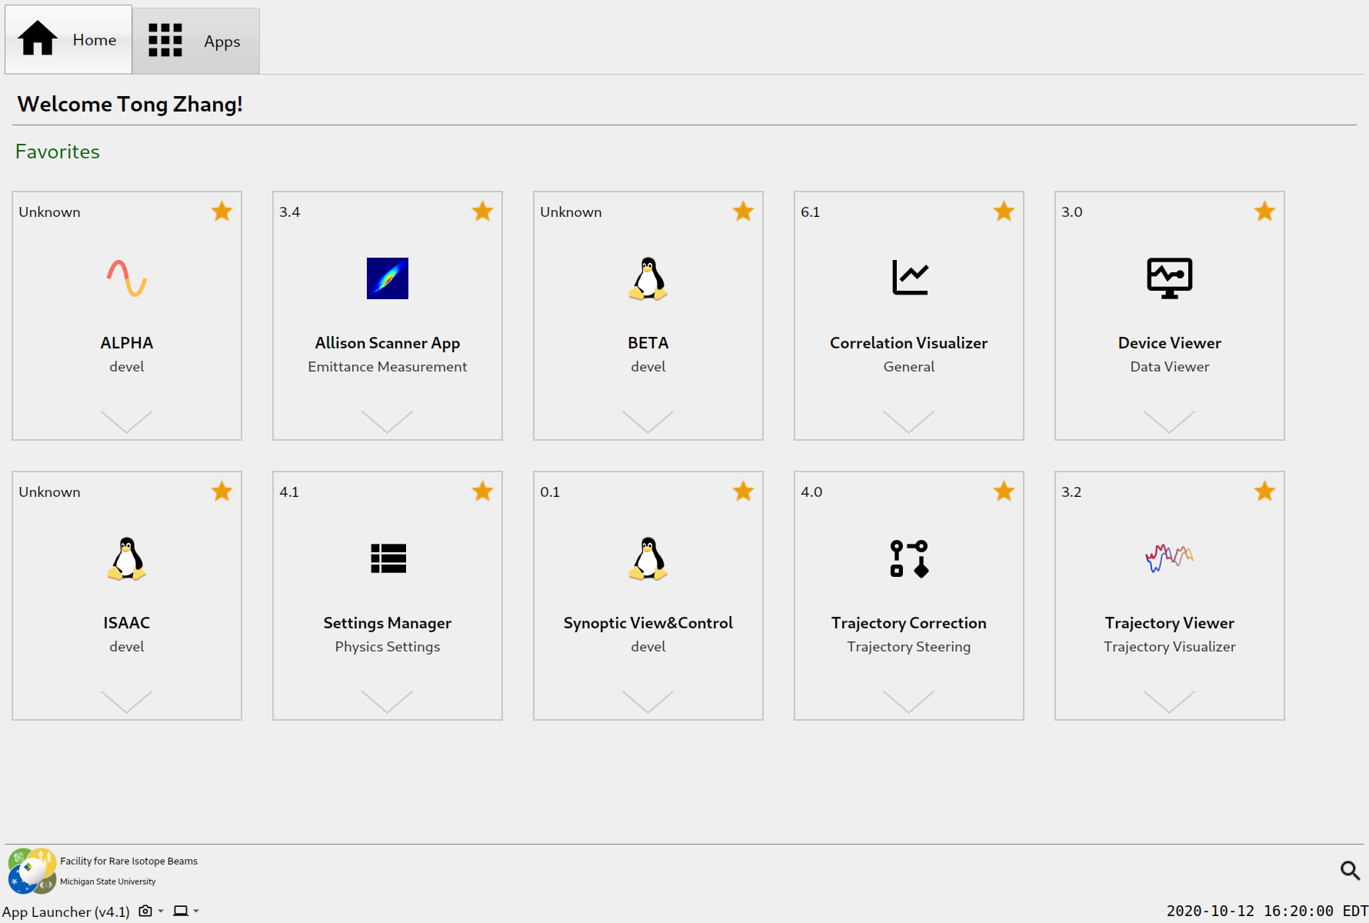
The main window of Device Viewer:
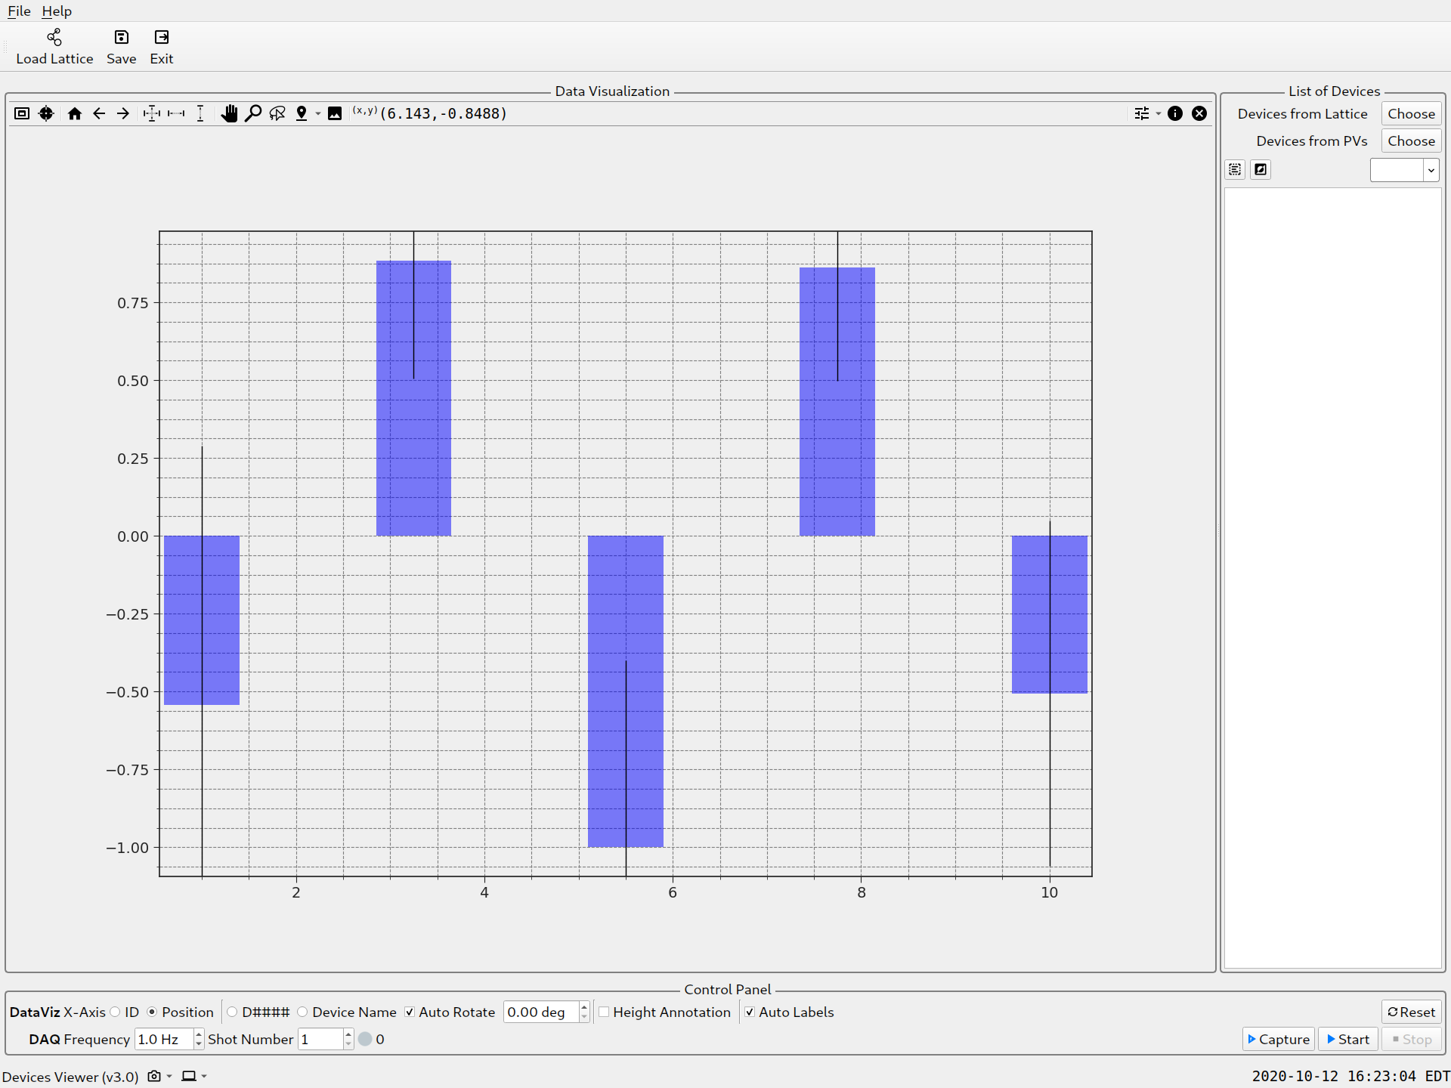

Monitor ND device readings
Here take the example of taking ND device average readings as an example, to show the typical set up of this program.
The fundamental steps are:
1. Load lattice (FRIB/LINAC)
2. Select devices by device type, here the device type is ND
3. Set up DAQ
4. Save the data

Load Lattice
Load lattice is needed only for one time after the app is started, after that, you can select different types of devices (see next section).
Click ‘Load Lattice’ tool in the toolbar, or hit the keyboard shortcut: Ctrl + Shift + L
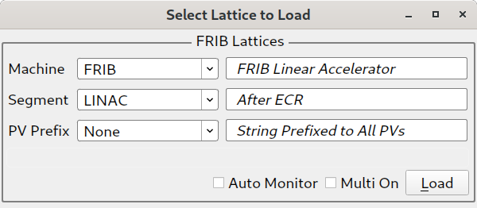
Choose ‘LINAC’ in the Segment combobox, then click Load button.

Select Devices
Click the ‘Choose’ button next to ‘Devices from Lattice’,
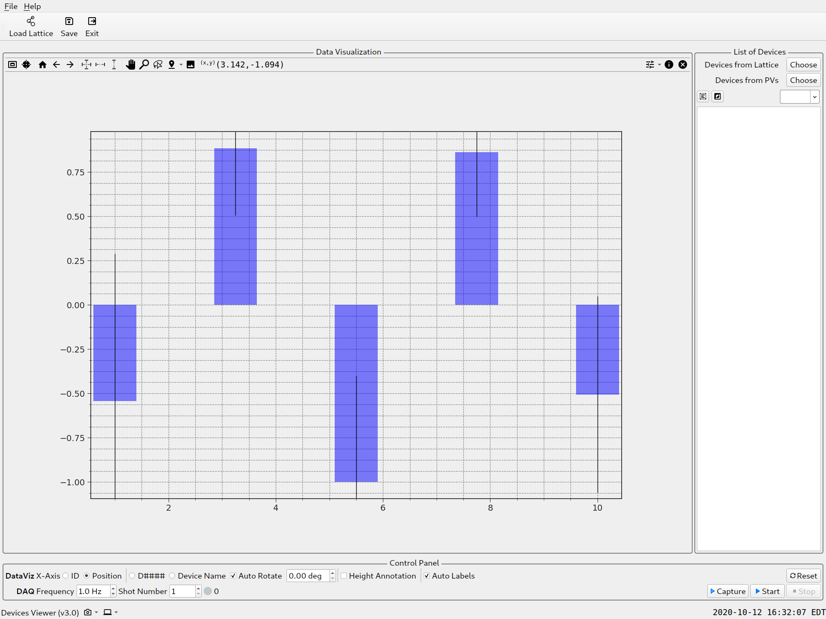
which will direct to the device selection dialog as following:
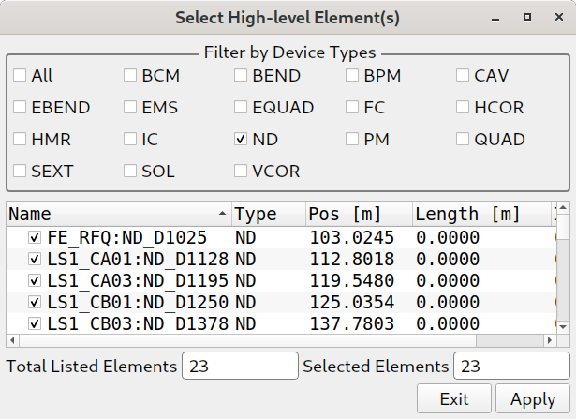

Select all the devices of the checked type, it is recommended to select only one type each time, in this example, only check ‘ND’, then click Apply button to select all of them, the Exit.
In the List of Devices panel of the main window, the selected ND devices will appear:
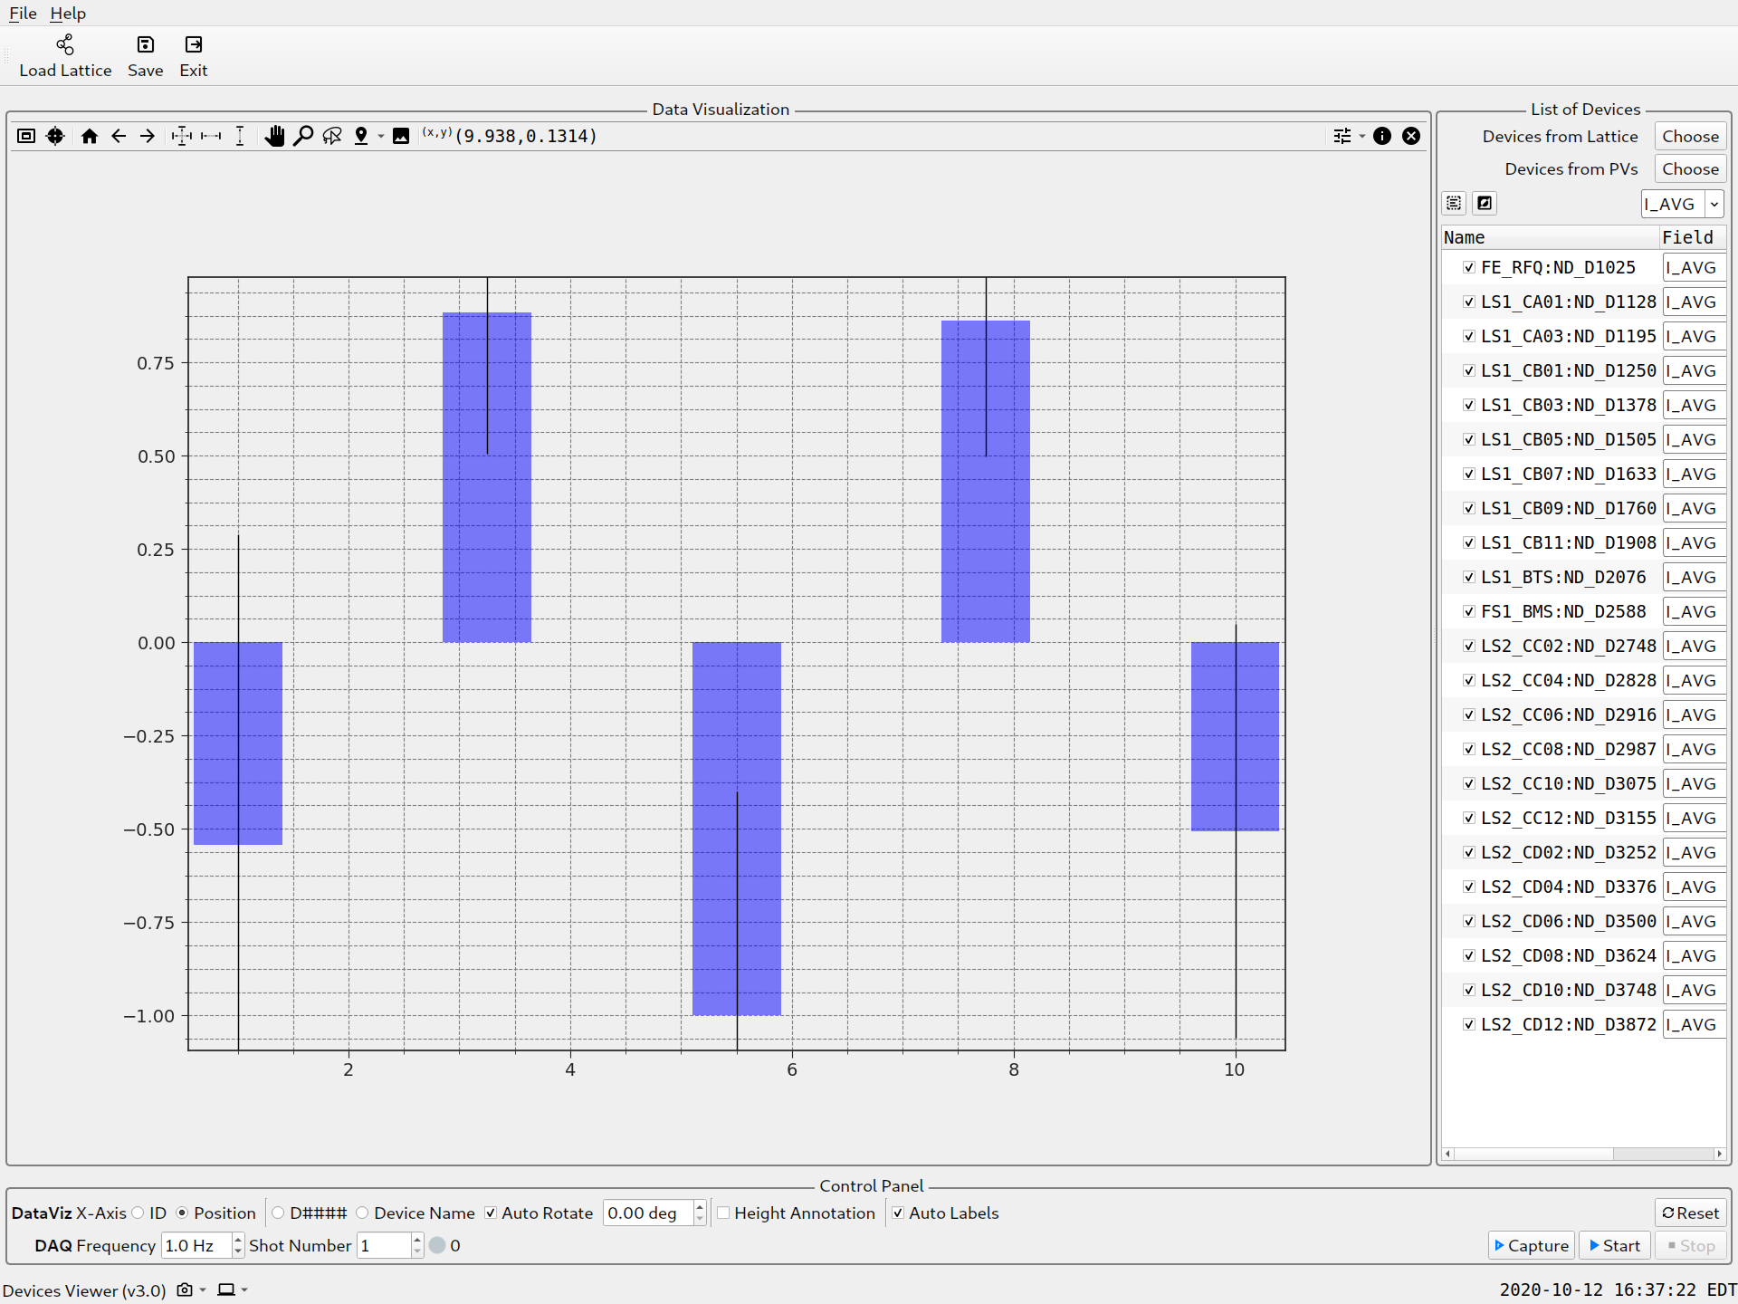
All checked devices will be used in the DAQ, so now you’ll have another chance to check/uncheck devices.

Set up DAQ
There’re two ways of the DAQ:
1. Continuously monitoring the device readings: for monitoring/data visualization purpose
2. Only take data as configured for one time: for data acquisition/recording purpose
After configuration, please do not forget to press Reset button, otherwise, you may not be aware what has been configured.
The following figure shows the DAQ rate is 5 Hz, i.e. each second the program will get 5 shots of signal for all of the selected devices, and for each DAQ iteration, the program will get 300 shots in total, i.e. ~ in 1 minute.
Check ‘ID’ if showing devices on the figure from left to right, ‘Position’ show the longitudinal position, and check ‘D####’ to label x-axis with device D numbers, ‘Device Name’ with full device names, Check ‘Height Annotation’ to put values onto each bar.
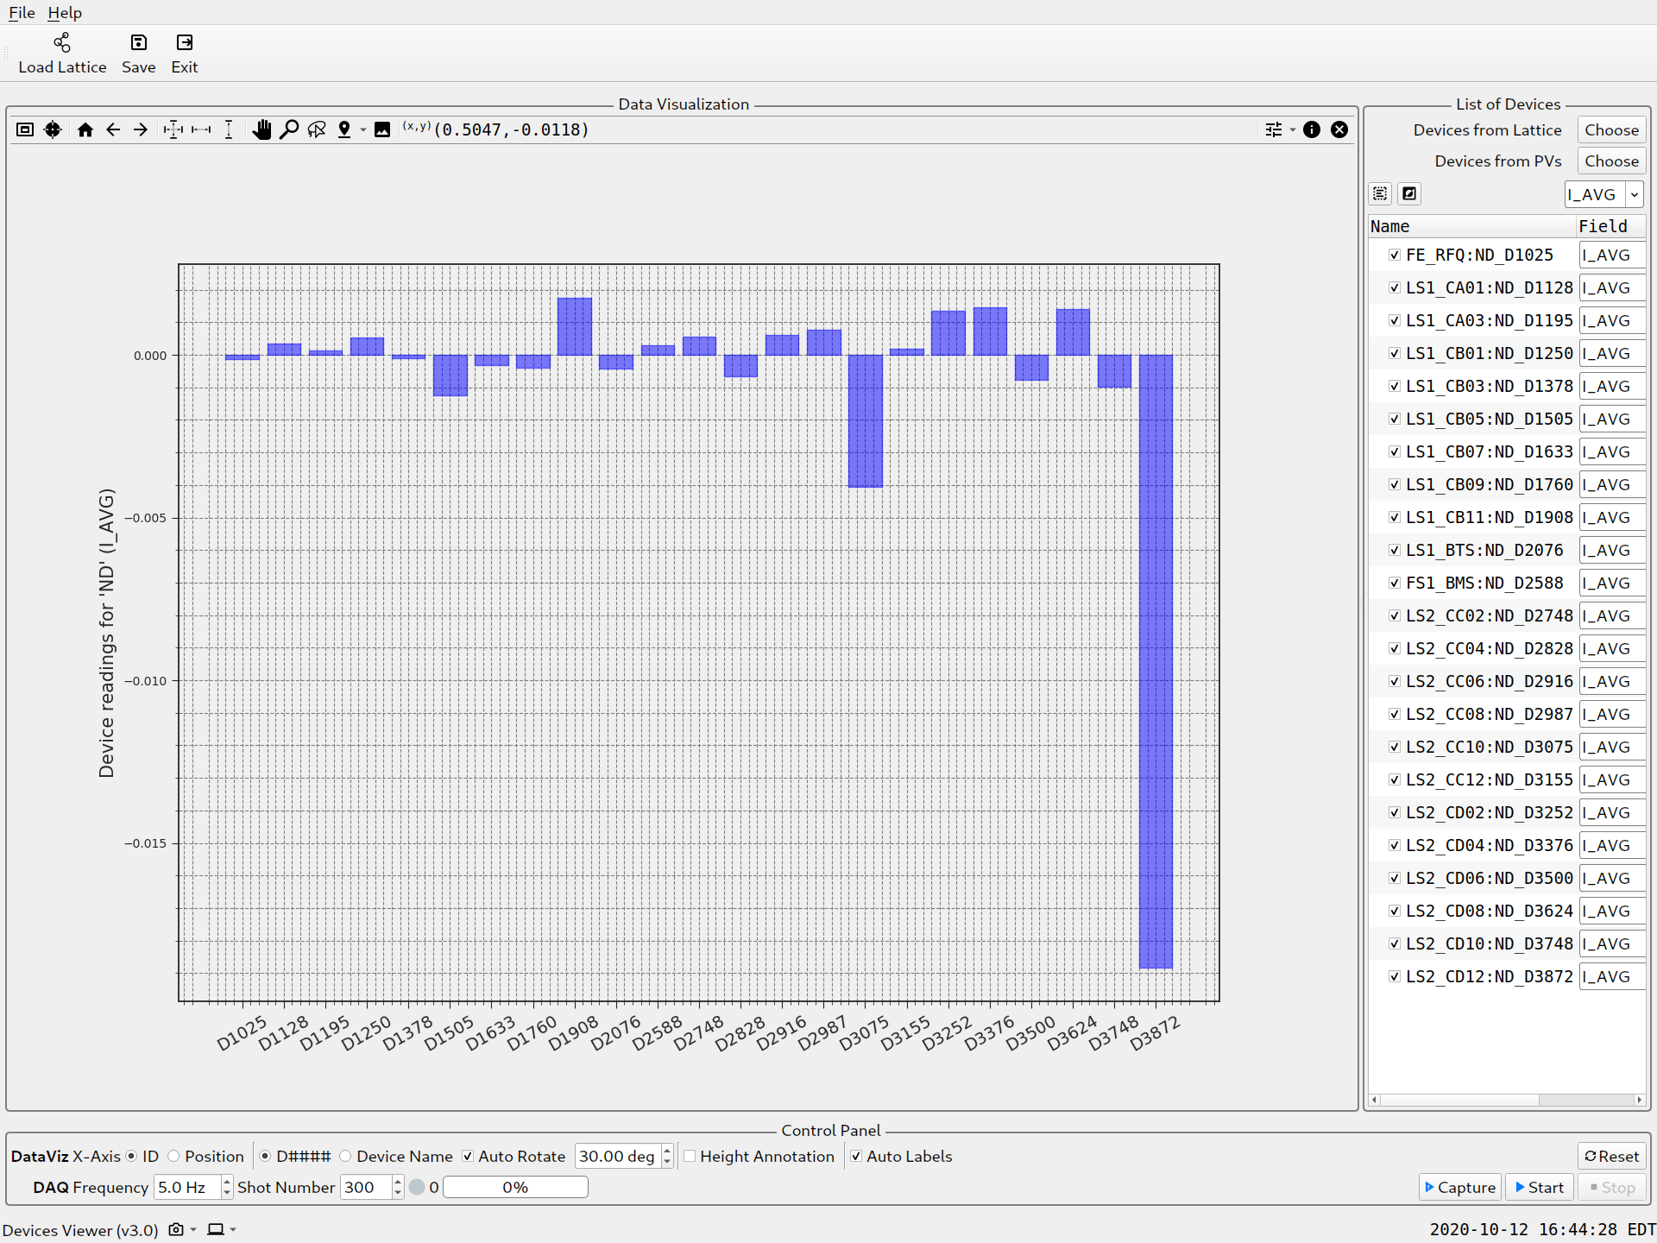
For use case 1, press ‘Start’ button to start the monitoring work, for the above configuration, the plot will update every one minute.
For use case 2, press ‘Capture’ button to start the DAQ work, after 1 minute, the data will be plot onto the figure.
The progress bar shows the DAQ progress.

Save Data
After Capturing is done, press the Save button in the toolbar to save the data, you will reach the following dialog:
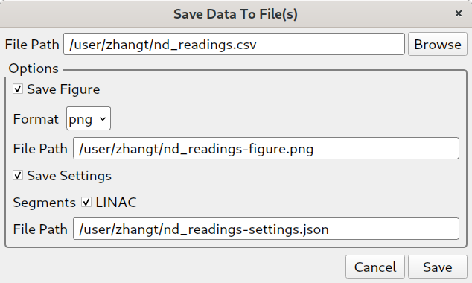

Select the file path for the data, and check the options to save figure and settings, click Save to save the data/figure/settings.
Below is the saved csv data file from this example:
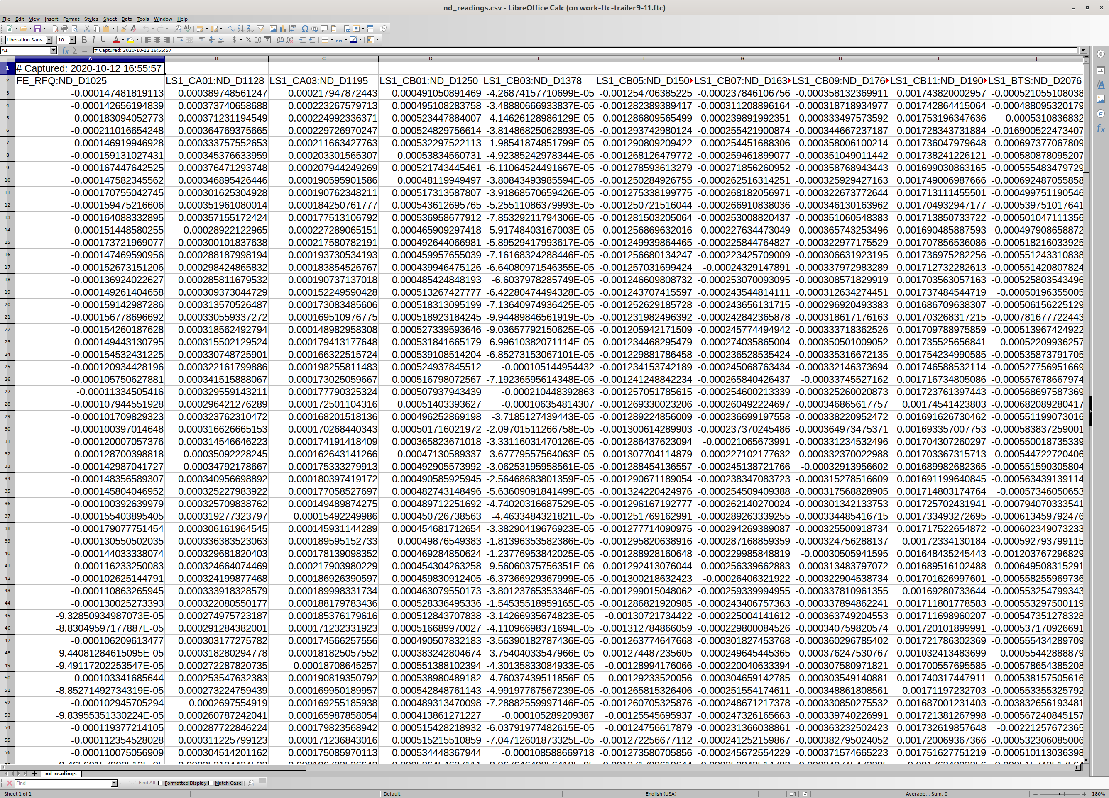
Each row is acquired at the same time as one shot, in this there, there are 300 data rows in total, together with the device names as the head row, and the saved time.

Bonus
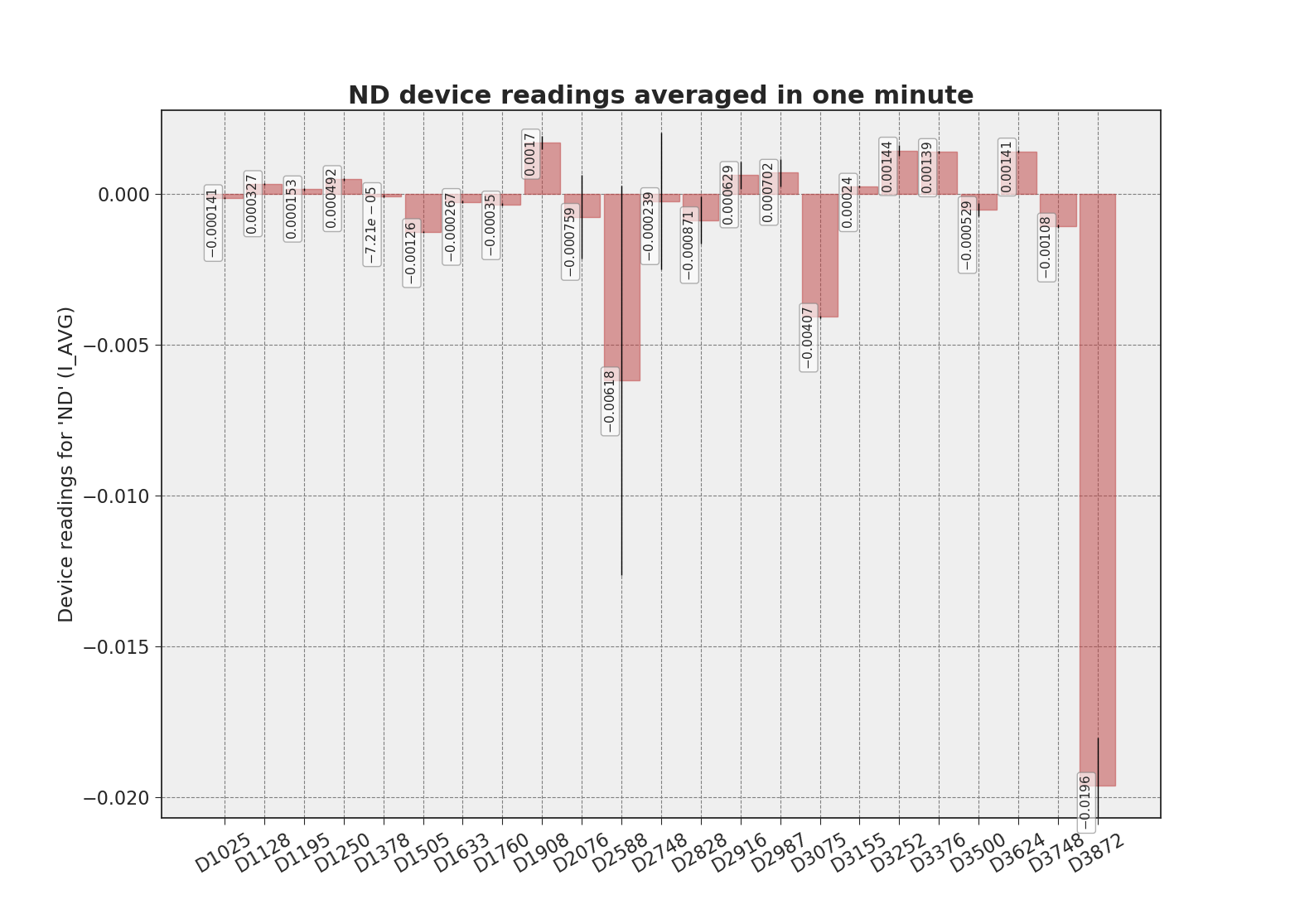
The plot figure can be configured for better data visualization, right clicking (shortcut: c,c (press c twice)) on the figure will pop up the figure configuration dialog, inside which, you can configure the figure with title, xy labels, font style, bar color, annotation text, etc…

How to reach this document:
In the App Launcher, click the help icon of Device Viewer card, see the following figure:
