Manage Settings with the App ‘Settings Manager’

Tong Zhang, 2020-10-02

This document is a brief guide to show how to use ‘Settings Manager’ to change the machine state with pre-generated or saved settings data files, which could be read by the app, and how to save machine states, i.e. take snapshot, as data files.

By default, all the data files are kept in the shared directory: **/files/shared/ap/settings_manager/**.All the users belong to group **apg** have read access, the user who saved data file have the write access as well.

Following there are two sections, one is the most regular user guide for ‘Settings Manager’, and the other is the guide of how to support cavity tuning with ‘Settings Manager’.

# How to use Settings Manager

‘Settings Manager’ is a GUI application built upon the Python framework so-called ‘PHANTASY’, which provides a lot of fundamental Python libraries to communicate the EPICS controls devices in the object-oriented way, modularized Qt UI components, as well as general routines for efficiently crafting PyQt applications for the high-level physics controls of the accelerator.

## Open Settings Manager

Startup **App Launcher**, from where the physics apps could be started. In the terminal input the following command: /files/shared/ap/run_apps.sh

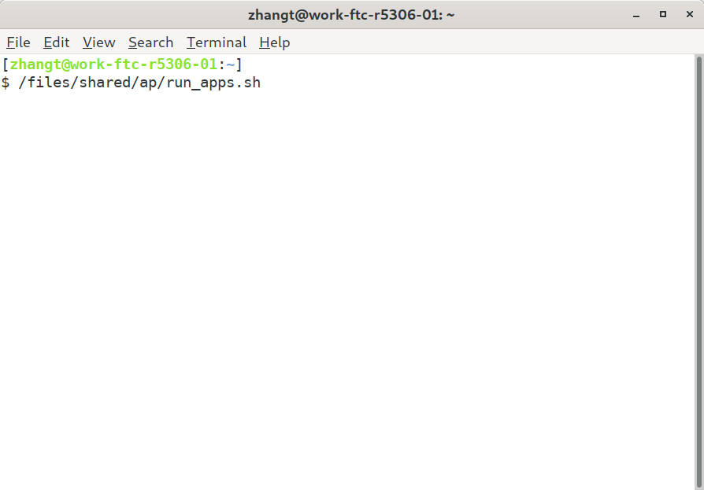

You’ll reach the main page of App Launcher, the default tab ‘Home’ shows all the applications that are marked as ‘favorite’[1], single click the app icon will trigger the starting up. Searching is support by clicking the search button in the right bottom, or hit Ctrl + F, input string to filter the app you’re after, hit Esc key to clear search.

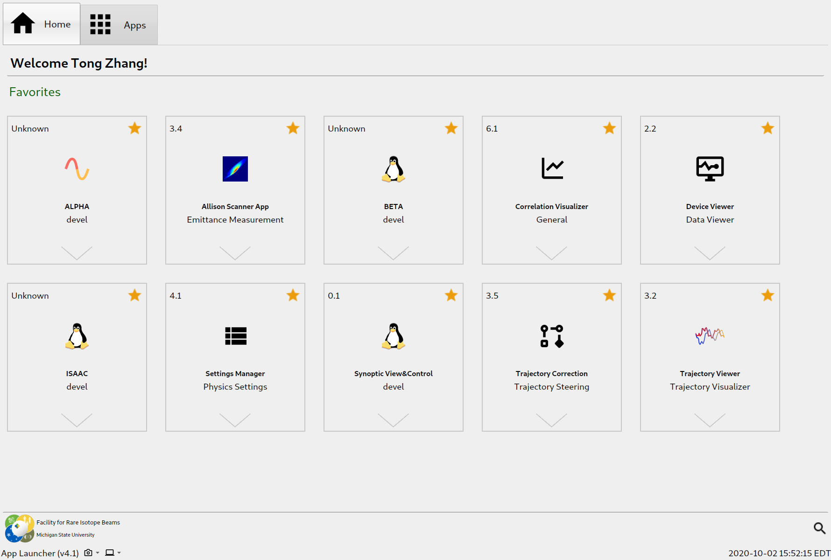Now clicking Settings Manager card to start it up, the following figure show the main window.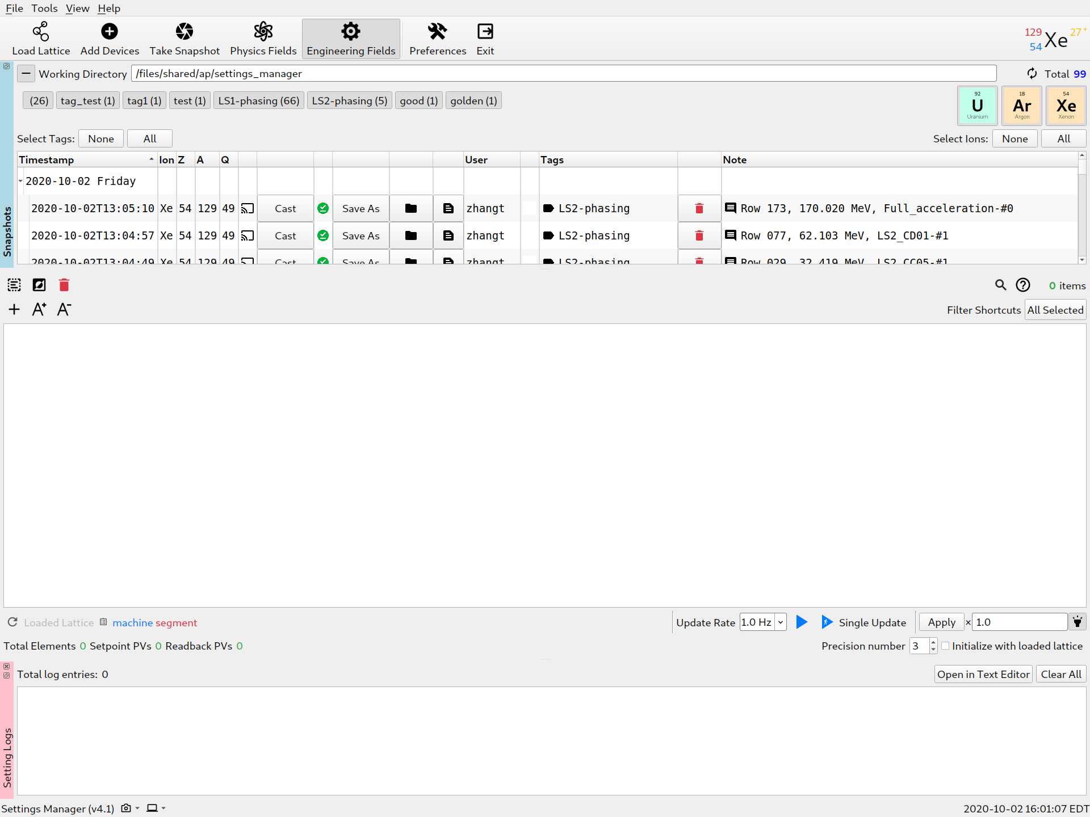

## UI of Settings Manager

There are four major parts:

1. **Top toolbar**: major operations, e.g. Take Snapshot will create a new snapshot which will appears in Snapshots window.
2. **Snapshots window**: list all the data files in the working directory, also manage the snapshot in the memory before saving to a file.
3. **Settings view and control window**: show the setting values, setpoint, readback, device info, and more, as well as the buttons to set device with the values to change machine state. Settings view supports sort, search.
4. **Device setting logs window**: show all the setting record when changing machine state.

After the app is started, all the settings data files will be loaded into Snapshots window from the default working directory. And the user is ready to load any of them to start the work. The Snapshots window can be relocated by clicking the undock button The same applies to Device setting logs window.

The Snapshots window supports sorting by hitting the column header, e.g. by clicking ‘Note’, the table will sort w.r.t. the note strings. Also convenient filtering function is supported, e.g. check/uncheck ion name buttons to show/hide corresponding rows, the same rule applies to tags filter buttons.

## Load Settings

Loading the settings in the data file could be done by clicking the ‘Cast’ button of each row of Snapshots window, see the following figure.

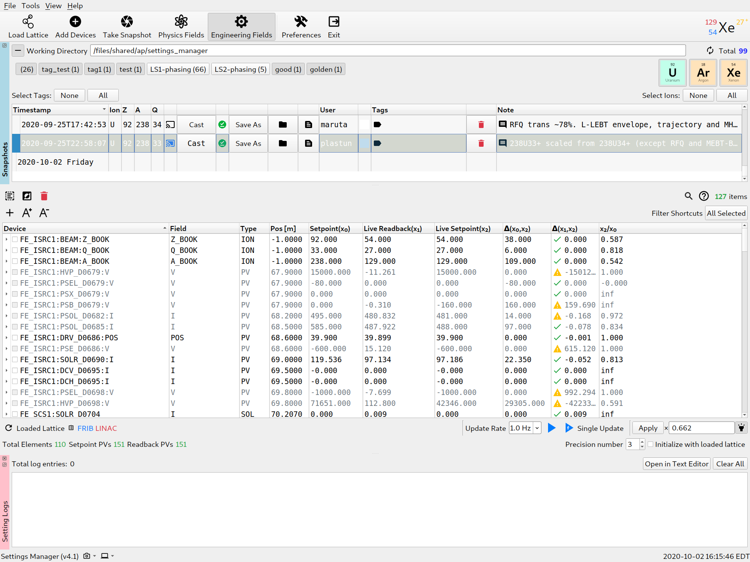

Check the rows in Settings View (mark the Device column is checked) by clicking the checkbox, or via right-clicking context menu after selected rows (multiple selection is supported with Ctrl and Shift keys).

Then click Apply button to set the devices with the values in Setpoint column, or x0. Additional scaling factor may be multiplied. Auto calculated scaling factor will be triggered if the loaded settings is for different ion species, e.g. the example showed here is for Uranium, if this setting is to apply on Xe, 66.2% of x0 is the setpoint to set. However, the user is free to change the scaling factor.

## Save Settings

Save settings is to save all the devices listed in Settings View, regardless of checked/unchecked status. Push ‘Take Snapshot’ tool, it will make a new entry in Snapshots window, show as below, from here, the user has the option to save it as a data file, or leave it in the memory[2].

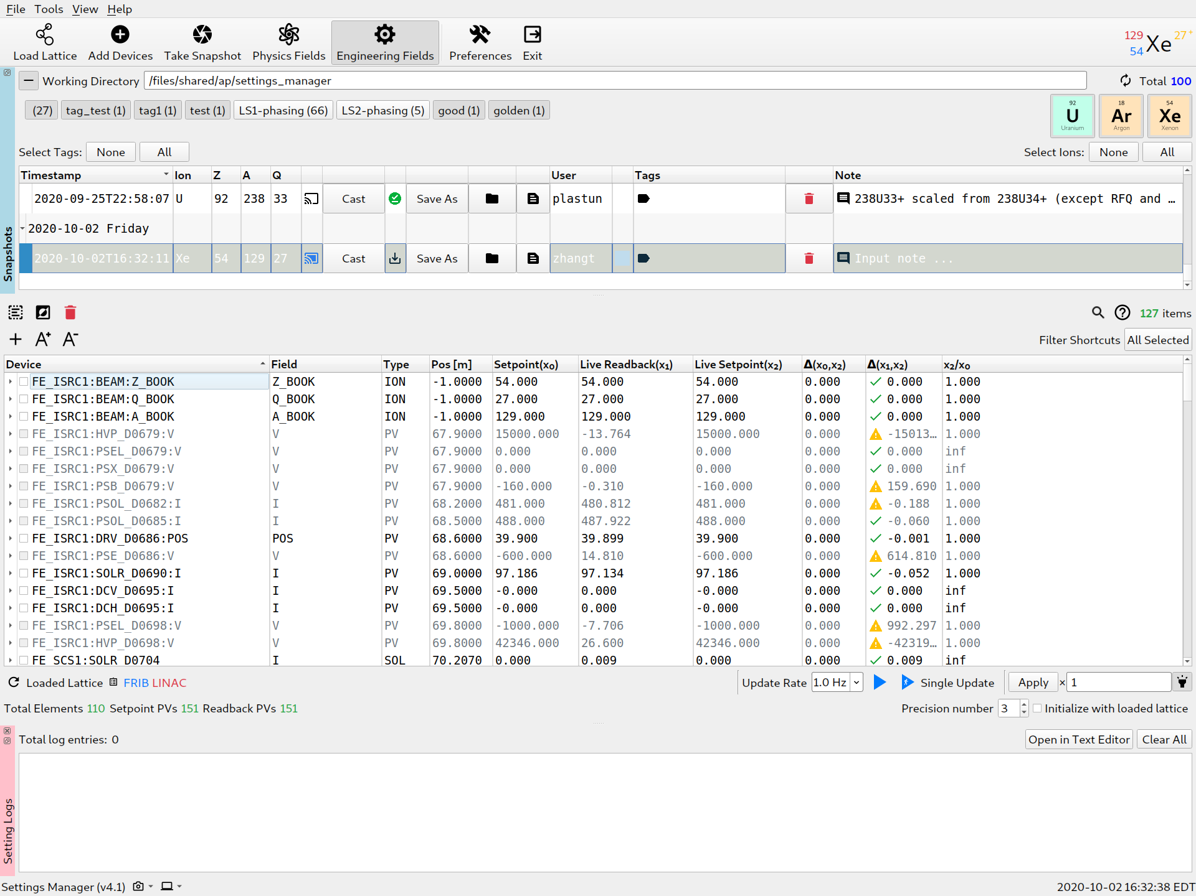

Save to the disk by click Save As button in the row, the app will auto fill out the filename, usually the user does not need to change. After that, the user has the opportunity to change the metadata of the data file, i.e. change the Tags and Note columns, any changes of this two columns will auto update the data file.

Deletion option is also provided by clicking delete button left of Note column.

# Device Settings for Cavity Tuning

## Data Files

Data directory: **/files/shared/ap/settings_manager/settings_support_cavity_tuning**

For LS1 cavity tuning, original Excel data file: 20200224_phase_scan_setting_list_maruta.xlsx

The generated settings files for Settings Manager are in folder: 36Ar10_LS1

The tag name in Settings Manager: **LS1-phasing**

For LS2 cavity tuning, original Excel data file: ARR04_phase_scan_ver20200322.xlsx

The generated settings files for Settings Manager are in folder: 129Xe49_LS2

The tag name in Settings Manager: **LS2-phasing**

## Work with Settings Manager

In Settings Manager, only check the interested tag, e.g. LS1-phasing, the following figure shows the filtered settings in Snapshots window

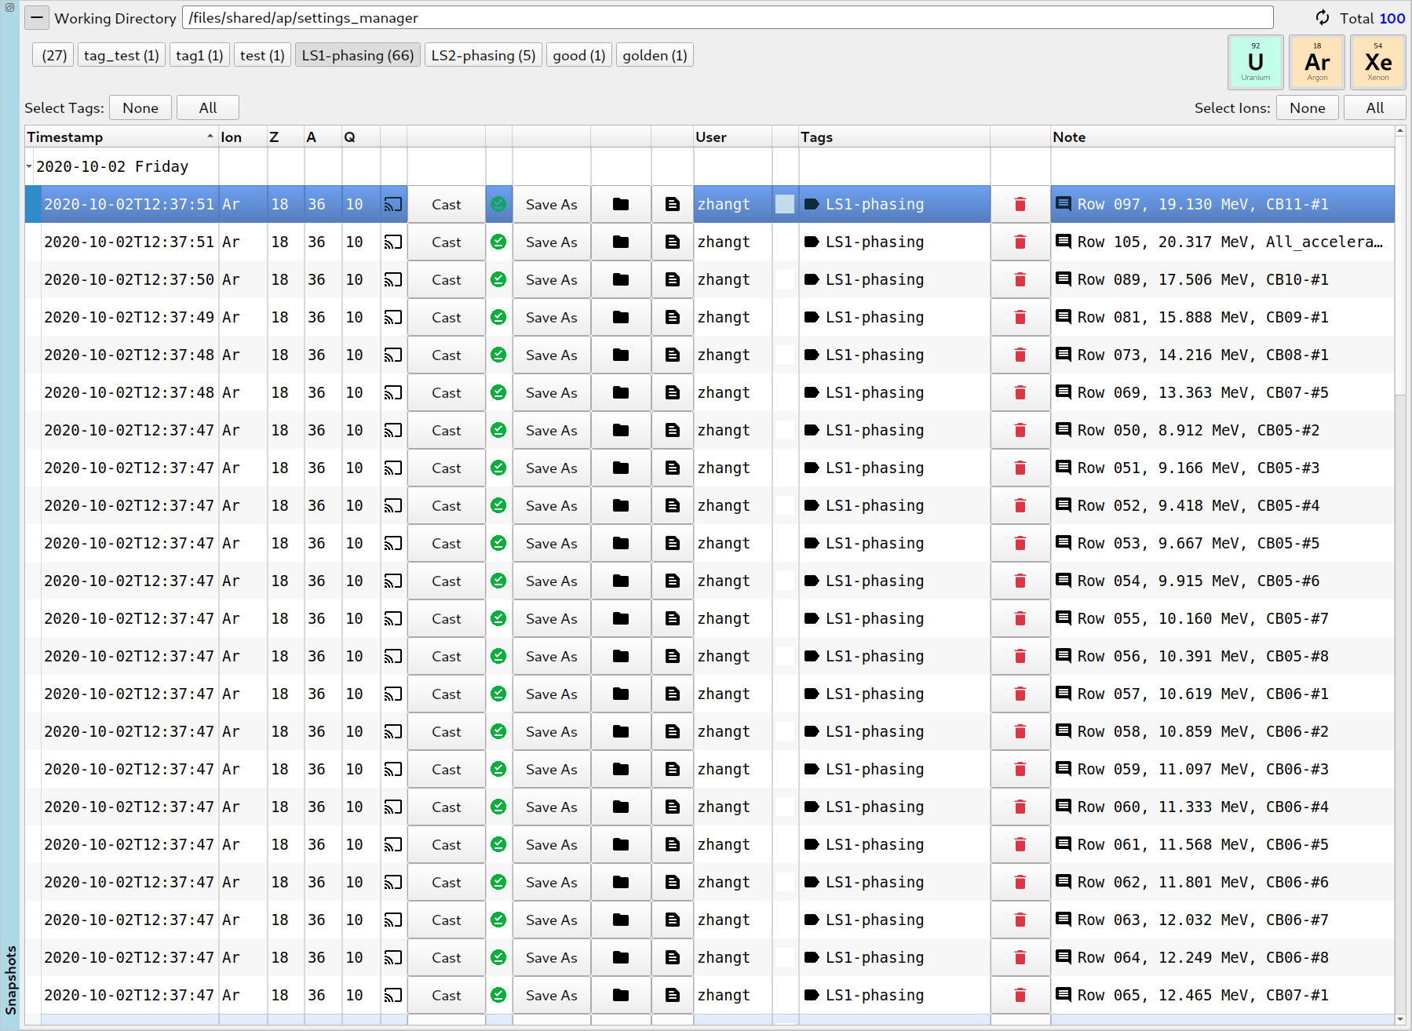Load the settings as needed. A bit explains about the Note. For instance, the selected Note is ‘Row 097, 19.130 MeV, CB11-#1’, which means this settings is extracted from 97th row of the file 20200224_phase_scan_setting_list_maruta.xlsx, the simulated energy is 19.130 MeV/u, and it is the first cavity of CB11 module. The user has the option to locate the data file by clicking the two buttons left of User column.

The same rule applies to LS2 cavity tuning.

1. Currently, version 4.1 does not support user to change the favorite status of the app, version 5.0 will support the feature, as well as add/remove arbitrary app into the list.
2. The snapshot will be destroy when the app is closed or crashed, sometimes, the user just keep the snapshot for testing, then this option is good, otherwise, save to disk is always a good idea.