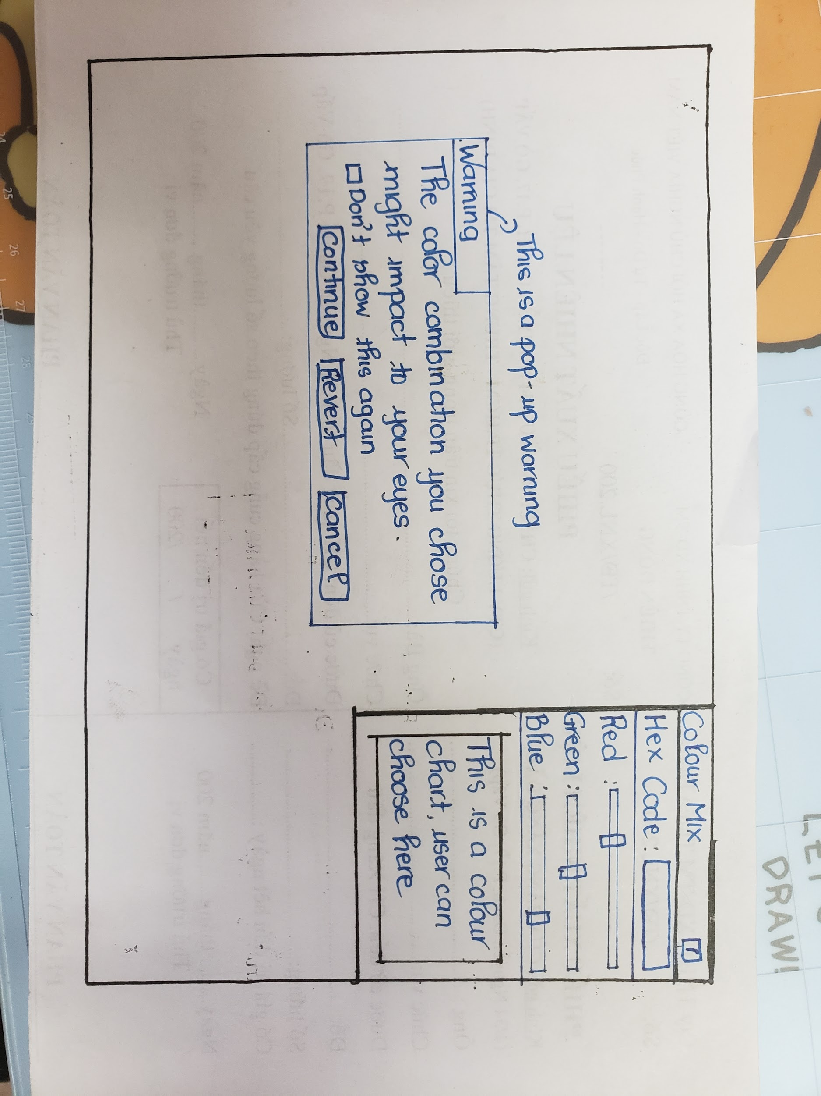

For each of the 3 solutions you have created, comment on the conceptual model that your interface presents to the user. Be sure to show a picture of your interface along with your discussion. For each conceptual model, describe the mental model you expect the user to create. **SECTION 1**

1. The conceptual model I have for the image editor is a list of colour options users can choose from. This way, if the user is an expert with the colour, they can save some time by entering the HEX Code directly, or intermediate users can mix and match the colour on the RGB bar and beginner users can drag to select the colour that best fits them. If the user changes the data in one of the 3 sections, the other 2 will change to match with it. For the error about the mixed colour could impact their eyes, the user will have an option to continue and ignore the error, revert to return to the original state of the image or to cancel if they would like to change it.
2. This mental model will let the user to construct the colours on their own or to find a new colour. Since the Conceptual Model help user “fill-in” the other 2 sections when 1 is changed, this would help the user understand the system better. For the error, the user will be acknowledged by the system and they can choose to receive the error message later on or disable it forever.