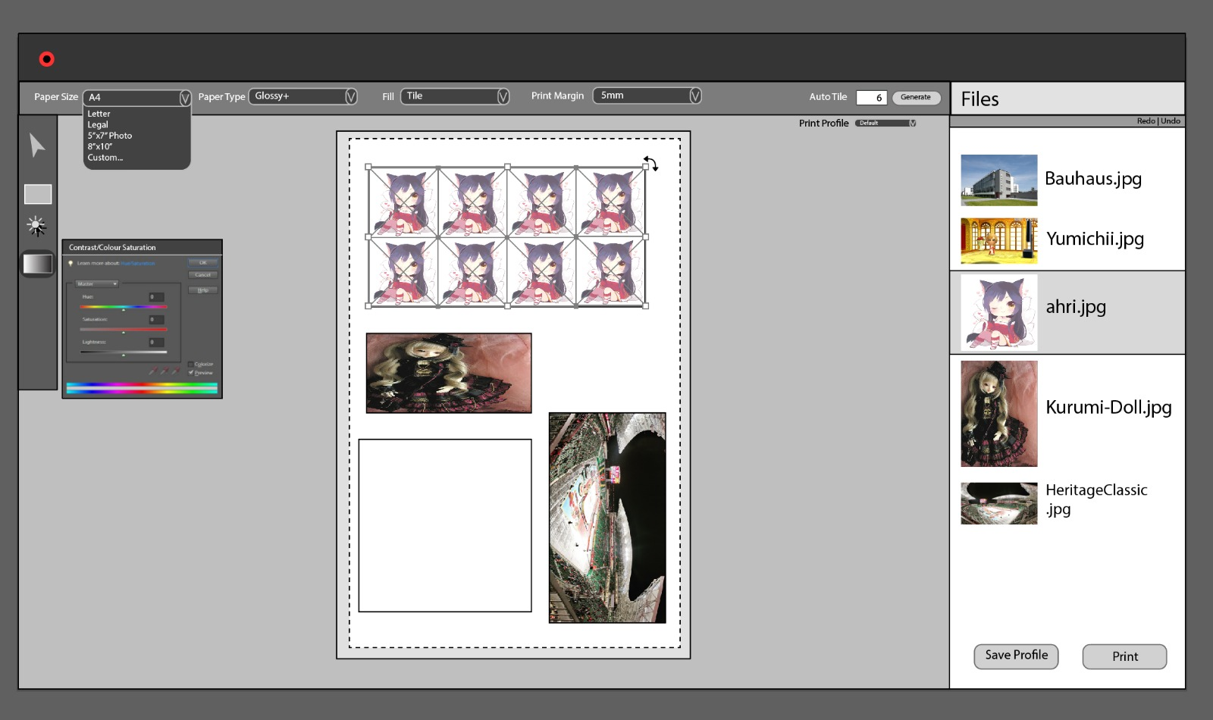

Describe how your interface implements each of the following:

* **Reversibility of decisions:** In the app we don’t actually have an undo button or reverse button for it but user can simply use this shortcut, Ctrl+Z and it will work exactly as undo, go back one step.
* **Constraints on values to be entered:** At the moment it seems that the only constraints to the user is the paper type and the fill option. For paper, user can custom to any size they want and for the margin, user can decide how thick or how thin they want for the edge of the paper.
* **Examples that will help the user envision the results of settings:**
* **Size:** let say if user change the size of the paper so whatever they want, the software will based on that given measurement (either from user or preset) and draw a layout of that measurement and allow user to put image only to that area.
* **Fill:** For the fill option, user can select from a list of fill option like tile(fill the space with as many pic as it can), stretch, fit, portrait or landscape and the image will automatically change according to the option.

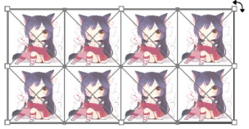

* **Margin**: this can be set specifically by the user and the preview will show a grey out area where the outer line will be the original scale of the paper and the inner line will be the space left for printing after the margin



* **Preview of what the results of the user’s decisions will look like:** The middle part is where the user can preview the result in type of paper they are printing (in the image is the A4 type). The preview will be exactly the same as what will be print out and so the user can move the image to a proper area.
* **Gestalt principles, and focusing of attention:**
* We have **Similarity** for multi-picture when they are printed in grouped
* **Proximity** is also exist to help user distinguish image from imported files to image that are being preview on paper.

Discuss how you selected the colour palette for your page and why you selected this palette.

* Basically it's simple and monochromatic, the colours are (more or less) the same throughout. The side panel on the right is white to stand out as a seperate part and the toolbar on the left is darker to contrast the grey background. The colours contrast well together so everything is visible and everything important stands out.