Pro-Option Robotics Challenge Lab 1

Mobility Challenge - Labyrinth

In this challenge lab you will design and implement software to autonomously move the VEX EDR robot through a pre-defined labyrinth using the Integrated Encoder Modules and mobility concepts taught in the course.

# LEARNING OUTCOMES

Upon successful completion of this challenge lab, you will have demonstrated the ability to:

* Create and load an autonomous application using RobotC on the VEX EDR Cortex controller
* Implement the concept of mobility
* Use Integrated Encoder Modules to track accuracy within robotic mobility

# SPECIFICATIONS

Your task is to write an autonomous software application using RobotC that will successfully navigate a Labyrinth course in the classroom. Your software design should take into account the concepts of mobility taught in class and should use the Integrated Encoder Modules on the VEX EDR platform.

The robot must first begin at the starting point, and get to the goal area by completing turning and forward movement behaviors.

You are not allowed to interact and/or touch the robot once the program has started. Doing so will results in loss of marks. You robot must be programmed to stay within the lines of the Labyrinth, which will be taped on the floor (no you do not have to sense the lines… This is a mobility and IEM challenge).

The design of the Labyrinth will be as follows:

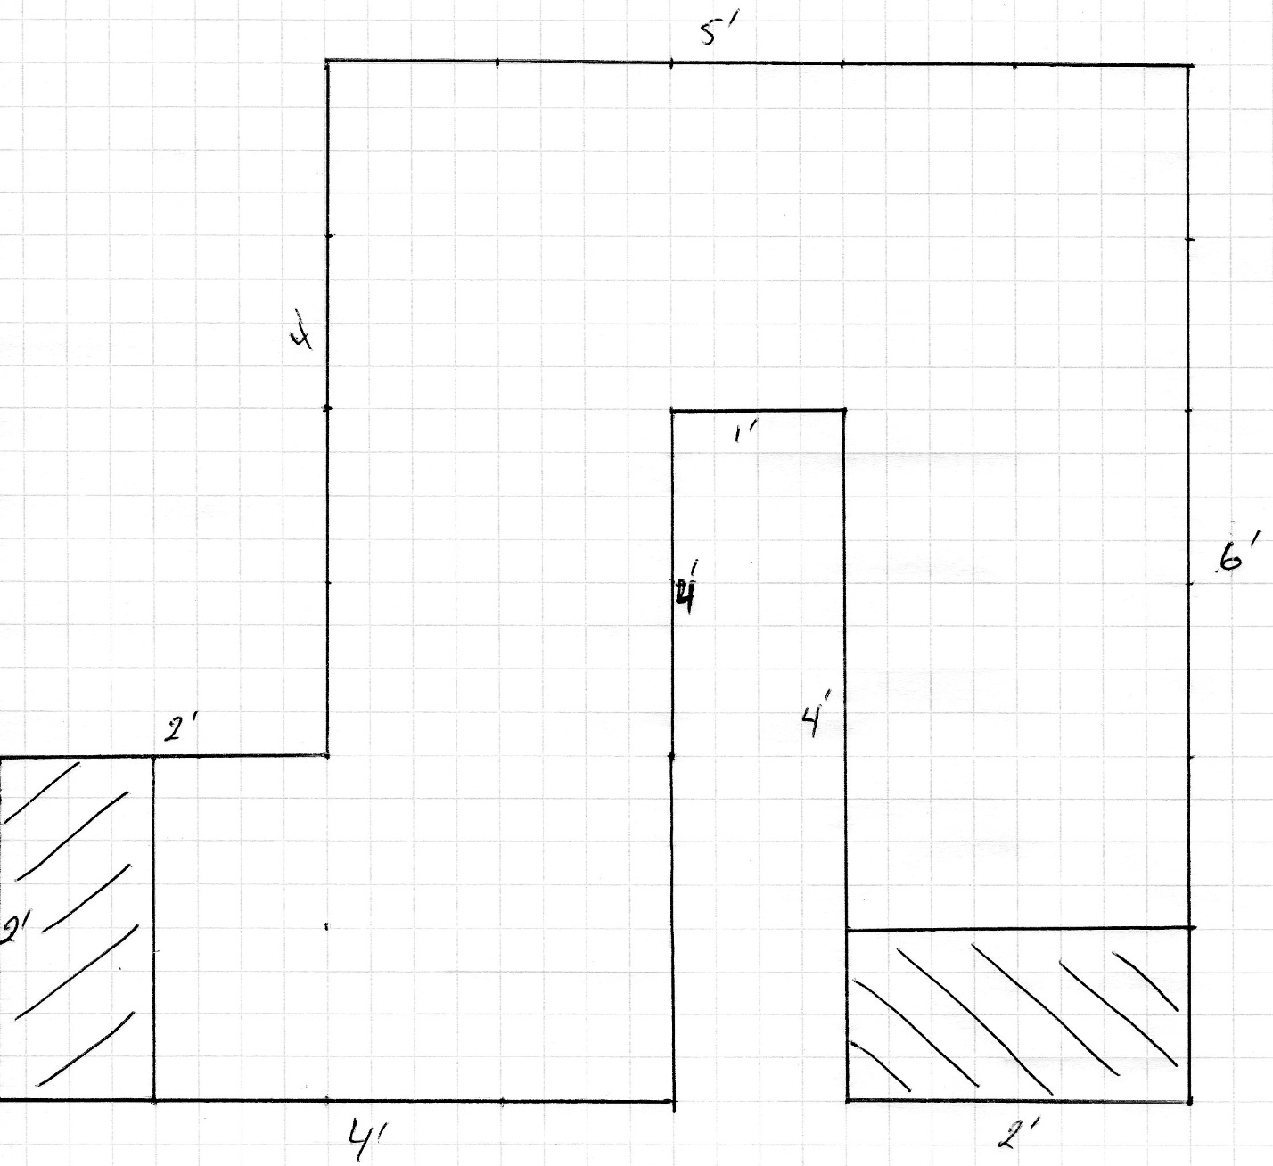

# SUBMISSION REQUIREMENTS

Once you have completed your lab upload your RobotC source file to the Blackboard Challenge Lab 1 link.