**Slack:**

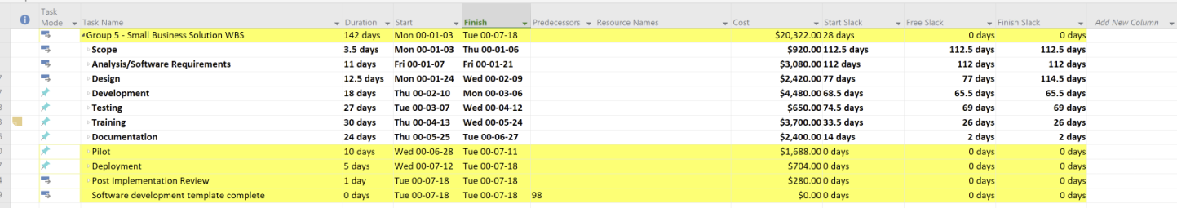

Slack – The slack is the amount of time from the start time of a task to the end time that can be delayed from the next class. For example, there is 26 days of slack before we have to start the documentation stage.

**Term Definitions:**

Effort driven cost – the amount of the work for a task stays the same, but when you have more people the days shorten for it, but if you have less resources, the task lengthen in time.

Fixed cost - The Fixed Cost field shows nonrecourse task expense.

Work cost – The work cost field shows resource task expense.

Materials Cost – The material cost field shows material task expenses to build up the project.

Resource assignment – The resource assignment is when a resource is assigned for completing a task.

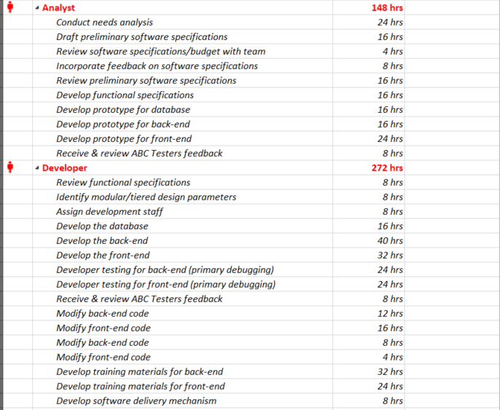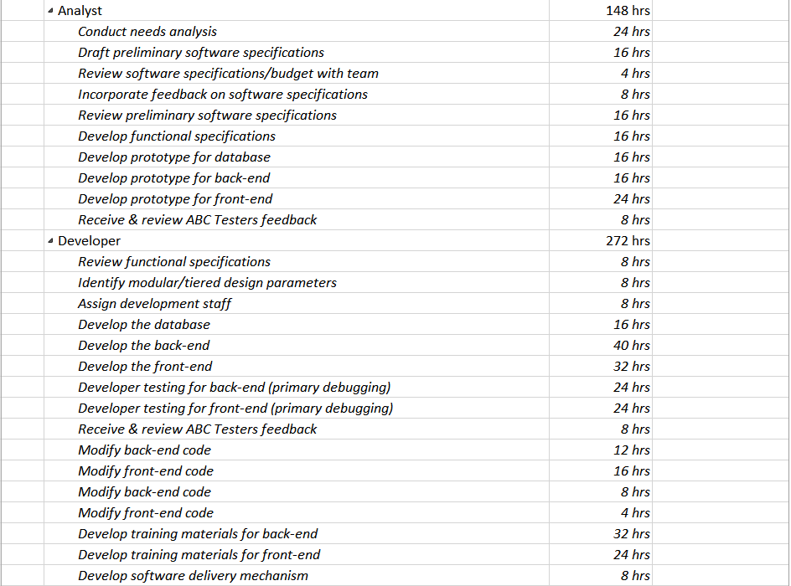

To fix our overscheduled developers and analyst, we have to reschedule some of the work day between task to help relieve some of the pressure that was facing them and give them a better time frame for finishing the project within the constraints.

**Baseline:**

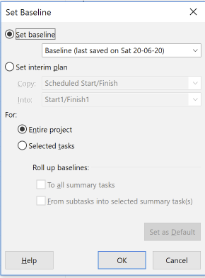

Setting the baseline for the project.

**Project Information:**

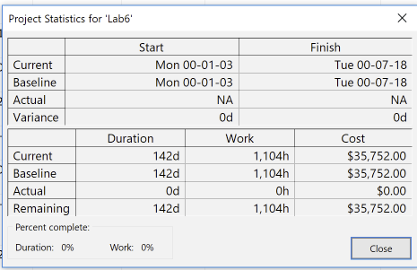

Our total cost for the project will be $35,752.00 and our total work hours is 1,104h.

**Reports/Views/Cost:**

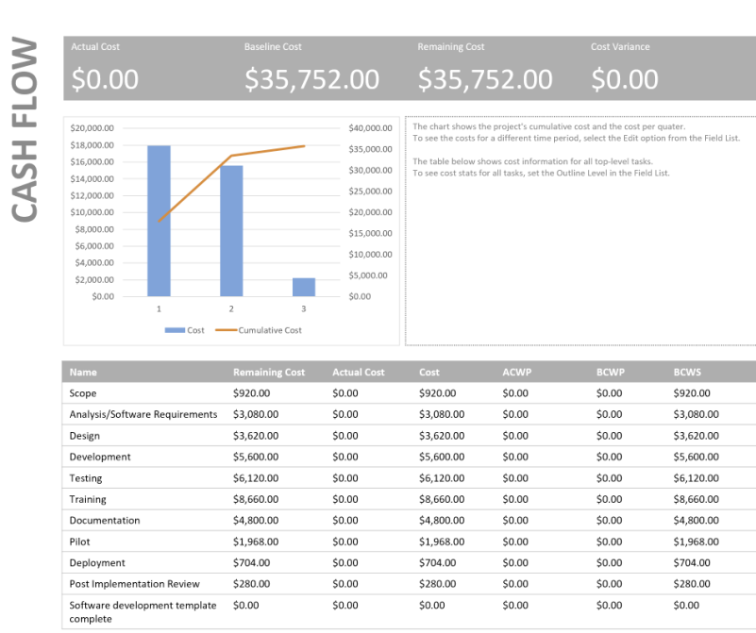

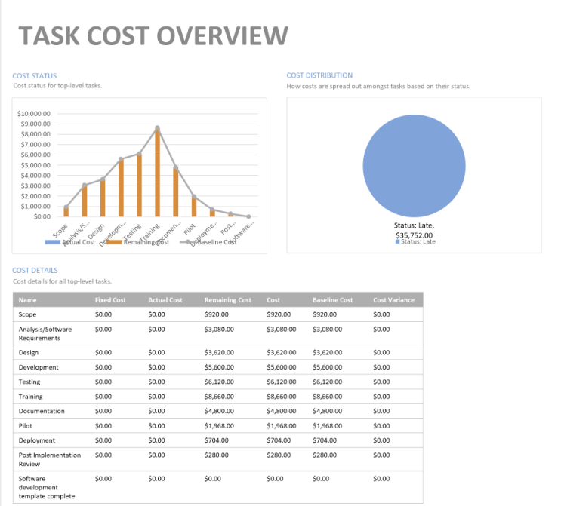

Our training cost are the most expensive cost as we have to train all the workers at the business and also have to teach the developers how to pick up where the last developer picked off.

Our second most expensive category is testing because we are outsourcing all our testing to a vendor.

Lastly, our third most expensive category is development. This is because the system has to be developed from scratch.