**Khai Phan Thanh (100901164)**

**Question 1)**

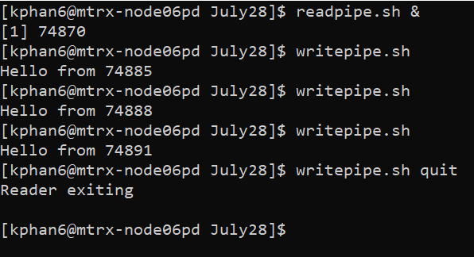

* Trap comment on readpipe.sh is to remove the temporary file created to handle the pipe
* $1 indicate if there is any argument entered into writepipe or not. For example, quit is an argument which will be stored instead of “Hello from $$”, where $$ is the pid (process id). Quit argument will then read by readpipe and quit the execution, also remove the temp file.

**Question 2)**

* The clientpipe.sh will take the value of log_record (what user entered after “Please enter a comment:”), store it into temporary file of log_server_pipe. Serverpipe.sh will read the log and echo it.
* Mkfifo -m 666 $fifo is setting the permission for the temporary file. 666 mean read and write permission (4+2).
* What I did to make the server stop is:

