**Khai Phan Thanh (100901164)**

**It seems that there is an error on the directory that you provided to us for testing. So I will just use that link as much as I could. Whenever I can’t do it, I will demonstrate it on my user directory. Some image will not display the cursor correctly due to system default/**

* **Error Message**

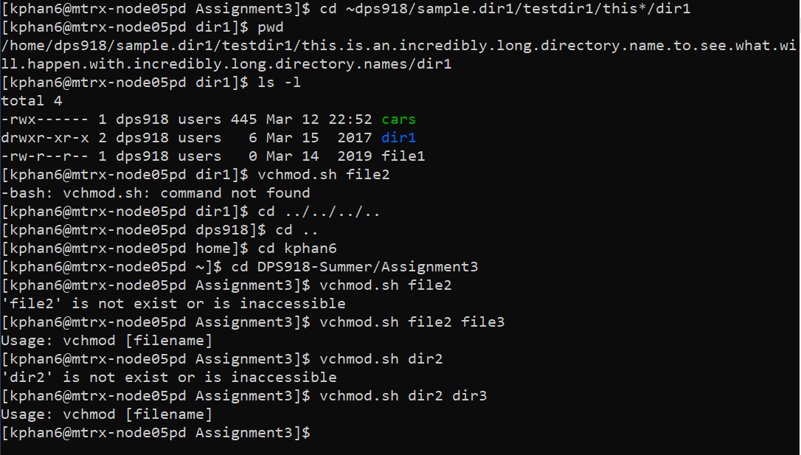

* **Entering** ~dps918/sample.dir1/testdir1/this*/dir1/cars **(for some reason, I produced an error said I cannot access this director**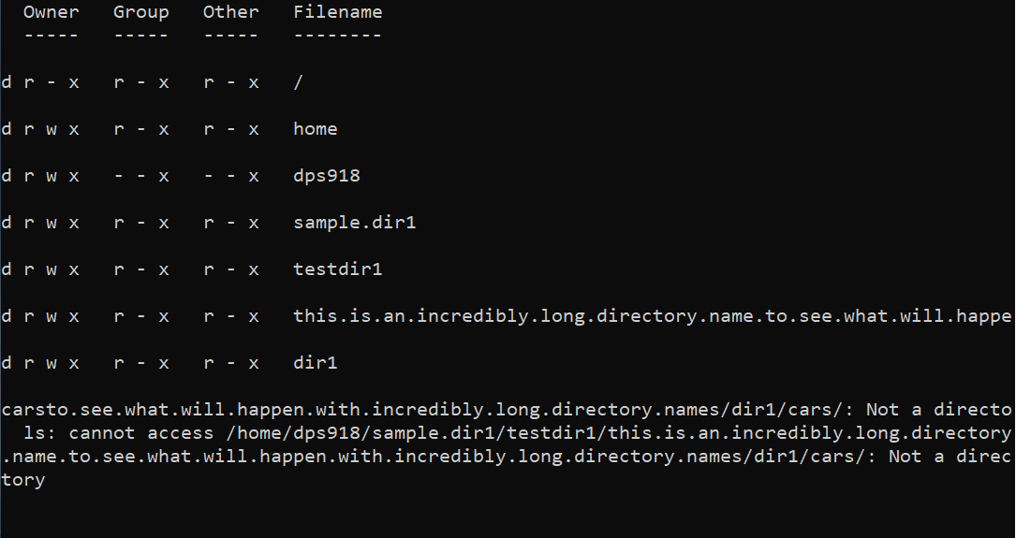
* **Instead, I will just redirect up to** ~dps918/sample.dir1/testdir1/this*/dir1/cars

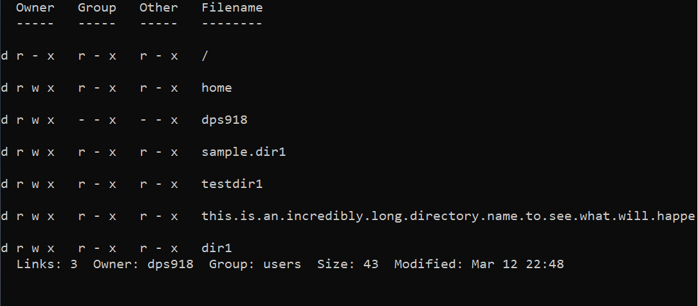

* **Hitting “k” 2 times will produce this**

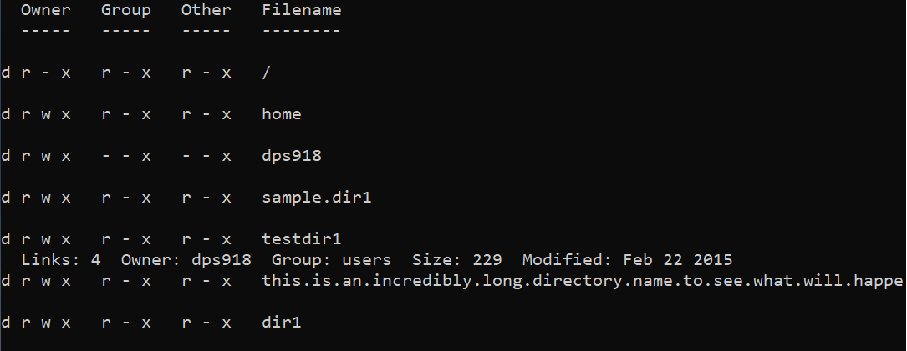

* **Hitting “h” 5 times will add write permission to the directory (I can only do it on my own directory)**

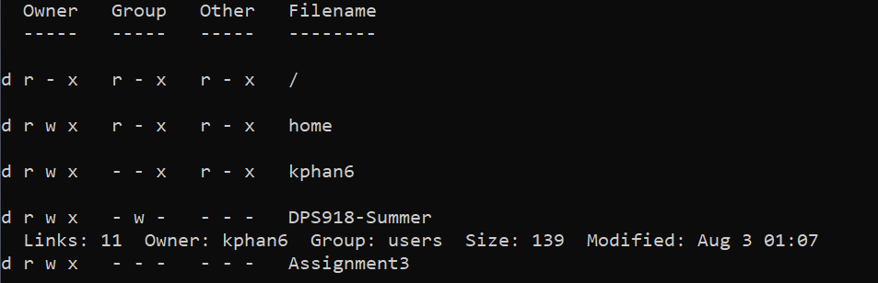

* **Hit “k” 3 times will bring the cursor to the root, in the group section between “r” and “x” permission**

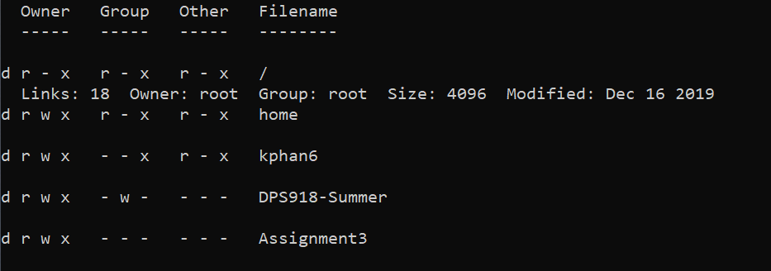

* **Hit “w” and “k” will not do anything as it is the root directory and already on the top of the line. Hit “l” 2 times will bring the cursor to the “r” permission of other, hit “j” 4 times will bring the cursor to the end display**

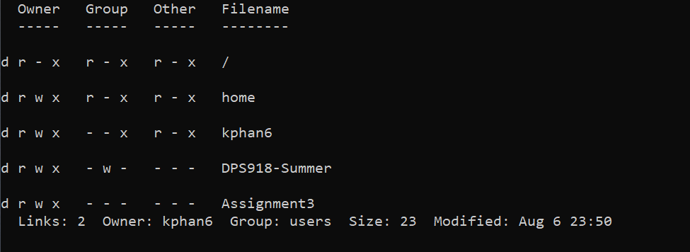

* **Hit “j” 6 times will bring the cursor to the “r” permission of owner**

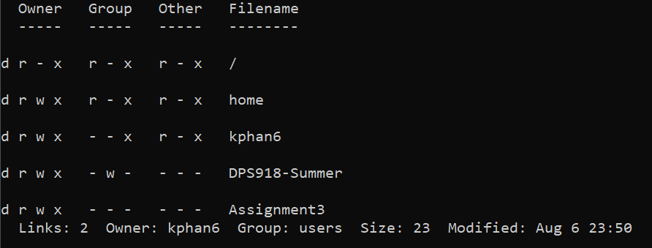

* **Hit “h” will have no effect as it already on the farest left side of the screen. Hit “q” will quit the program**

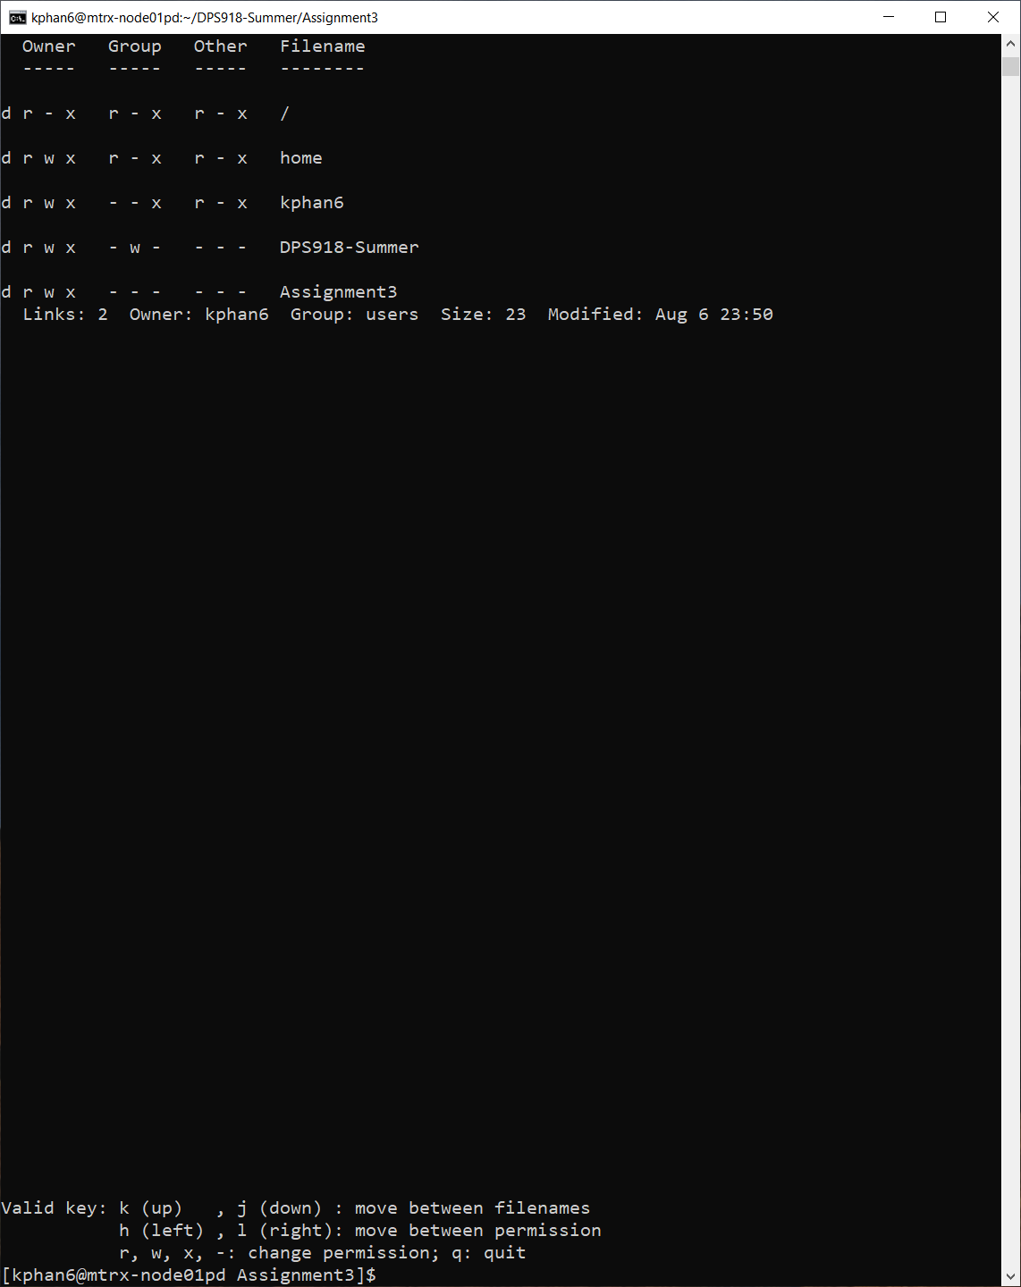

* **Hit the pattern “hhhrkhh-“ will bring the cursor left 3 positions, set “r” permission to other, hit “k” to move up one line, bring cursor left 2 positions and remove “w” permission for group**

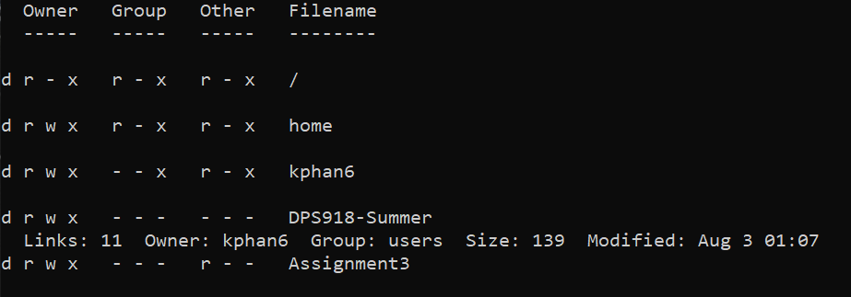

* **Hit “q” will exit the program**

