1. Answer the following questions. You need to practically develop Q1~Q4 in Matrix. For Q5 and Q6, you can use your word to explain it (you can also demonstrate it in Matrix and explain it).

Make sure to submit a MS-Word file which contains all answers and screenshots .

**Question 1)** Create a script (name it as Q1_yourname.sh) which does the followings: (2 marks)  
A.    Create an array (name it WORDS) with the following data  
      spy spider spiderman spin spiderweb spiral sport sportswear sportscast  
B.    Display the size of the array  
C.    Display the length of each word in the array  
D.    Display all elements except the first two  
E.    Replace spid with SpID .

* Coding Part

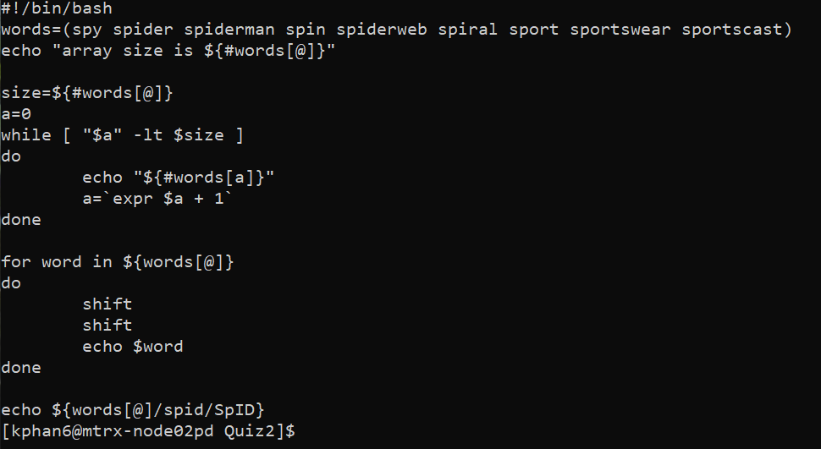

* Result Part

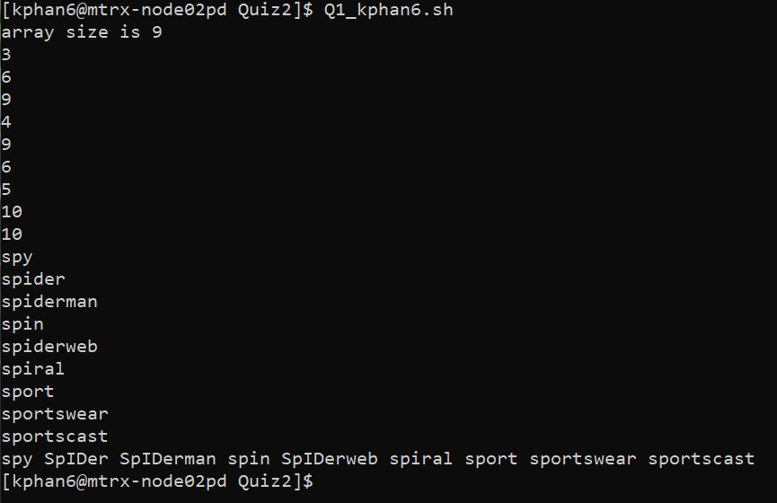

**Question 2)** Create a script (name it as Q2_yourname.sh) which does the followings: (1.5 marks)  
A.    Create an associative array (name it myCourses) which stores your current courses in this semester (more than three courses) in the following format:

*pairs of "Course Code" and "Course name", like "storing ULI101" and "Intro to Unix" into the Array.*

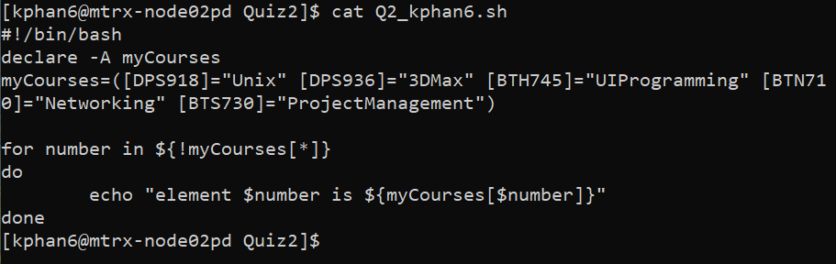

B.    Display all the array data (both course code and course name)

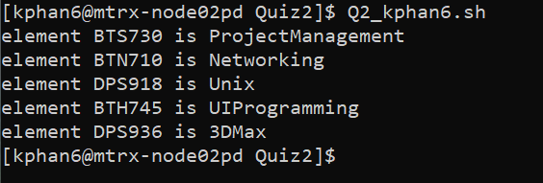

**Question 3)** Design a function which takes two number from input and calculate the total and display it. Show how the function works. (1.5 marks)

* Coding Part

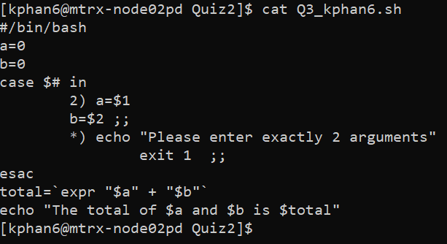

* Result Part

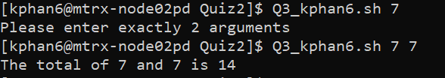

**Question 4)**Developa script which when executed perform the following actions: (2.5 marks)

a) Clear the page and display "Welcome to amazing script!" on the first line

b) if user press Ctrl+C, it displays "You Press Ctrl+C" on the first line

c) if user press arrow keys (Up, Down, Right, Left) it display proper message like "You press Up" on the first line

d) if user press "q", it exit from the script  ( the screen/cursor should be back to normal).

* Coding Part

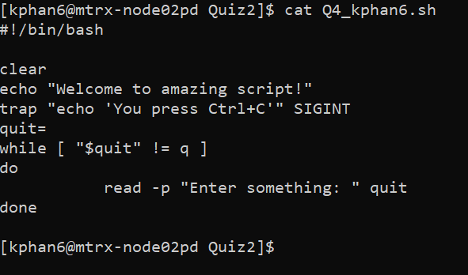

* Result Part

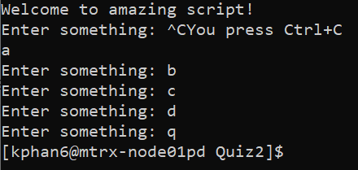

**Question 5)** Consider the following script (script1.sh): (1.5 marks)

while getopts ab:c opt  
do  
   case $opt in  
       a) aflag=1 ;;  
       b) bflag=$OPTARG ;;  
       c) cflag=1 ;;  
   esac  
done  
if [ "$aflag" = 1 ]  
   then echo "You entered option -a."  
fi  
if [ "$bflag" != "" ]  
   then echo "You entered option -b with keyword \"$bflag\"."  
fi  
if [ "$cflag" = 1 ]  
   then echo "You entered option -c."  
fi

Explain how it works when you call the script as follow : **script1.sh  -bx**

* The script will take option of -a, from -b to -c. Then once the option is enter, the rest of the program will execute.
* With argument of script1.sh -bx, there are 2 argument in there, one with the option -b and x is the argument stored in $OPTARG. It looks like they are connect to each other but getopts will read it seperately. Once the first letter is specify, the rest will be treated as argument.
* In the program, any argument entered with option b) will be stored in bflag and later on the program will check for the flag number and display the appropriate echo in each of the flag.
* Only option b) can accept an argument. If I entered script1.sh -ax, the x will be flag as an error since we didn’t specify option a) to read any argument.

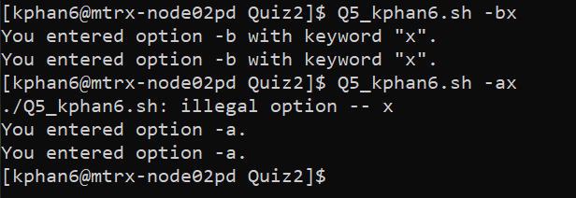

**Question 6)** Based on the experience that you have with name-pipe, explain how it works using a simple example.  (1 mark)

* I can create a fifo name-pipe and allow client+server to work on the exact same file. The server side will run the program to create and set permission for the file, then the client side will check if the file is exist and only run if there is a file. Then client side will input something into the file and the server will retrieve the information from that exact same file.