**Khai Phan Thanh (100901164)**

**Slide 4)**

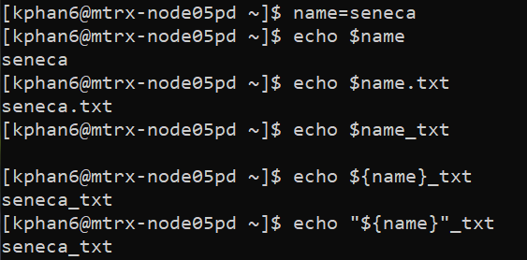

* On the first part, we initialize a variable of name with value of seneca. Then when we tried to have $name.txt, it fetch the value of variable name and add the extension of .txt to the end. However, when we coming to _txt, it required a separate {} or “” to read the value of $name, otherwise it will read it as a whole letter

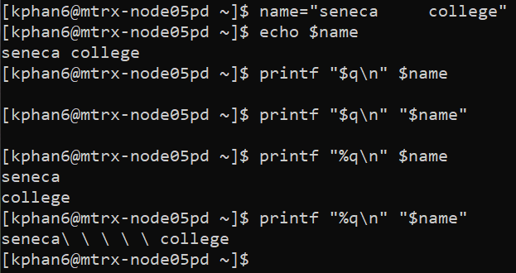

* On the second part, we have a multiple spacing in the value seneca college. What the first printf do is it will ignore the multiple spacing and count it as only one, then when it detect a space, it will split the word with \n. For second printf, since the variable is already in the strong quotation mark, it will read the multiple space and once a space is reading, it will add a slash to it.

**Slide 5)**

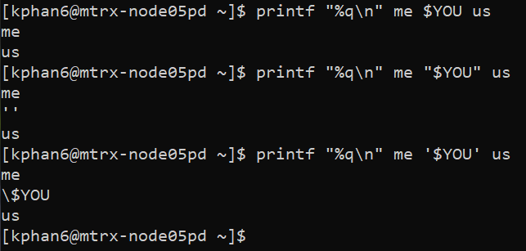

**Slide 6)**

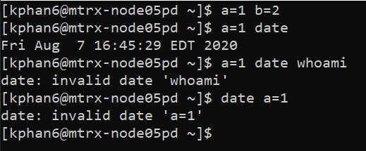

* Command A) (a=1 b=2) and command B) (a=1 date) will successfully execute

**Slide 10)**

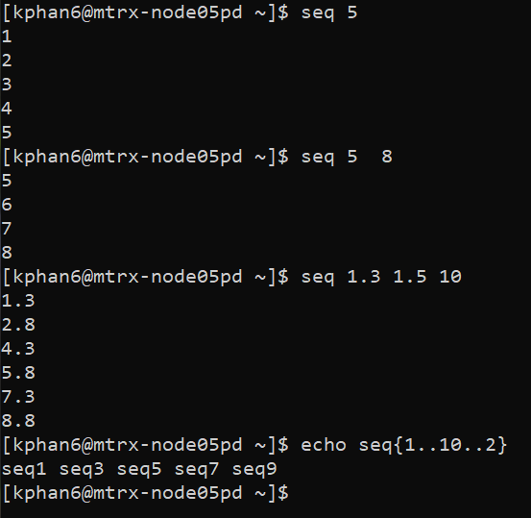

* Sequence will display a sequence of number. If only one argument specified, it will begin with 1 and increment by 1 until it reached the desired value
* If there are 2 arguments, the sequence will display between the range of number (as #2 example)
* If there are 3 arguments, the 1st will be starting value, 2nd is the incremental amount and 3rd is the last possible display value

**Slide 11)**

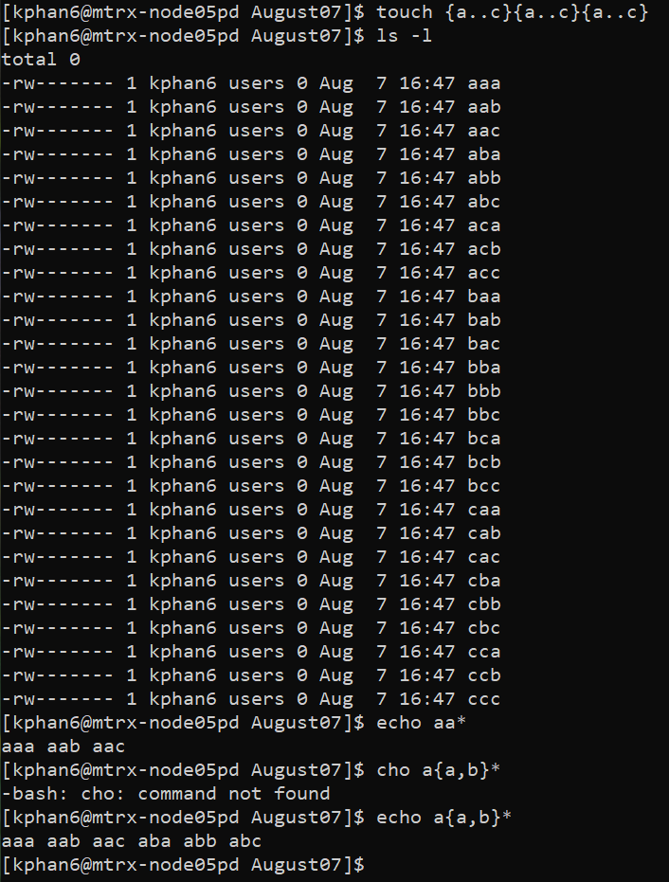

* This will create a list of file with starting letting from a to c (a,b,c), with a middle letter from a to c (a,b,c) and an ending letter from a to c (a,b,c)

**Slide 12)**

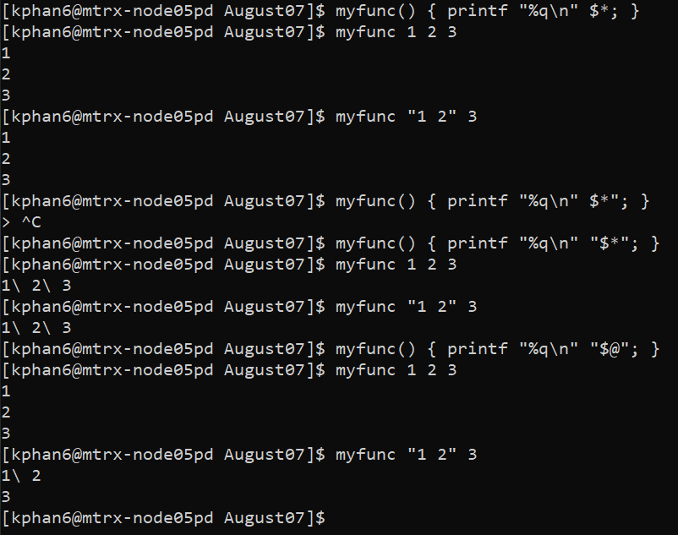

**Slide 14)**

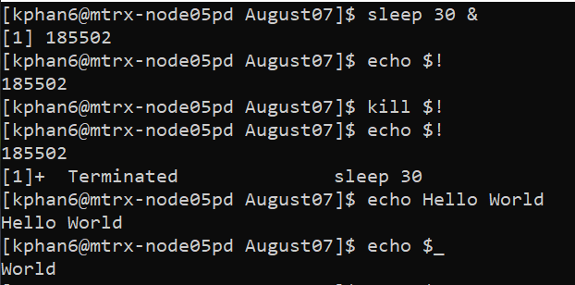

**Slide 15)**

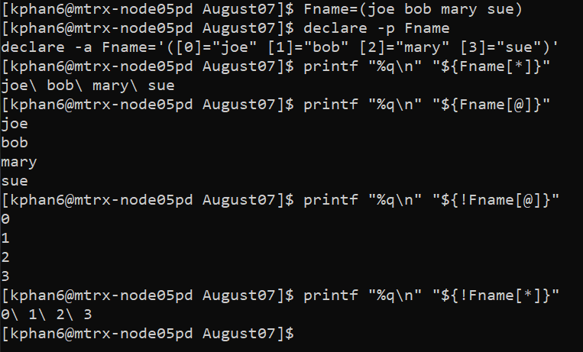

* It declares the arrays to be 2D array. When running it with the *, it display the value in one line and detect if there is a space, it will add a \. For @, when detecting a space, it will break the line.
* When applying ! for the array, it will display the other value that is associate with the value in the array and same phenomenom apply for * and @

**Slide 16)**

