Khai Phan Thanh (100901164)

Activity Slide 13

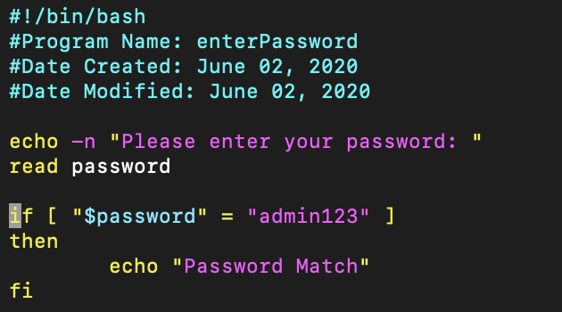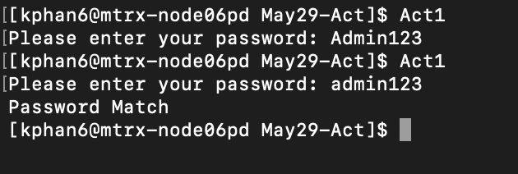

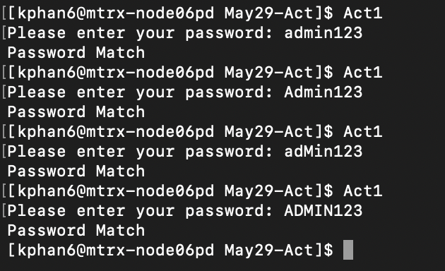

Activity Slide 16

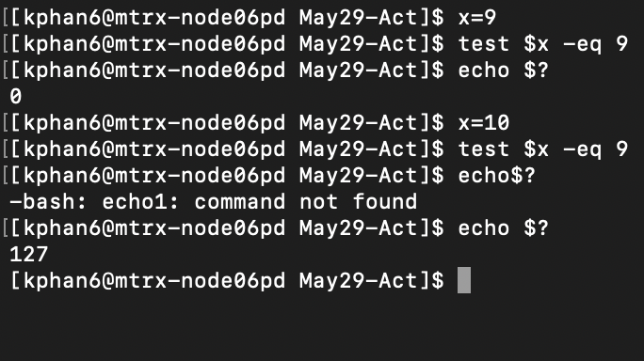

Activity Slide 20

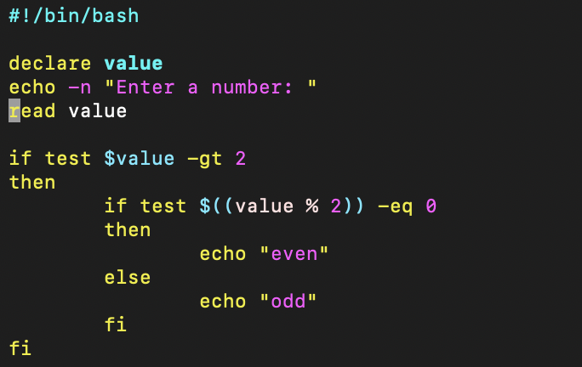

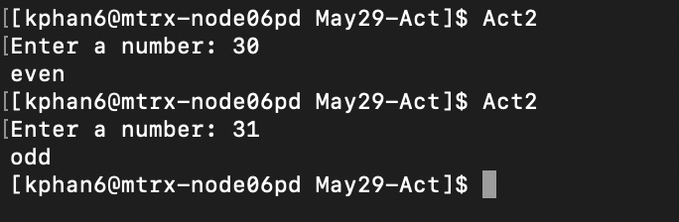

Activity Slide 21

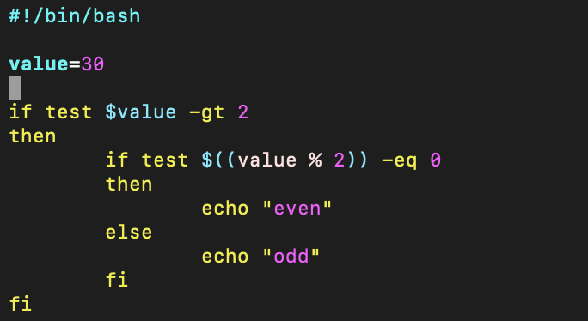

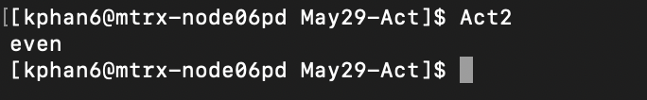

Activity Slide 29

* The while loop will check if # variable is not equal than 0, then it will echo or print value of $1 to the screen
* When there is a value equal to 0, the program stop

Activity Slide 30

* Yellow: take the list of address in addresses file and send an email to all the person in the list
* Orange: It still start the counting from 3 to 2 to 1 to “BLAST OFF!!!” and a delay 1s in between the calling
* Blue: create a list of student_id in between 1 and 1000