**Khai Phan (100901164) – DPS918**

**Question 1)**

Explain what does the following commands do:

head -7 file1

* Get the top 7 lines in file1

find / -name "tempfile"

* Find the file with name tempfile, any stderr and stdout will print in the screen

chmod 644 file1

* Apply new permission (rw-r--r--) to file1, where read and write apply for user, and read apply for groups and other

grep sky$ testfile

* Find any matching value where it contains the word sky in the end of the line in testfile

mkdir  THIS IS A ULi_Example

* Create a directory call This is a ULI_Example

**Question 2)** You execute the following command and receive the output:

**$ awk '{ print }' cars**  
plym    fury    77     73     2500  
chevy   nova    79     60     3000  
ford    mustang 65     45     17000  
volvo    gl       78     102    9850  
ford    ltd     83     15     10500  
Chevy   nova    80     50     3500  
fiat    600     65     115    450  
honda   accord  81     30     6000  
ford    thundbd 84     10     17000  
toyota  tercel  82     180    750  
chevy   impala  65     85     1550  
ford    bronco  83     25     9525

Answer the followings:

1. Modify the command to display all cars_info which their price (last column) is greater than 8000.

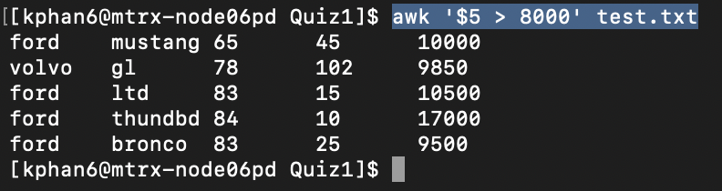

2. Modify the command to display car_name and model (1st and 2nd column) for those cars which their name starts with "f".

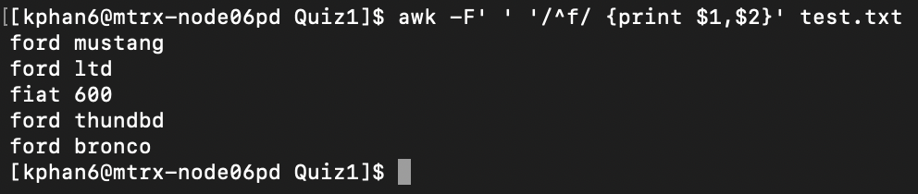

**Question 3)**Based on your experience of working with SED and AWK, explain one main advantages of each command. Explain your answer by a practical use (real world scenario) of using these commands.

* SED check each line at a time in the file and perform “address instruction” if a line matched, then display the new result to the screen. The advantage of SED is it reads per-line in the file or per-streams of character.
* AWK can check the a “table” file field, where it is separate by a space or any special character, apply the filter, then filter what field to be display.
* To me, SED seems to work like it will sort the file and display the whole line where the sort is done (more like display information in horizontal way?) while AWK can sort and filter the data by column and display only the necessary field ($) (more like display information in vertical way?).

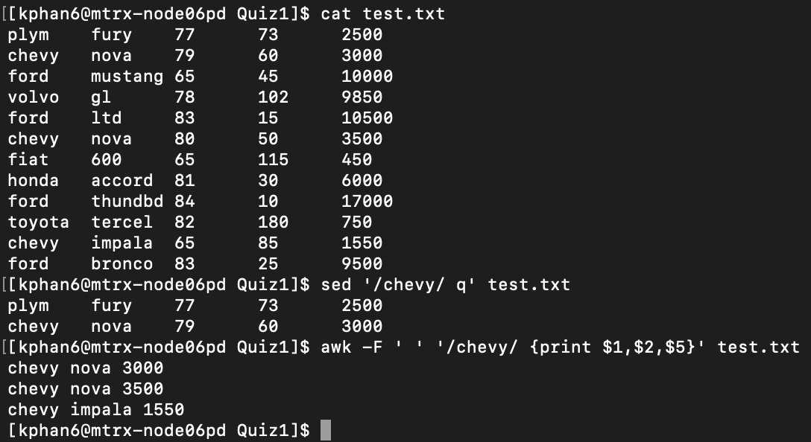

**Question 4)**Consider the following scrip is saved in a filename: Q2.sh

value=55  
if test $((value % 2)) –eq 0  
then      
  echo "yap"   
else  
  echo "nop"  
fi

Answer the followings:

1. What does the output of the program?

* The output will be “nop”, since 55%2 will not equal 0

1. How does this program work? Explain each line.

* Line 1 create an instant of value with preset of 55. Line 2 will check if value of $value%2 will equal 0 or not (has no remain). If the test contains 0, it will print “yep”, otherwise print “nop”

1. To make this script more dynamic, instead of hardcode the value of 55, modify this program to prompt/ask user to enter a "value".

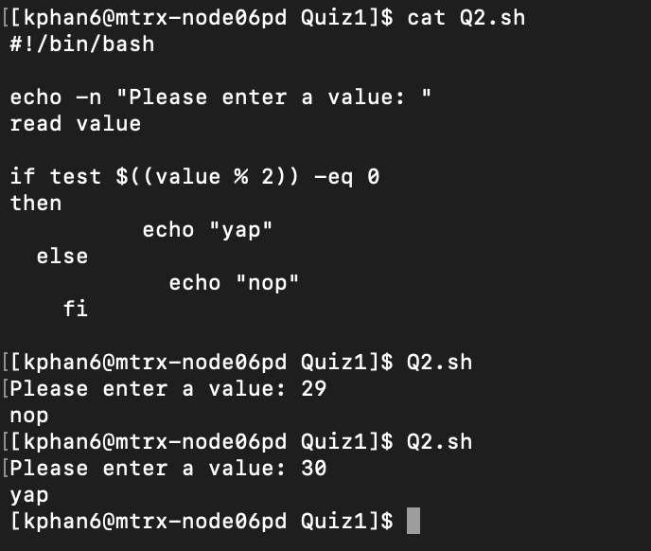

**Question 5)**Create a file contains three phone no and person name as follow

Jack, 4161112222

Sara, 4163334444

Mick, 6471112222

Try to assign this file to a "file descriptor" and display the file content using the declared file descriptor.

