Khai Phan Thanh (100901164)

Activity Slide 18

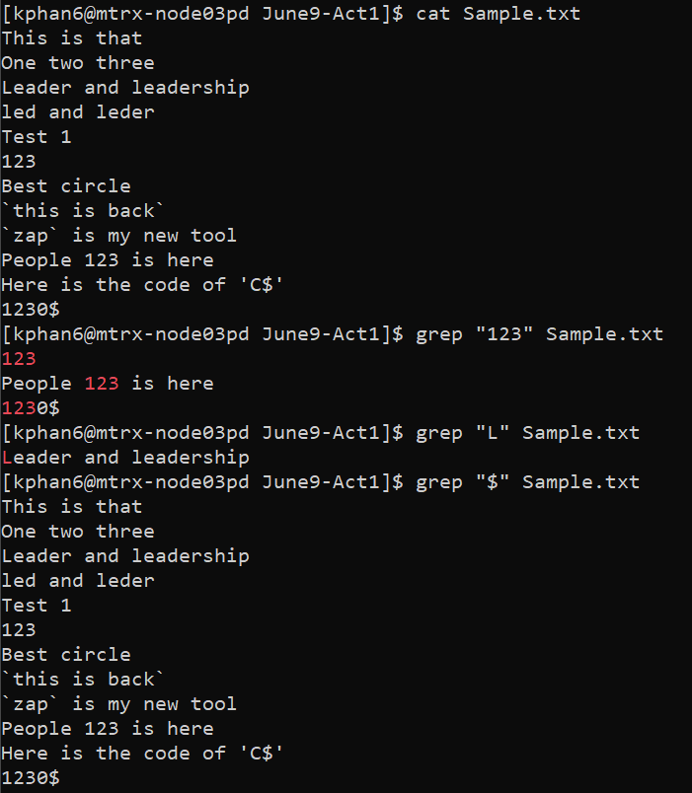

Activity Slide 36

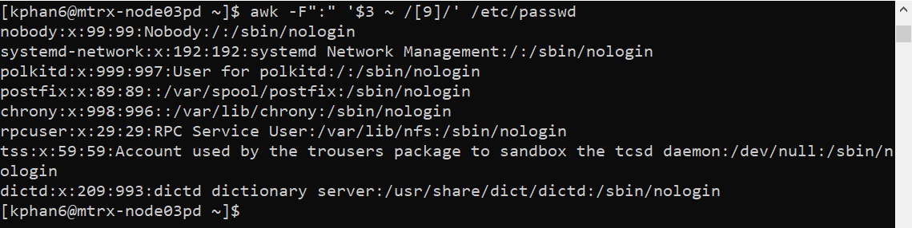

Activity Slide 38

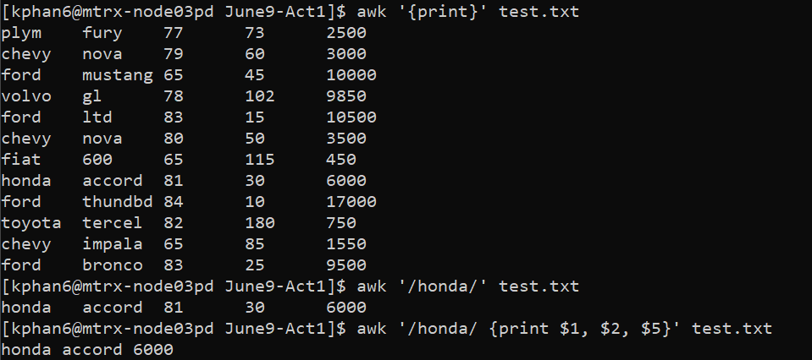

Activity Slide 47

