Khai Phan Thanh (100901164)

Activity Slide 4

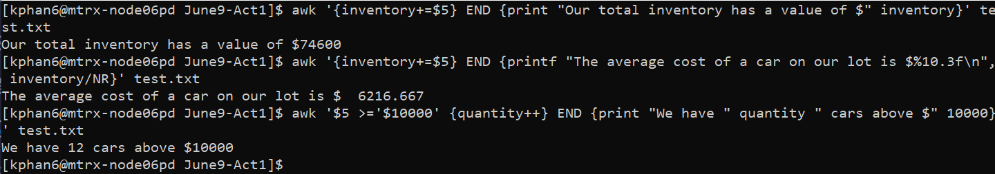

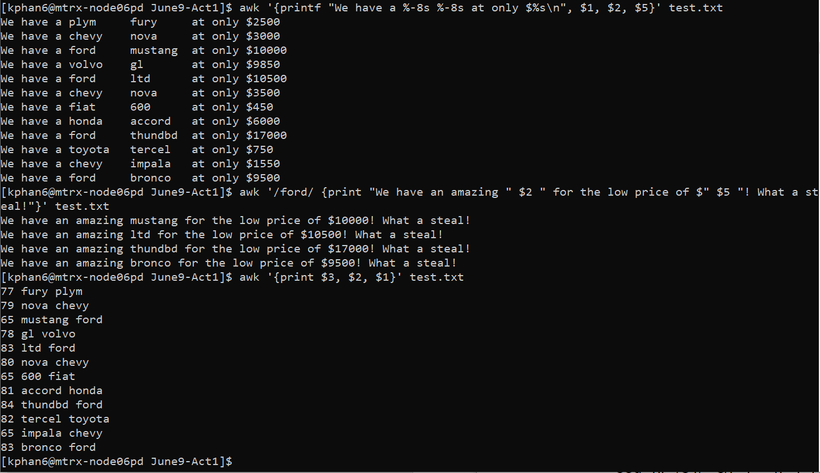

Activity Slide 12

* The command awk ‘END {print NR}’ Sample.txt will print the number of line in the Sample.txt file

Activity Slide 13

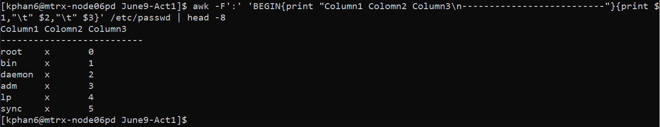

Activity Slide 14

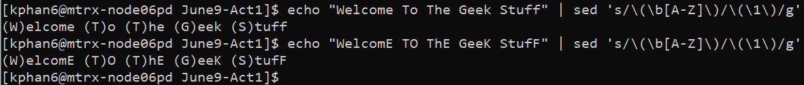

What it does is it take the first letter in each word, note if it is capitalized or not (by using the bracket)