Khai Phan Thanh (100901164)

**Assignment 1:** Answer the following questions in MS-Word file, take a screenshot of each question/output, and add the related commands/scripts for each question.

1. Develop a script (name it as Q1-yourname.sh) which accept an input parameter/argument as *line_number* and display that line of the **data.txt** file.
2. *e: Q1-yourname.sh 12* → *display line 12 of the data.txt file*

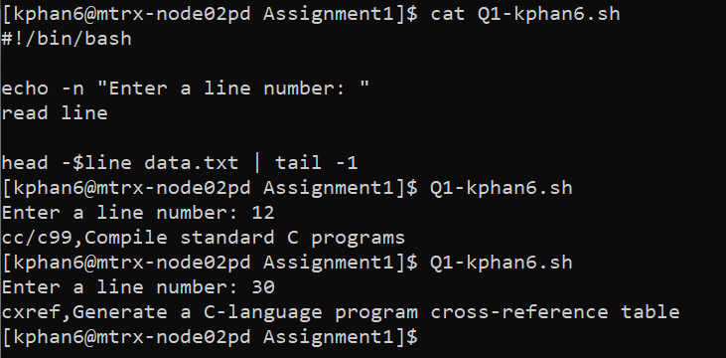

1. Write a script to accept two arguments (filename) (like ./myscript *filename1* *filename2*) The script performs the following:
2. Check whether user provide the correct number of arguments. Display proper error message if requires.

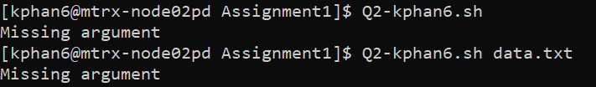

1. Check whether both filenames are exists. Display proper error message if requires.

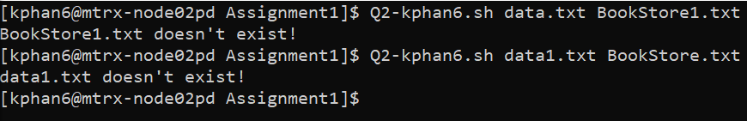

1. Calculate the number of bytes/characters in each file and if the number of characters in both files are the same, the script displays “Files are similar”, otherwise it displays “Files are different”

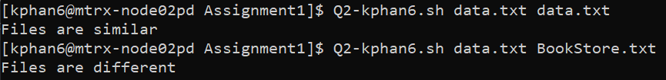

1. Using the filters (SED/GREP/AWK) develop a shell script which displays only the IPv4 address of the current computer.

*Hint: Use IPCONFIG to display IP setting, and use filters in order to display only IPv4.*

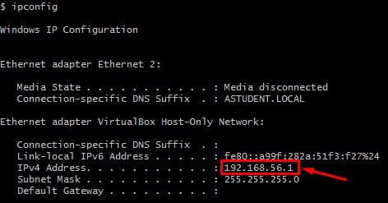

**Method 1: using ip addr to display ip address information in bash**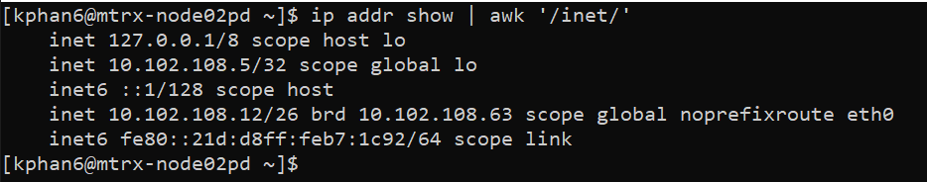

**Method 2: using ipconfig in CMD, copy the data into the file and filter the result**

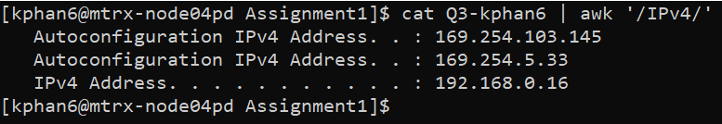



The reason why there is a gap between “^” and “IPv4” is that when the command ipconfig is running, it generates some space in the result and when I copy in the result, the space is still exist so if I do grep ‘^IPv4’, it will not understand as the space is still occur as one chracter

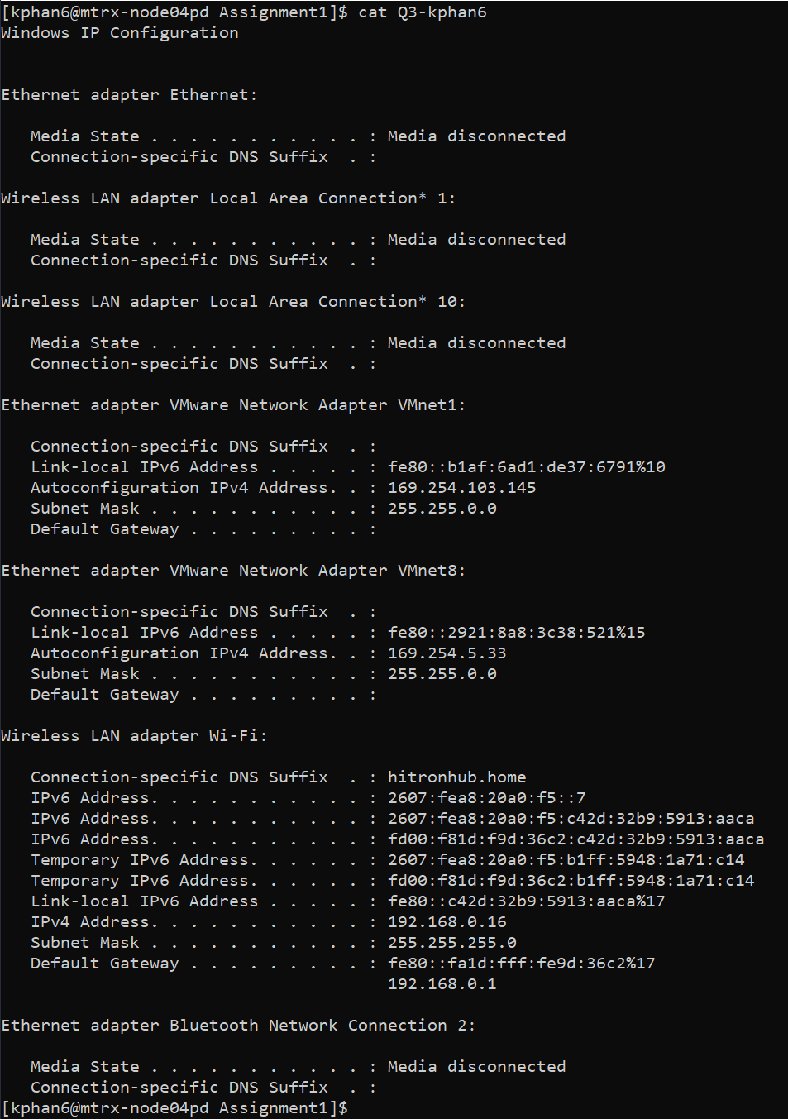

1. Upload the **BookStore.txt** file into your Matrix account. This file contains book information in five columns including, BookID, Book Title, Year, Publisher Name and Price. Develop shell scripts (for each step, develop a script) which perform:
2. Print the first five book records in the file

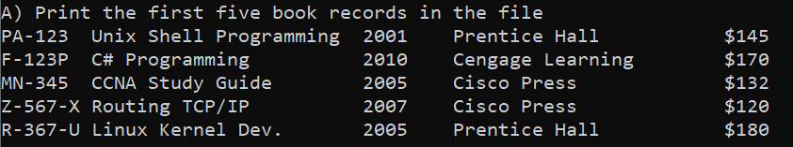

1. Print all the book records which aren’t published by “Cengage Learning”

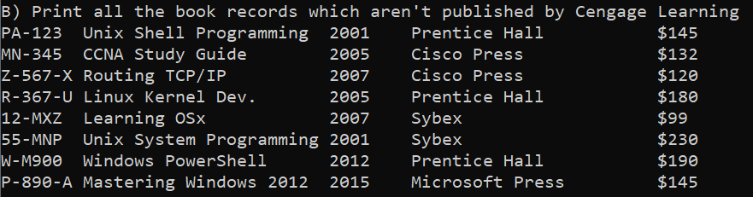

1. Print all the book names (in uppercase) which are published by “Prentice Hall”.

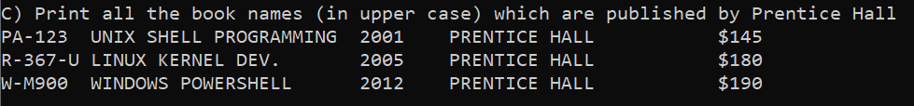

1. Print all the book IDs which are published after 2010.

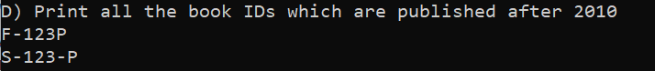

1. Print all the book records which their BookID has pattern like “R-367-U” (Start with an alphabet follow by hyphen, three digits , hyphen and an alphabet)

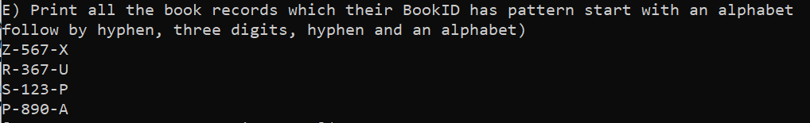

1. Print all the book records like a report as follow:

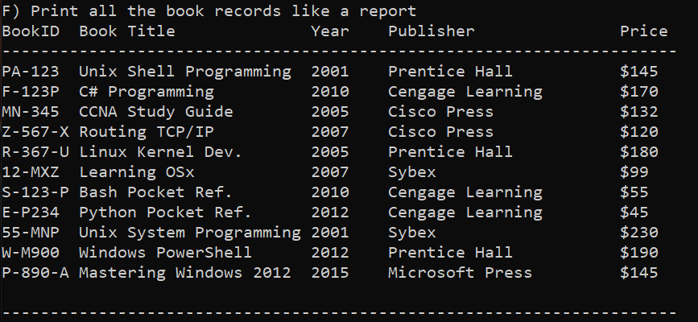

1. Script details

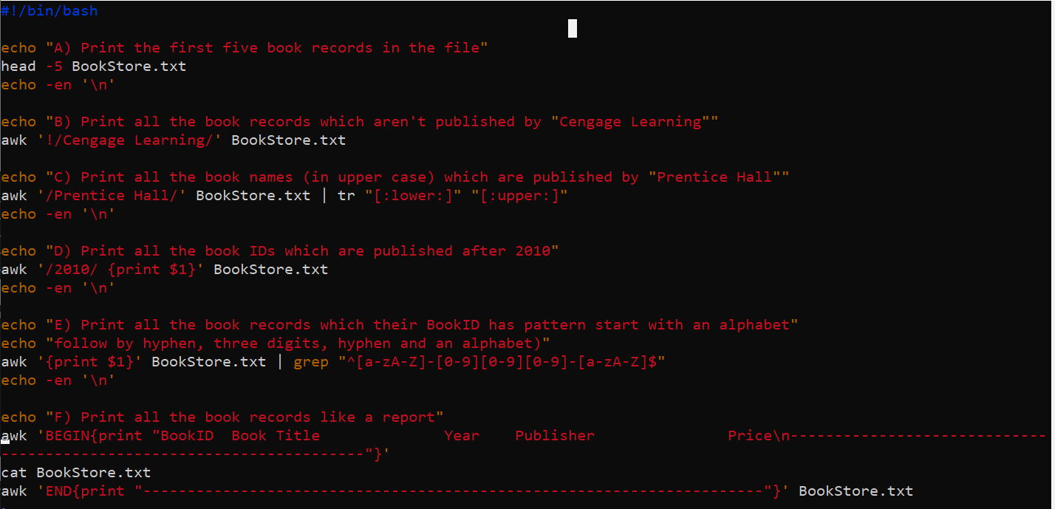

1. Complete the following steps:

* You are asked to open a data-file from my machine and display the file content. How do you do this? Here are the data-file info: o My username: shahdad.shariatmadar o The datafile (credential.txt) is located in Quiz1-Data in my machine as follow:

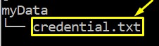

* How do you display the permission setting of credential.txt?

For both of the above question:

