Khai Phan Thanh (100901164)

Activity Slide 8

* Line 1 create an echo of “Enter Password”
* Line 2 use stty to disable echoing of typed character
* Line 3 read the value of entered password
* Line 4 is very important, if this like is not in the code, what will happen is after execute the code, whatever you type into the screen will be hidden for you, and you can’t know what exactly you typed in. The only way to fix it is to type stty echo in the hidden screen and after that it will enable echoing of typed character
* Line 5 is just to display the value of I typed in

Activity Slide 14

* Line 1 create an echo of Enter the name of an animal
* Line 2 read the value of entered animal
* Line 3 create an echo of “Here are some intersting facts about (value of typed in Line 2)”
* From Line 4 to 19 is switch case. What it will do is take the entered value in line 2, compared with the value that exist in each case to see if they are equal or not, if it does, whatever inside the case will be execute, and it will end with a double “;”, if it doesn’t equal, it will skip and run to the next one available. Case \* always in the last option refer to “every other case”, where no matching value found will go there.
* Line 19 esac is reverse of case, to end the switch case

Activity Slide 16

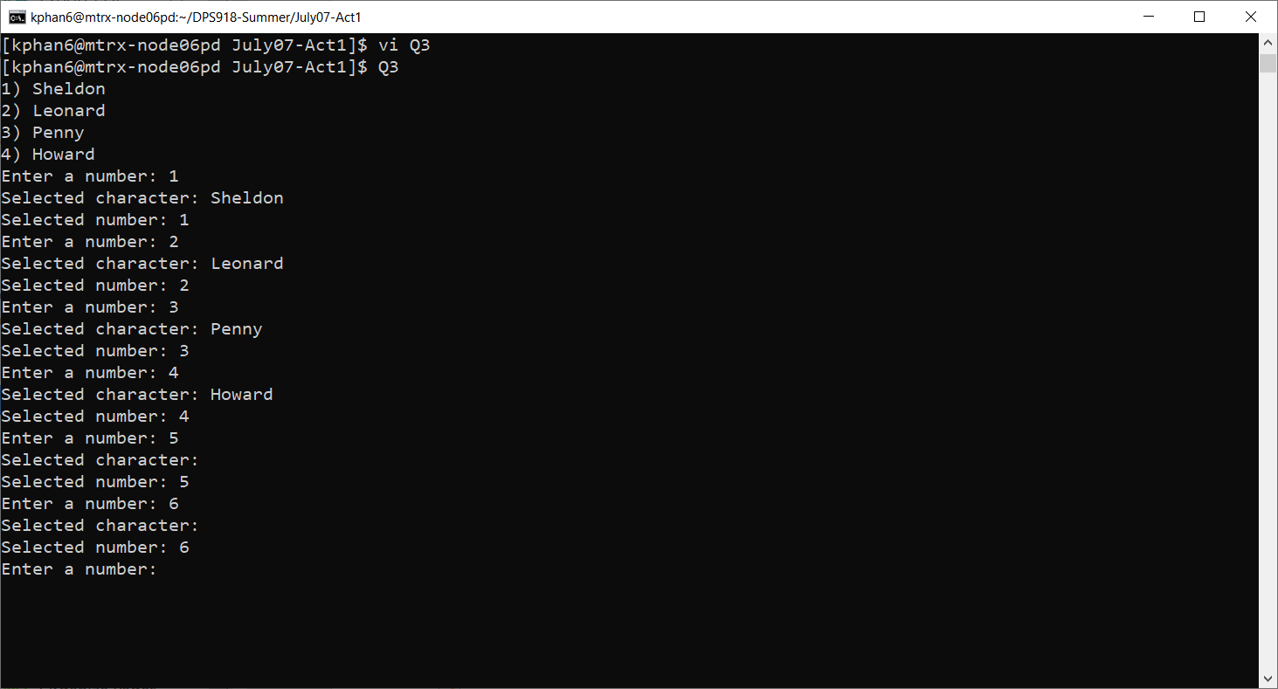

It will display the letter Sheldon Leonard Penny Howard in order of 1,2,3,4. Then it will ask user to select a number and display the character position with the numbem. If a user enter a number out of range, it will display no character since there is no character in that position.