Khai Phan Thanh (100901164)

**Step 1:**

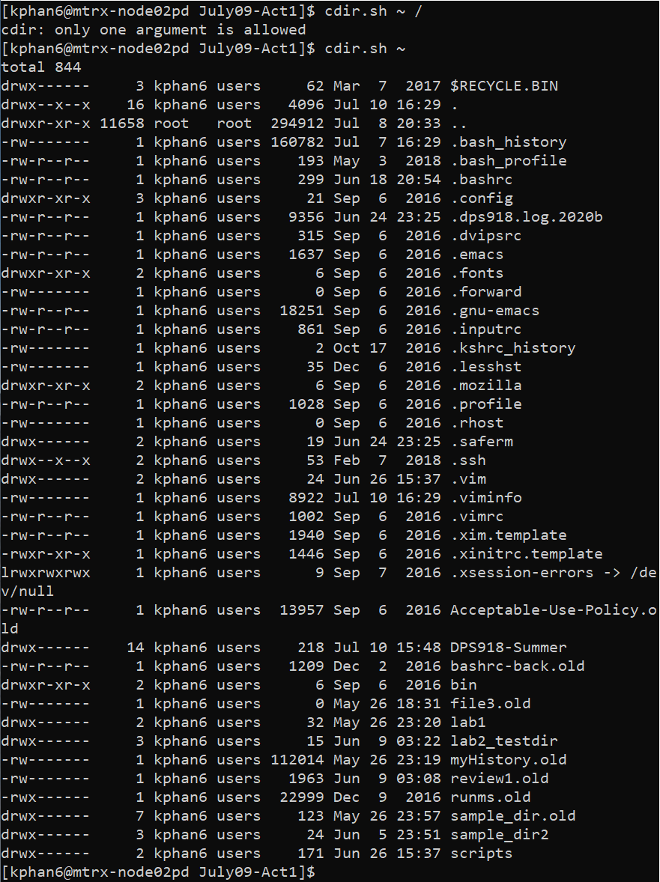 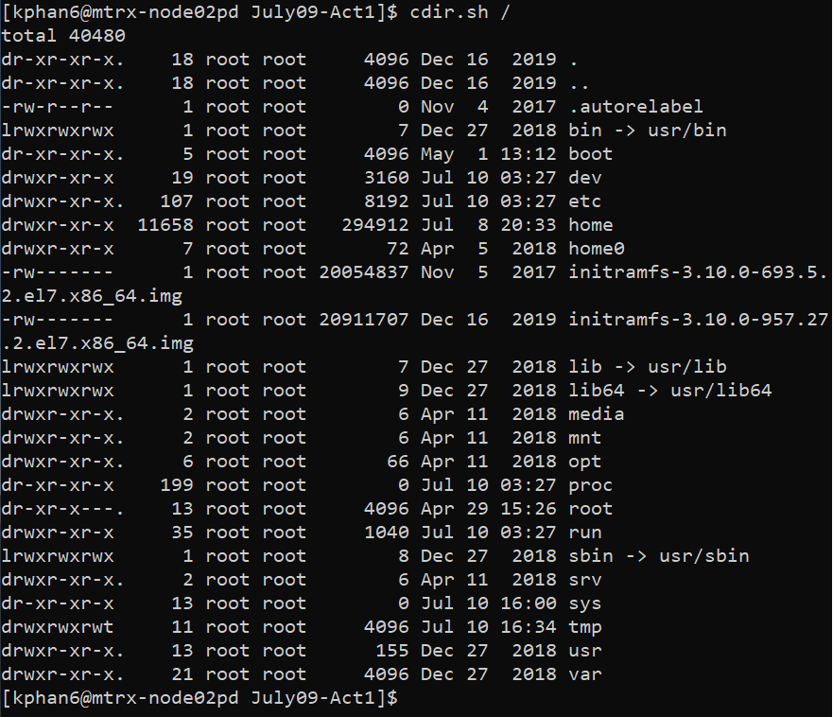

* Cdir.sh ~ / will give an error because it has 2 arguments of ~ and /
* Cdir.sh ~ will display all files in my home matrix
* Cdir.sh / will display all files in the root folder of my account

**Step 2:**

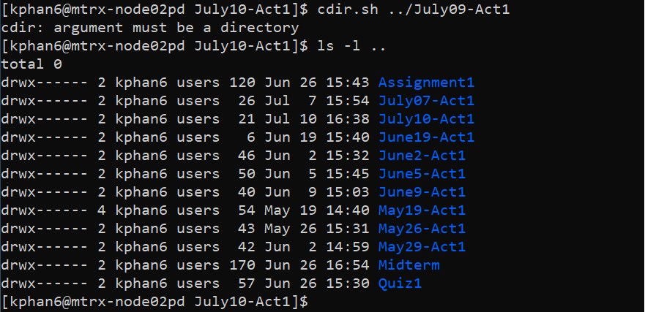

* It display an error because there is no folder with name July09-Act1

**Step 3:**

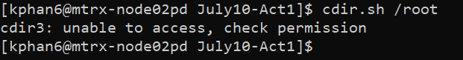

* I don’t have the permission on the /root folder so whenever I tried to access any folder that I don’t have permission, I will get an error that make sense instead of standard error produced by default

**Step 4:**

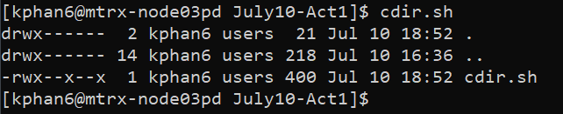

* This will grep all the line into a temp file and display it without the top line (the line with # of files)

**Step 5:**

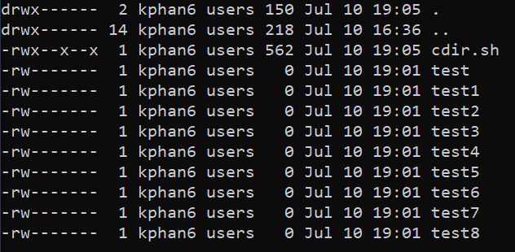

* This will only display 12 lines at a time in one display, if I want to go next, I need to press “n” or press “q” to quit

**Step 6:**

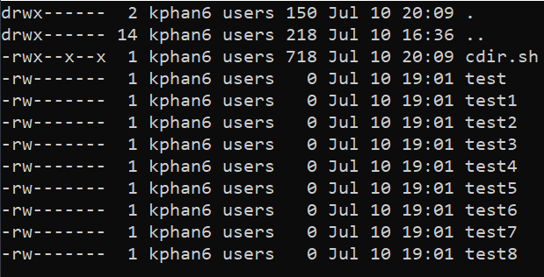

* This will only display 12 lines at a time in one display, when the next screen Is up, the last line from the previous screen will appear on the first line to ensure no data is missing

**Step 7:**

* There is a cursor in the terminal but I was unable to take a screenshot for it so I will skip this one

**Step 8:**

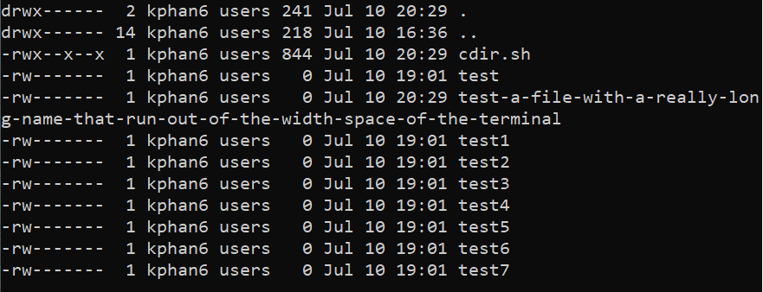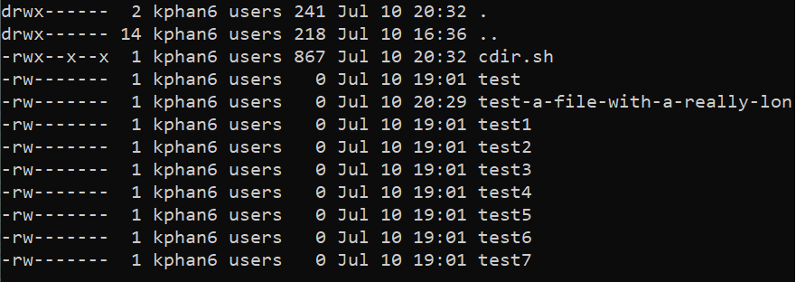

* For a really long file name, the left one is the default what will display. The right one is the one that has been modified to fit the screen. The file name will only display more if the user expand the width of the display, otherwise, the name will be cut at the edge of the display.

**Step 9:**

* For this one, I don’t really see the different as I am still able to get Ctrl-C to work and it just like Q + <Enter>
* From what I understand, trap help to cleanup the temporary files in tmp folder, but I am unsure if the process happen at the beginning of the code (when the code is execute) or right after user hit Ctrl-C

**Step 10:**

* Moving up and down with cursor

**Step 11:**

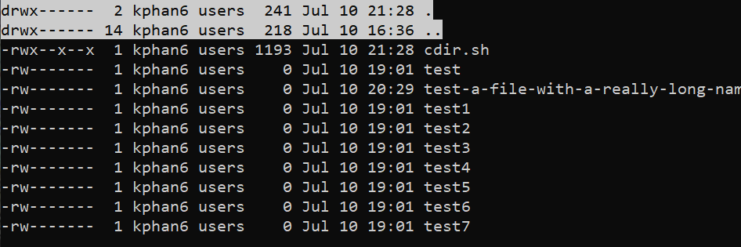

* This will highlight all line that is a directory in the folder

**Step 12:**

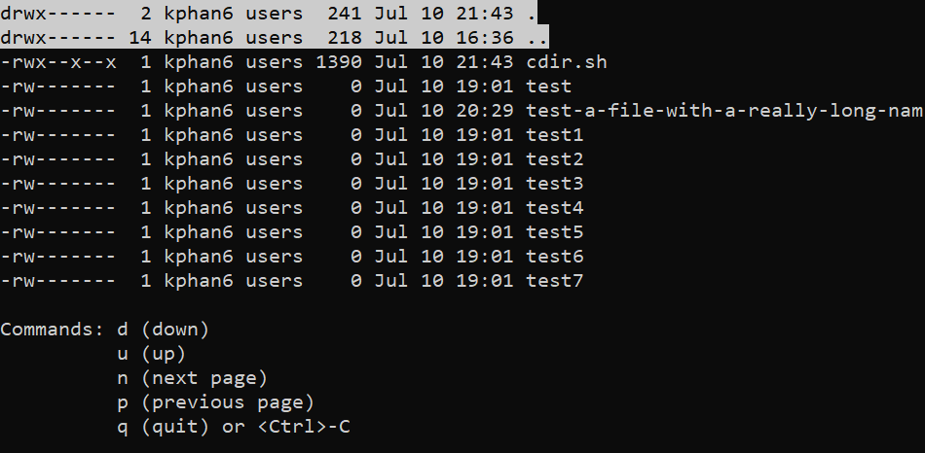

* This step will create a menu command for user to go around the work

**Step 13:**

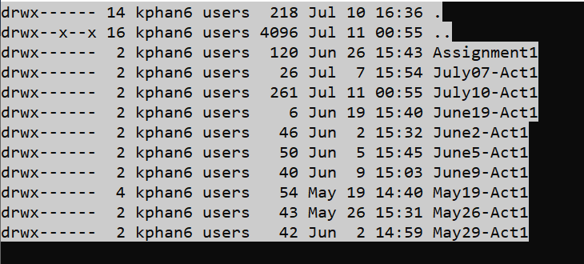

* If the select option is the directory (“.” Or “..”), it will display file information within the directory

**Step 14:**

* Echo command has been turn off when the code is running and will be back on as soon as user hit Ctrl-C or q + Enter key

**Step 15:**

* Instead of using <Enter> key for every command, this time, user only need to press the key according for each action (n for next page) and it will move to the next page

**Step 16:**

* Instead of using keyword to move around the page or use u/d to move the cursor up and down, we will switch them into actual <Left>, <Right>, <Up> and <Down> keyboard.

**Step 17:**

* To remove the flicker between each key when press, use redraw to reduce the number of screen clear occur. Every time the screen clear is working, it create a flicker. Now, screen clear only occur when user want to move data to the next page or go back to the previous page

1. **What does the CASE command do in this script?**
   * + First CASE will check the number of argument. If $# is 1, it will set the directory to what is it $1, if $# is 0, it will set the directory to current directory and if $# is more than 1, it will prompt an error that excess arguments.
     + Second CASE will check for command input receive from user, whether they want to move forward or backward the pages, or to move the cursor up and down and select something.
2. What does the SED command do in this script?
3. **What does the TRAP command do in this script?**
   * + TRAP command will activate when the command <Ctrl>+C is activate. First, it will clear the stty option (set it back to normal), then remove the temp file. After that, it will ready for the next command at line 19 on the screen.
4. **What does the STTY command do in this script?**
   * + First STTY locate within the TRAP to set the changes back to default when <Ctrl>+C is hit, where
       - Canon: to disable to -icanon command (explain later)
       - Icrnl: disables carriage-return to newline conversion
       - Echo: to display the typed word
     + Second STTY set the print terminal line setting as:
       - -i canon: to skip the <Enter> key for command
       - Min 1 is minimum 1 character before the command is executing
       - Time 0 is delay time of 0ms
       - -icrnl: enables carriage-return to newline conversion
       - -echo: to hidden any typed word
     + Third STTY set the changes back to default when “q” is hit. Mostly the same with first STTY