**Khai Phan Thanh (100901164)**

**Activity Slide 10**

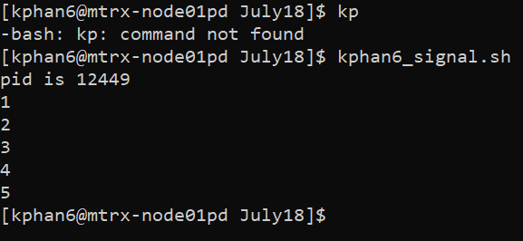

* **Line 2 will display the my personal ID in the server**
* **Line 3 will automatically create a variable of Count and set it to 0. It will then check if the value of Count is less than 5 or not**
* **If the value of Count is less than 5, it will sleep for 3s and increase Count value by 1. After each sleep, it will display the value of Count after increased**
* **The program exit when Count is larger than 5. It will exit with code 0**

**Activity Slide 11**

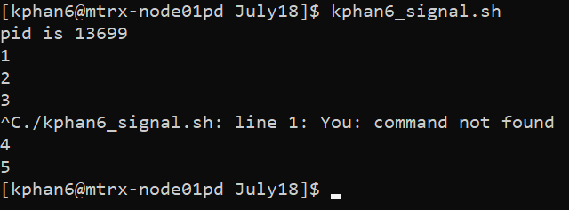

* **The trap will send a signal to a user when a certain action is perform that is not regularly happen as per usual flow of control. In this case, we have set the trap of #2, which is for Ctrl+C. When I press the Ctrl+C in the middle of the program, it warn me and ignore the command.**

**Activity Slide 12**

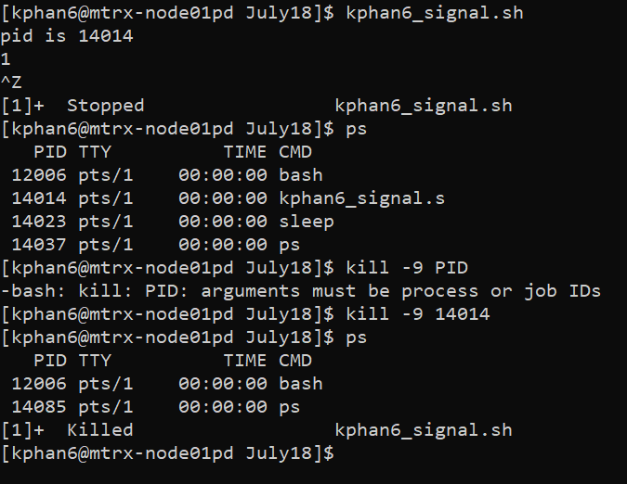

* **Ctrl+Z will force the program to exit and stop immediately**
* **Ps will list all of the process that is running**
* **Kill -9 PID will force to kill the running process of the specified PID**
* **After killing the process, the process is no longer in the running list**