**Khai Phan Thanh (100901164)**

**Activity Slide 16**

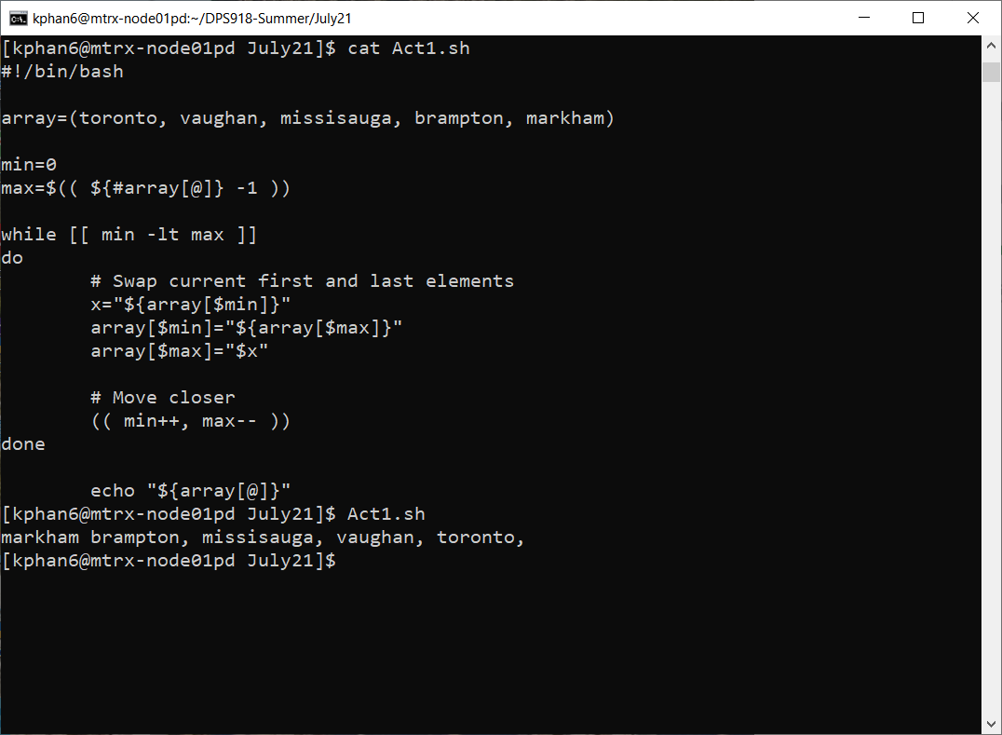

**Activity Slide 18**

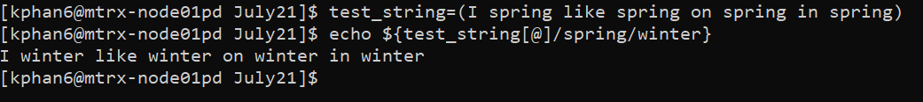

**Activity Slide 19**

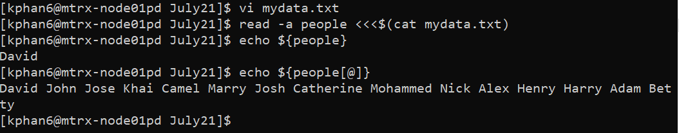

**Activity Slide 23**

