**Khai Phan Thanh (100901164)**

**Activity Slide 4**

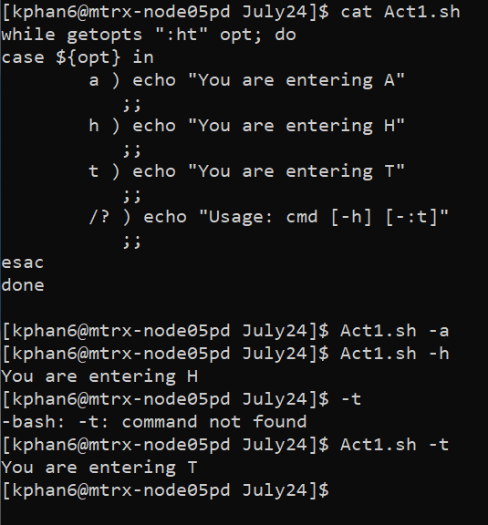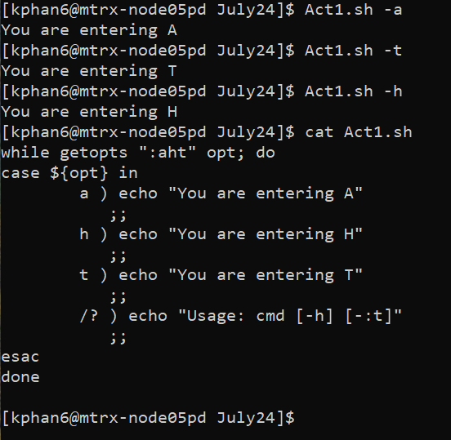

* On the left side, if we don’t specify the a) option for getopts, only -h and -t is accessible to the case. On the right side, if we add -a to the getopts option, we can access a) in the case. Moreover, you can type Act1.sh -ht and both -h and -t will be execute at the same time.

**Activity Slide 8**

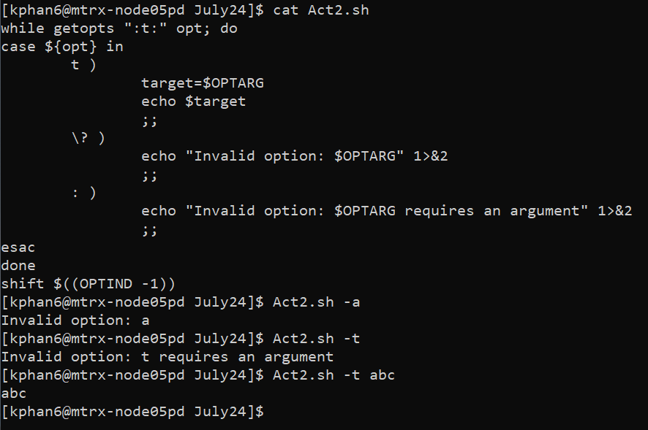

* OPTARG will take an argument after the valid option and store the argument into OPTARG. When echoing the OPTARG, an entered value will display

**Activity Slide 12**

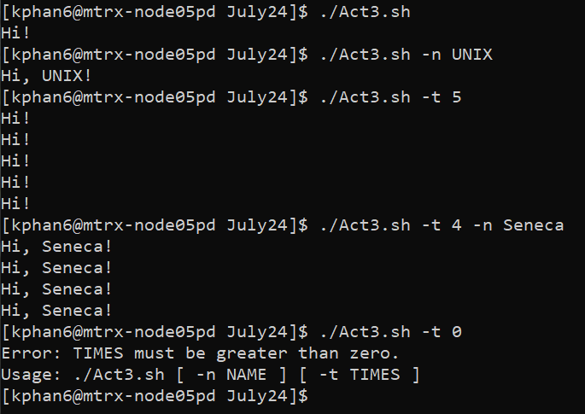

* **Option -n keep the argument in OPTARG and use it to display the argument value, in the above case is UNIX and Seneca**
* **Option -t gets the repeated time so it can repeat the execution in that number of time. In this case, it will repeat the “Hi!” String that number of time. If user enter a value for -t that is not a number, an error will be display. Same situation if user doesn’t specify any value or have a value that is less than 1.**
* **When specified -t to be 0, it is invalid as -t must receive any value greater than 0.**