**Objectives:**

* Learn about the basic 3DS Max interface including
  + creation of basic shapes
  + modification of shape creation arguments
  + coordinates
  + view ports
  + move, scale, rotate tools
  + sub-object editing
  + basic modifiers
  + shortcut keys
  + sub-object editing
  + modifiers

**Part 1**

**Basic shapes and parameters**

In this first part of the lab we will create a castle using various shapes

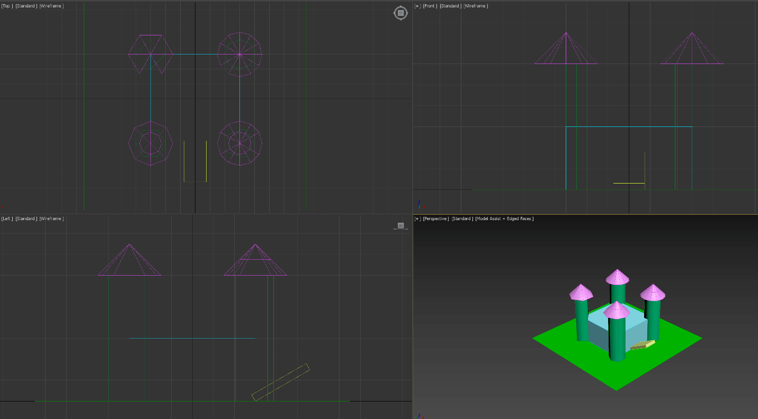

The castle is centred at the origin.

* The main building is a box, 60 units in length and width, 30 units tall, name this object **building**
* The tower at each corner is 60 units tall, 10 units radius. Towers are positioned so that they are centred at the corner of the main building. Name each tower as towerPosition, where Position is two words. The first is either Front or Back, while the second is either Left or Right. Thus, the front right tower should be named "towerFrontRight"
* The roof of each tower is 15 units tall, 15 units radius. Name each roof as roofPosition. The first is either Front or Back, while the second is either Left or Right.
* The drawbridge is a box, 30 units length, 15 units width, 3.5 units tall, rotated at 30 degrees from the horizon. Name this object "bridge"
* The land is a plane that is 150 units by 150units, centred at origin. Name this plane "land"

The other parameters such as number of sides and number of segments can be gleaned by looking at the image in the orthographic viewports.

**Part 2**

**SubObject editing and Modifiers**

In this part of the lab we will create a simple model of a plane. Note that the steps do not necessarily have to be done in exactly this order.

* start by creating a stick where the L:W:H ratios are 4:1:1 (thus if length was 80 units, then width and height would be 20 units each). The stick should have 4 length segments
* select and lift the edge separating the front most square and the second square on the top.
* connect the edges that form the second square from the front on both sides and extrude the bottom rectangle of that square
* connect the edges that form the last square. Do this on both sides. move these edges up so that the top rectangle is smaller than the bottom one. Extrude these top rectangles
* select the rear edge of the rear top square and its opposite edge on the top face and connect them with 2 edges (thus dividing it into 3 rectangles. Extrude the middle rectangle
* using the scale and move operators adjust the extruded faces so that the wings and fins look about right for a plane (it will still look really chunky
* Apply a mesh smooth modifier to the object, use classic subdivision 3 or 4 iterations.

**Useful notes and references:**

* if the shading (colours) look wrong, make sure you are in model assist rendering mode.
* right clicking on the spinners in the status bars sets the value to 0. Thus, you can use it to easily centre any object by selecting it, switching to the move operator and right clicking on spinners
* You can clone any object by holding the shift key and dragging the object away with the move operator (create a copy)
* once an object is created, you will often not be able to alter it in the creation tab but instead must go to the modify tab to change the object

Hot keys (max has a ton of hotkeys... here are the ones that might be useful to you for this lab:

* w - move manipulator
* e - rotate manipulator
* r - scale manipulator (reasoning behind this I think is because the buttons are ordered in the main tool bar from left to right as move, rotate, scale... so w,e,r are beside each other on qwerty key board)
* alt-w - toggles between maximizing active viewport and switching back to multiviewport view
* f3 - toggles shaded and wired only view
* f4 - toggles show edges

part B: [Video](https://youtu.be/mER4eAyENcc)