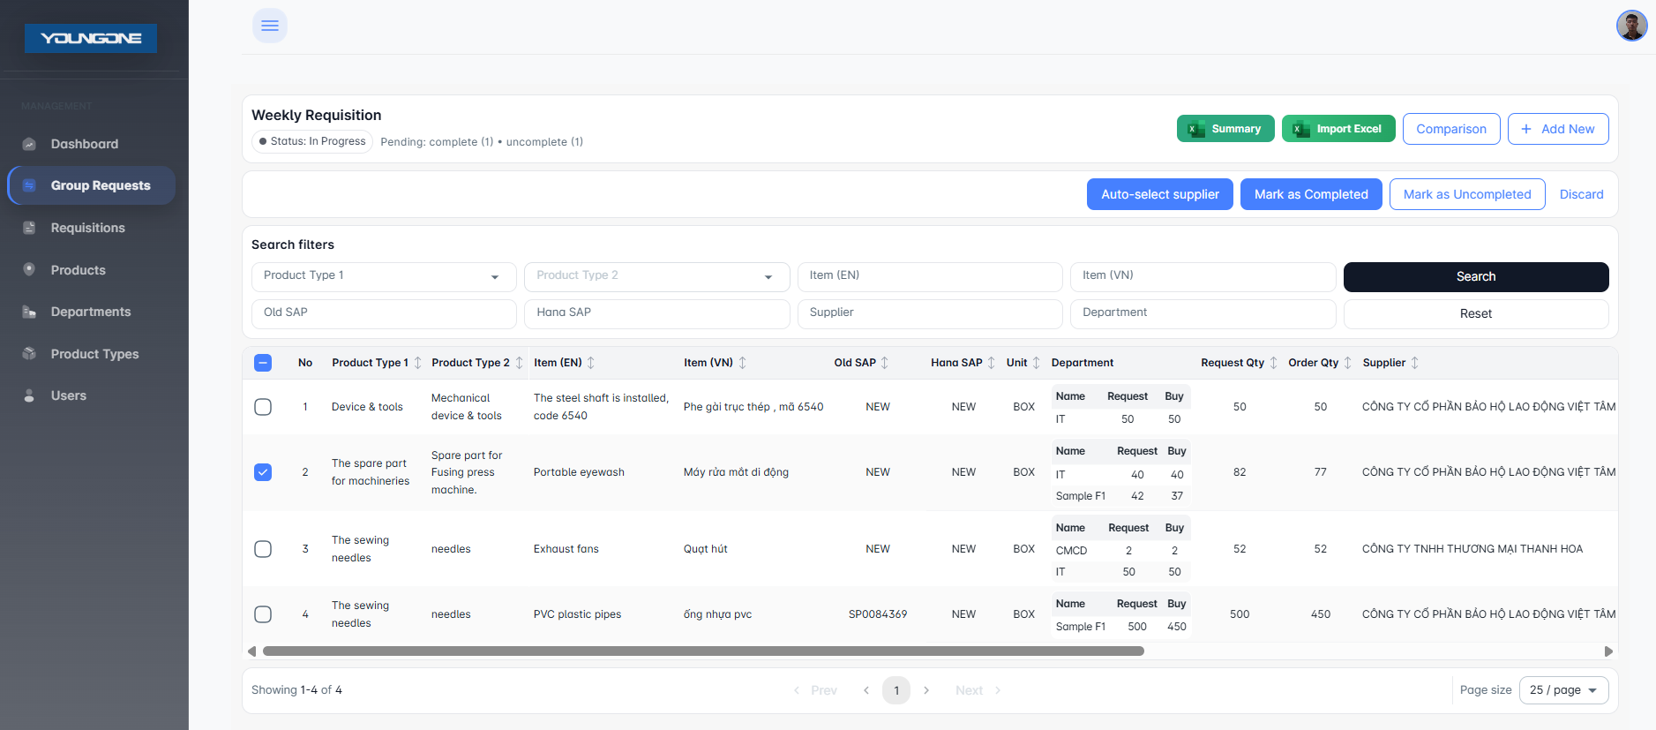

Automatic supplier selection
Confirm that the request is ready or assign it to the relevant department.
The user can uncheck the box after marking it as completed.

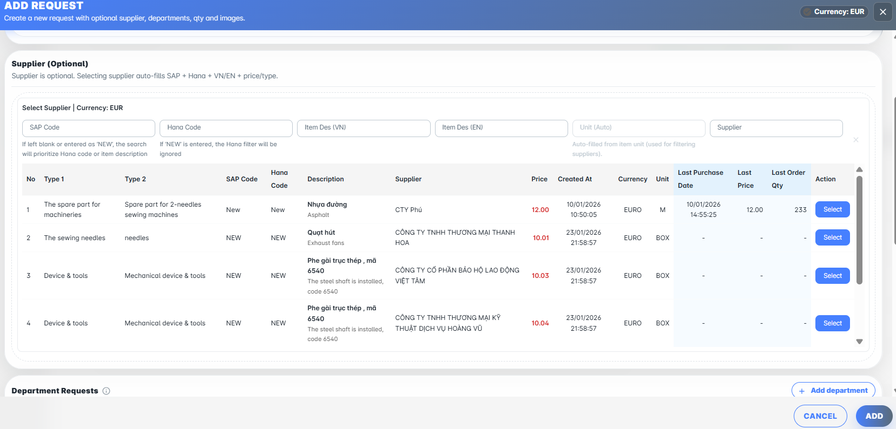
Purchase History

