Reading Assignment

Mục lục

Reading Assignment: When should accessor methods be used? 2

Question:If you create a constructor method to build a DVD by title then create a constructor method to build a DVD by category. Does JAVA allow you to do this? 3

# **Reading Assignment:** When should accessor methods be used?

Accessor methods are used to access fields of an object. So getters and setters are both accessor methods. Observer method is the right term for a method that makes a more general observation about an object, without causing externally observable side effects.

You should use accessor methods rather than directly accessing state data because they provide an abstraction layer. Here are just two of the benefits that accessor methods provide: You don’t need to rewrite your code if the manner in which a property is represented or stored changes.

In computer programming, an accessor method is a method that fetches private data that is stored within an object. An accessor provides the means by which to obtain the state of an object from other program parts.

It's okay for a method to return an object in terms of an interface that the object implements because that interface isolates you from changes to the implementing class. This sort of method (that returns an interface reference) is not really a "getter" in the sense of a method that just provides access to a field. If you change the provider's internal implementation, you just change the returned object's definition to accommodate the changes. You still protect the external code that uses the object through its interface.

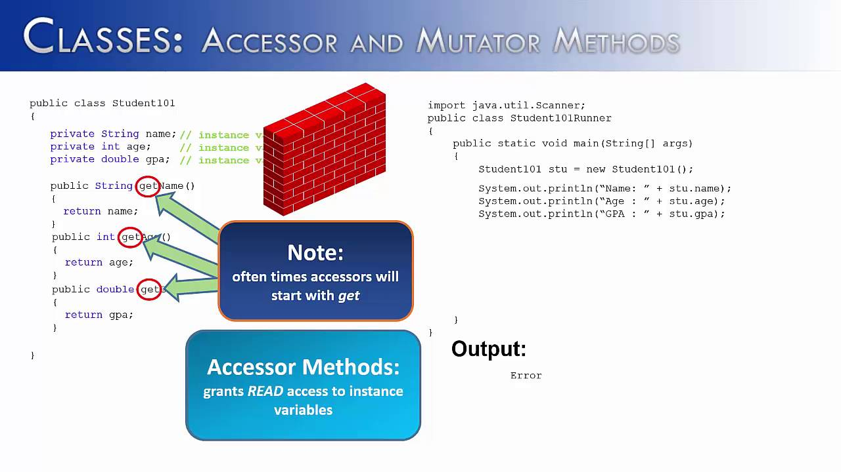

# **Question:**If you create a constructor method to build a **DVD** by title then create a constructor method to build a **DVD** by category. Does JAVA allow you to do this?

Answer:

Java does not allow to do this. Because when create a constructor method to build a **DVD** by title then create a constructor method to build a **DVD** by category, they have duplicate signatures (Name constructor method: DigitalVideoDisc, datatypes: String).