## **Introduction**

### Purpose of this document

This document gives description of requirements, constrains, interface to other systems, supports for the content management system (CMS). It also includes the COTS acquisition plan with time table for the CMS.

This document is primarily intended to be proposed to a customer for its approval and a reference for developing the first version of the system for the development team.

### Scope of this document

Describes the scope of this requirements definition effort. Introduces the requirements elicitation team, including users, customers, system engineers, and developers. This section also details any constraints that were placed upon the requirements elicitation process, such as schedules, costs, or the software engineering environment used to develop requirements

Elicitation team for this project is group 3 which includes:

* Phan Thế Hùng
* Đặng Thị Thảo My
* Bùi Nguyễn Thiện Khánh
* Nguyễn Anh Quân

Customers of this system are the cybercation café’s owners which includes:

* A barista
* An administrator
* An online game enthusiast
* A sale person
* A computer engineer

This CMS will be developed and tested on group 3 computer. After the CMS has been approved by the Cybercation café owners, it will be depolyed on an apache web server.

### **Overview**

Provides a brief overview of the product defined as a result of the requirements elicitation process

### Business Context

Provides an overview of the business organization sponsoring the development of this product. This overview should include the business's mission statement and its organizational objectives or goals

The sponsor for this project is the Cybercation café. They are a group of five people who want to create a new business café model. Beside from original café model, the Cybercaion café also provides other services such as:

* E-learning packages for industry certification
* Testing for industru certification
* Training/conference room for hire
* Photocopy/scanning services
* Graphic design and print
* Web server and hosting

The Cybercation café is a newly establish business. They are going to open the first shop in Ho Chi Minh city and the second one in Ha Noi. That also want to implement a customer loyalty program and will invest in technology to archive these following goals:

1. To provide Internet services, E-Learning, testing, graphic... throughout the Asian region that are of top quality, reliability
2. To provide technological feature, to achieve strategic goal (1) (*).
3. To encourage and prepare our human resources team to enhance their knowledge and skills within each featured context.
4. To increase growth and development through business expansion
5. To make use of information technology to achieve our goals, objectives, and CSFs and to add value to the business Value Chain and Supply Chain
6. To grow the business by attracting regular business customers who can easily access our services in all our locations through a customer loyalty system.
7. To maintain profitability and build a consolidated fund to use for expansion costs

## **General Description**

### User Problem Statement

This section describes the essential problem(s) currently confronted by the user group.

### User Objectives

This section describes the set of objectives and requirements for the system from the user's perspective. It may include a "wish list" of desirable characteristics, along with more feasible solutions that are in line with the business objectives

### User Characteristics

Describes the features of the user community, including their expected expertise with software systems and the application domain

### Similar System Information

Describes the relationship of this solution with any other installed solutions (if any). Specifies if this solution is intended to be stand-alone, or else used as an integrated component of a solution product. If the latter, this section discusses the relationship of this product to the larger product

### General Constraints

Lists general constraints placed upon the design team, including speed requirements, industry protocols, hardware platforms, and so forth

## **Functional Requirements by Application**

This section lists the functional requirements within each of the recommended applications in ranked order. Functional requirements describe the possible effects of a particular software system (such as an accounting system), in other words, *what* the system must accomplish. Other kinds of requirements (such as interface requirements, performance requirements, or reliability requirements) describe *how* the system accomplishes its functional requirements.

Functional requirements will be described in terms of ‘must’, ‘should’, ‘could’, or ‘ideally could’.

Each functional requirement should be specified in a format similar to the following…

### Functional Requirements of: <application 1>

#### Scope requirement for <application 1>

*What is impacted by this application? Describe how this application will address the needs identified. Describe interactions with other requirements*

#### **<Functional requirements within application 1)>**

“The application **must** ….”

*Describe what top level functions or modules the application must or should have*

<name of function or module>

##### “The … module must (or ‘should’, etc) be able to …”

Second-level (functions within the module):

* + - * 1. “This function must (or ‘should’, etc)…”
        2. “This function must (or ‘should’, etc)…”

### Functional Requirements of: Customer Relationship Management System

#### **Scope requirement for customer relationship management system (CRM).**

Customer Relationship Management System (CRM) is designed to collect information, requests and maintain good relationship on customers across various channels, especially through the Cybercation’s café website. Well-structured CRM will satisfies customers and create customers’ loyalty.

Customer will have ability to submit a ticket (request) for their problem or question that related to services which are provided by Cyberations’ café. This can be done by user account or as an anonymous. Tickets will be analysed and separated to appropriate people within 24 hours with different level of priorities. CRM will also provide a FAQs page, a list of questions and answers that are commonly asked when using our services. Customer who raise requests will able to track their ticket as well, basically tickets will have 3 status: sent, pending for answer and solved. Answer will be sent to user’s personal account or can be listed into FAQs page if it is commonly questioned. Live chat will available during the office hours which give customer a fast and direct support from our Helpdesk team.

From the Helpdesk side, when logging to helpdesk account, they will have permission to check new tickets, change tickets’ status, separate ticket to appropriate categories, and answer or guide customers through email or live chat system.

CRM also automatically generate report with metrics, KPIs and statistics weekly.

#### **Functional requirements within customer relationship management system (CRM):**

The Application will have 2 modules:

* Requests categorizing, tracking, processing system.
* Online consulting and guidance system.

##### **Request categorizing, tracking, processing system**

* + - * 1. Raise new ticket (user side).

Users or anonymous can submit tickets to helpdesk team.

* + - * 1. View tickets (user side).

Only users can view, modify or add new related tickets, anonymous will receive answers through their email account.

* + - * 1. Track tickets’ status (user side).

Users can track their tickets’ status when log to view ticket page.

* + - * 1. Overview dashboard (Helpdesk side).

Helpdesk can open overview page to easily control tickets.

* + - * 1. View tickets (Helpdesk side)

Helpdesk can view detail information of the ticket

* + - * 1. Separate tickets (Helpdesk side).

Helpdesk can separate tickets to appropriate department.

* + - * 1. Change tickets status (Helpdesk side)

Helpdesk can change the tickets’ status to: pending for answer or solved.

* + - * 1. Delete a tickets (Helpdesk side).

Helpdesk can delete a ticket if it contain sensitive information or not related to Cybercations’ café services.

* + - * 1. Rate ticket priority (Helpdesk side)

Depends on problems’ seriousness helpdesk will rate the priority of the ticket and send to appropriate people.

* + - * 1. Weekly report.

CRM will automatically generate a report that content statistics from both customer and helpdesk side to determine the efficient of the system.

* + - 1. **Online consulting and guidance system**
         1. Live chat service (user side).

Anyone can use chat windows to talk to service desk team to receive direct online guidance.

* + - * 1. FAQs page (user side).

Everyone can access to FAQs to search for questions or problems that are commonly asked.

* + - * 1. Live chat service (helpdesk side)

Helpdesk can answer customers question throughout live chat windows during office hours

* + - * 1. FAQs page (Helpdesk side)

Helpdesk can post, edit or delete a question.

### Functional Requirements of: content management system

#### **Scope requirement for content management system (CMS)**

Content management system is a web-based system which manages all operations on web server and contents of the official website of the company. All interactions between users and the CMS are processed through web interface.

The manager has all the authority to view, create, update and delete any content of the website. Customers can register an account for online study and testing services. All accesses and requests are verified and controlled by the CMS. At the end of month, the CMS will create a report about registered courses and services.

The CMS will also provides APIs which allow human resource department to upload announcements which relates to human resource activities such as recruitment, trainings, etc… to the website..

#### **Functional requirements within content management system**

The application must have 2 modules:

* Courses information maintaining and updating system
* Courses registering and participating system

##### **Courses information maintaining and updating module**

* + - * 1. Add a new course

Authorized people can add a new course to the website

* + - * 1. View a course

Authorized people can view information of a course on website

* + - * 1. Modify a course

Authorized people can modifies information of a course on website

* + - * 1. Delete a course

Authorized people can delete a course from website

* + - * 1. Add a new test

Authorized people can add a new test to website

* + - * 1. View test

Authorized people can view information of a test

* + - * 1. Modify a test

Authorized people can modifies information of a test

* + - * 1. Delete a test

Authorized people can delete a test from website

* + - * 1. Add a new user

Authorized people can add a new lower level user

* + - * 1. View a user

Authorized people can view information of a lower level user

* + - * 1. Modify a user

Authorized people can change information of a lower level user

* + - * 1. Delete a user

Authorized people can delete a lower level user

* + - * 1. Add a new announcement

Authorized people can add a new announcement to the website

* + - * 1. View an announcement

Authorized people can view information of an announcement

* + - * 1. Modify an announcement

Authorized people can modifies information of an announcement

* + - * 1. Delete an announcement

Authorized people can delete an announcement from website

* + - * 1. Add a new category

Authorized people can add a new category

* + - * 1. View a category

Authorized people can view information of a category

* + - * 1. Modify a category

Authorized people can modifies information of a category

* + - * 1. Delete a category

Authorized people can delete a category

##### **Courses registering and participating module**

* + - * 1. Registering

New customer can register a member account

* + - * 1. Enrolling courses

Members can enroll courses

* + - * 1. Taking test

Members can take tests

* + - * 1. Modifying personal information

Members can modifies their personal information

* + - * 1. Changing password

Members can change their password

* + - * 1. Login

Members can login to their account

* + - * 1. Logout

Members can logout of their account

* + - * 1. Verifying user

The CMS can verify logged-in member and assign appropriate authority.

* + - * 1. View personal information

Members can view their personal information

* + - * 1. Monthly report

The CMS will record members’ activities such as courses and tests they take, theirs searching keywords. At the end of each month, the CMS will generate reports on those activities.

## **Interface Requirements**

* 1. **Interface Requirements of Customer Relationship Management System (CRM)**

#### **Requests categorizing, tracking, processing system**

* + - 1. **USER INTERFACES**

Interaction between users, helpdesk and requests categorizing, tracking, processing system, online consulting, guidance system will be done through web interface

* + - * 1. **GUI**

From users’ side, requests page will be organized as the following image:

### Interface Requirements of content management system

#### **Courses information maintaining and updating module**

##### **User Interfaces**

Interaction between users and course information maintaining and updating module will be processed through web interface

* + - * 1. **GUI**

The course information maintaining and updating module will be menu-driven system which includes a left side menu. The menu includes categories and sub categories as the following picture:

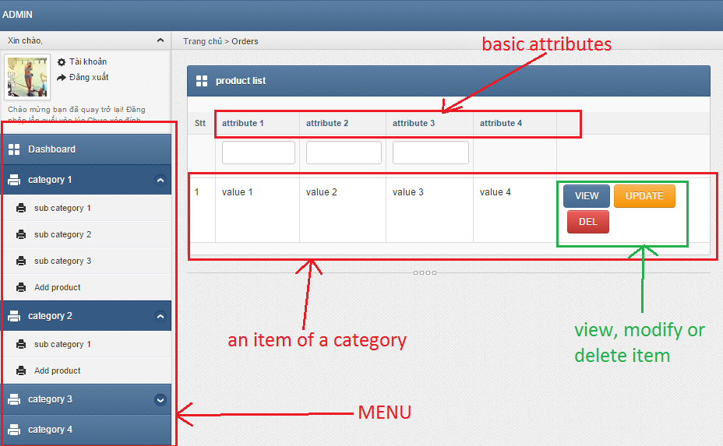

**View function interface (attribute change due to category)**

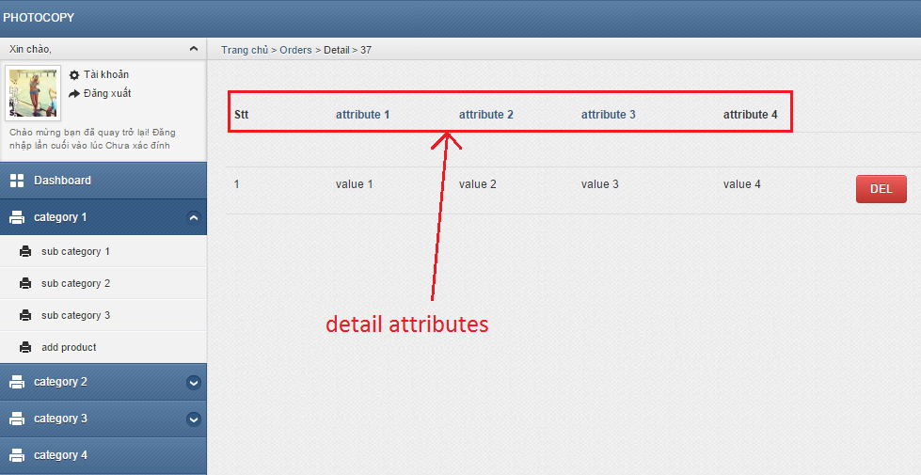

**Modify function interface (attribute change due to category)**

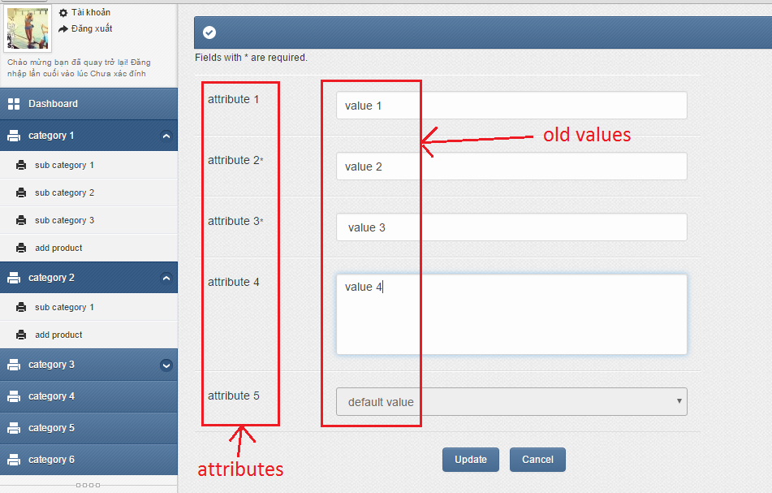

**Create function interface (attribute change due to category)**

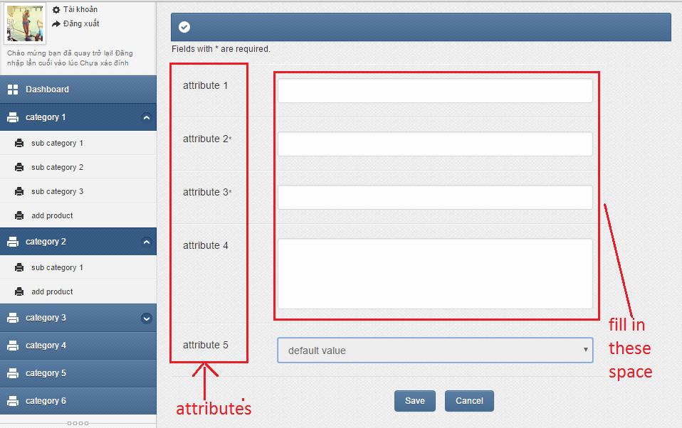

* + - * 1. **Ease of use**

User need 1 day of training to get used to the interface and categories.

* + - * 1. **Task match**

The course information maintaining and updating module will be 100% match to all functional requirements

* + - * 1. **User support**

In case any of functional requirements does not work as expected, the Cybercation café owners can send us a request for support through email or phone. If the problem is not related to any systematic errors, it will be solved within 3days. If the problem is related or systematic errors, we will evaluate the problem and inform the Cybercation café owners about needed time ro solve the problem.

* + - * 1. **Perceived consequences**

This module let manager know what information will appear on the website in a visual way. As a result, the manager can give a faster, more reliable and more effective decision about the website’s content.

#### **Courses registering and participating module**

##### **User Interfaces**

Interaction between users and course courses registering and participating module will be processed through web interface

* + - * 1. **GUI**

The course courses registering and participating module will be menu-driven system. The menu includes categories and sub categories as the following picture

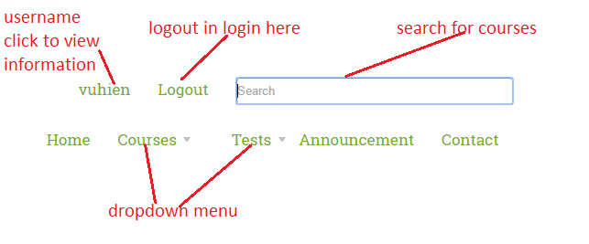

**Register interface**

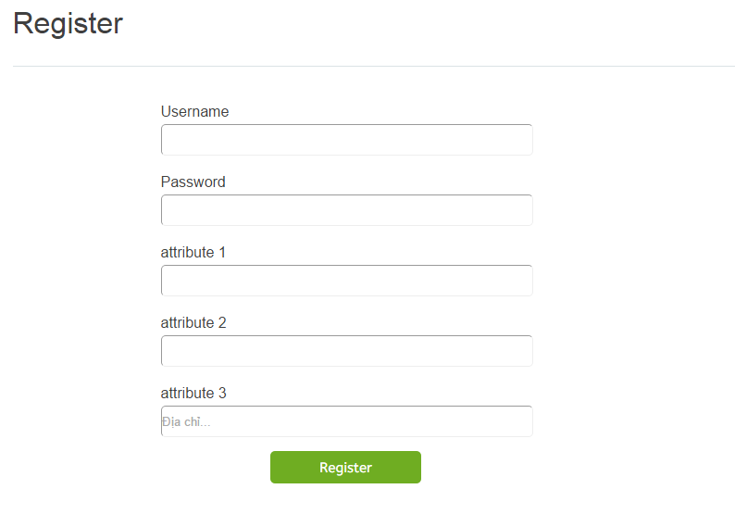

**Login interface**

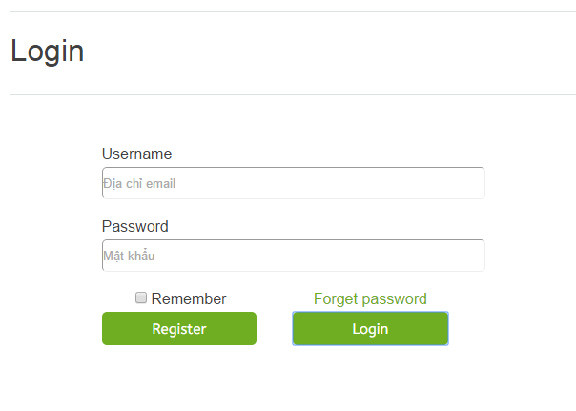

**Personal information interface**

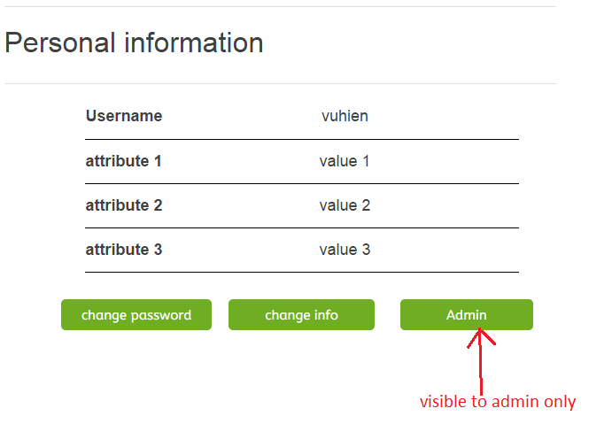

**Change personal information interface**

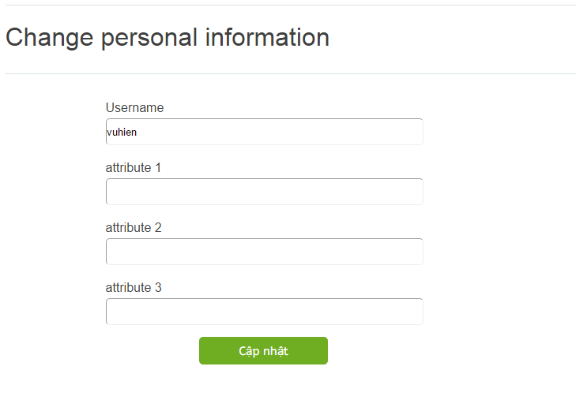

**Change password interface**

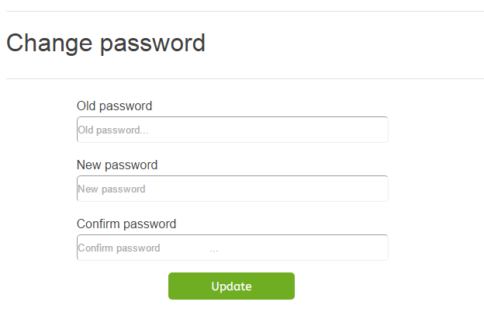

* + - * 1. **Ease of use**

No training is needed.

* + - * 1. **TASK MATCH**

The course information maintaining and updating module will be 100% match to all functional requirements

* + - * 1. **USER SUPPORT**

In case any of functional requirements does not work as expected, the Cybercation café owners can send us a request for support through email or phone. If the problem is not related to any systematic errors, it will be solved within 3days. If the problem is related or systematic errors, we will evaluate the problem and inform the Cybercation café owners about needed time or solve the problem

* + - * 1. **PERCEIVED CONSEQUENCES**

The website will help to promote the business over the internet. Customer can access to the services at anywhere, anytime and the user interface is very easy to use, therefore, it helps to attract more customers and make them feel comfortable. The course courses registering and participating module will automate and accelerate registering and courses participating processes and help users to find their desired courses.

## platform requirement

*Describes interfaces to and requirements for hardware devices*

### hardwares:

including peripherals (screens, printers, etc)

### Estimated capacities (CPU speed, memory size, online & offline storage).

* 1. **Operating System and Database Requirements**

### Networking, Internet, Communications Requirements

### Data Backup, Recovery

### Security (Virus Protection, Firewall)

## **Data Conversion**

The Cybercation café is a newly established business. Therefore, only basic information (such as offered courses, company location, etc…) will need to be import manually to the system

## **Other non-functional Requirements**

Specifies any other particular non-functional attributes required by the system. Examples are provided below.

### Security

### Reliability

### Maintainability

### Portability

### Application Compatibility

### Serviceability

### Others as appropriate

**Note: You need NOT complete this section – it is for your information only. Simply remove it**

1. **Operational Scenarios**

This section should describe a set of scenarios that illustrate, from the user's perspective, what will be experienced when utilizing the system under various situations as follows:

In the broad sense, a scenario is simply a proposed specific use of the system. More specifically, a scenario is a description of one or more end-to-end transactions involving the required system and its environment. Scenarios can be documented in different ways, depending up on the level of detail needed. The simplest form is a use case, which consists merely of a short description with a number attached. More detailed forms are called scripts. These are usually represented as tables or diagrams and involved identifying an action and the agent (doer) of the action. For this reason, a script can also be called an action table.

Although scenarios are useful in acquiring and validating requirements, they are not themselves requirements, because they describe the system's behavior only in specific situations; a specification, on the other hand, describes what the system should do in general.

**Note: You need NOT complete this section – it is for your information only. Simply remove it.**