Request for Proposal

for

C O N F I D E N T I A L

Prepared by:

Table of Contents

1. Executive Summary 4
2. Introduction & Overview 5
2.1 Purpose 5
2.2 Scope 5
2.3 Structure of this Document 5
2.4 Definitions 5
2.4 Timetable for Procurement 6
3. Terms & Conditions 7
3.1 General Conditions 7
3.2 Basis of Tendering 7
3.3 Format of Proposal 7
3.4 Method of Response 8
3.5 Confidentiality 8
3.6 Further Information 9
4. Overview and Objectives of Buyer 10
4.1 Structure of Organisation 10
4.2 Company Goals & Objectives 10
5. Current IT Department 11
6. Current Systems 11
6.1 Applications 11
6.2 Hardware 11
6.3 Utilities 11
6.4 Networking, Internet, Communications 11
6.5 Printers 11
6.6 Other 11
7. Solution Requirements 12
7.1 Overview 12
7.2 Software Requirements 12
7.3 Hardware Requirements 12
7.4 Data Volumes 12
7.5 Communication, Networking Requirements 12
7.6 Data Backup, Recovery 13
7.7 Security (Virus Protection, Firewall) 13
7.8 Data Conversion 13
8. Contract Inclusions 14
8.1 Warranties 14
8.2 Technical Support 14
8.3 Preventative Maintenance 14
8.4 Upgrades & Expansion 14
8.5 Implementation 14
8.6 Project Management 14
8.7 Training 14
8.8 Performance & Service Standards 15
8.9 Acceptance Procedures 15
8.10 Payment Procedures 15
8.11 Intellectual Property 15
9. Supplier Responses 16
9.1 Executive Summary 16
9.2 Information about Supplier 16
9.3 Present Clients 16
9.4 Compliance with Requirements 16
9.5 Statement of Costs 16
9.6 Implementation Plan 16
9.7 Training Plan 16
9.8 Staff Assigned to Project 16
10. Software & Hardware Evaluation Process 17
11.1 Software 17
11.2 Hardware/Operating System/Network 17
11. Vendor Evaluation 18
11.1 Background 18
11.2 Staff Involved 18
11.3 Contract 18
11.4 Costs 18
11.5 Honesty 18
11.6 Services 18
12. Concluding Statement 19

1. Executive Summary

Cybercation café is a new business which established by 5 members come from different profession. The business offers internet café service along with other services such as e-learning packages, testing for certificate, training/conference room for hire, etc… The content management system (CMS) is a web-based system which helps the Cybercation café owners to manage contents and operations happen on their official website.
This RFP document provides vendor detail information about application requirements for implementation of the CMS and the Cybercation café so that the vendor can prepare for the proposal they will provide. For hardware and platform, the CMS is deployed on Apache webserver run on Microsoft window operating system. Users can access to Cybcercation services through the internet anywhere, anytime .All data backup, recovery, security and data conversion will be clearly stated. In general, the CMS consists of 2 modules:
- Courses information maintaining and updating module: manage website’s contents
- Courses registering and participating module: allow users to take part in Cybercation café’ services and manage operation happens on website
Because this is a new business, there is no existing IT department. However, they have already set up some computers, internet connection, electricity sytems to prepare for their business.
There are some terms and conditions in this document that vendors must follow, includes: general conditions, basis tendering, format of proposal, method of response and confidentiality. Moreover, vendors need to pay attention to contraction inclusion for the CMS. This section will list wanted inclusions of Cybercation café’s owners includes: warranties, technical support, preventative maintenance, upgrade and expansion, implementation, training, performance & service standard, acceptance procurement and intellectual property.

2. Introduction & Overview

2.1 Purpose
The main purpose of this document is to request vendors for proposals to and provides them necessary information about solution requirement if content management system so that they can prepare for their proposal. Overview of Cybercation café business and existing system is also provided for reference.

2.2 Scope
This RFP contains solution requirements for content management system (CMS), includes software, platform, operating, communicationg and recovery requirements. The requirements will be explained in detail so that vendors can understand and prepare for their proposal. Content management system (CMS) is a web-based system which will be deployed on Apache webserver and can be accessed through web broswers. The system consists of 2 modules:
- Courses information maintaining and updating module: manage website’s contents
- Courses registering and participating module: allow users to take part in Cybercation café’ services and manage operation happens on website

In addition, existing IT derpartment and systems will be presented to vendors in case an intergration plan is needed or a component can be reused.
Terms and conditions about confidentiality, format, how to respone to this RFP document and other general conditions will be clearly defined. Vendors must follow this terms and conditions. Overview and objectives of Cabercation café are also provided for reference.

2.3 Structure of this Document

- Introduction and Overview
The purpose for the system and the timelines for proposals and evaluation.

- Terms and Conditions
The terms and conditions relating to submitting a solution response to this RFP.

- Overview and Objectives of Buyer
Information about Cybercation Café business and its objectives.

- Current IT Department and System

- Solution Requirements
A breakdown of the requirements for the proposed solution including software, hardware, software, and communications that should be included in the proposed solution.

- Contract Inclusions
A breakdown of the contractual inclusions relating to implementation, project management, payment, warranties, technical support and maintenance of the solution.

- Vendor Responses
A detailed breakdown of items that must be included in the proposal response and other documentation relating to the solution.

- Software and Hardware Evaluation Process
A breakdown of the Software and Hardware evaluation Processes.

- Vendor Evaluation
A breakdown of the vendor evaluation process.

- Closing Statement

2.4 Definitions

CMS is the abbreviation of Content Management System

2.5 Timetable for Procurement

The solution and vendor selection process will be completed four weeks after the closing date for submitting proposals. The successful vendor will be notified at this time. Documentation will be returned to all unsuccessful vendors at the completion of this process. Our detailed timeline is as follows:
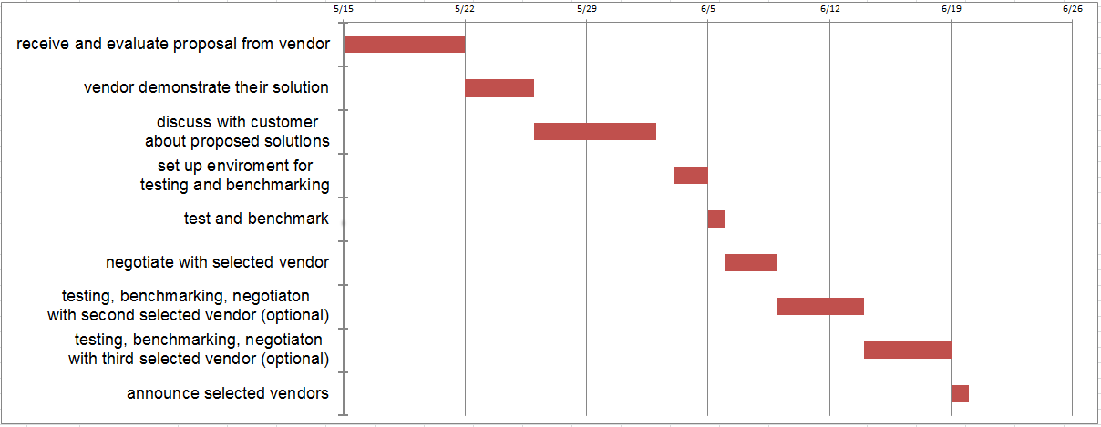

3. Terms & Conditions

Vendors should carefully note the terms and conditions below when submitting their proposals.

General Conditions

    - Any information in this RFP remains strictly confidential until made public on agreement by both consultants and the business.
    - The Consultants shall take sole ownership of the entire project until completion, and then all the deeds will be handed over to the business.
    - To work inside the proposed budget the Consultants will deal with all payments until completion, and then a negotiated bill payment plan can be worked out.
    - The Business are requesting proposals with the intent of offering a contract to a vendor that provides the best solution to the proposal contained in this RFP. The Business reserves the right not to offer a contract and also to reject any or all proposals that are received.
    - The vendor must keep The Consultants updated on the progress of the installation of the system. If the vendor does not meet the agreed delivery date without acceptable reasons, then the vendor will be responsible for any additional costs. These criteria will also apply to any products or services that were promised.
    - Any costs or liabilities incurred by the vendor in responding to this RFP will be the sole responsibility of the vendor.
    - Unless otherwise approved by the Business delivery will be made during business hours only and there should be no cancellations or substitutions.

3.2 Basis of Tendering

… companies were short-listed from the Registration of Interest advertised in ….

Each company will be sent a copy of the RFP.

3.3 Format of Proposal

All proposals submitted are to use the following structure:
    - Title page to include company name, address and contact details including telephone number, e-mail address, and facsimile number.
    - An Executive Summary before the table of contents page. This should contain a synopsis of the vendor’s project development approach and pricing structure.
    - A table of contents page with a comprehensive breakdown of the proposal.
    - List of relevant qualifications and work history for all staff that will be working on the project.
    - Proposed solutions for the system.
    - Cost estimates for the proposed solutions.
    - Timetable for procurement and implementation of proposed solutions.
    - A check list showing each of the proposal requirements has been included.
    - A covering letter, which must be signed by a staff member who has the authorisation to sign a commitment/signature page form. This must confirm that the statements and commitment made by the vendor are legitimate and correct and may be relied upon by The Business and The Consultants when making a decision.
    - Any variations from the requirements in this RFP, no matter how small must be clearly indicated.
    - Proposal sections must correspond to the sections and section layouts of this RFP. Each section is to begin on a new page and begin with a summary of the details that are to follow.
    - An outline numbering system that matches each response by the vendor to the requirement or request stated in the RFP.
    - Each response must be printed on A4 paper, one side only, Arial font, size 14 for headings and size 11 for the detail, black ink only.
    - Each response must be bound on the left-hand side.

3.4 Method of Response

Proposals must be delivered to The Consultants at the following address accompanied by a soft dopy of the proposal on a CD or ZIP disk.

- It is the responsibility of The Consultants to stamp the proposal with the date and time the proposal was received. It is the vendor’s responsibility to have the proposal correctly marked and delivered to The Consultants on time.
- Two copies of the proposal must be submitted by The Consultants. Each proposal should be placed in a separate envelope and appropriately identified with due date, time and the RFP number. The vendor’s name, address, telephone number, fax number, proposal number should be clearly shown on the outside of the envelope.
- If the decision is taken to withdraw the proposal, this must be in writing, prior to the date and time set for receipt of proposals. Any proposal that is not withdrawn within that time will stand for a period of 30 days until such time as a decision is made by the business on the proposals contract.
- Please provide a printed response of all schedules. Include any spreadsheet files if applicable. These must be on the CD or ZIP disk together with the original RFP response.

3.5 Confidentiality

No news or public disclosures pertaining to this RFP shall be made without prior written approval of The Consultants or as stated within this RFP.
The vendor will not release any information other than which is absolutely necessary to any third parties including contractors. The vendor also commits to not releasing any information that has been provided in this RFP or further information supplied by The Business or The Consultants. Confidentiality of The Business’ data, files, and other confidential information is extremely important and any evidence of leakage or disclosure will result in legal action. This applies to the vendor, their employees, and subcontractors. Any additional information provided has been done so on the proviso that it is kept in strict confidence and secrecy.

3.6 Further Information

Any questions regarding this RFP should be directed to:
Phan Thế Hùng – 1359013@itec.hcmus.edu.vn

4. Overview and Objectives of Buyer

4.1 Structure of Organisation
Ho Chi Minh Cybercation Café

( Headquarter )
Customer Relation Department
Human Resource Department
Content and Services Department
Financial Department
Technical Department
Sales and Marketing Department
Ha Noi Cybercation Café

(Branch)

The organization has 2 main layers and one supporting layer, including:
+ A headquarter
+ A branch as a supporting layer
The headquarter have six departments:
+ Customer Relation Department
+Human Resource Department
+Content and Services Department
+Financial Department
+Sales and Marketing Department
+Technical Department
The head of the each department share equal privileges and equal in business decisions.

4.2 Company Goals & Objectives
- To provide Internet services, E-Learning, testing, graphic... throughout the Asian region that are of top quality, reliability
- To provide technological feature, to achieve strategic goal.
- To encourage and prepare our human resources team to enhance their knowledge and skills within each featured context.
- To increase growth and development through business expansion
- To make use of information technology to achieve our goals, objectives, and CSFs and to add value to the business Value Chain and Supply Chain
- To grow the business by attracting regular business customers who can easily access our services in all our locations through a customer loyalty system.
- To maintain profitability and build a consolidated fund to use for expansion costs

5. Existing IT Department
The Cybercation Café business does not have an existing IT Department because it is a new start-up business. However, the owners’ have three employee that experienced in IT-related field.

6. Existing Systems

6.1 Applications
- Microsoft SQL server
- XAMPP package

6.2 Hardware
- PCs, keyboards, mouses
- 1 printer

6.3 Utilities

6.4 Networking, Internet, Communications
- Internet connection
- Phone

6.5 Printers
- N/A

6.6 Other

7. Solution Requirements
[This section can be taken directly from the SRS. NOTE: This section is 50% of the total marks for the RFP document]

7.1 Overview
Content management system is a web-based system which manages all operations on web server and contents of the official website of the company through web browers. All interactions between users and the CMS are processed through web interface.
Customers can register an account for online study and testing services. All accesses and requests are verified and controlled by the CMS. At the end of month, the CMS will create a report about registered courses and services.
The CMS will also provide APIs which allow human resource department to upload announcements which relates to human resource activities such as recruitment, trainings, etc… to the website…

Applications Software Requirements

Functional requirements within content management system
The application consists of 2 modules:
- Courses information maintaining and updating system
- Courses registering and participating system

Courses information maintaining and updating module
        - Add a new course
Authorized people can add a new course which is provided by Cybercation café to the website through web interface
        - View a course
Authorized people can view information of a course which is provided by Cybercation café on website through web interface
        - Modify a course
Authorized people can modifies information of a course which is provided by Cybercation café on website through web interface
        - Delete a course
Authorized people can delete a course which is provided by Cybercation café from website through web interface
        - Add a new test
Authorized people can add a new test to website through web interface
        - View test
Authorized people can view information of a test which is provided by Cybercation café to the website through web interface
        - Modify a test
Authorized people can modifies information of a test which is provided by Cybercation café on website through web interface
        - Delete a test
Authorized people can delete a test which is provided by Cybercation café from website through web interface
        - Add a new user
Authorized people can add a new lower level user to user list through web interface
        - View a user
Authorized people can view information of a lower level user to user list through web interface
        - Modify a user
Authorized people can change information of a lower level user to user list through web interface
        - Delete a user
Authorized people can delete a lower level user from user list through web interface
        - Add a new announcement
Authorized people can add a new announcement to the website through web interface
        - View an announcement
Authorized people can view information of an announcement through web interface
        - Modify an announcement
Authorized people can modifies information of an announcement on the website through web interface
        - Delete an announcement
Authorized people can delete an announcement from website from the website through web interface
        - Add a new category
Authorized people can add a new category to category list through web interface
        - View a category
Authorized people can view information of a category in category list through web interface
        - Modify a category
Authorized people can modifies information of a category in category list through web interface
        - Delete a category
Authorized people can delete a category in category list through web interface

Courses registering and participating module
        - Registering
New customer can register a member account through web interface
        - Enrolling courses
Members can enroll courses through web interface
        - Taking test
Members can take tests through web interface
        - Modifying personal information
Members can modifies their personal information through web interface
        - Changing password
Members can change their password through web interface
        - Login
Members can login to their account on the website
        - Logout
Members can logout of their account
        - Verifying user
The CMS can verify logged-in member and assign appropriate authority.
        - View personal information
Members can view their personal information through web interface
        - Monthly report
The CMS will record members’ activities such as courses and tests they take, theirs searching keywords. At the end of each month, the CMS will generate reports on those activities.

Interface Requirements of content management system

Courses information maintaining and updating module

User Interfaces
Interaction between users and course information maintaining and updateing module will be processed through web interface

        - GUI
The course information maintaining nad updateing module will be menu-driven system which includes a left side menu. The menu includes categories and sub categories as the following picture:
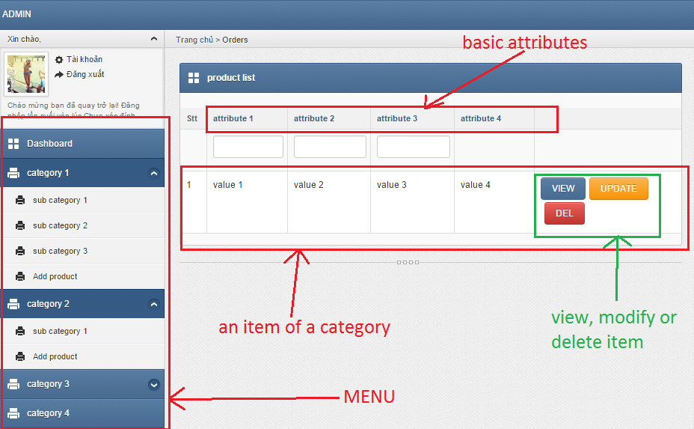

View function interface (attribute change due to category )
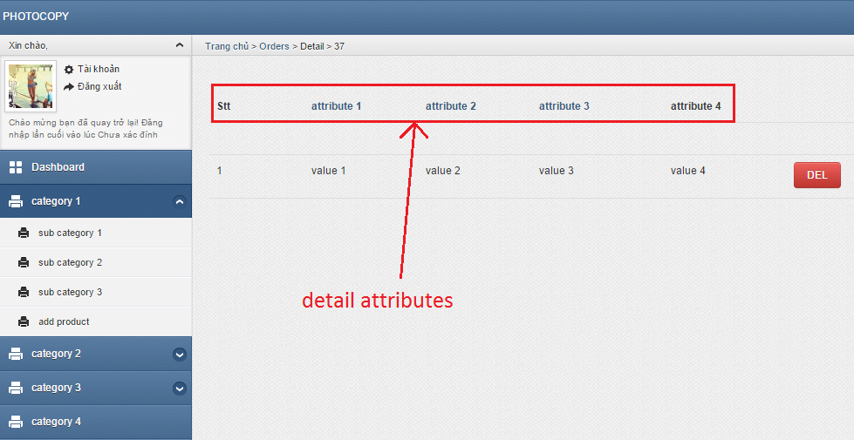

Modify function interface (attribute change due to category)
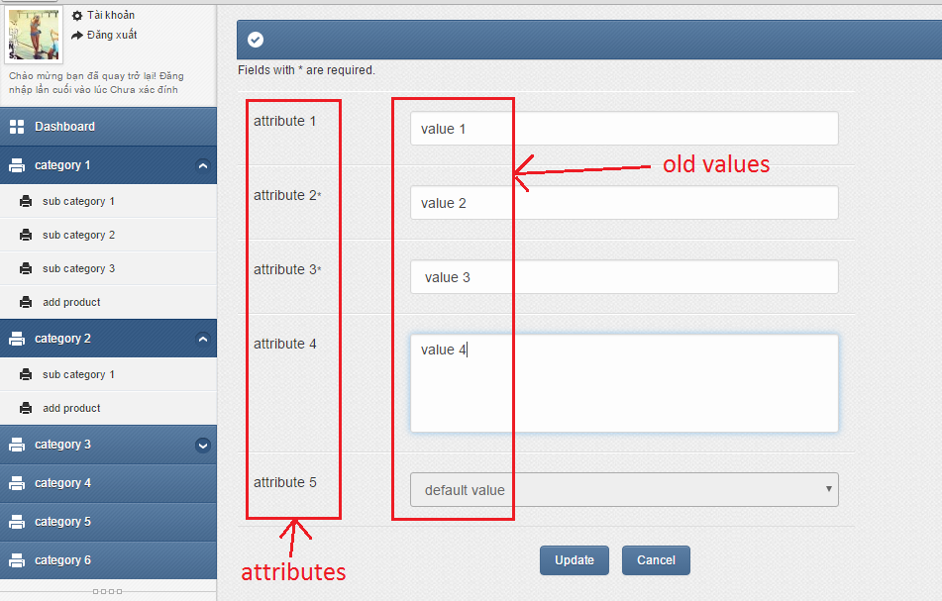

Create function interface (attribute change due to category)
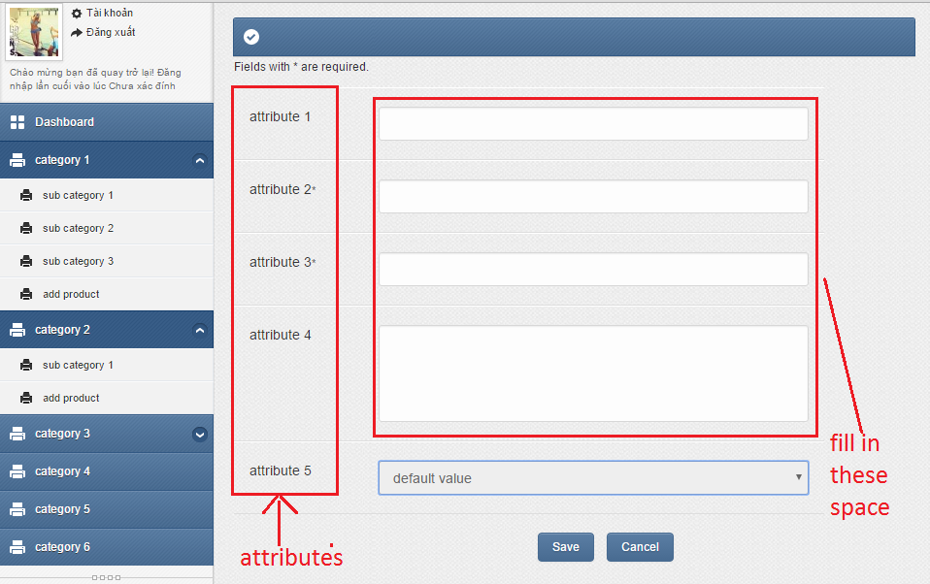

        - Ease of use
- Minimum (no redundant), logical steps needed to process a task
- Consistent, simple layout (not too many components)
- Clear, readable, text font
- Understandable, informative, positive error message
- Guidance documentation
- Cross-browser support
- Informative icons, graphics.
        - Task match
The course information maintaining and updating module will be 100% match to all functional requirements
        - User support
- System training
- Service desk support: 2
  - 4/7 through email
  - working hour from Monday to Saturday through phone
- data backup and recovery
        - Perceived consequences
This module let manager know what information will appear on the website in a visual way. As a result, the manager can give a faster, more reliable and more effective decision about the website’s content.

Courses registering and participating module

User Interfaces
Interaction between users and course courses registering and participating module will be processed through web interface
        - GUI
The course courses registering and participating module will be menu-driven system. The menu includes categories and sub categories as the following picture
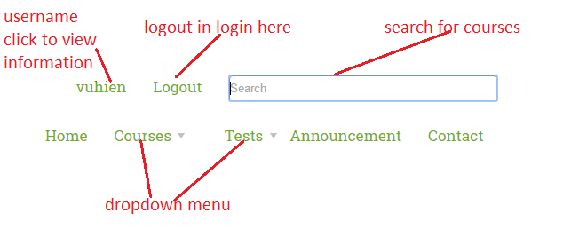

Register interface
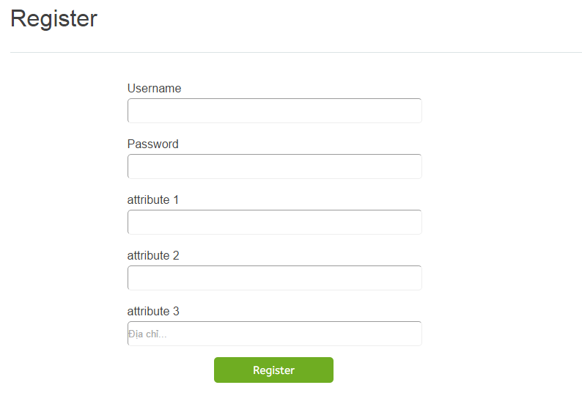

Login interface
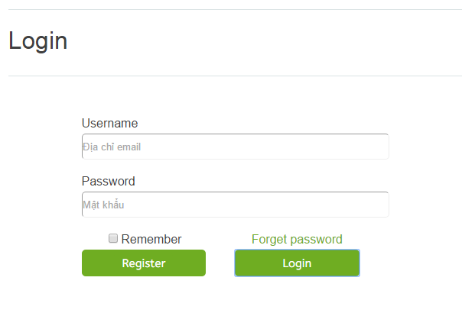

Personal information interface
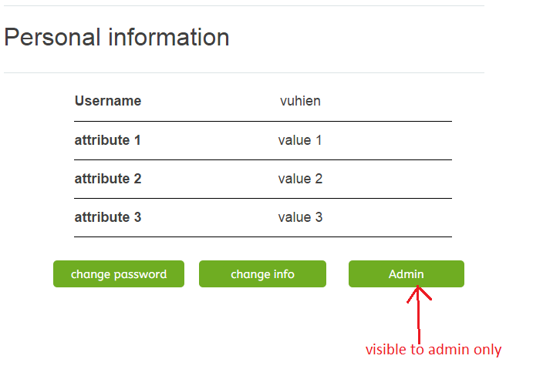

Change personal information interface
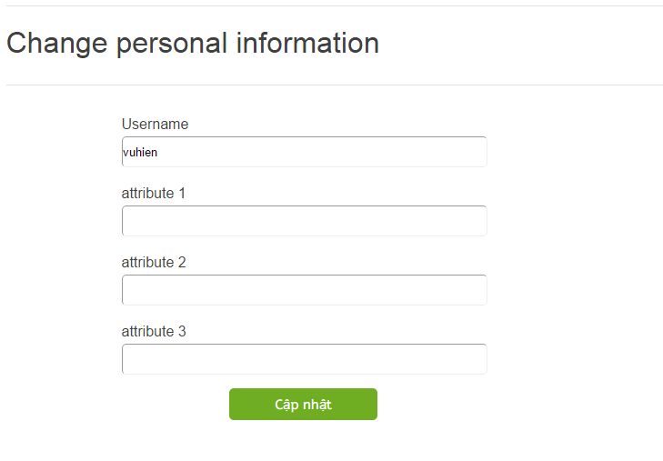

Change password interface
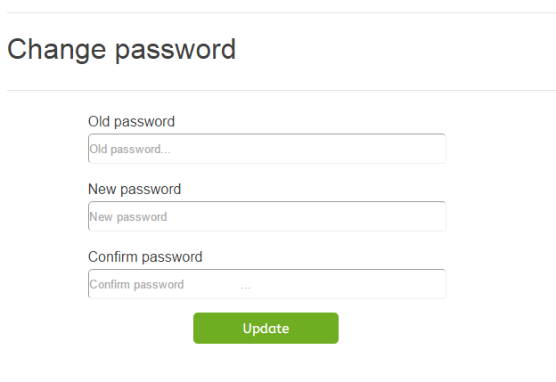

        - Ease of use
- Minimum (no redundant), logical steps needed to process a task
- Consistent, simple layout (not too many components)
- Clear, readable, text font
- Understandable, informative, positive error message
- Guidance documentation
- Cross-browser support
- Informative icons, graphics.
        - TASK MATCH
The course information maintaining and updating module will be 100% match to all functional requirements

7.3 Platform Requirements: Hardware including peripherals (screens, printers, etc) and estimated capacities (online offline storage, CPU speed, memory size).

Hardware :
- 15 inches screen
- At least 5 CPUs, keyboards, mouses, screens produced from 2010 or later
- At least 1 routers
Estimated capacities :
- 4GB or higher ram CPU
- At least 150GB of memory storage

7.4 Operating System and Database Requirements
- Microsoft SQL server
- Microsoft window 7 or higher or linux

7.5 Communications Requirements: Networking, Internet
- Lighting cable internet

7.6 Data Backup, Recovery
- Backup recovery plan for disaster
- Backup and recovery plan for data lost
- Backup electricity power
- RAID 3 or higher

7.7 Security (Virus Protection, Firewall)
- Common antivirus software is required (Avast, Avira, etc…)
- Window firewall

7.8 Data Conversion
The Cybercation café is a newly established business. Therefore, only basic information (such as offered courses, company location, etc… ) will need to be import manually to the system

8. Contract Inclusions
//Nhung dieu khoan trong hop dong

8.1 Warranties
As part of the proposal,
The warranty period of the product the third party provide must be longer than three years.
The process of fixing the product issue, response time, and total fee of the warranty and support service must be recorded and report back to the business.
The business is allowed to extend the warranty period.
The details of restriction policies of the warranty must be clear between the business and the vendor.
The technical standard needs to enable the interoperability between the service provider and the business information, specifically, the record systems.
Every damage of the product caused by the third party will make the party replace another new one without additional fees.
//Bao hiem,bao hanh

8.2 Technical Support
//Ho tro ki thuat

As part of the proposal:
Technical support options always be 24/7
The third party provides what products and services are under technical support and what are excluded.
Manual/guide documents for technical support is arranged and included.
The third party provide the technical support request process and response a solution based on the problem level.
The request must be tracked by the business and the solution must be conduct immediately based on the damage level.

8.3 Preventative Maintenance
//Viec bao tri phong ho rui ro
As part of the proposal:
A report of the current statistic of the product should be provided to the business.
The vendor must documented the available preventative maintenance options and the option details.
The third party must announce the price and payment for the preventative maintenance options before the maintenance procedures begin.

8.4 Upgrades & Expansion
//Nang cap va mo rong
As part of the proposal:
The third party take responsible for outline the schedule for annual upgrade
Annual meeting will be conduct to discuss about the expectations from the client for the next upgrade
The third party will take responsible for managing risk and future strategies
The details and price of the next upgrade will be outlined by the third party and change further by the business.

8.5 Implementation
//Chay business ntn
As part of the proposal, the vendor will conduct an implementation plan that includes:
Implementation service’s requirements
Implement time required to execute the service/system
Additional fees or changes must be record and clear
As part of the proposal:
If the implementation is fail to complete due to deadline, the the third party have to pay the penalty of 30% of total payment of the product for each deadline is made.
If the implementation is disagreed by the clients, the third party must prepare another substitute implementation plan.

8.6 Project Management
//Ke hoach kiem soat du an
As part of the proposal, the vendor will conduct a project plan that includes:
The project manager’s information
Qualification of the project manager
The project’s completed task timeline
The responsible roles for the project
As part of the proposal:
The project manager must keep contact with the business to keep track on the process of the product.
The project manager takes full responsible for

8.7 Training
//Dao tao
As part of the proposal , the vendor will include a training plan that includes :
The person that took responsible as a trainer from the vendor
The qualification of the trainer
Timeline of the training sessions and the total hours of training
The details of each training sessions

8.8 Performance & Service Standards
//Nhung chuan muc ve van hanh va dich vu
As part of the proposal, the vendor will need to conduct a set of performance and service standards that includes:
The measurement escalation of the standard
The person who responsible as the measurer
The report include the process and the frequency for the measure
The details of standard matches or failure to match the standard.

8.9 Acceptance Procedures
//Cac buoc chap nhan
As part of the proposal, the vendor will need to:
Conduct the testing process and report the statistic
Listing the acceptance provision
Define the system acceptance policies and the current implemented policies

8.10 Payment Procedures
//Cac buoc thanh toan
As part of the proposal, the vendor will indicate acceptance of the following payment schedule:
30% payment prior to product delivery.
20% payment at the commencement of implementation project
20% payment at the commencement of the training session completion
30% payment the business accept the product from the vendor

8.11 Intellectual Property
//So huu tri tue
The vendor will retain intellectual property rights over software/solutiosn where they can:
Demonstrate rights of intellectual property at the beginning of the contract
Demonstrate the work including the specific architecture and an implementation belong to the vendor
The Cybercation Café business will retain all the intellectual property rights over customisation that were done specifically by the Café staff.

9. Supplier Responses

9.1 Executive Summary
//Tom tat toan bo

9.2 Information about Supplier
//Thong tin ve supplier

9.3 Present Clients
//cac khach hang hien tai

9.4 Compliance with Requirements
//Thoa thuan va su dong y cua 2 ben ve cac requirements

9.5 Statement of Costs
//Thong bao chi phi

9.6 Implementation Plan
//ke hoach di vao hoat dong

9.7 Training Plan
//ke hoach dao tao

9.8 Staff Assigned to Project
//cac nhan vien duoc giao trong du an

10. Software & Hardware Evaluation Process
[This section is 20% of the marks for the RFP]

10.1 Evaluation of Software

// methodology, giới thiệu sơ sơ cách đánh giá, giới thiệu các tiêu chí (đưa file excel evaluation vào )

10.2 Evaluation of Hardware/Operating System/Network.

https://autonline.aut.ac.nz/webapps/blackboard/execute/displayLearningUnit?course_id=_82316_1&content_id=_3536037_1

Online study guide

11. Vendor Evaluation

11.1 Background

11.2 Staff Involved

11.3 Contract

11.4 Costs

11.5 Honesty

11.6 Services

12. Concluding Statement

//Loi ket

