**Request for Proposal**

For

**Content management system for Cybercation café**

#### C O N F I D E N T I A L

Prepared by:

Group No.3

Phan Thế Hùng - 15905055

Đặng Thị Thảo My - 15905067

Bùi Nguyễn Thiện Khánh - 15907679

Nguyễn Annh Quân - 15905072

**Table of Contents**

1. Executive Summary 4

2. Introduction & Overview 5

2.1 Purpose 5

2.2 Scope 5

2.3 Structure of this Document 5

2.4 Definitions 5

2.4 Timetable for Procurement 6

3. Terms & Conditions 7

3.1 General Conditions 7

3.2 Basis of Tendering 7

3.3 Format of Proposal 7

3.4 Method of Response 8

3.5 Confidentiality 8

3.6 Further Information 9

4. Overview and Objectives of Buyer 10

4.1 Structure of Organisation 10

4.2 Company Goals & Objectives 10

5. Current IT Department 11

6. Current Systems 11

6.1 Applications 11

6.2 Hardware 11

6.3 Utilities 11

6.4 Networking, Internet, Communications 11

6.5 Printers 11

6.6 Other 11

7. Solution Requirements 12

7.1 Overview 12

7.2 Software Requirements 12

7.3 Hardware Requirements 12

7.4 Data Volumes 12

7.5 Communication, Networking Requirements 12

7.6 Data Backup, Recovery 13

7.7 Security (Virus Protection, Firewall) 13

7.8 Data Conversion 13

8. Contract Inclusions 14

8.1 Warranties 14

8.2 Technical Support 14

8.3 Preventative Maintenance 14

8.4 Upgrades & Expansion 14

8.5 Implementation 14

8.6 Project Management 14

8.7 Training 14

8.8 Performance & Service Standards 15

8.9 Acceptance Procedures 15

8.10 Payment Procedures 15

8.11 Intellectual Property 15

9. Supplier Responses 16

9.1 Executive Summary 16

9.2 Information about Supplier 16

9.3 Present Clients 16

9.4 Compliance with Requirements 16

9.5 Statement of Costs 16

9.6 Implementation Plan 16

9.7 Training Plan 16

9.8 Staff Assigned to Project 16

10. Software & Hardware Evaluation Process 17

11.1 Software 17

11.2 Hardware/Operating System/Network 17

11. Vendor Evaluation 18

11.1 Background 18

11.2 Staff Involved 18

11.3 Contract 18

11.4 Costs 18

11.5 Honesty 18

11.6 Services 18

12. Concluding Statement 19

## 1. Executive Summary

Cybercation café is a new business which established by 5 members come from different profession. The business offers internet café service along with other services such as e-learning packages, testing for certificate, training/conference room for hire, etc… The content management system (CMS) is a web-based system which helps the Cybercation café owners to manage contents and operations happen on their official website.

This RFP document provides vendor detail information about application requirements for implementation of the CMS and the Cybercation café so that the vendor can prepare for the proposal they will provide. For hardware and platform, the CMS is deployed on Apache webserver run on Microsoft window operating system. Users can access to Cybcercation services through the internet anywhere, anytime .All data backup, recovery, security and data conversion will be clearly stated. In general, the CMS consists of 2 modules:

* Courses information maintaining and updating module: manage website’s contents
* Courses registering and participating module: allow users to take part in Cybercation café’ services and manage operation happens on website

Because this is a new business, there is no existing IT department. However, they have already set up some computers, internet connection, electricity sytems to prepare for their business.

There are some terms and conditions in this document that vendors must follow, includes: general conditions, basis tendering, format of proposal, method of response and confidentiality. Moreover, vendors need to pay attention to contraction inclusion for the CMS. This section will list wanted inclusions of Cybercation café’s owners includes: warranties, technical support, preventative maintenance, upgrade and expansion, implementation, training, performance & service standard, acceptance procurement and intellectual property.

For the selection for suitable package, we use Requirements lead approach as there are many vendors can provide us a content management system and functions within content management system need customizing for Cybercaion café’s services. Each vendor’s package will be scored to find the most suitable one. Criteria for selection and evaluation are present to all interested vendors.

## 2. Introduction & Overview

### 2.1 **Purpose**

The main purpose of this document is to request vendors for proposals to and provides them necessary information about solution requirement if content management system so that they can prepare for their proposal. Overview of Cybercation café business and existing system is also provided for reference.

### 2.2 **Scope**

This RFP contains solution requirements for content management system (CMS), includes software, platform, operating, communication and recovery requirements. The requirements will be explained in detail so that vendors can understand and prepare for their proposal. Content management system (CMS) is a web-based system which will be deployed on Apache webserver and can be accessed through web browsers. The system consists of 2 modules:

* Courses information maintaining and updating module: manage website’s contents
* Courses registering and participating module: allow users to take part in Cybercation café’ services and manage operation happens on website

In addition, existing IT department and systems will be presented to vendors in case an integration plan is needed or a component can be reused.

Terms and conditions about confidentiality, format, how to response to this RFP document and other general conditions will be clearly defined. Vendors must follow this terms and conditions. Overview and objectives of Cybercation café are also provided for reference.

Selection and evaluation processes are also clearly present to vendors. Vendors should pay attention to this section.

### 2.3 **Structure of this Document**

* Introduction and Overview

*The purpose for the system and the timelines for proposals and evaluation.*

* Terms and Conditions

*The terms and conditions relating to submitting a solution response to this RFP.*

* Overview and Objectives of Buyer

*Information about Cybercation Café business and its objectives.*

* Current IT Department and System
* Solution Requirements

A breakdown of the requirements for the proposed solution including software, hardware, software, and communications that should be included in the proposed solution.

* Contract Inclusions

A breakdown of the contractual inclusions relating to implementation, project management, payment, warranties, technical support and maintenance of the solution.

* Vendor Responses

A detailed breakdown of items that must be included in the proposal response and other documentation relating to the solution.

* Software and Hardware Evaluation Process

A breakdown of the Software and Hardware evaluation Processes.

* Vendor Evaluation

A breakdown of the vendor evaluation process.

* Closing Statement

### 2.4 **Definitions**

CMS is the abbreviation of Content Management System

### 2.5 **Timetable for Procurement**

The solution and vendor selection process will be completed four weeks after the closing date for submitting proposals. The successful vendor will be notified at this time. Documentation will be returned to all unsuccessful vendors at the completion of this process. Our detailed timeline is as follows: (please see Sheet 1, PreliminarySchedule.xlsx file for better view)

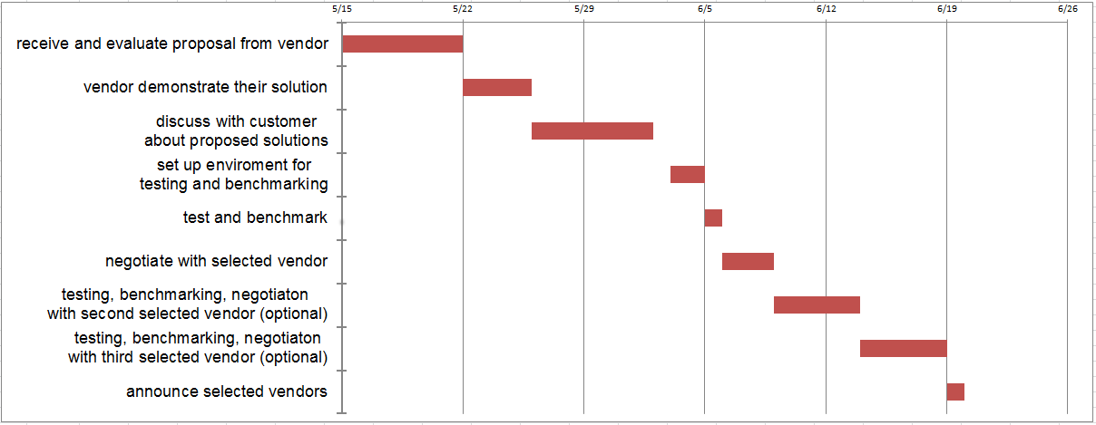

## 3. Terms & Conditions

Vendors should carefully note the terms and conditions below when submitting their proposals.

### **General Conditions**

* + - Any information in this RFP remains strictly confidential until made public on agreement by both consultants and the business.
    - The Consultants shall take sole ownership of the entire project until completion, and then all the deeds will be handed over to the business.
    - To work inside the proposed budget the Consultants will deal with all payments until completion, and then a negotiated bill payment plan can be worked out.
    - The Business are requesting proposals with the intent of offering a contract to a vendor that provides the best solution to the proposal contained in this RFP. The Business reserves the right not to offer a contract and also to reject any or all proposals that are received.
    - The vendor must keep The Consultants updated on the progress of the installation of the system. If the vendor does not meet the agreed delivery date without acceptable reasons, then the vendor will be responsible for any additional costs. These criteria will also apply to any products or services that were promised.
    - Any costs or liabilities incurred by the vendor in responding to this RFP will be the sole responsibility of the vendor.
    - Unless otherwise approved by the Business delivery will be made during business hours only and there should be no cancellations or substitutions.

### 3.2 **Basis of Tendering**

Each company will be sent a copy of the RFP.

### 3.3 **Format of Proposal**

All proposals submitted are to use the following structure:

* + - Title page to include company name, address and contact details including telephone number, e-mail address, and facsimile number.
    - An Executive Summary before the table of contents page. This should contain a synopsis of the vendor’s project development approach and pricing structure.
    - A table of contents page with a comprehensive breakdown of the proposal.
    - List of relevant qualifications and work history for all staff that will be working on the project.
    - Proposed solutions for the system.
    - Cost estimates for the proposed solutions.
    - Timetable for procurement and implementation of proposed solutions.
    - A check list showing each of the proposal requirements has been included.
    - A covering letter, which must be signed by a staff member who has the authorisation to sign a commitment/signature page form. This must confirm that the statements and commitment made by the vendor are legitimate and correct and may be relied upon by The Business and The Consultants when making a decision.
    - Any variations from the requirements in this RFP, no matter how small must be clearly indicated.
    - Proposal sections must correspond to the sections and section layouts of this RFP. Each section is to begin on a new page and begin with a summary of the details that are to follow.
    - An outline numbering system that matches each response by the vendor to the requirement or request stated in the RFP.
    - Each response must be printed on A4 paper, one side only, Arial font, size 14 for headings and size 11 for the detail, black ink only.
    - Each response must be bound on the left-hand side.

### 3.4 **Method of Response**

Proposals must be delivered to The Consultants at the following address accompanied by a soft dopy of the proposal on a CD or ZIP disk.

* It is the responsibility of The Consultants to stamp the proposal with the date and time the proposal was received. It is the vendor’s responsibility to have the proposal correctly marked and delivered to The Consultants on time.
* Two copies of the proposal must be submitted by The Consultants. Each proposal should be placed in a separate envelope and appropriately identified with due date, time and the RFP number. The vendor’s name, address, telephone number, fax number, proposal number should be clearly shown on the outside of the envelope.
* If the decision is taken to withdraw the proposal, this must be in writing, prior to the date and time set for receipt of proposals. Any proposal that is not withdrawn within that time will stand for a period of 30 days until such time as a decision is made by the business on the proposals contract.
* Please provide a printed response of all schedules. Include any spreadsheet files if applicable. These must be on the CD or ZIP disk together with the original RFP response.

### 3.5 **Confidentiality**

No news or public disclosures pertaining to this RFP shall be made without prior written approval of The Consultants or as stated within this RFP.

The vendor will not release any information other than which is absolutely necessary to any third parties including contractors. The vendor also commits to not releasing any information that has been provided in this RFP or further information supplied by The Business or The Consultants. Confidentiality of The Business’ data, files, and other confidential information is extremely important and any evidence of leakage or disclosure will result in legal action. This applies to the vendor, their employees, and subcontractors. Any additional information provided has been done so on the proviso that it is kept in strict confidence and secrecy.

### 3.6 **Further Information**

Any questions regarding this RFP should be directed to:

Phan Thế Hùng – 1359013@itec.hcmus.edu.vn

## 4. Overview and Objectives of Buyer

### 4.1 **Structure of Organisation**

The organization has 2 main layers and one supporting layer, including:

+ A headquarter

+ A branch as a supporting layer

The headquarter have six departments:

+ Customer Relation Department

+Human Resource Department

+Content and Services Department

+Financial Department

+Sales and Marketing Department

+Technical Department

The head of the each department share equal privileges and equal in business decisions.

### 4.2 **Company Goals & Objectives**

1. To provide Internet services, E-Learning, testing, graphic... throughout the Asian region that are of top quality, reliability
2. To provide technological feature, to achieve strategic goal.
3. To encourage and prepare our human resources team to enhance their knowledge and skills within each featured context.
4. To increase growth and development through business expansion
5. To make use of information technology to achieve our goals, objectives, and CSFs and to add value to the business Value Chain and Supply Chain
6. To grow the business by attracting regular business customers who can easily access our services in all our locations through a customer loyalty system.
7. To maintain profitability and build a consolidated fund to use for expansion costs

## 5. Existing IT Department

The Cybercation Café business does not have an existing IT Department because it is a new start-up business. However, the owners’ have three employee that experienced in IT-related field.

## 6. Existing Systems

### 6.1 **Applications**

* Microsoft SQL server
* XAMPP package

### 6.2 **Hardware**

* PCs, keyboards, mouses
* 1 printer

### 6.3 **Utilities**

### 6.4 **Networking, Internet, Communications**

* Internet connection
* Phone

### 6.5 **Printers**

* N/A

### 6.6 **Other**

## 7. Solution Requirements

***[This section can be taken directly from the SRS. NOTE: This section is 50% of the total marks for the RFP document]***

### **7.1 Overview**

Content management system is a web-based system which manages all operations on web server and contents of the official website of the company through web browers. All interactions between users and the CMS are processed through web interface.

Customers can register an account for online study and testing services. All accesses and requests are verified and controlled by the CMS. At the end of month, the CMS will create a report about registered courses and services.

The CMS will also provide APIs which allow human resource department to upload announcements which relates to human resource activities such as recruitment, trainings, etc… to the website…

### **Applications Software Requirements**

#### Functional requirements within content management system

The application consists of 2 modules:

* Courses information maintaining and updating system
* Courses registering and participating system

##### Courses information maintaining and updating module

* + - * 1. Add a new course

Authorized people can add a new course which is provided by Cybercation café to the website through web interface

* + - * 1. View a course

Authorized people can view information of a course which is provided by Cybercation café on website through web interface

* + - * 1. Modify a course

Authorized people can modifies information of a course which is provided by Cybercation café on website through web interface

* + - * 1. Delete a course

Authorized people can delete a course which is provided by Cybercation café from website through web interface

* + - * 1. Add a new test

Authorized people can add a new test to website through web interface

* + - * 1. View test

Authorized people can view information of a test which is provided by Cybercation café to the website through web interface

* + - * 1. Modify a test

Authorized people can modifies information of a test which is provided by Cybercation café on website through web interface

* + - * 1. Delete a test

Authorized people can delete a test which is provided by Cybercation café from website through web interface

* + - * 1. Add a new user

Authorized people can add a new lower level user to user list through web interface

* + - * 1. View a user

Authorized people can view information of a lower level user to user list through web interface

* + - * 1. Modify a user

Authorized people can change information of a lower level user to user list through web interface

* + - * 1. Delete a user

Authorized people can delete a lower level user from user list through web interface

* + - * 1. Add a new announcement

Authorized people can add a new announcement to the website through web interface

* + - * 1. View an announcement

Authorized people can view information of an announcement through web interface

* + - * 1. Modify an announcement

Authorized people can modifies information of an announcement on the website through web interface

* + - * 1. Delete an announcement

Authorized people can delete an announcement from website from the website through web interface

* + - * 1. Add a new category

Authorized people can add a new category to category list through web interface

* + - * 1. View a category

Authorized people can view information of a category in category list through web interface

* + - * 1. Modify a category

Authorized people can modifies information of a category in category list through web interface

* + - * 1. Delete a category

Authorized people can delete a category in category list through web interface

##### Courses registering and participating module

* + - * 1. Registering

New customer can register a member account through web interface

* + - * 1. Enrolling courses

Members can enroll courses through web interface

* + - * 1. Taking test

Members can take tests through web interface

* + - * 1. Modifying personal information

Members can modifies their personal information through web interface

* + - * 1. Changing password

Members can change their password through web interface

* + - * 1. Login

Members can login to their account on the website

* + - * 1. Logout

Members can logout of their account

* + - * 1. Verifying user

The CMS can verify logged-in member and assign appropriate authority.

* + - * 1. View personal information

Members can view their personal information through web interface

* + - * 1. Monthly report

The CMS will record members’ activities such as courses and tests they take, theirs searching keywords. At the end of each month, the CMS will generate reports on those activities.

#### Interface Requirements of content management system

##### Courses information maintaining and updating module

###### User Interfaces

Interaction between users and course information maintaining and updateing module will be processed through web interface

* + - * 1. **GUI**

The course information maintaining nad updateing module will be menu-driven system which includes a left side menu. The menu includes categories and sub categories as the following picture:

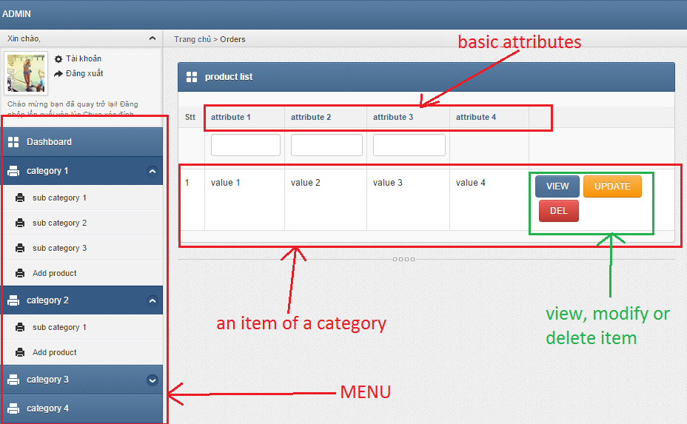

**View function interface (attribute change due to category )**

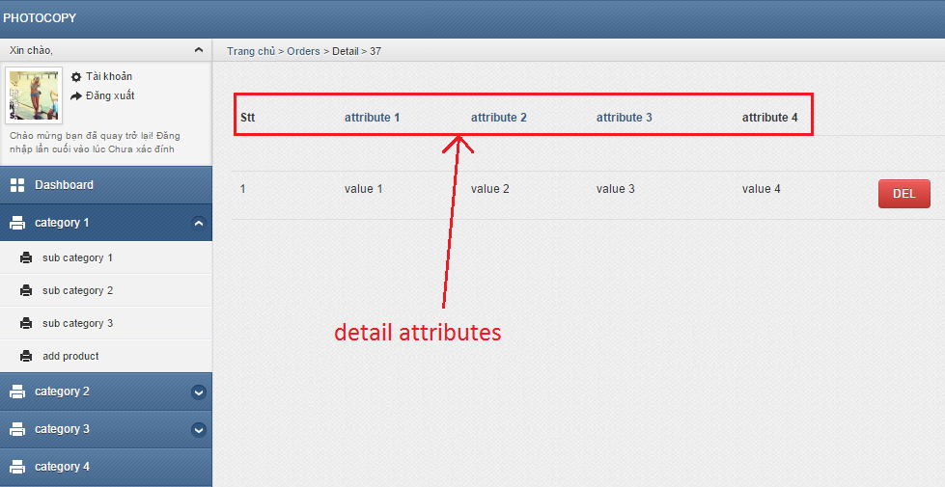

**Modify function interface (attribute change due to category)**

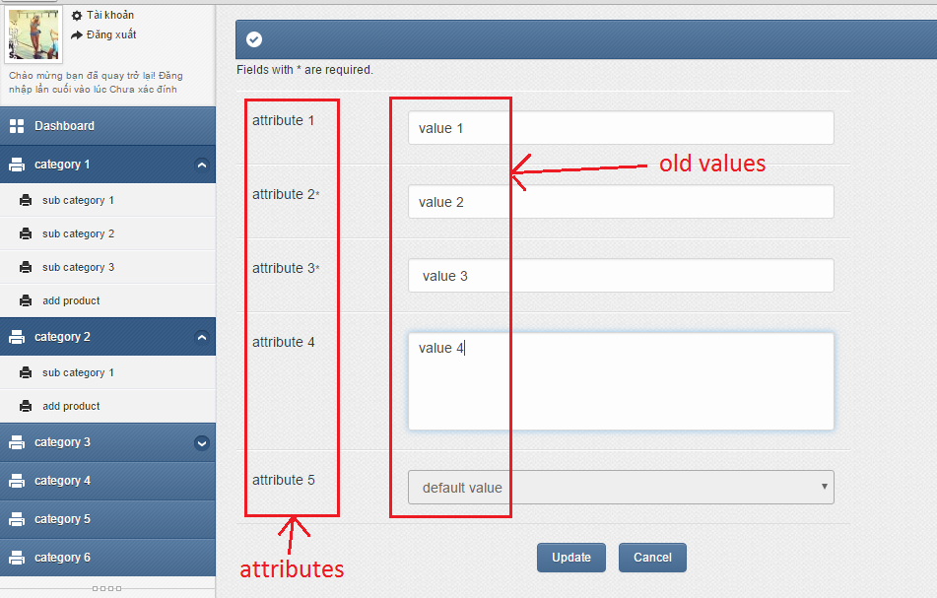

**Create function interface (attribute change due to category)**

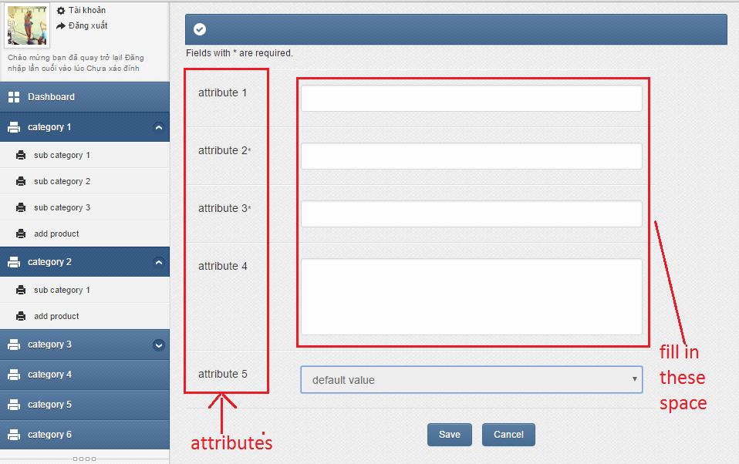

* + - * 1. **Ease of use**
* Minimum (no redundant), logical steps needed to process a task
* Consistent, simple layout (not too many components)
* Clear, readable, text font
* Understandable, informative, positive error message
* Guidance documentation
* Cross-browser support
* Informative icons, graphics.
  + - * 1. **Task match**

The course information maintaining and updating module will be 100% match to all functional requirements

* + - * 1. **User support**
* System training
* Service desk support: 2
  + 4/7 through email
  + working hour from Monday to Saturday through phone
* data backup and recovery
  + - * 1. **Perceived consequences**

This module let manager know what information will appear on the website in a visual way. As a result, the manager can give a faster, more reliable and more effective decision about the website’s content.

##### Courses registering and participating module

###### User Interfaces

Interaction between users and course courses registering and participating module will be processed through web interface

* + - * 1. **GUI**

The course courses registering and participating module will be menu-driven system. The menu includes categories and sub categories as the following picture

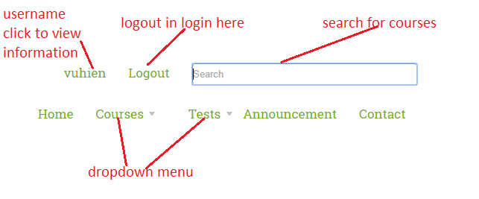

**Register interface**

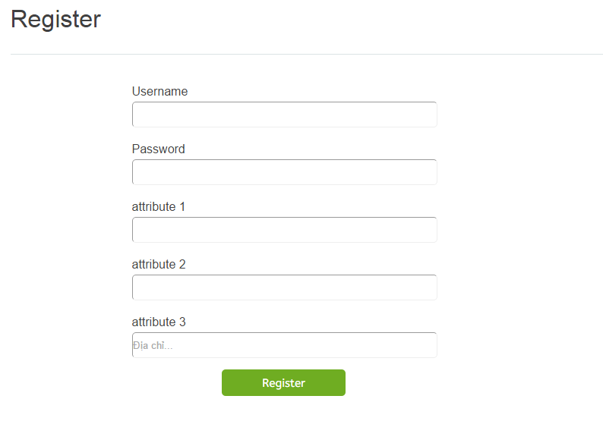

**Login interface**

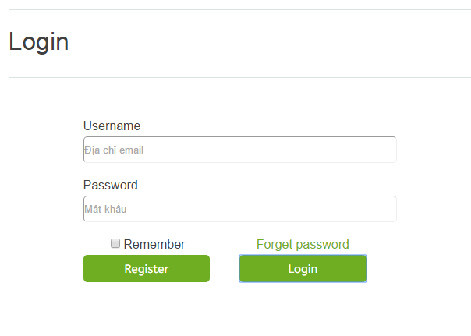

**Personal information interface**

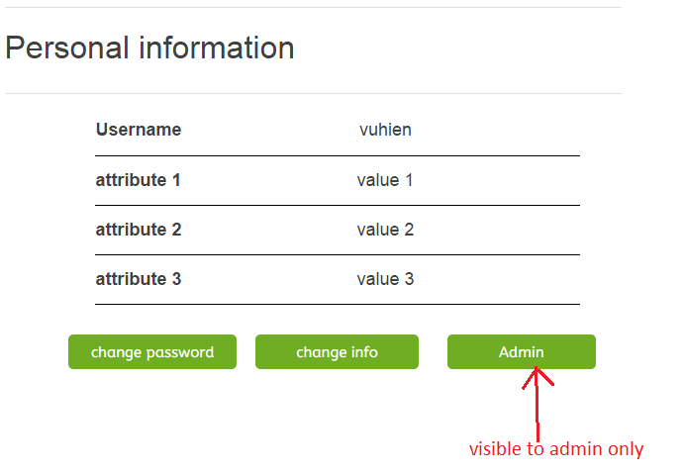

**Change personal information interface**

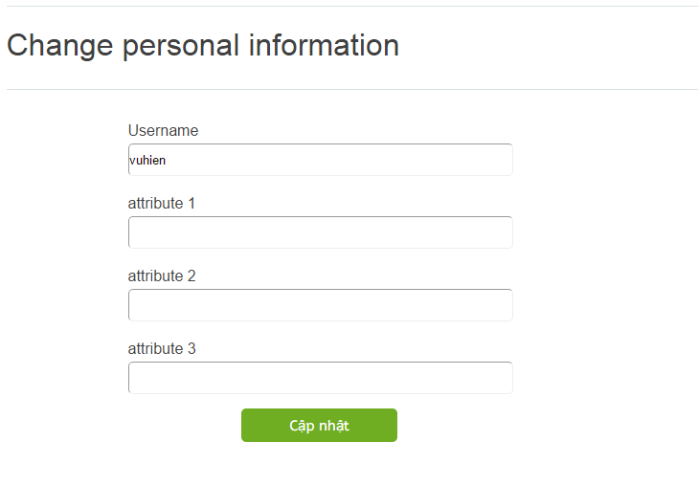

**Change password interface**

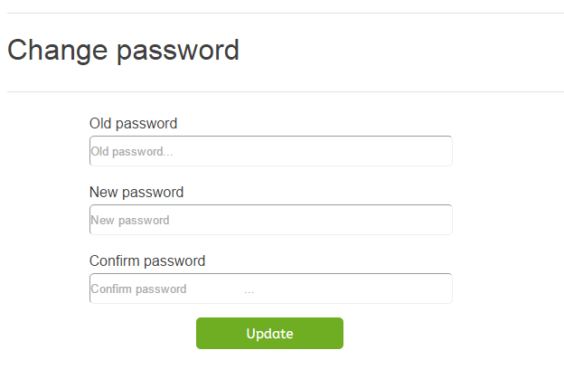

* + - * 1. **Ease of use**
* Minimum (no redundant), logical steps needed to process a task
* Consistent, simple layout (not too many components)
* Clear, readable, text font
* Understandable, informative, positive error message
* Guidance documentation
* Cross-browser support
* Informative icons, graphics.
  + - * 1. **TASK MATCH**

The course information maintaining and updating module will be 100% match to all functional requirements

### **7.3 Platform Requirements: Hardware including peripherals (screens, printers, etc) and estimated capacities (online offline storage, CPU speed, memory size).**

### **Hardware :**

* 15 inches screen
* At least 5 CPUs, keyboards, mouses, screens produced from 2010 or later
* At least 1 routers

Estimated capacities :

* 4GB or higher ram CPU
* At least 150GB of memory storage

### **7.4 Operating System and Database Requirements**

* Microsoft SQL server
* Microsoft window 7 or higher or linux

### **7.5 Communications Requirements: Networking, Internet**

* Lighting cable internet

### **7.6 Data Backup, Recovery**

* Backup recovery plan for disaster
* Backup and recovery plan for data lost
* Backup electricity power
* RAID 3 or higher

### **7.7 Security (Virus Protection, Firewall)**

* Common antivirus software is required (Avast, Avira, etc…)
* Window firewall

### **7.8 Data Conversion**

The Cybercation café is a newly established business. Therefore, only basic information (such as offered courses, company location, etc… ) will need to be import manually to the system

## 8. Contract Inclusions

//Nhung dieu khoan trong hop dong

### **8.1 Warranties**

The whole services’ warranties content:

* + - All services (HRMS, CMS, and CRM) will be safe-deployed on appointed hosting and domain. Hosting, domain contract will become effective as from this proposal is accepted from both sides.
    - Developing side must have responsible to fix any core problem (problem with functionality, code) within 72 hours after errors are detected and will available for 2 years.
    - Developing side with assures that product will run smoothly, stable and content all of the functionalities, options from the design.
    - System will have up-time more than 98% monthly.
    - Systems’ operation will be up-to-dated with latest related technologies for the first 6 months.
    - System is checked once a month for errors, spam mails and redundant codes.

### **8.2 Technical Support**

Technical support will be provided in various ways:

* Live chat service on developing main Website during office hours (8 am to 5h30pm for normal days, 8 am to 11h30 am for Saturday, not available in holidays).
* Phone call support during office hours (8 am to 5h30pm for normal days, 8 am to 11h30 am for Saturday, not available in holidays).
* Messages box, customer can send messages to technical support team when logging in their account which is provided by developing team anytime.
* All the technical problems will be separated to appropriated department with different priorities.
* Developing side have responsibility to arrange a technician to come to Cybercations’ café to solve the problems if critical failure is found (core problems). Developing team may not responsible for problems that come from Cybercations’ café staffs’ carelessness.

### **8.3 Preventative Maintenance**

System will content preventative maintenance solutions:

* Domain health checked monthly.
* Systems’ performance, speed test will be checked once a month.
* Malwares will be scanned weekly to prevent security problems.
* Soft data backup for whole systems daily and hard data backup monthly.
* Parallel server backup data can be provided (Optional).
* Update viruses’ definition files and anti-viruses soft wares every 2 months in first year.

### **8.4 Upgrades & Expansion**

Any requests for upgrading and expanse the system are also provided by developing team.

* For upgrading existed functionality will be charged 8$ per working hour of developing team. Before progress all need working hours and the price will be discussed and calculated for Cybercations’ café side.
* For expanding the systems which new functionalities are added, the price will be 10$ per working hour. Before progress all need working hours and the price will be discussed and calculated for Cybercations’ café side.
* If third party applications are needed, developing will calculate and give a detailed plan, cost to Cybercations’ café side.

### **8.5 Implementation**

Developing team will have responsibility to implement the whole service correctly without any errors.

* Before setup the service, Cybercations’ safe infrastructures must assures minimum requirements of the system that mentioned about in SRS report (5.Platform Requirements).
* Total implement time to deploy and execute the system is from 5/01/2016 to 26/08/2016. More detailed schedule is attached in Preliminary Schedule file.
* During the deployment, there may have unexpected cost, these costs will be discussed with Cybercations’ café and noted clearly.
* If the developing team is fail to complete the implementation due to deadline, the developing team have to pay penalty of 30% of total payment of the system cost for each deadline is made.
* If the implementation is not fit the Cybercations’ café requirements that are mentioned in SRS, the developing team must prepare another substitute one.
* If Cybercations’ café change the requirements without notice the developing team or change the function after developing team developed, this will be list as upgrading function and the cost are mentioned at section

### **8.6 Project Management**

* The system should be developed using Scrum methodology. If vendors want to use other methodology, they have to discuss with us in the proposal
* Vendor need to present a demo or a prototype every 2 weeks
* Meeting cannot be held without the present of Cybercation café’s owners, at least 1 IT consultant team’s member, scrum master/project manager
* Changes of cost, timeline, requirement have to be approved by Cybercation café’s owners and must be informed every relevant people.

### **8.7 Training**

* After selected, vendor must prepare and present a training plan for the CMS system, the plan must include face to face training section
* After the training, users of the system must be able to perform their tasks without any difficulty.
* Vendor must also provide Quick Reference Guides and training document

### **8.8 Performance & Service Standards**

This section will be discussed during proposal.

### **8.9 Acceptance Procedures**

After the CMS has been tested, vendor must deploy the system on Cybercation café’s hardware system. Cybercation café’s owners will import their data and perform a trail run for 3 days. If there is no other request, the implementation and deploy section will be completed, contract will be approval and money will be paid.

### **8.10 Payment Procedures**

Money will be paid through bank account. After the contract has been confirmed as completed, selected vendor and Cybercation café’s owners will exchange their bank accounts and money will be transfer with receipt.

### **8.11 Intellectual Property**

After money has been transferred, Cybercation café’s owners have the right to change, modify, delete and trade any part of the CMS. However, Cybercation café must keep the signature of vendor at the bottom of the website.

Any additional fee caused by using another copyright of another organization will be paid by selected vendor.

## 9. Supplier Responses

### 9.1 **Executive Summary**

Vendors must provide us a summary for the proposal they will present

### **9.2 Information about Supplier**

We would like to learn about your company's experience with web-based system. Please provide us with following information:

* What are the most popular services/products of your company?
* How long have your company been providing solution for web-based system?
* What is the size and cost of those systems?
* Who will in charge of this CMS solution?
* Some websites which we can visit
* Does your company have any certification from well-known organiazations such as Microsoft, IBM, etc... and what are those certification?
* How do we keep in touch with your company?

### **9.3 Present Clients**

We also want to know about clients which your company has been working with. Please provide us with following information:

* An overview of your clients
* Which products/services your company prodive them?
* What do they think about the products/services?

### **9.4 Compliance with Requirements**

For the requirements of the CMS, please provide us a matrix which show how much can you affort for each provided requirements.

### **9.5 Statement of Costs**

In this section, vendors will need to present the cost for each component they will provide us as well as cost for set up, running, maintainance and upgrate.

### **9.6 Implementation Plan**

In this section, vendor will need to use a Gantt chart to present steps and needed time to implement the CMS. Total time to implement the CMS should be within 2 months. In addition, vendors must present us development methodology and needed resources for implementation.

### **9.7 Training Plan**

In this section, vendors will have to provides training plan for Cybercation café to use the CMS

### **9.8 Staff Assigned to Project**

In this section, vendors need to provide us information of the following people:

* Project manager
* Developement team
* UX/UI design team
* People who we can contact for information and discussion
* Any other information if necessary

## 10. Software & Hardware Evaluation Process

**10.1 Evaluation of Software**

For the selection for suitable package, we use Requirements lead approach as there are many vendors can provide us a content managemetn system and functions within content management system need customizing for Cybercaion café’s services.

The evaluation process of software will be conducted as a two main stage process, including: initial review, evaluation scoring, and cost scoring. The details of each stage is described as flollows.

For detail criterias, please see SoftwareEvaluation_CMS_Group_3.xlsx file

**Stage 1: Initial Review**

In this stage, our evaluation team will review the responsiveness of any proposal we received. Proposals which does not meet our minimun requirements of the RFP will be considered non-responsive and will be rejected.

**Stage 2: Evaluation Scoring**

In the stage 2, there are two steps:

Step 1: Scoring

Accepted proposals will be scored by the evalution team based on the evaluation criteria in the software evaluation matrix as provided along with the RFP. If there are confusing or unclear items in proposals, the evaluation team may send letters of questions for clarification.

Step 2: Interview

We require all the vendors of accepted proposals to join an interview and give a presentaion. During the interview, we will discuss about remained ambiguities in proposals and ensure a better understanding between the evaluation team and offerers.

In order to pass our second stage, vendors must achieve at least 70% of the total technical score of our evaluation criteria. Vendors with a score lower than this mininum score will be eliminated from our consideration.

For detail criterias, please see SoftwareEvaluation_CMS_Group_3.xlsx file

**10.2 Evaluation of Hardware/Operating System/Network.**

Our company will offer a hardware platform we already have. All the proposal packages will be implemented on this platform in order to evaluate their performance and compatibility with the system we provided.

## 11. Vendor Evaluation

### **11.1 Background**

Please provide the information as followed:

* The present owners of the vendor
* The qualification of the vendor
* The vendor’s specialty and brief information about the company’s background
* The directions of the vendor
* Introduction of your company portfolio and remarkable projects

### **11.2 Staff Involved**

Please provide the information as followed:

* The members and their information that will participate in the project
* The person who will act as a main contact to the business.
* The responsibility of each department involved in the project
* The agreement of working in the project

### **11.3 Contract**

Please provide the information as followed:

* Vendor agreement in the contract inclusions section
* Vendor responses to the RFP
* Vendor policies in building the system
* Vendor policies in working with the business

### **11.4 Costs**

### Please inform documentation of cost details and your budget that you are used to build the system.

### **11.5 Honesty**

Please provide the proof and information of the company including certificates and license.

Please provide your company rating and ranking.

### **11.6 Services**

Please provide the information as followed:

* Please inform the the after-support and monitoring service availability.
* Please inform the general summary of your services
* Please attach documentation of activities of serving the business

## 12. Concluding Statement

The Cybercation café is a unique business that ambitious to reach across Vietnam cities. With many services such as online E-learning, testing, and internet café, the business is willing to look for a proper vendor that suitable to build up the system that it requires to officially launch the business and satisfied the needs of the business. The opportunity to work with the Cybercation Café is a chance for the vendor to work with an experience team that any vendor could ever have.