

International School

Group Project
CMU-IS 432
Project Proposal
Version 1.0
Date: September 14, 2024

SELF RESTAURANT MANAGEMENT SYSTEM

Created by
Hoang, Le Minh 28211106252
Nguyen, Le Trung 28211136693
Nhan, Phan Thien 28211102808
Quan, Ha Minh 27211242285
Tin, Nguyen Tan 28219044809
Tram, Le Thi Thanh 28201153339

Approval of Mentor:

Name_____________________________Signature____________Date

PROJECT INFORMATION

Project acronym
Project Title
Start Date |  | End Date
Lead Institution | International School, Duy Tan University
Project Mentor | Hoang, Nguyen Thai
Scrum master  / Project Leader & contact details | Nhan, Phan Thien  Email: phanthiennhan230104@gmail.com  Tel: 0944068045  ID: 28211102808
Partner Organization
Project Web URL
Team members | Name | Email | Tel
28211106252 | Hoang, Le Minh | leeminhhoang2409@gmail.com | 0334292826
28211136693 | Nguyen, Le Trung | letrungnguyen1004@gmail.com | 0867656419
27211242285 | Quan, Ha Minh | haminhquan.work@gmail.com | 0337963424
28219044809 | Tin, Nguyen Tan | nguyentin.22042004@gmail.com | 0398931209
28201153339 | Tram, Le Thi Thanh | thtram1282004@gmail.com | 0788521308
REVISION HISTORY

Version | Date | Comments | Author | Approval
1.0 | 11/09/2024 | Initial Document | Phan Thien Nhan

TABLE OF CONTENTS
1. Project Title 5
2. Project Overview 5
3. Project Background and Motivation 5
4. Proposed Solution 6
5. Related Works or Projects on the Market 7
6. Objectives and Deliverables 8
7. Methodology and Tools 9
8. Timeline 9
9. Project Team 10
10. Risk Management 10
11. Budget and Resources 11
12. Project constraints 12
13. Conclusion 13
14. References 13

Project Title
ABC: Ingredient-Based Recipe Finder with Nutritional Insights.

Project Overview
ABC is a application designed to streamline business processes for self-service restaurants. Customers can easily place orders through mobile devices or computers at their tables, adding special notes for specific requests. The system efficiently manages the menu and automatically updates it, aiding staff in monitoring and managing table statuses. With flexible payment integration, comprehensive sales reporting, and automated inventory management, the software provides a customer database, reviews, and feedback to enhance the overall dining experience and service quality.

Project Background and Motivation

Problem about delays and errors, affecting customer satisfaction and revenue. Delays and confusion in food preparation. Manual transactions lead to errors, affecting revenue and customer satisfaction. Not having an online website limits your online visibility and ability to attract potential customers

Proposed Solution
The proposed solution is ABC, a mobile application designed to reduce delays, errors and improve customer experience, improve food preparation, reduce confusion and improve efficiency. Beside that, this application will support accurate payment processing, improve customer satisfaction.
Core Features and Functionalities:
- Choose and Check Status of Table:
  - When guest click on this function, the app will show list of table and their current status
- Order foods and Check Status of food:
  - When guest click on order function, the app will show the menu for them to order. When they click on check food status function, the app will show the status of food.
- See Invoice:
  - When guest click on this function, the app will show the invoice the customer has ordered with their accumulated points.
- Manage Food and Notificate Status of Food :
  - The application allows chefs to add, delete, view food lists and notify the status of food
- Manage Table Map, Payments and Report Revenue:
  - The application helps cashiers manage table maps, assist in payments and report daily revenue
- Manage Account:
  - Admin can see account lists, add, delete, modify account in this application
- Display detailed information of each branch:
  - Web Browser can search and see detailed information of each brand on the online website
Technologies and Approach:
- Frontend: The app will be built using React Native to ensure it is cross-platform (iOS and Android), offering a seamless, intuitive user interface and intuitive user interface directly interactive user interface.
- Backend: Spring Boot will handle the server-side logic, while MySQL will store user data, recipe information, and nutritional content.
- Nutritional Database: The application will integrate with APIs such as Food Database API, Nutrition Analysis API or Recipe Search API to get accurate nutritional information for ingredients and recipes..
- Algorithm for Recipe Matching: The ingredient matching algorithm recommends dishes based on user input, using basic matching techniques or machine learning for more advanced personalization.
- Personalization Engine: A user profile system will be built to retrieve customer information. This will allow the app to recommend dishes based on preferences and ordering history.
System Context Diagram:
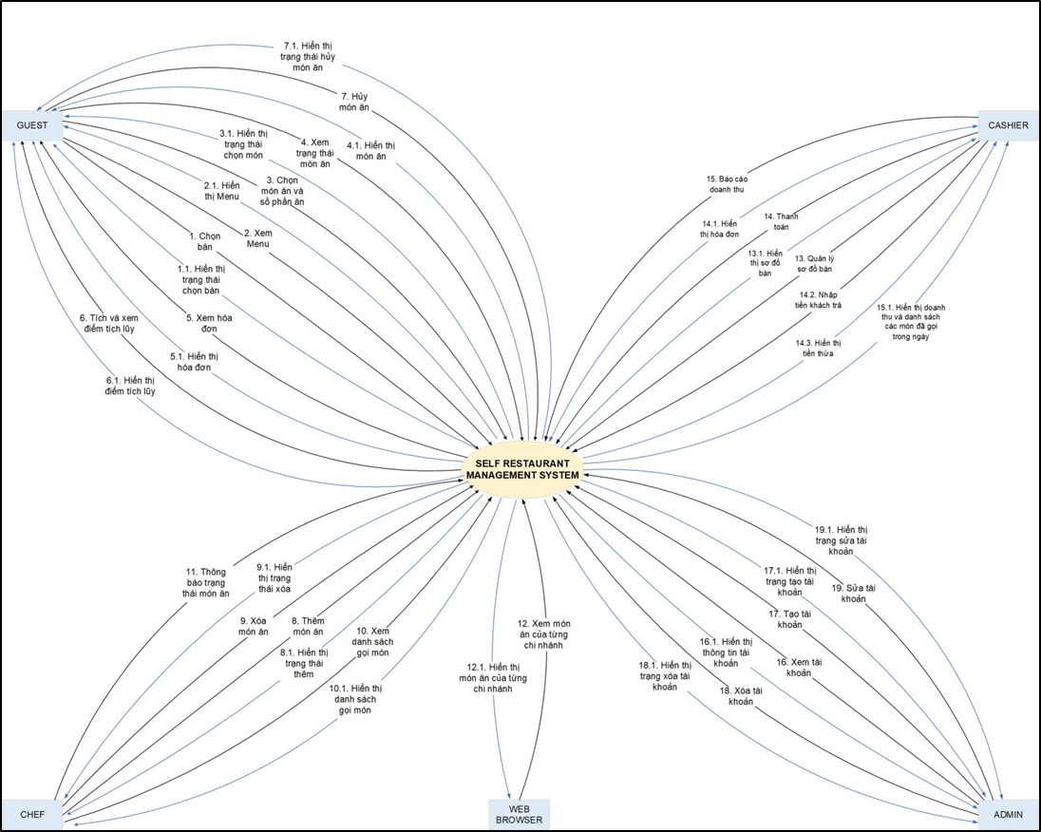

Related Works or Projects on the Market
- Many restaurants today have applied advanced technologies to enhance customer experience and optimize operational processes. However, most of these solutions only focus on managing reservations or payments and do not focus on personalizing the customer's dining experience. ABC Restaurant will provide personalized dish recommendations based on customers' preferences and ordering history, provide detailed nutritional information, and help customers maintain a healthy diet - all in one system, making it a more comprehensive solution for food lovers and health-conscious people.
- Table for a comparison of these products.
Characteristics | MyFitness  Pal | Yummly | PlateJoy | Mealime | ABC
Recommend dishes based on user suggestions |  |  |  |  | +
Self-service technology | + |  | + | + | +
Raw material analysis | + |  | + |  | +
Menu diversity | + |  |  |  | +
Track user entry and exit time | + |  |  |  | +
Preferential and remuneration policies | + | + | + | + | +
User Profile Personalization | + | + | + |  | +
Cross-Platform Availability | + | + | + | + | +
Instructions for using the items |  | + | + | + | +

Objectives and Deliverables
Objectives:
- Objective 1: Develop a fully functional mobile application that allows customers to enter and order food directly on the application.
- Objective 2: Implement the dish analysis feature to calculate ingredient quantities and analyze prices for each recipe.
- Objective 3: Create a user profile system that personalizes meal recommendations based on customer preference data and ordering history.
- Objective 4: Implement a meal tracking feature to track meal time and needs when guests need it.
- Objective 5: Ensure cross-platform functionality for iOS and Android devices.
Deliverables:
- Deliverable 1: The mobile application offers dishes from the restaurant's list.
- Deliverable 2: The backend system stores user profiles, dish data and personalizes dish recommendations for customers.
- Deliverable 3: Features to track food consumption time and customer needs.
- Deliverable 4: Full cross-platform availability on both iOS and Android, with a user-friendly interface for seamless navigation.

Methodology and Tools
Project Management Approach
- Agile Methodology: We will adopt an agile development methodology, using sprints to deliver features iteratively and gather feedback continuously. This ensures flexibility and responsiveness to changing needs, while promoting transparency and collaboration.
Development Methodology
- Scrum Framework: We will implement the Scrum framework within the agile approach, with defined roles (Product Owner, Scrum Master, Development Team) and events (Sprint Planning, Daily Scrum, Sprint Review, Retrospective). This provides a structured and efficient workflow.
Technical Stack
- Programming language: Javascript, HTML, CSS, Java.
- Framework: React, React-Native, Spring Boot, Bootstrap.
- Database: MySQL
- Database Management System: MySQL Workbench.
- Develop tools: Visual Studio Code, Intellij.
- Version Control System: Github.
- Project Management: JiraBoard.

Timeline
No | Task Name | Duration  (days) | Start Date | End Date
1 | Initial | 9 | 03/09/2024 | 11/09/2024
2 | Development | 89 | 12/09/2024 | 09/12/2024
3 | Close | 6 | 10/12/2024 | 15/12/2024
 | Duration | 104 | 03/09/2024 | 15/12/2024
Table 1: Project Timeline

Project Team
Full Name | Phone | Email | Position
Nhan, Phan Thien | 0944068045 | phanthiennhan230104@gmail.com | Scrum Master
Hoang, Le Minh | 0334292826 | leeminhhoang2409@gmail.com | Developer
Nguyen, Le Trung | 0867656419 | letrungnguyen1004@gmail.com | Developer
Quan, Ha Minh | 0377048335 | haminhquan.work@gmail.com | Developer
Tin, Nguyen Tan | 0398931209 | nguyentin.22042004@gmail.com | Developer
Tram, Le Thi Thanh | 0788521308 | thtram1282004@gmail.com | Developer

Risk Management
- Risk 1: Difficulty in integrating with third-party APIs for nutritional data (e.g., Edamam, Nutritionix) may delay development.
  - Mitigation: Start researching and testing third-party APIs early in the project timeline. Prepare backup API options and allocate buffer time for integration and testing.
- Risk 2: Designing a personalized algorithm to recommend dishes can be complicated and take longer than expected.
  - Mitigation: Break the algorithm development into smaller, manageable tasks. Develop a basic version first and then enhance it gradually. Schedule extra time for testing and refining.
- Risk 3: Time constraints may affect the thorough testing of the app on multiple platforms (iOS and Android).
  - Mitigation: Conduct parallel testing during the development process, leveraging automated testing tools for cross-platform compatibility. Allocate additional time for beta testing.
- Risk 4: Budget limits may limit access to certain APIs or tools required for the dish's database.
  - Mitigation: Prioritize essential features and identify free or lower-cost alternatives. Consider using open-source resources where possible and keep the scope realistic.
- Risk 5: Unexpected changes in user requirements or feedback might require modifications to the app, extending development time.
  - Mitigation: Set up clear communication channels with stakeholders and define the project scope early. Schedule frequent check-ins to gather feedback and adjust the plan if necessary.

Budget and Resources
NO | Criteria | Prices  (USD) | Amountours(Hours) | Tota(USD)
1 | Working hour | $2/hour | 3328 | $4992
Total cost |  |  |  | $4992
Table 2: Total Cost Estimation
Description | Amount | Unit
Number of members | 4 | Person
Number of working hours per day | 6 | Hour
The cost of working per hour per person | 2 | USD
The duration of the project | 3 | Month
The number of working day | 104 | Day
Table 3: Description Cost
Explain:
- Amount of working hours = 4 members * 6 hours/day * 104 days = 2496 hours
- Cost of working hour: 2496 hours * $2/hours = $4992

Project constraints
Constraint | Constraints Description | Guidelines for Acceptance
Economic | The total cost of the project cannot exceed $4992. | Elements for consideration are design costs, production costs, maintenance costs, operating costs, and sales price
Environmental | The final product should ensure consistent performance across iOS and Android devices while minimizing battery usage through optimized app processes. | The impact of the design on the environment as well as the impact of the environment (e.g. temperature range, humidity, vibration, electromagnetic interference immunity, and shock) on the design should be considered. Design for recycling and design to use recycled materials should also be considered
Ethical | N/A | Ethical considerations can be broad. Areas that are typically addressed include intellectual property, reverse-engineering, privacy, security, and the conflict between cost and safety
Public health, safety, and welfare | N/A | Includes safety standards as well as the impact of the design on users (for example, electrical or physical hazards)
Social and Global | The product will reduce the time and efforts of tasks related to class management, attendance, and multiple-choice exam grading. | Addresses aspects such as benefits, risks, the man-machine interface, the acceptance of products by the intended user or by society at large, and global and socially responsible engineering.
Cultural | N/A | Which cultural characteristics could influence the approach?  How do the design from different cultures differ?
Sustainability | The product will need to be maintained and upgraded in the future. This includes providing software updates, bug fixes, and feature improvements. | Refers to the sustainability of resources, including material, energy, supplies, manufacturing techniques, personnel, operation, and the need for additional infrastructure, as well as the sustainability of the design including reliability, lifetime, durability, reusability, maintainability.

Conclusion
ABC, with its flexible and convenient business model, is becoming increasingly popular and popular. By allowing customers to choose their own food and pay, it not only minimizes waiting time but also provides a quick and economical dining experience. ABC not only meets customers' dietary needs effectively but also contributes to reducing food waste and promoting healthy lifestyles. This project contributes to the field of software engineering by developing real-time data processing features and user-centered design. With the combination of open spaces and simple menus, ABC showcases creativity in the culinary industry, while contributing to sustainability goals and improving the quality of everyday life.

References
[1] Software Development Standards for the Guidance and Control Software Project https://sw-eng.larc.nasa.gov/
[2] General Software Coding Standards and Guidelines https://www.nws.noaa.gov/oh/hrl/developers_docs/General_Software_Standards.pdf
[3] Scrum and best practices:
https://docs.microsoft.com/en-us/azure/devops/boards/sprints/best-practices-scrum?view=azure-devops
[4] The Scrum Guide: https://www.scrum.org/resources/scrum-guide
[5] The ISO/IEC & IEEE/EIA Standard 12207, IEEE standards: IEEE-829 [3], IEEE-1008 [5], IEEE-1012
[6] Draw tool: Visio
[7] IEEE: https://www.ieee.org/

