NETFLIXSCOPE

Exploratory Data Analysis of Netflix Movies & TV Shows

Advance Programming Lab-I (Python)
Subject Code: CSE(AI/CPS/CS/DS)-3006

Project by:
Name | Scholar No.
Anupam Bichpuria | 25U022014
Ishu Nayak | 25U022004

Abstract
This report presents a comprehensive Exploratory Data Analysis (EDA) of the Netflix Movies and TV Shows dataset, which contains 8807 records across 12 attributes. The analysis covers data cleaning, univariate and multivariate explorations of content types, genres, countries of production, temporal trends, durations, ratings, and outlier detection. Key findings include the dominance of movies over TV shows, the prevalence of International Movies and Dramas as top genres, the United States and India as leading content producers, and a library that predominantly targets mature audiences (TV-MA rating). The analysis is implemented in Python using Pandas, NumPy, Matplotlib, and Seaborn.

1. Introduction
Netflix is one of the largest media and video streaming platforms in the world. Understanding the composition of its content library is valuable for content strategy, market analysis, and recommendation systems. This project performs an in-depth EDA on the Netflix titles dataset to uncover patterns and insights.

Objectives
1. Understand the structure and quality of the Netflix dataset.
2. Clean and preprocess the data for reliable analysis.
3. Perform univariate, bivariate, and multivariate analyses.
4. Visualize key patterns using appropriate charts.
5. Summarize findings, limitations, and conclusions.

2. Dataset Description
The dataset netflix_titles.csv contains 8807 records and 12 columns. Each row represents a single title (Movie or TV Show) available on Netflix. The columns include: show_id, type, title, director, cast, country, date_added, release_year, rating, duration, listed_in (genres), and description.

3. Tools and Methodology
The analysis was conducted in a Jupyter Notebook using the following Python libraries:
• Pandas (data manipulation and analysis)
• NumPy (numerical computing)
• Matplotlib (static visualizations)
• Seaborn (statistical visualizations)
The methodology followed a standard EDA pipeline: data loading, inspection, cleaning, transformation, univariate analysis, bivariate analysis, multivariate analysis, outlier detection, and synthesis of findings.

4. Data Cleaning and Preprocessing
Missing values were identified in the following columns:
Column | Missing Count | Percentage
director | 2634 | 29.9%
cast | 825 | 9.4%
country | 831 | 9.4%
date_added | 10 | 0.1%
rating | 4 | 0.0%
duration | 3 | 0.0%

Handling strategy:
• director, cast, country: Filled with "Unknown" (no reliable imputation method).
• rating, duration: Filled with mode values.
• date_added: Rows with missing date_added were dropped (very few).
• After cleaning: 8797 rows retained with zero missing values.
• Duplicate detection: Checked for duplicate (title, type) pairs and removed any found.
The date_added column was parsed into datetime format, and year_added, month_added components were extracted. The duration column was split into numeric values for analysis (minutes for Movies, seasons for TV Shows).

5. EDA Visualizations and Explanations

Figure 1: Content Type Distribution
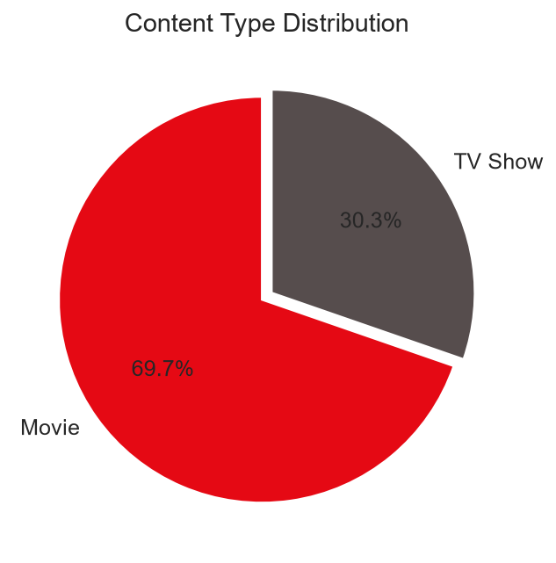
Movies account for 69.7% of the library (6131 titles), while TV Shows make up 30.3% (2666 titles). Netflix clearly prioritizes movie content.

Figure 2: Top 15 Genres on Netflix
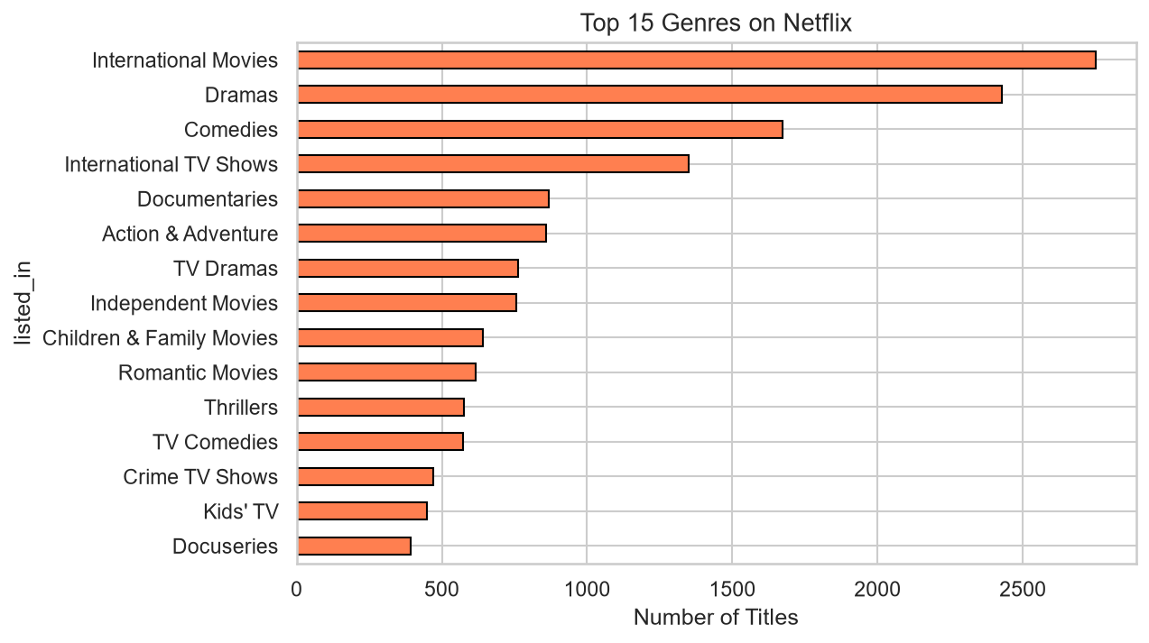
The most common genre is "International Movies" with 2752 titles, followed by "Dramas" (2427). The dominance of "International" genres reflects Netflix's global expansion strategy.

Figure 3: Top 15 Content-Producing Countries
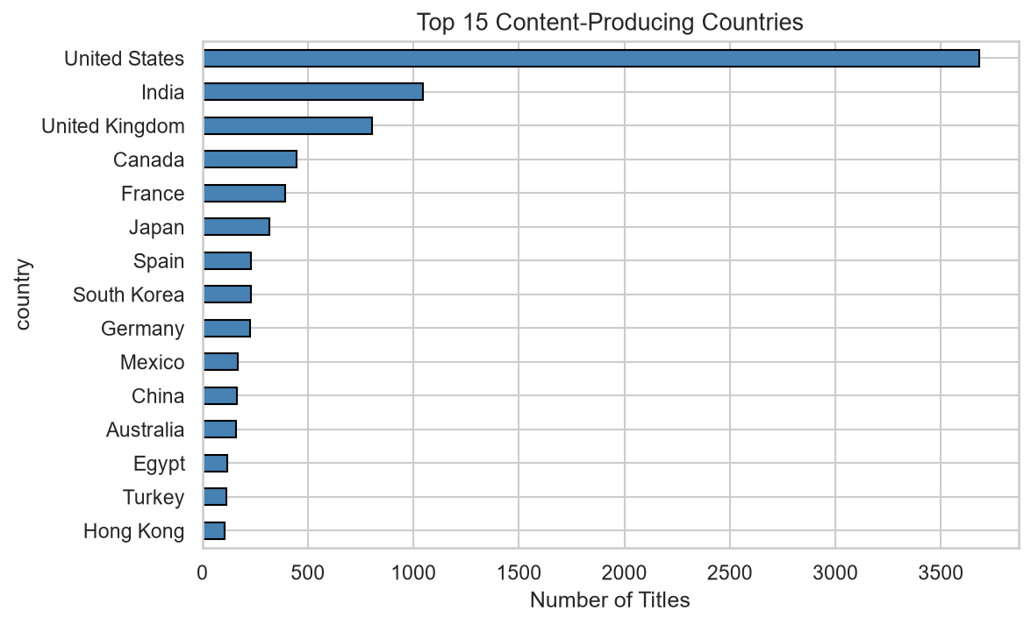
The United States leads with 3683 titles, followed by India (1046). These two countries together contribute a significant portion of all Netflix content.

Figure 4: Titles Added to Netflix by Year
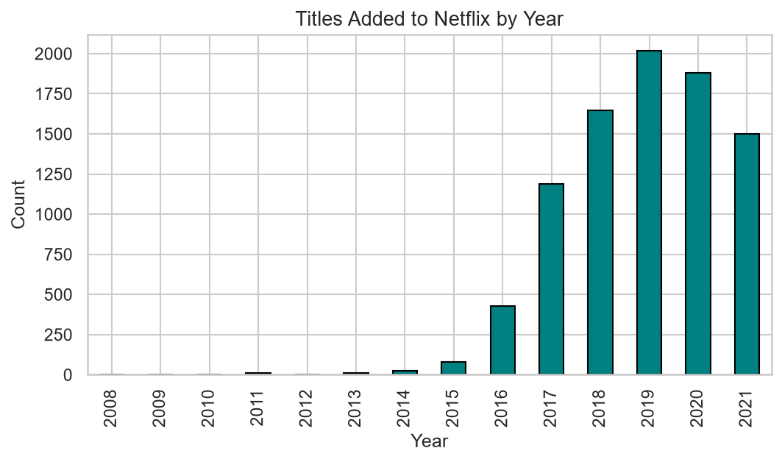
Netflix's content library grew rapidly from 2015 to 2019. The year with the most additions reflects the platform's aggressive content acquisition period. A slight dip around 2020 may correlate with pandemic-era production slowdowns.

Figure 5: Movie Duration Distribution
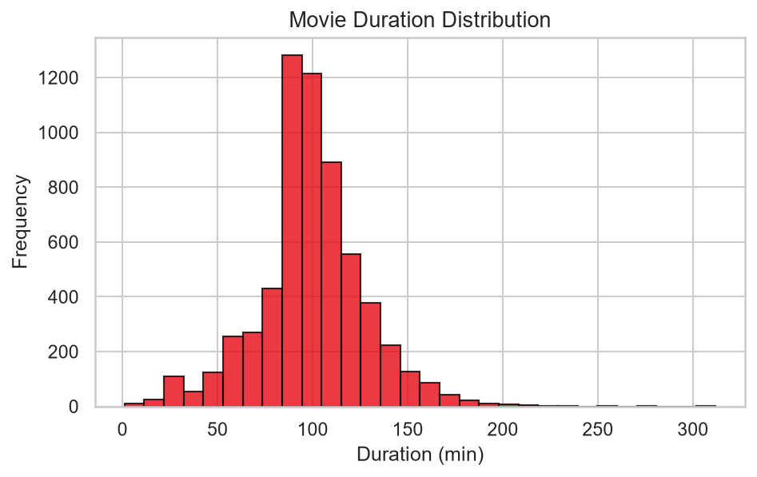
The median movie duration is 98 minutes. Most movies fall in the 80-120 minute range, which is typical for feature films.

Figure 6: TV Show Number of Seasons
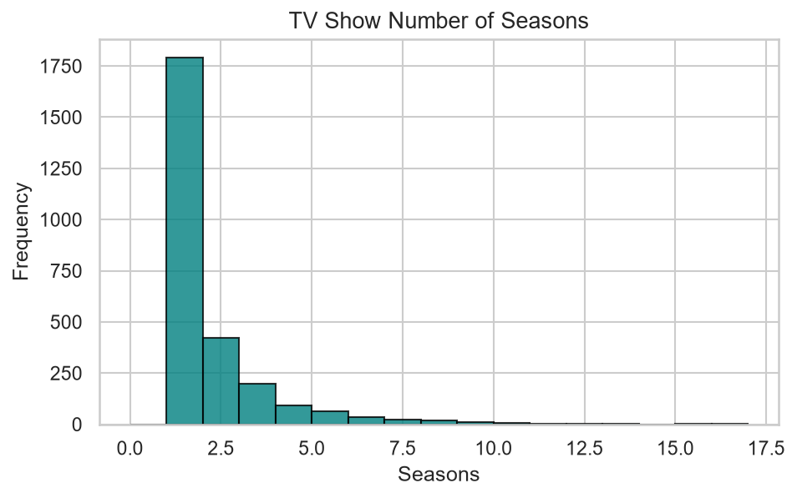
The median number of seasons for TV shows is 1. The vast majority of TV shows on Netflix have only 1 season, indicating a large number of limited series or single-season acquisitions.

Figure 7: Content Rating Distribution
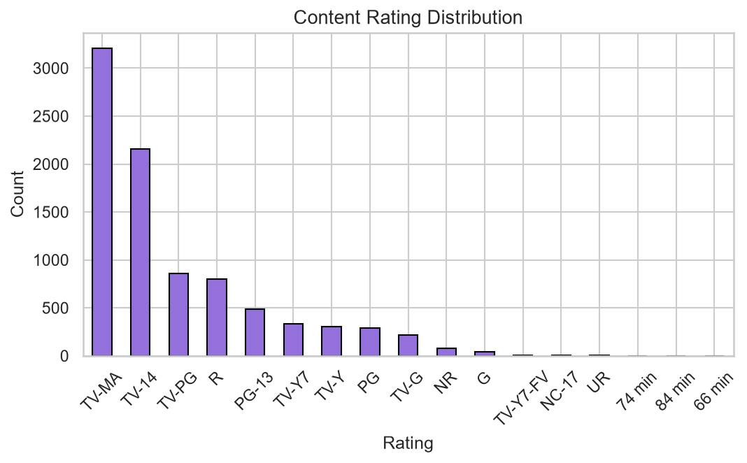
TV-MA is the most common rating with 3209 titles, indicating that Netflix's catalogue skews toward adult-oriented content. TV-14 follows with 2157 titles.

Figure 8: Correlation Heatmap of Numerical Features
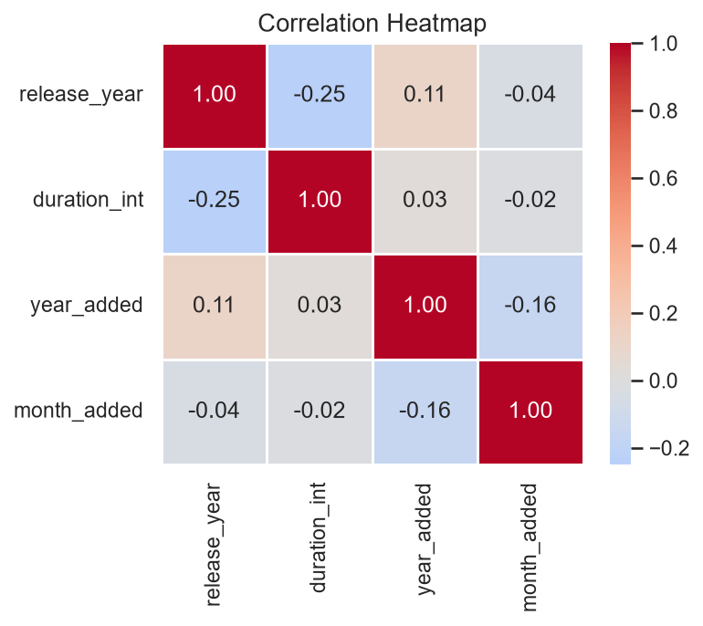
The correlation heatmap shows relationships between numerical variables. release_year and year_added have a moderate positive correlation, which is expected — newer titles tend to be added sooner. Duration and release_year show a weak relationship.

Figure 9: Outlier Detection — Box Plots
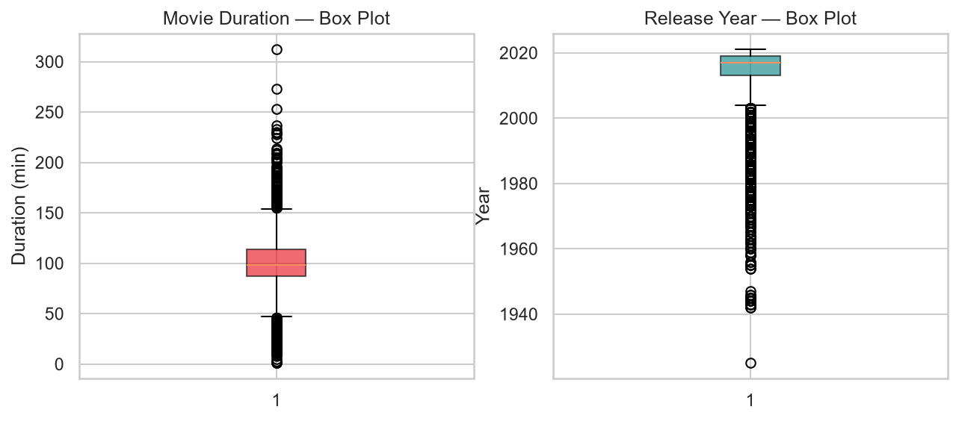
Using the IQR method on movie durations: Q1=87, Q3=114, IQR=27. Outlier bounds: [46, 154] minutes. 453 movies were identified as duration outliers. The release year box plot shows the central tendency toward recent years with older titles as outliers.

6. Results and Findings
1. Content Split: Movies (6131) significantly outnumber TV Shows (2666) — roughly a 70-30 split.
2. Top Genre: "International Movies" is the dominant genre with 2752 titles.
3. Leading Countries: United States (3683 titles) and India (1046 titles) are the top producers.
4. Duration: Median movie length is 98 minutes; median TV show has 1 season(s).
5. Ratings: TV-MA (3209 titles) is the most common rating, reflecting an adult-focused catalogue.
6. Growth: Netflix added content most aggressively between 2016-2019.
7. Outliers: 453 movies had durations outside the IQR bounds.

7. Limitations
• The dataset is a snapshot up to approximately mid-2021 and may not reflect current content.
• Director and cast fields have significant missing data, limiting personnel-based analysis.
• Genre labels are Netflix-assigned and may differ from industry-standard categorizations.
• Multi-country titles are counted once per country after splitting, slightly inflating per-country counts.
• No user engagement data (views, ratings by users) is available for deeper analysis.

8. Conclusion
This EDA reveals that Netflix has built a content library that is predominantly movie-based and adult-oriented, with a strong global footprint, particularly in the United States and India. The platform expanded its library aggressively between 2016 and 2019. International content features prominently, reflecting Netflix's strategy to serve a global audience. Most TV shows are limited to a single season, while movies cluster around the standard 90-100 minute runtime. The analysis also highlights data-quality challenges such as missing metadata in director and cast fields. Future work could incorporate user-engagement metrics and more recent data to deepen the insights.

9. References
1. Netflix Movies and TV Shows Dataset — Kaggle (https://www.kaggle.com/datasets/shivamb/netflix-shows)
2. Pandas Documentation — https://pandas.pydata.org/docs/
3. Matplotlib Documentation — https://matplotlib.org/stable/
4. Seaborn Documentation — https://seaborn.pydata.org/
5. McKinney, W. (2017). Python for Data Analysis, 2nd Edition. O'Reilly Media.

