Code illustration

Part B:

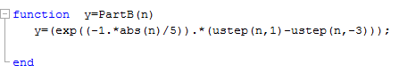

Here I have implemented the required function y[n]

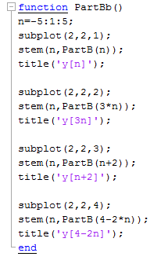

Here I have used stem to plot the discrete functions y1[n] & y2[n] &y3[n] & y[n]

Then I used subplot as required in part B-c to view them in the same figure

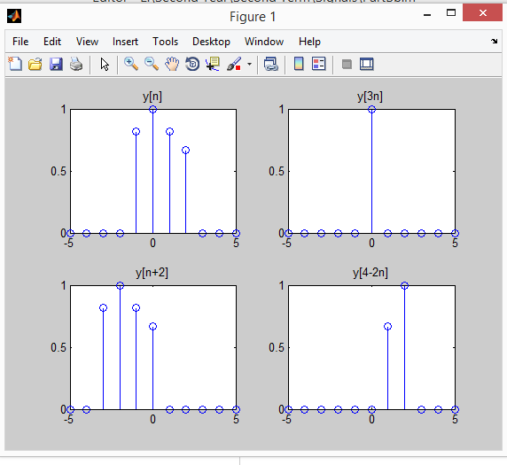

Part C:

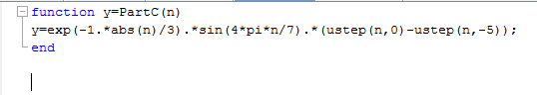

Here I have implemented the required function Z[n]

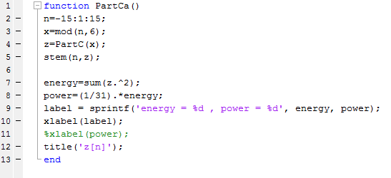

In the first part I used stem to plot the figure then I have calculated energy and power

Part C

B)

Energy=lim (sum(-15 to 15))(z[n])^2

=5\*(z[0]^2+z[1]^2+z[2]^2+z[3]^2+z[4]^2+z[5]^2)

=(0+0.6986^2+(-0.2228)^2+(-0.2876)^2+ 0.2061^2+0)\*5

=3.396806

Power=1/(2n+1) \*energy

=1/31 \*3.396806

=0.10957

