**Review of Programme Chameleon.**  
  
<http://programmechameleon.com/new/>

Thanks for adding - ;looks good but:

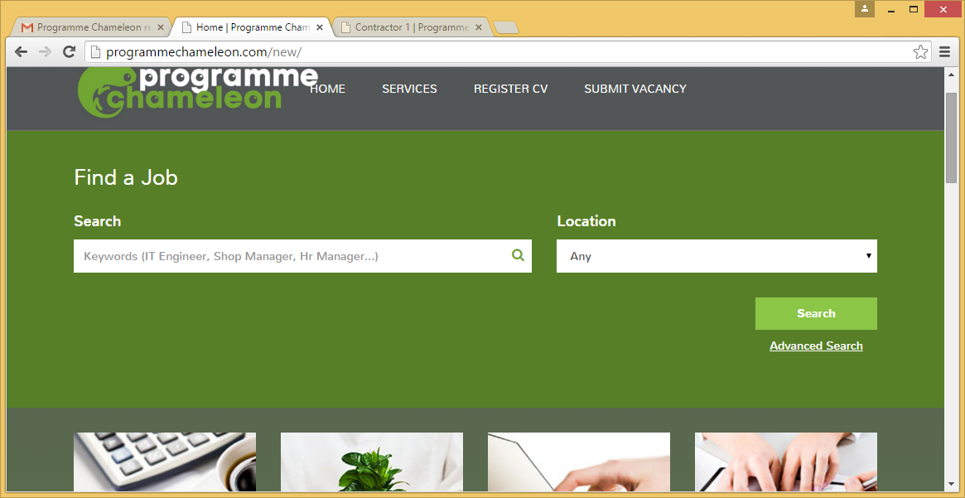

Find a job box needs to be much smaller, takes up most of the initial page. Can it possibly be resized to one or two lines max? instead of search – could just be search for Vacancies. And remove find a job.

Spacing of menu – Home overlaps with logo, please change so it doesn’t.

Please centre the smaller impages in the boxes. They are aligned left.

Instead of button in boxes saying access it, can the text just say click here and be a hyperlink.

In Menu, can we add Resources please

<http://programmechameleon.com/new/company/company-sample>

Fine – just spacing in expertise when on Mobile

See below, can the colours (green) be a little different, they are not visible enough. Possibly with a white border.

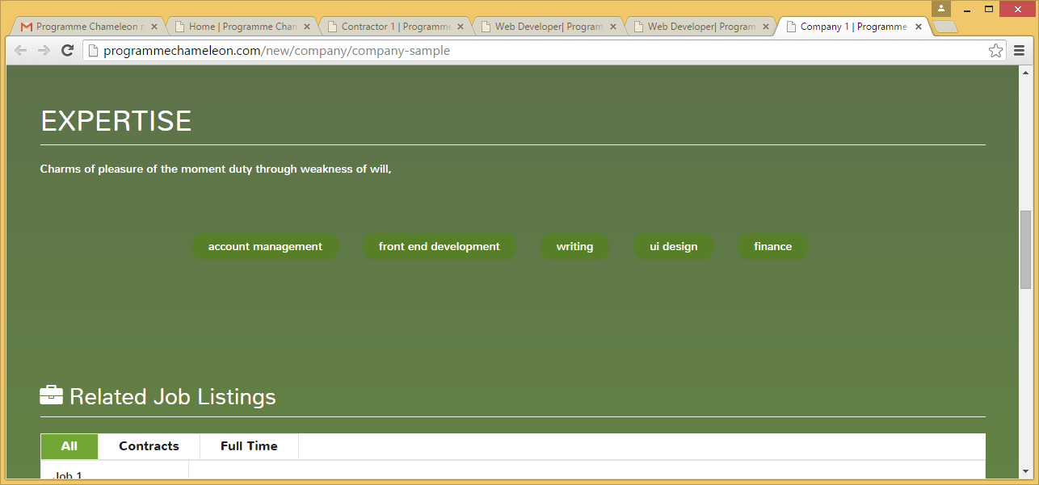

<http://programmechameleon.com/new/free-resources>

Can document icons be a bit smaller also, I think we need to have same theme running thorugh the whole site on all pages as close as possible, so the blend form grey into green as a background and light green or white in others – hope this makes sense.

This is how I would like it to look theme wise :

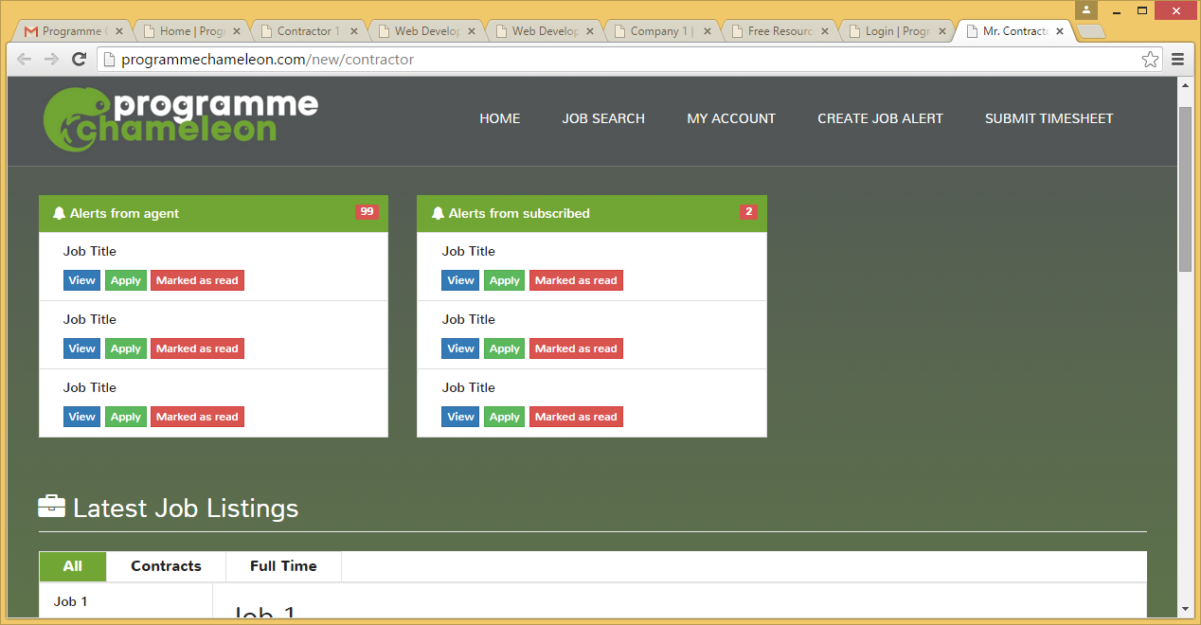

<http://programmechameleon.com/new/login>

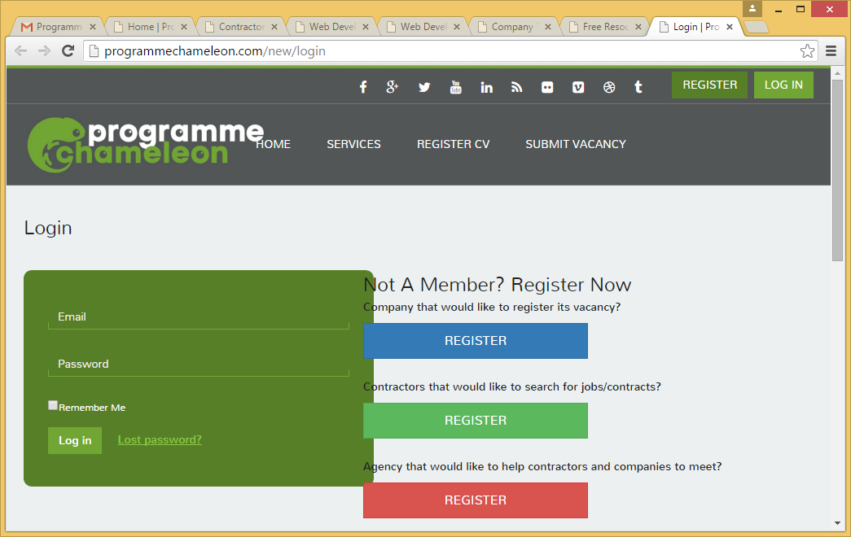

Spacing, overlapping with box. Please fix. Buttons can be a little less wide.

<http://programmechameleon.com/new/contractor>

On contractor page - the alerts etc look good. Can we have an email to the contractor whenever an alert is posted on the site saying they have one - so they revisit site?

I think that you can remove the text saying would you like to apply for a job?

 could we have the submit time sheet in the menu option and change the menu to contractors - with drop down of submit time sheet, register cv, Job Search

So a landing page identifying it as contractor’s page - with menu items relating to contractor. Could be static links under main menu just above the alerts from agent bar saying register/ update cv | submit time sheet | Record expenses

<http://programmechameleon.com/new/contractor/register>

no changes needed except to apply theme as per previous comments.

<http://programmechameleon.com/new/contractor/account>

Looks good.

<http://programmechameleon.com/new/contractor/create-job-alert>

In keywords - just say : Eg Project Manager, London (like it is in the job search keywords )

<http://programmechameleon.com/new/contractor/search-job>

Looks good - location should be uk based list to choose from. You Should be able to get it quite easily. All reference to resume should be changed to CV or Curriculum Vitae.

<http://programmechameleon.com/new/contractor/submit-timesheet>

Looks good, only comment is if they select days or months, the hours of working need to be changed to reflect. And if they select hours, they will need start and finish times in and to enter times for lunch.   
  
<http://programmechameleon.com/new/company>

Looks good  - just apply theme as per previous comment

<http://programmechameleon.com/new/company/register>

Instead of owner have company position

And contact name. Also - with password, are you going to validate it?

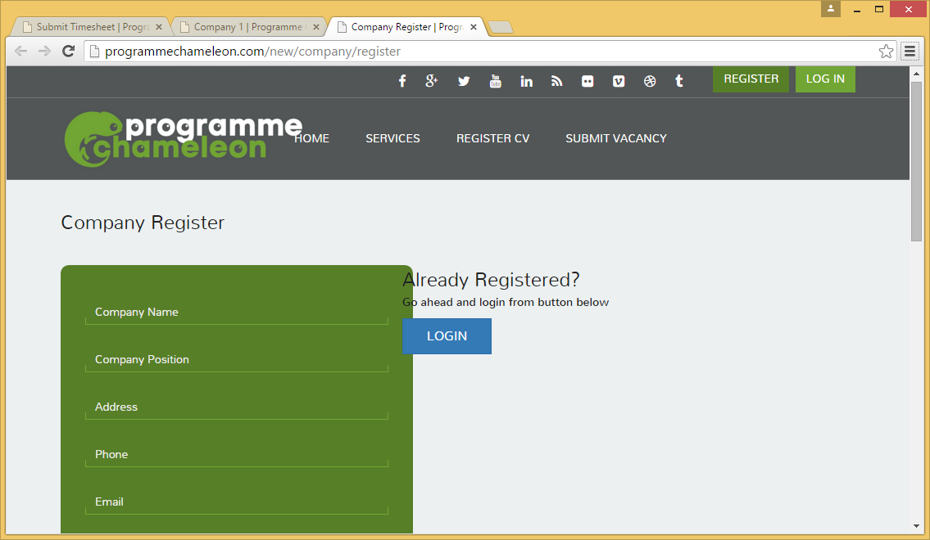

Spacing – please fix

<http://programmechameleon.com/new/company/job-post>

Looks good - should we make all jobs only valid for max 2 weeks, so if they need longer they use more credits.

<http://programmechameleon.com/new/company/resume-search>  
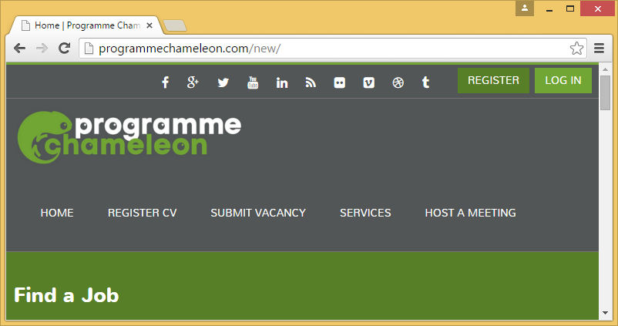

Font for find a job should be same as menu font, and all across the site.

<http://programmechameleon.com/new/agency>

Should have see timesheet button in all contractors, of a page listing weeks and simple list of contractors linking back to their profile, with a view timesheet for that week next to their name. for example:

|  |  |  |  |  |
| --- | --- | --- | --- | --- |
| Contractor | Week | Submitted timesheet | Company Authorised | Agent Authorised |
| Contractor 1 | 16-11-15 – 20-11-15 | Display Yes/ No | Display yes/no | Display yes/no |

Recent Notifs – should be just Notifications. Font can be a little smaller. Could be similar to what is shown in CP but for agents.

<http://programmechameleon.com/new/agency/register>

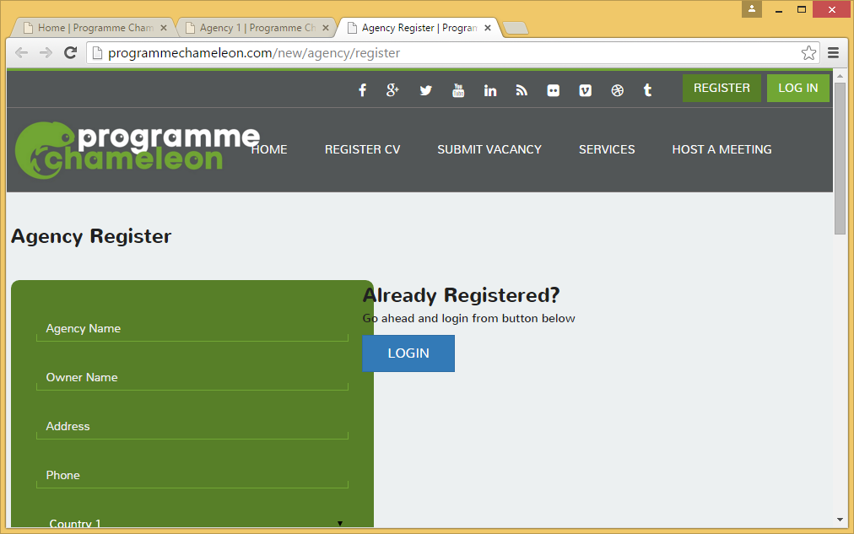

Alignment – overlapping the logo and registration box. Please resolve. Font needs to be the same as menu – apply throughout site.

<http://programmechameleon.com/new/agency/notif-list>

No Further changes

<http://programmechameleon.com/new/agency/offer-job>

looks good.

<http://programmechameleon.com/new/admin>

Looks good, will have to review more when beta testing.

<http://programmechameleon.com/new/admin/login>

Looks fine – can change PC to Programme Chameleon Logo?

<http://programmechameleon.com/new/admin/cms>

Looks fine.

<http://programmechameleon.com/new/admin/job>

Looks good, something like this would be useful for the agency or company

<http://programmechameleon.com/new/admin/contractor>

good

<http://programmechameleon.com/new/admin/company>

Good

<http://programmechameleon.com/new/admin/agency>

Good

<http://programmechameleon.com/new/admin/timesheet>

Good

<http://programmechameleon.com/new/admin/price-list>

Good

<http://programmechameleon.com/new/admin/resources>

InsteaGood.