
ASSIGMENT2
CLOUD SERVER PROJECT

Ip Adress : 113.50.212.235
DNS: http://cybershieldme.info/

Uthara Manojkumar
35354777

Table of contents

Setting up web server………………………………3
Setting up wordsress………………………………..5
Changing the sub path……………………………..8
Linking with a DNS entry…………………………9
S SL/TLS Documentation………………………….11
Reference……………………………………………….15

Setting up web server

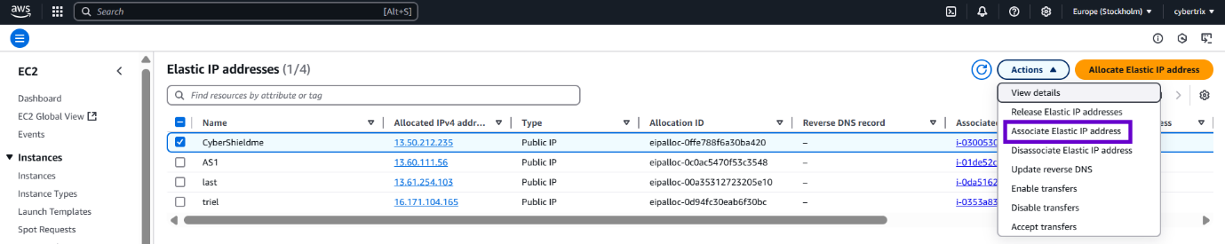
- Launch Ubuntu instance and associate Elastic IP address.

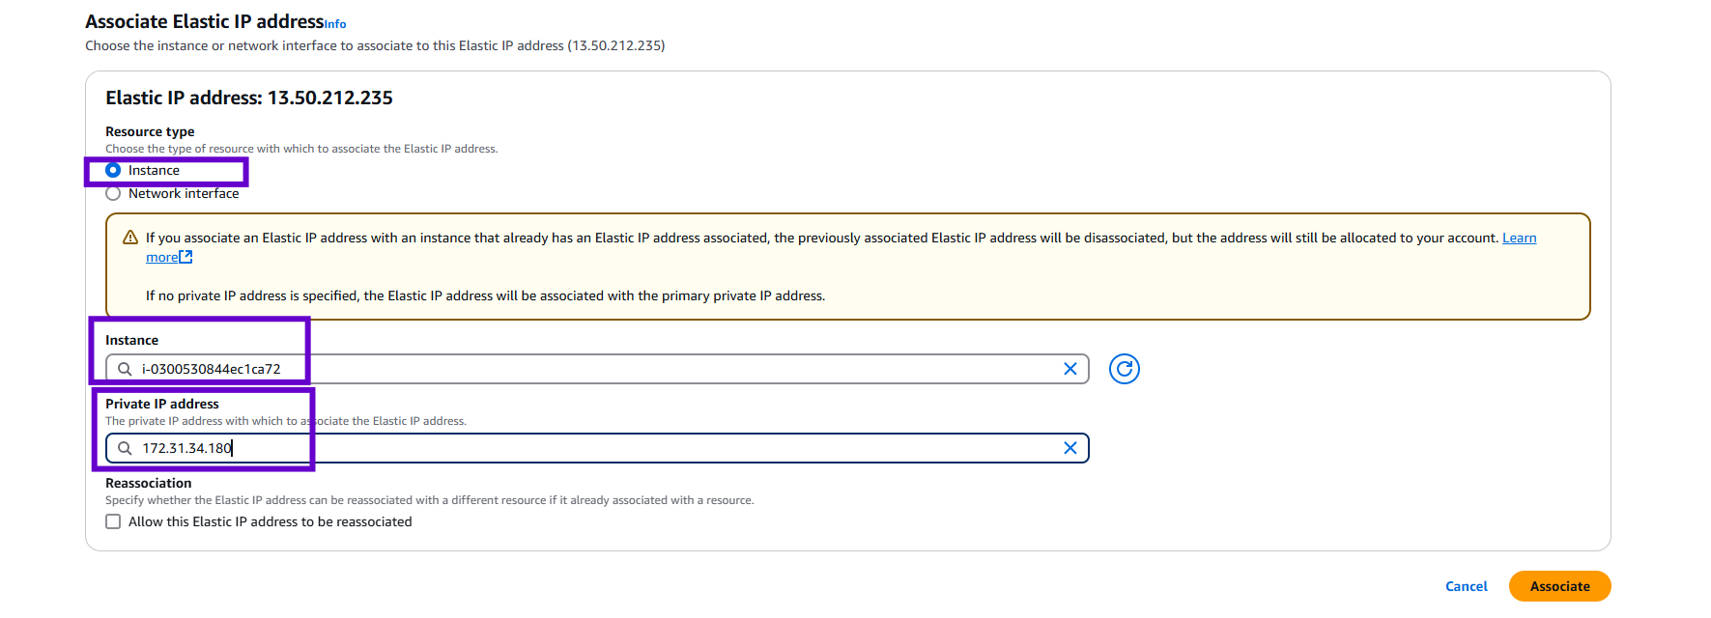

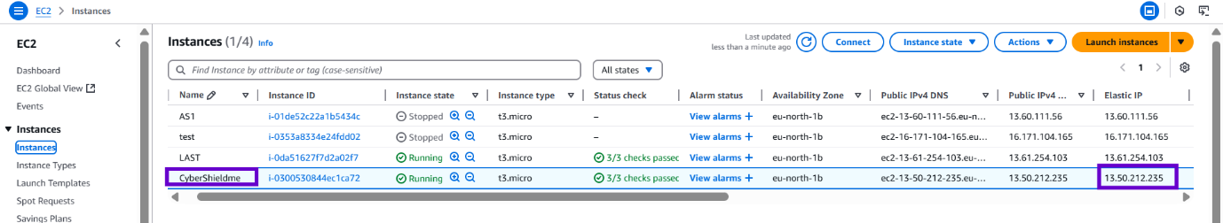

2. Open linux terminal to connect SSH client to EC2 instance + attach Elastic IP to the new instance.
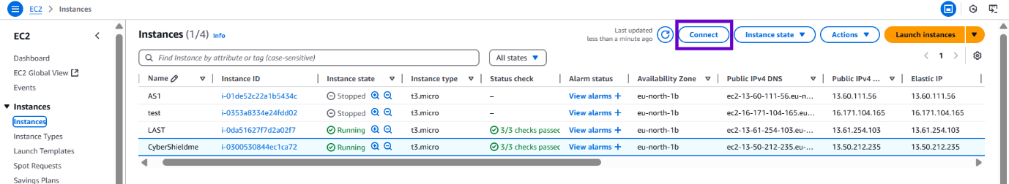

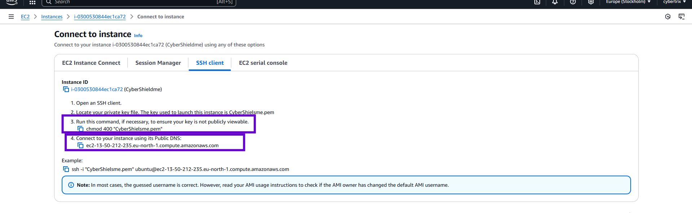

3.conect to the terminal by changing the public IP address to elastic IP address

Before : with publicIP adress

After: with elastic IP adress

4. Now update and upgrade the page



5. installing Apache server on ubuntu

6. Install php runtime and php mysql connector.

7. Install MySQL server.

8. Install php runtime and php mysql connector.

9. Login to MySQL server

10. Change authentication plugin to mysql_native_password (change the password to something strong)

11. Create a new database user for wordpress (change the password to something strong)

12. Create a database for wordpress

13. Grant all privileges on the database 'wp' to the newly created user
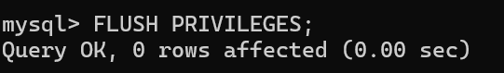
14. now exit


Setting up wordsress

15. Change directory and download WordPress.


16. Unzip


17. Move wordpress folder to apache document root


18 . restart the apache page
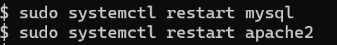

19 . search your Ip address or refresh the page to get word press welcome page
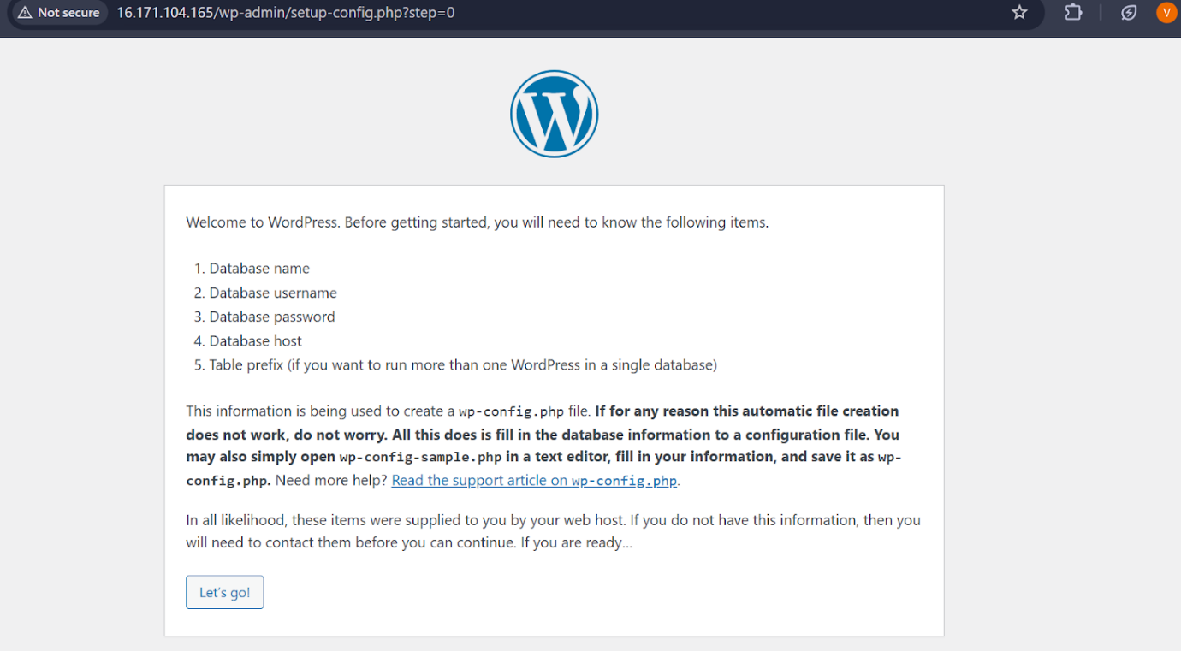

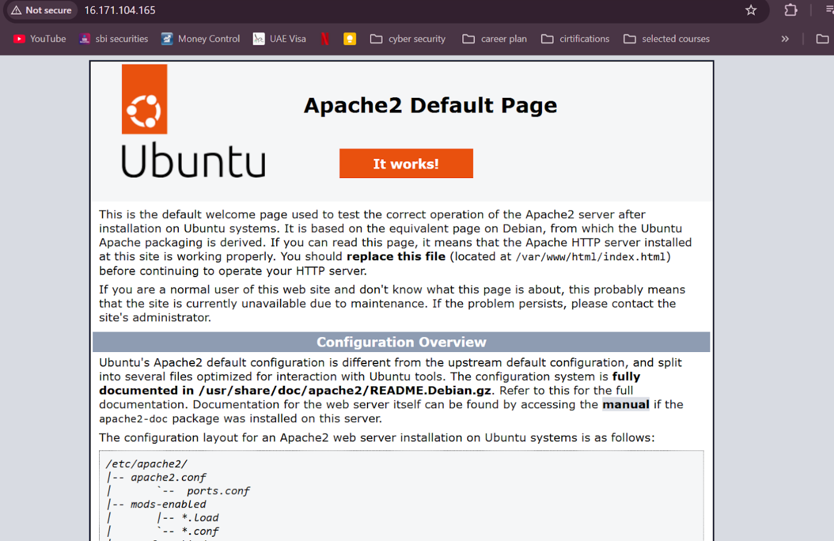
the apache page will change to wordprss

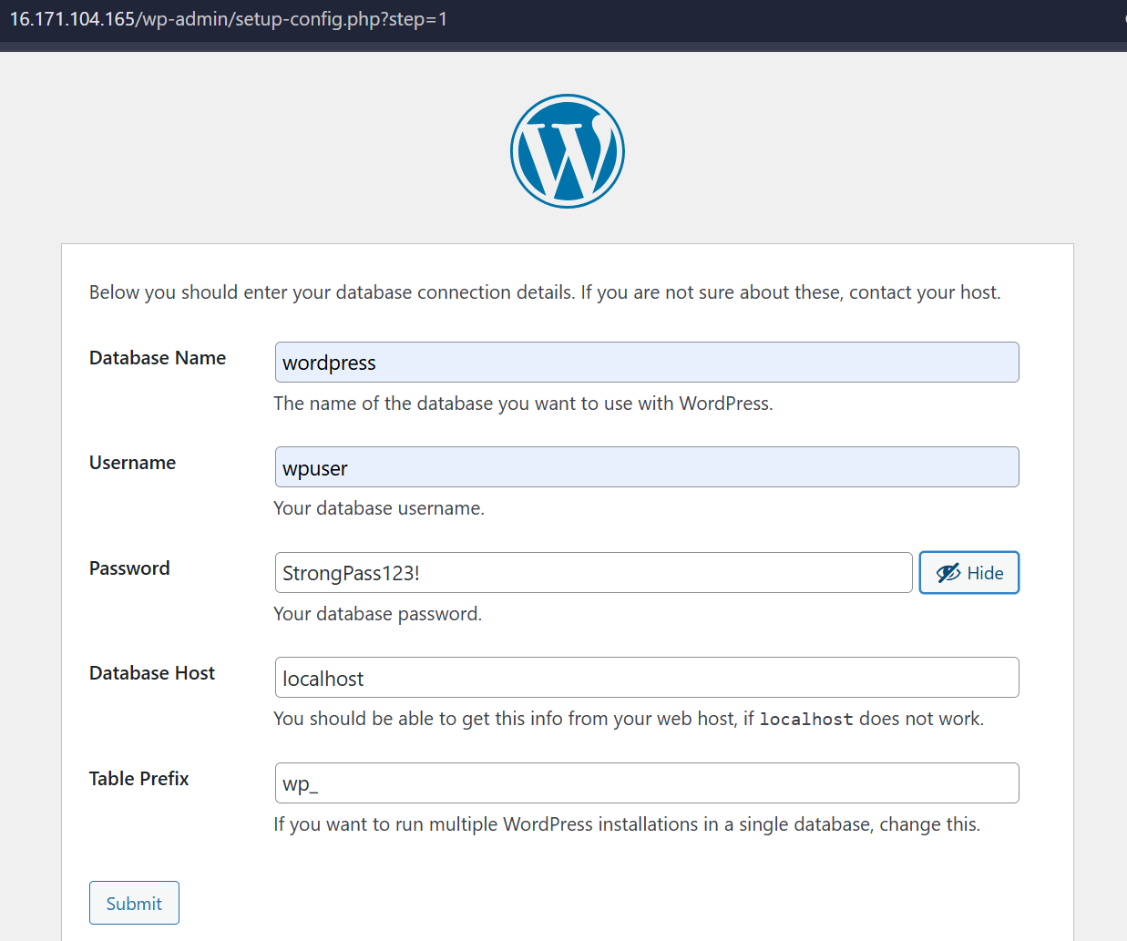

Changing the sub path
1. Changing Apache congfiguration
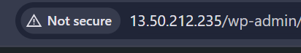
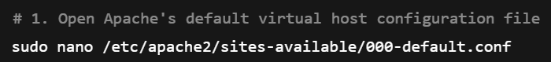
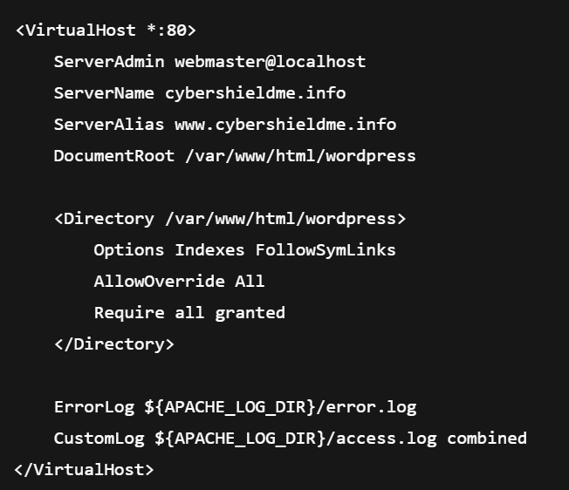
Make sure your WordPress files are in /var/www/html/wordpress. If not, adjust DocumentRoot accordingly.
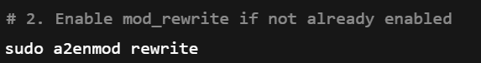

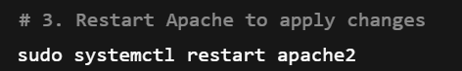



Linking with a DNS entry
1. Create hosted Zone using Route53
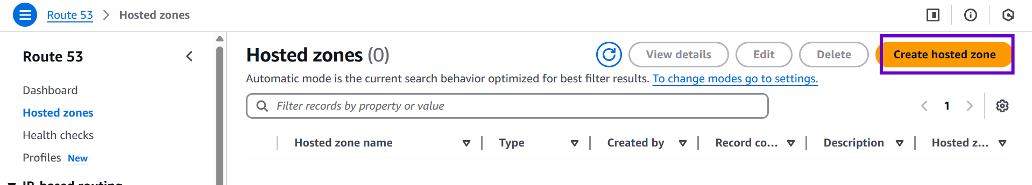
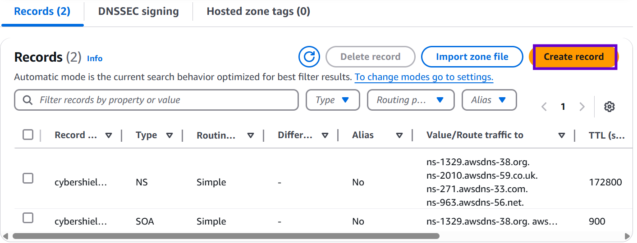

2. Create records of A type.
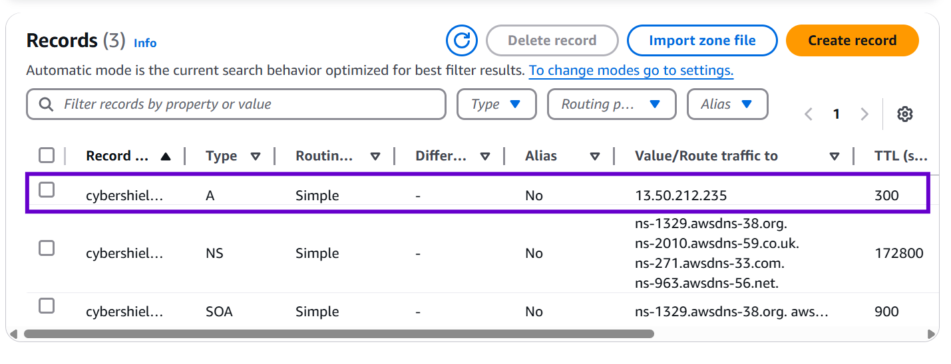

3.Change the Nameservers on GoDaddy (or from where you have bought the DNS
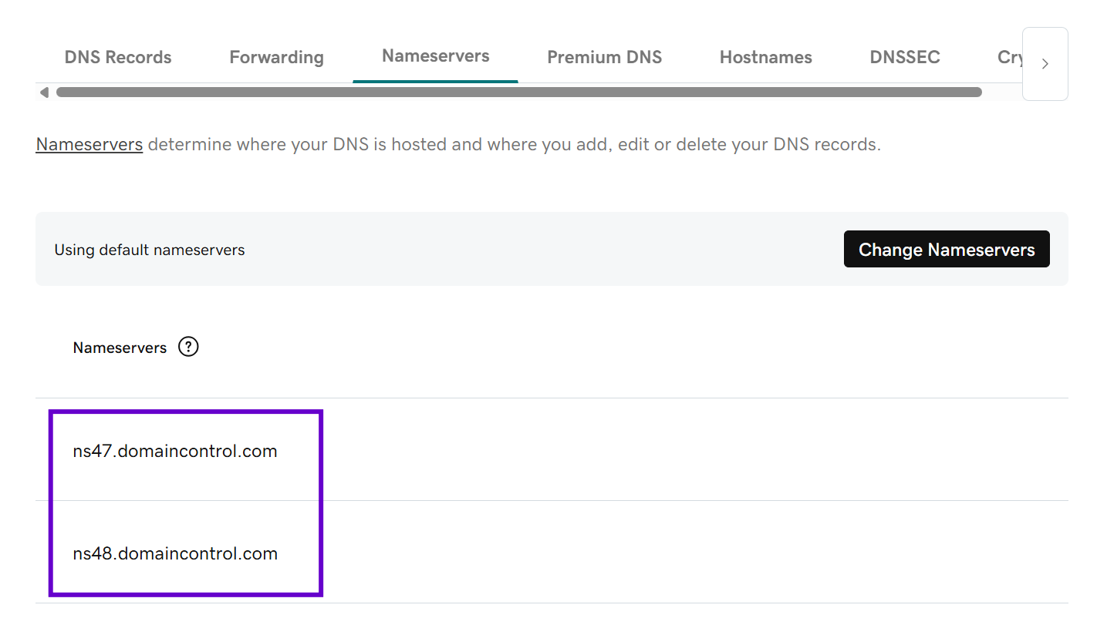

S SL/TLS Documentation

1.Enabling HTTPS with Certbot on Ubuntu 20.04 Using Apache.
Install Certbot and Apache Plugin

2. Connects to Let’s Encrypt
Verifies your domain (must be public)
Updates your Apache config with SSL
Creates /etc/letsencrypt/live/cybershieldme.info/ for the certs


3. UFW (Firewall) Settings (already done, but double-check)

4. coding

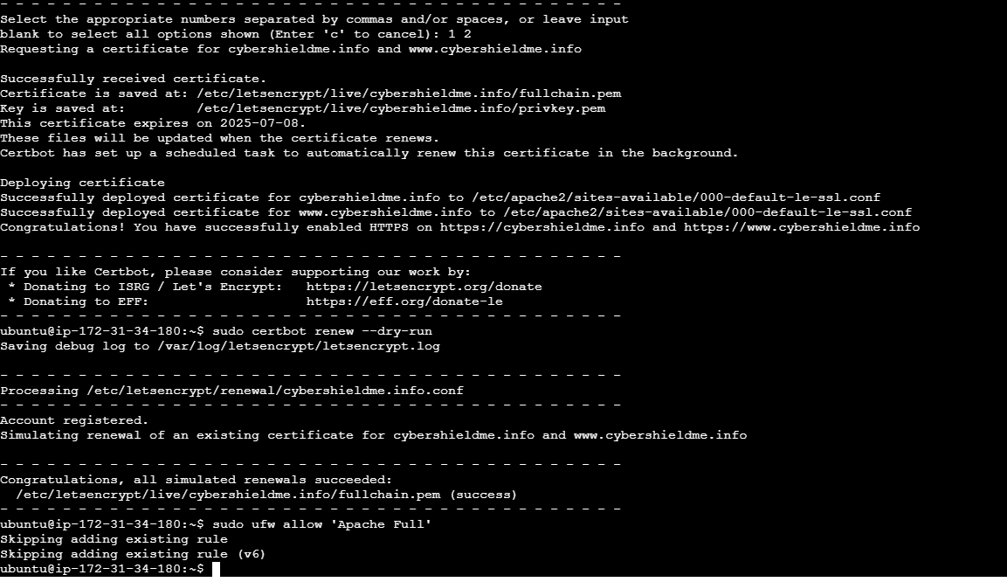

Reference

GitHub Repository
All deployment steps, configuration files, and project iterations are documented in the public GitHub repository:
🔗 https://github.com/uthara-mk/cybershieldme-aws-wordpress-site

