95. Unique Binary Search Trees II
Given an integer n, return all the structurally unique BST's (binary search trees), which has exactly n nodes of unique values from 1 to n. Return the answer in any order.

Example 1:

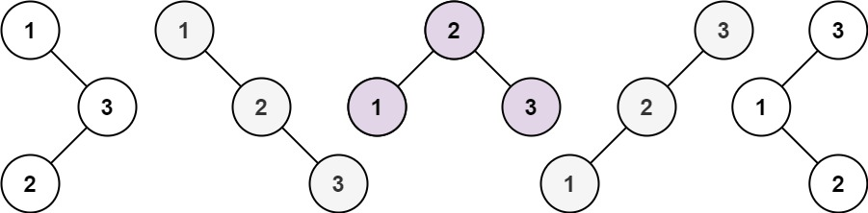
Input: n = 3
Output: [[1,null,2,null,3],[1,null,3,2],[2,1,3],[3,1,null,null,2],[3,2,null,1]]
Example 2:
Input: n = 1
Output: [[1]]

Constraints:
- 1 <= n <= 8

Solution
Post-order traversal. For [1, n], each time choose 1 value as root, and recursively build left and right subtrees.

