2. Add Two Numbers
You are given two linked lists representing two non-negative numbers. The digits are stored in reverse order and each of their nodes contain a single digit. Add the two numbers and return it as a linked list.
Input: (2 -> 4 -> 3) + (5 -> 6 -> 4)
Output: 7 -> 0 -> 8

分析
问题的要点在于，设置一个变量carry来保存进位(其值为0或1)，计算接下来两个结点相加时需要加上carry的值。当carry为1，且l1和l2中的结点已经用完时，需要在结果链表中创造一个新的结点。

Solution
Intuition
Keep track of the carry using a variable and simulate digits-by-digits sum starting from the head of list, which contains the least-significant digit.
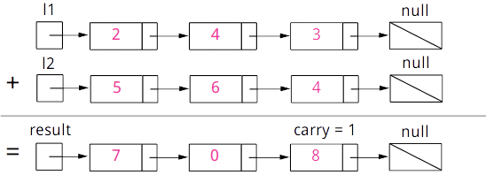
Figure 1. Visualization of the addition of two numbers: 342+465=807.
Each node contains a single digit and the digits are stored in reverse order.
Algorithm
Just like how you would sum two numbers on a piece of paper, we begin by summing the least-significant digits, which is the head of l1 and l2. Since each digit is in the range of 0…9, summing two digits may "overflow". For example 5+7=12. In this case, we set the current digit to 2 and bring over the carry=1 to the next iteration. carry must be either 0 or 1 because the largest possible sum of two digits (including the carry) is 9+9+1=19.
The pseudocode is as following:
- Initialize current node to dummy head of the returning list.
- Initialize carry to 0.
- Initialize p and q to head of l1 and l2 respectively.
- Loop through lists l1 and l2 until you reach both ends.
  - Set x to node p's value. If p has reached the end of l1, set to 0.
  - Set y to node q's value. If q has reached the end of l2, set to 0.
  - Set sum=x+y+carry.
  - Update carry=sum/10.
  - Create a new node with the digit value of (summod10)
  - and set it to current node's next, then advance current node to next.
  - Advance both p and q.
- Check if carry=1, if so append a new node with digit 1 to the returning list.
- Return dummy head's next node.
Note that we use a dummy head to simplify the code. Without a dummy head, you would have to write extra conditional statements to initialize the head's value.
Take extra caution of the following cases:
Test case | Explanation
l1=[0,1]  l2=[0,1,2] | When one list is longer than the other.
l1=[]  l2=[0,1] | When one list is null, which means an empty list.
l1=[9,9]  l2=[1] | The sum could have an extra carry of one at the end, which is easy to forget.
Java
public ListNode addTwoNumbers(ListNode l1, ListNode l2) {
ListNode dummyHead = new ListNode(0);
ListNode p = l1, q = l2, curr = dummyHead;
int carry = 0;
while (p != null || q != null) {
int x = (p != null) ? p.val : 0;
int y = (q != null) ? q.val : 0;
int sum = carry + x + y;
carry = sum / 10;
curr.next = new ListNode(sum % 10);
curr = curr.next;
if (p != null) p = p.next;
if (q != null) q = q.next;
}
if (carry > 0) {
curr.next = new ListNode(carry);
}
return dummyHead.next;
}
Complexity Analysis
- Time complexity : O(max(m,n)). Assume that m and n represents the length of l1 and l2 respectively, the algorithm above iterates at most max(m,n) times.
- Space complexity : O(max(m,n)). The length of the new list is at most max(m,n)+1.
Follow up
What if the the digits in the linked list are stored in non-reversed order? For example:
(3→4→2)+(4→6→5)=8→0→7

