236. Lowest Common Ancestor of a Binary Tree
Given a binary tree, find the lowest common ancestor (LCA) of two given nodes in the tree.
According to the definition of LCA on Wikipedia: “The lowest common ancestor is defined between two nodes p and q as the lowest node in T that has both p and q as descendants (where we allow a node to be a descendant of itself).”

Example 1:
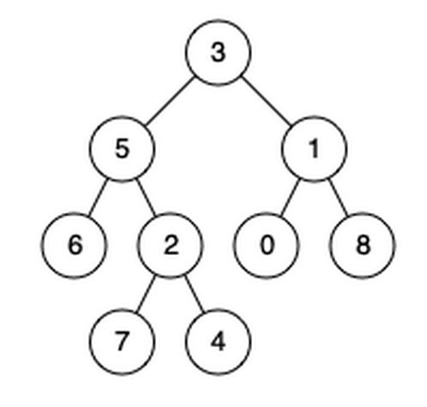
Input: root = [3,5,1,6,2,0,8,null,null,7,4], p = 5, q = 1
Output: 3
Explanation: The LCA of nodes 5 and 1 is 3.

Example 2:
Input: root = [3,5,1,6,2,0,8,null,null,7,4], p = 5, q = 4
Output: 5
Explanation: The LCA of nodes 5 and 4 is 5, since a node can be a descendant of itself according to the LCA definition.

Example 3:
Input: root = [1,2], p = 1, q = 2
Output: 1

Constraints:
- The number of nodes in the tree is in the range [2, 105].
- -109 <= Node.val <= 109
- All Node.val are unique.
- p != q
- p and q will exist in the tree.

Analysis
Note that this is NOT a binary search tree
Case 1:

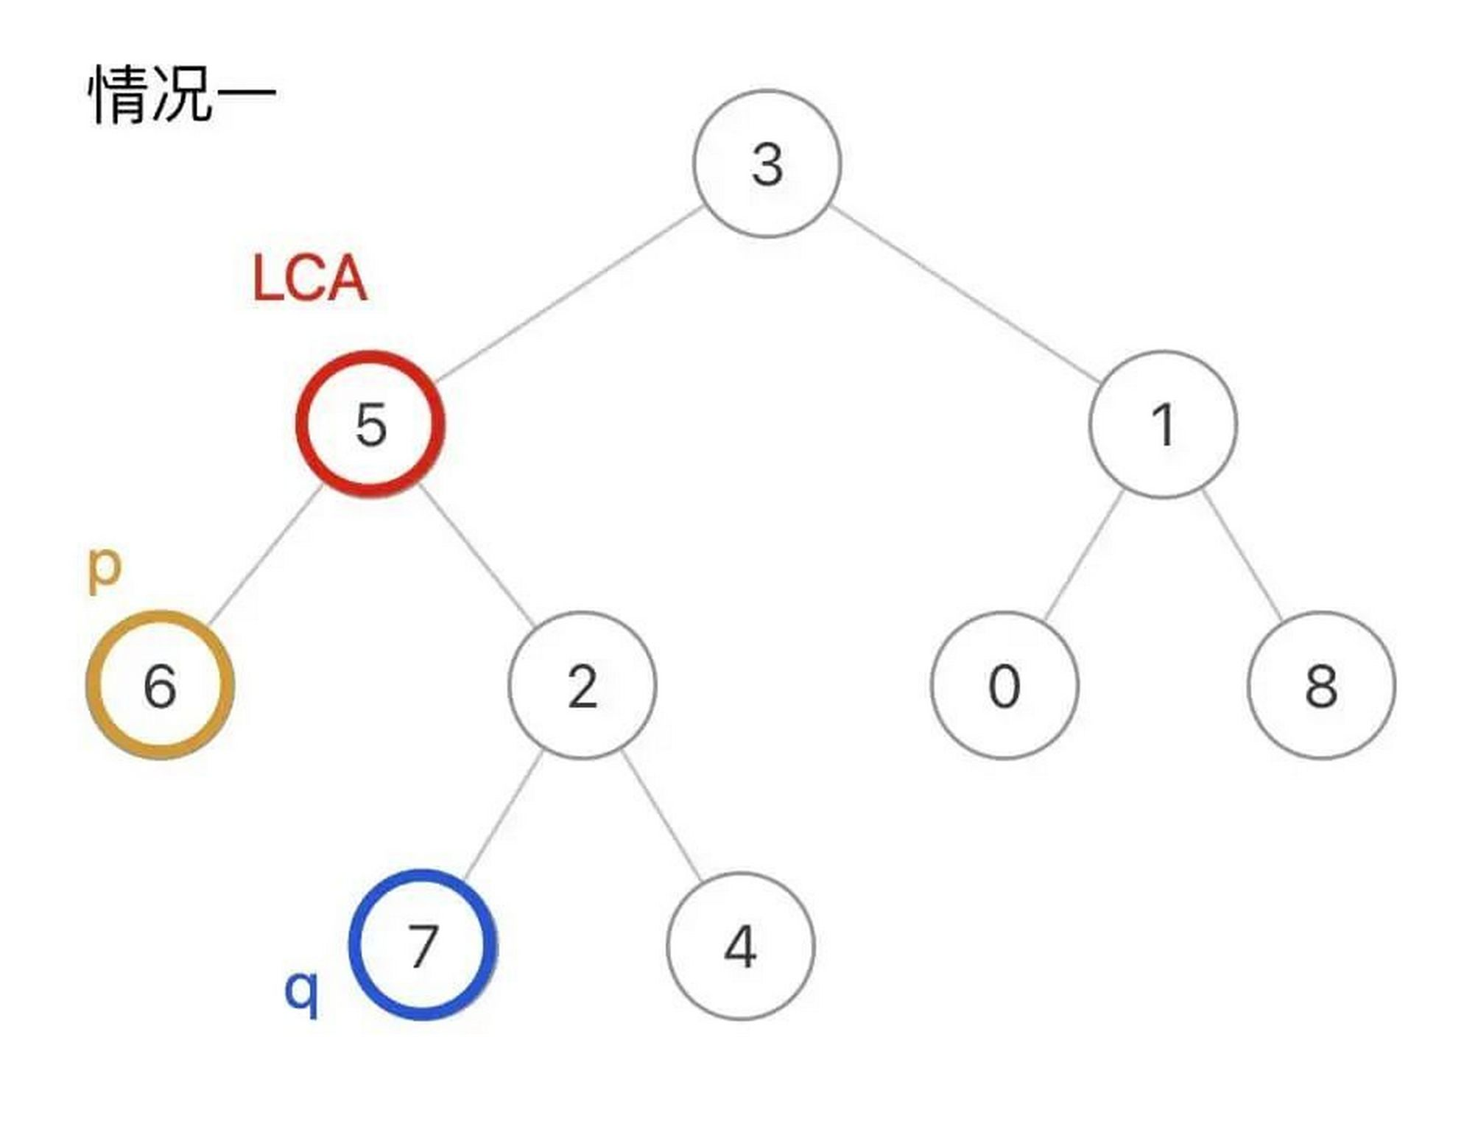
Case 2:

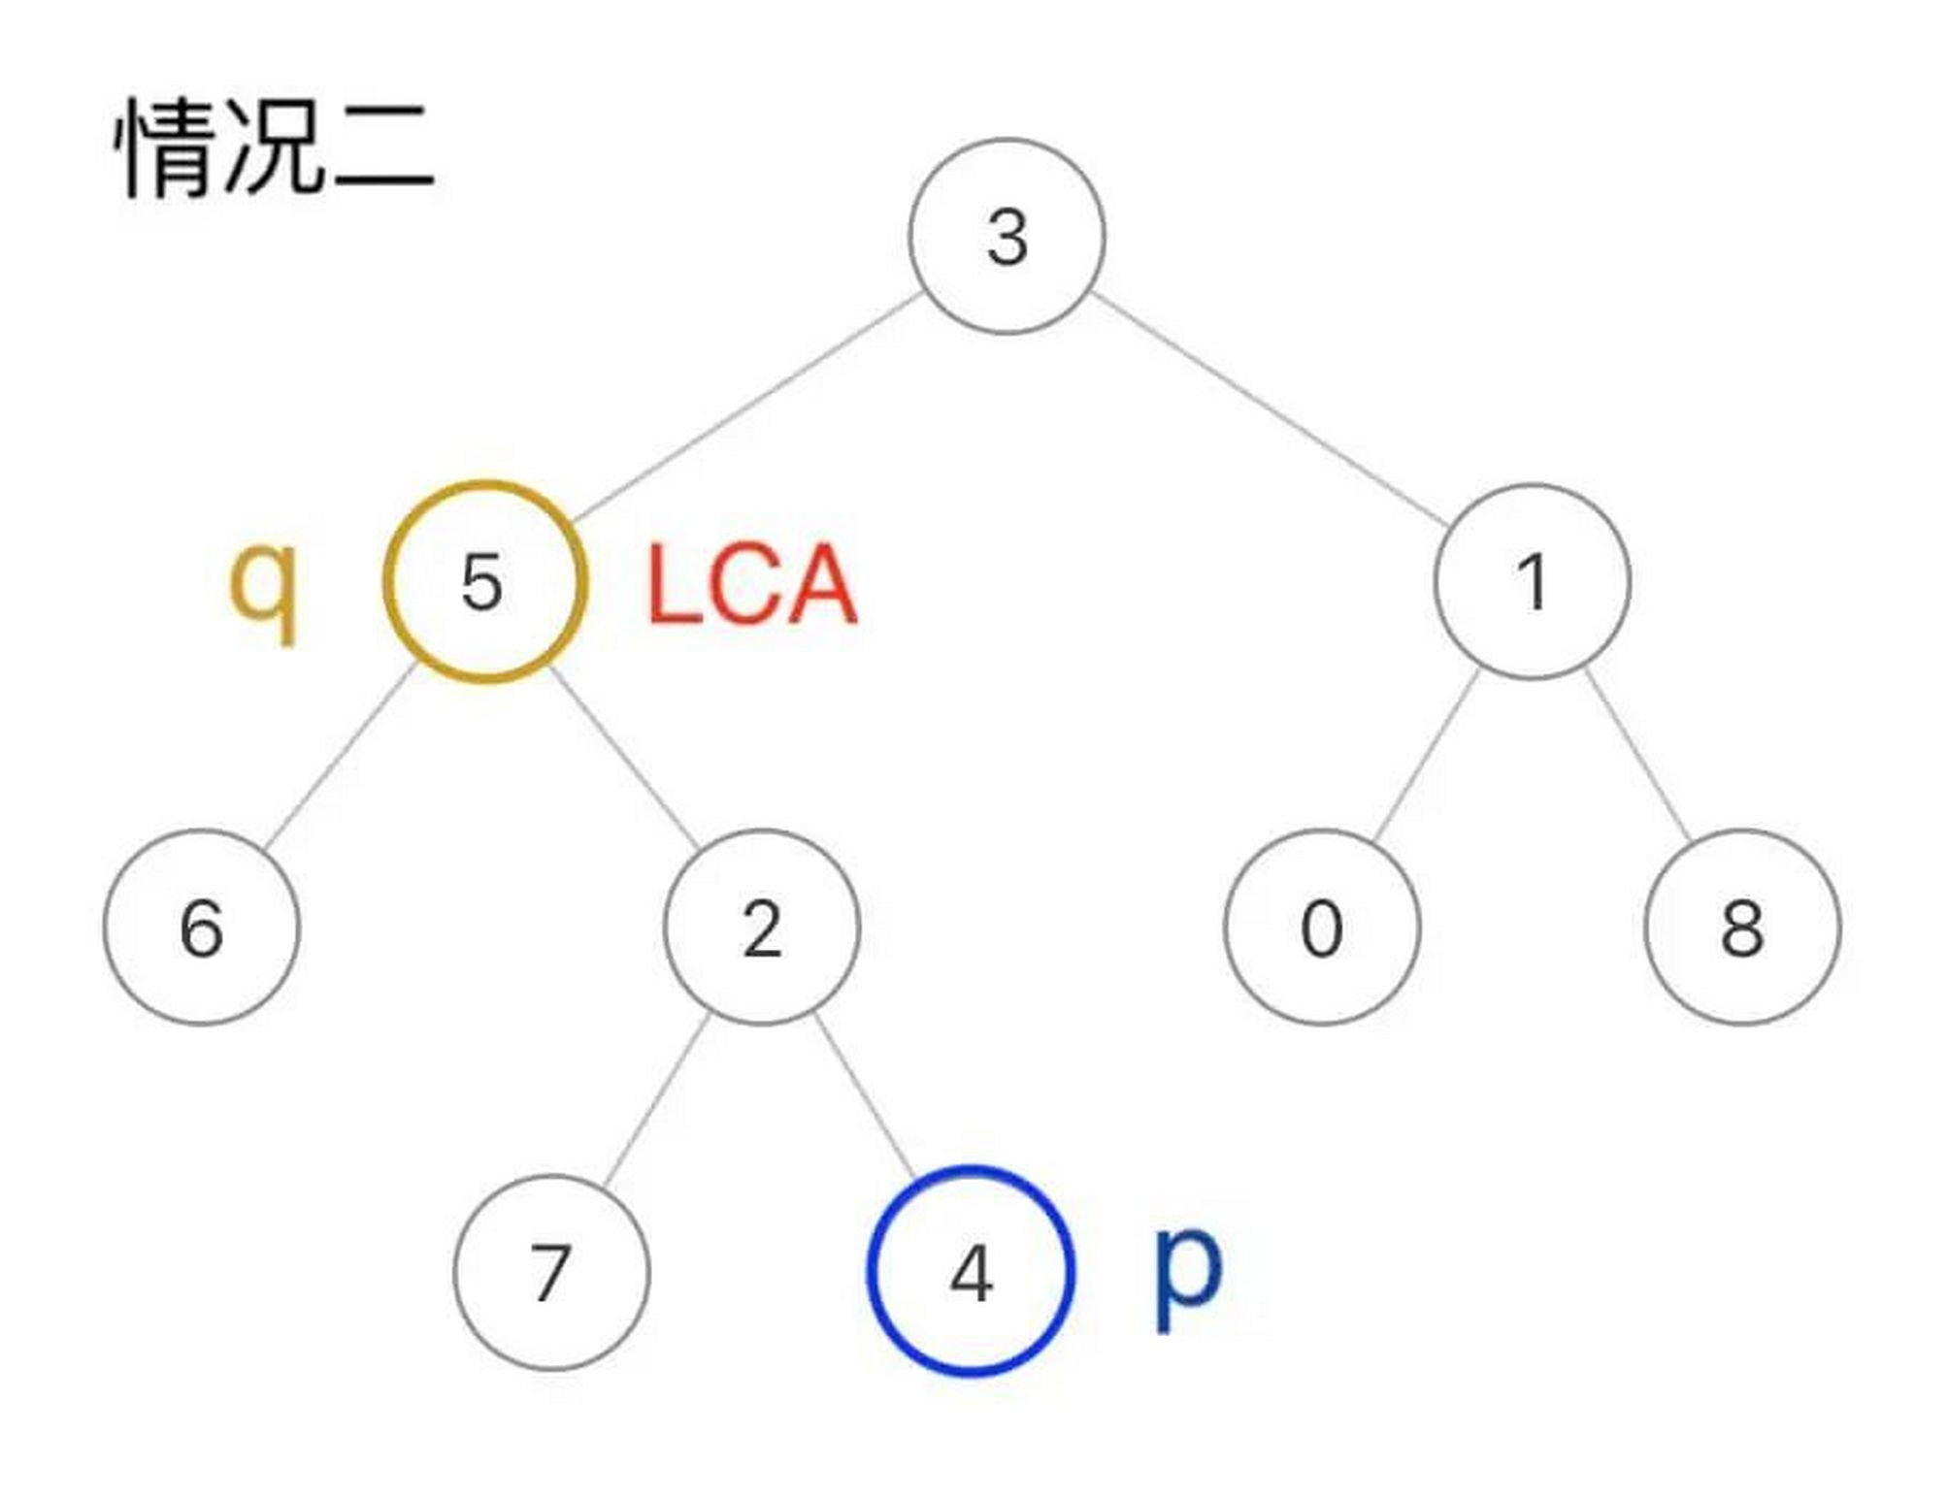
Solution: general post-order traversal
This solution also applies to problem 1644.
We do a post-order traversal of the tree. For case 1, we can find p in the left subtree of the LCA node, and q in its right subtree; for case 2, the LCA node itself is q, and we can find p in its right subtree. This means for any node in the tree, if we can find both q and p in any 2 of {itself, left subtree, right subtree}, this node is the LCA we’re looking for.
To make the program slightly faster, we can make it return early if LCA is already found.
See GeneralSolution.java

Solution: faster & trickier post-order traversal
This solution only applies to this problem.
Since q and p are guaranteed to exist in the tree, we can return immediately once we found either p or q:
- for case 1, this optimization has no effect. q and p still can be found in LCA’s subtrees.
- for case 2, it’s safe to blindly return q without knowing if p is in its subtrees. If p doesn’t exist in other subtrees(which is case 1), p must be in q’s subtrees since p is guaranteed to exist in the tree.
See FasterSolution.java

