1644.Lowest Common Ancestor of a Binary Tree II

Given the root of a binary tree, return the lowest common ancestor (LCA) of two given nodes, p and q. If either node p or q does not exist in the tree, return null. All values of the nodes in the tree are unique.
According to the definition of LCA on Wikipedia: "The lowest common ancestor of two nodes p and q in a binary tree T is the lowest node that has both p and q as descendants (where we allow a node to be a descendant of itself)". A descendant of a node x is a node y that is on the path from node x to some leaf node.

Example 1:
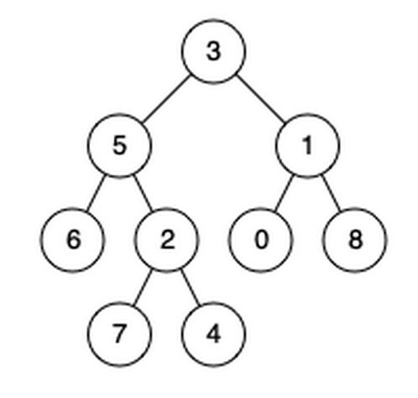
Input: root = [3,5,1,6,2,0,8,null,null,7,4], p = 5, q = 1
Output: 3
Explanation: The LCA of nodes 5 and 1 is 3.

Example 2:
Input: root = [3,5,1,6,2,0,8,null,null,7,4], p = 5, q = 4
Output: 5
Explanation: The LCA of nodes 5 and 4 is 5. A node can be a descendant of itself according to the definition of LCA.

Example 3:
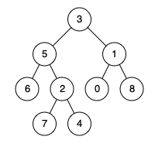
Input: root = [3,5,1,6,2,0,8,null,null,7,4], p = 5, q = 10
Output: null
Explanation: Node 10 does not exist in the tree, so return null.

Constraints:
- The number of nodes in the tree is in the range [1, 104].
- -109 <= Node.val <= 109
- All Node.val are unique.
- p != q

Analysis
Note that this is NOT a binary search tree
Case 1:

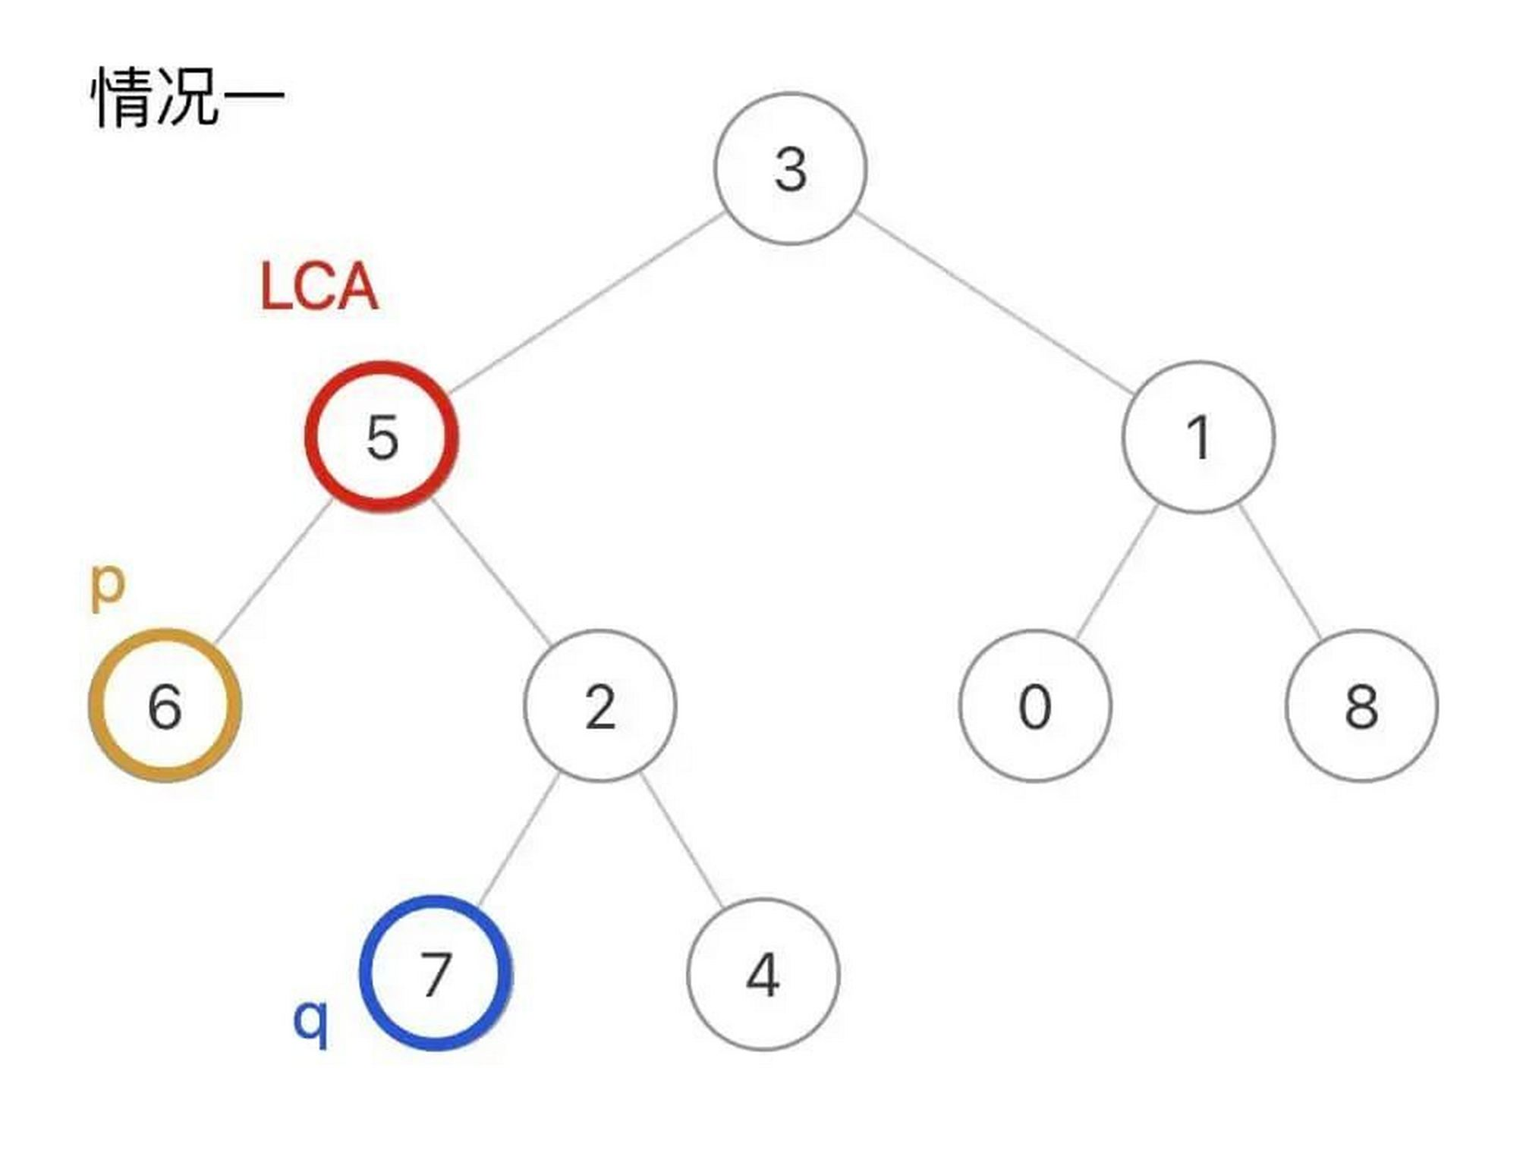
Case 2:

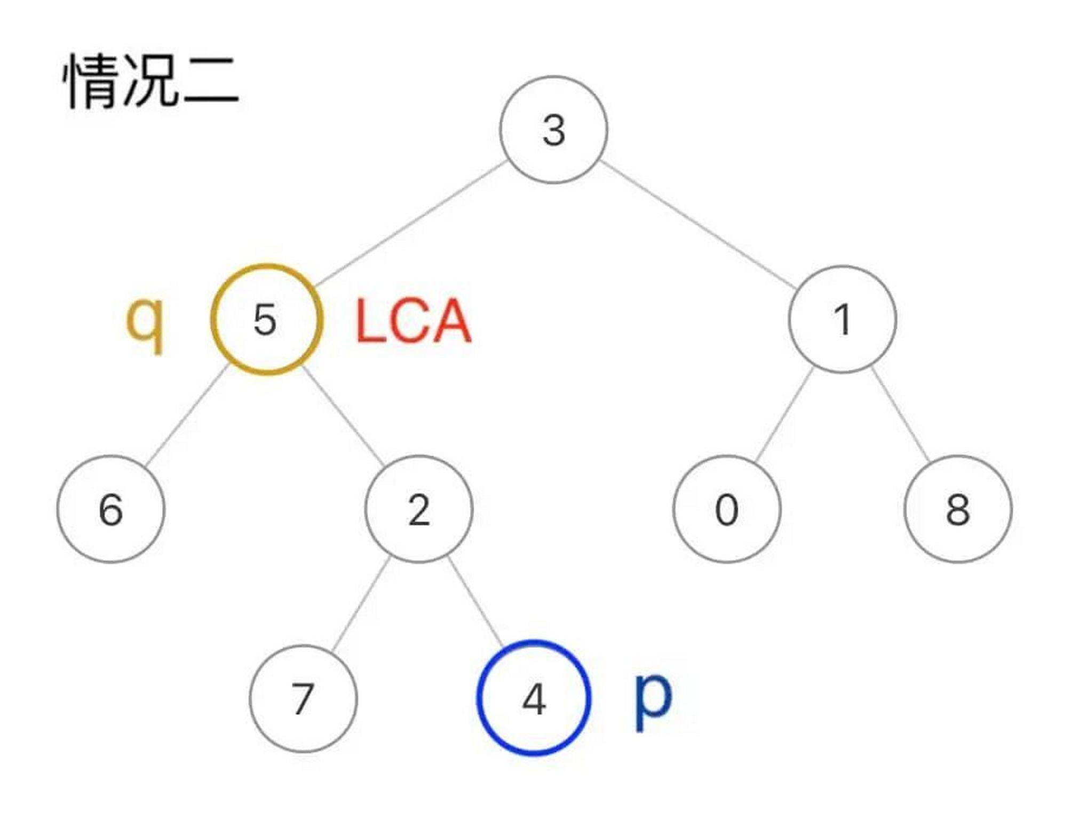
Solution: general post-order traversal
This problem is slightly different from problem 235: q and p might not exist in the tree. So we have to use this general solution.
We do a post-order traversal of the tree. For case 1, we can find p in the left subtree of the LCA node, and q in its right subtree; for case 2, the LCA node itself is q, and we can find p in its right subtree. This means for any node in the tree, if we can find both q and p in any 2 of {itself, left subtree, right subtree}, this node is the LCA we’re looking for.
To make the program slightly faster, we can make it return early if LCA is already found.
See Solution.java

