1676.Lowest Common Ancestor of a Binary Tree IV
Given the root of a binary tree and an array of TreeNode objects nodes, return the lowest common ancestor (LCA) of all the nodes in nodes. All the nodes will exist in the tree, and all values of the tree's nodes are unique.
Extending the definition of LCA on Wikipedia: "The lowest common ancestor of n nodes p1, p2, ..., pn in a binary tree T is the lowest node that has every pi as a descendant(where we allow a node to be a descendant of itself) for every valid i". A descendant of a node x is a node y that is on the path from node x to some leaf node.

Example 1:
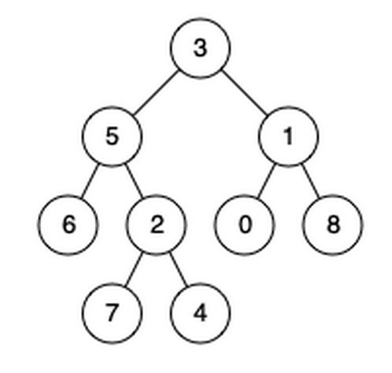
Input: root = [3,5,1,6,2,0,8,null,null,7,4], nodes = [4,7]
Output: 2
Explanation: The lowest common ancestor of nodes 4 and 7 is node 2.

Example 2:
Input: root = [3,5,1,6,2,0,8,null,null,7,4], nodes = [1]
Output: 1
Explanation: The lowest common ancestor of a single node is the node itself.

Example 3:
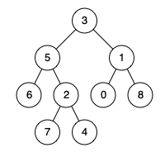
Input: root = [3,5,1,6,2,0,8,null,null,7,4], nodes = [7,6,2,4]
Output: 5
Explanation: The lowest common ancestor of the nodes 7, 6, 2, and 4 is node 5.

Constraints:
- The number of nodes in the tree is in the range [1, 104].
- -109 <= Node.val <= 109
- All Node.val are unique.
- All nodes[i] will exist in the tree.
- All nodes[i] are distinct.

Solution
First, convert the nodes array to a Set for O(1) query. Then do post-order traversal and count the nodes we found from the node itself, and both of its subtrees. The LCA node should be the first node where we can find all the nodes in the set.

