I certify the following about the thesis entitled (10 word maximum)   
  
**Black-box Optimization using Deep Neural Networks**

submitted for the degree of **Doctor of Philosophy**

1. I am the creator of all or part of the whole work(s) (including content and layout) and that where reference is made to the work of others, due acknowledgment is given.
2. The work(s) are not in any way a violation or infringement of any copyright, trademark, patent, or other rights whatsoever of any person.
3. That if the work(s) have been commissioned, sponsored or supported by any organisation, I have fulfilled all of the obligations required by such contract or agreement.
4. That any material in the thesis which has been accepted for a degree or diploma by any university or institution is identified in the text.
5. All research integrity requirements have been complied with.

*'I certify that I am the student named below and that the information provided in* *the form is correct'*

### Full Name: Dat Phan Trong

### Signed:

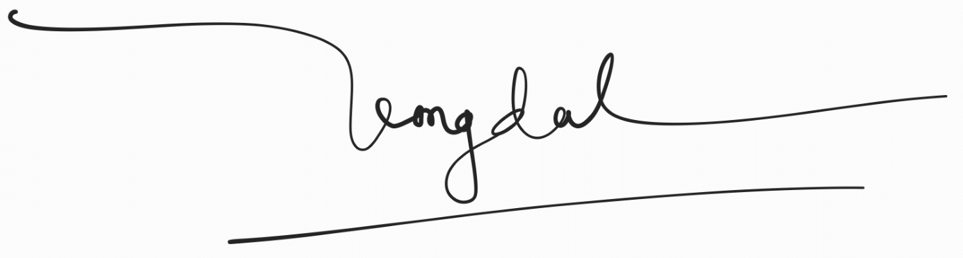

### Date: 25/01/2025