**KDS Back-End System**

**manual**

**2024**

**KDS System Manual**

1. Login to the system…………………………………………2
2. Create a company

2.1 Create a new company…………………………..3

2.2 Create a new branch of the company……………5

1. Gas shop creation and product creation…………………….6

3.1 Appoint gas shop manager………………………5

3.2 Create a department……………………………...7

3.3 Register gas shop staff…………………………..9

3.4 Create gas shop products……………………….15

3.5 Control goods registered in gas shop…..………17

3.6 Create a end-user on the gas shop…………...…21

1. Sales and purchases……………………………………...………..28

4.1 Create a purchase………………………………28

4.2 Create a sales order…………………………….32

4.3 Approve sales orders………………………..…33

4.4 Sales delivery………………………………….34

4.5 Invoice…………………………………………36

4.6 Payment………………………………………..40

1. **Login to the system**

For new registrations in the KVN system the contracted company information is created in the system and the login name and login password are e-mailed to the new company's administrator.

Email the system login and password to the company administrator. Login to the system with the given login and password.

- Login address: http://14.225.192.41:8029/

- User name: dataenergy

- Password: 123

After logging in to the company's admin system, update your login password.

Click the Reset password button and enter your email address in the email address input field.

System will send you an email with a link to reset your password.

Follow the instructions in the email to set a new password.

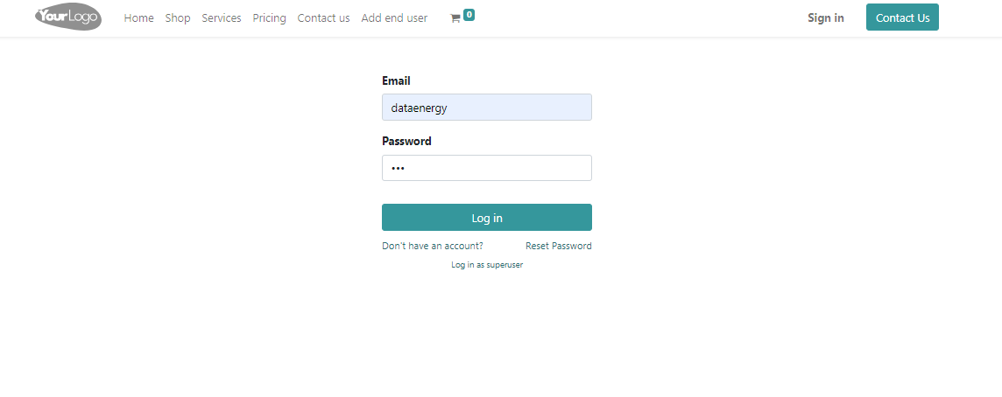

1. **Create a new company**

The details of the newly registered gas company need to be registered in the system, so the company administrator will register the company's information in all the necessary fields in the system, set it up, and set the rights and responsibilities.

**2.1 Create a new gas company**

After logging into the company's admin system, select the settings menu from the main menu and enter company information.

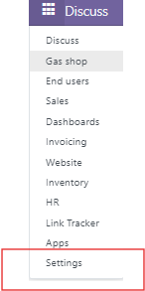

To do this, select the **Settings menu - User&Companies - Companies** and click the New button to create a new gas company information in the system.

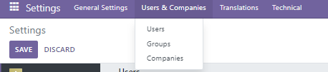

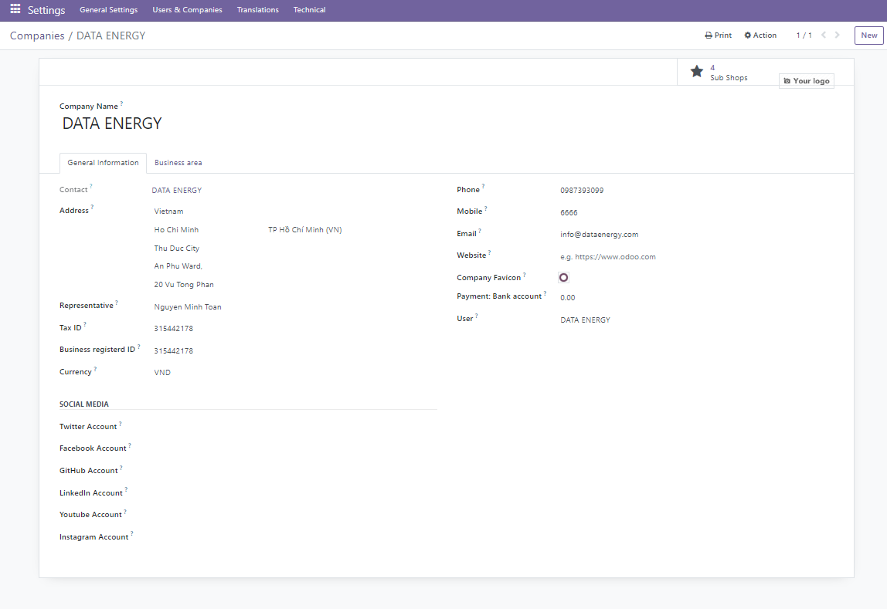

The company's administrator will register the information of the newly registered company in the system.

After entering the information in the fields, click the save button and the new company will be created in the system. The following fields must be filled in.

- Company name: Company name registration

- Address: Company address registration

- Representative: Register a representative

- Tax ID: Register of tax ID

- Business register ID: Register a Business Registration ID

- Currency: Currency registration

- Phone: Register a phone number

- Mobile: Register a mobile

- Email: Register an email

- Website: Register a website

- Company Favicon: Company Favicon registration

- Payment bank account: Register a payment bank account

- User: Register an user

- Social media: Social network registration

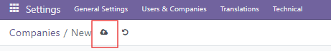

**2.2 Create a new branch of the company**

After creating a new company, the system administrator will create branch gas shops of that company.

To do this, select the Gas shop menu from the main menu of the system and click the New button to create a new gas shop.

Each branch of the gas company will be created in the company's admin system.

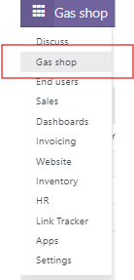 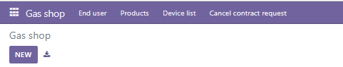

The following fields must be filled in.

- Gas shop name: Register a gas shop name

- Shop manager: Register a shop manager

- Business registered no: Register the business registration number in the system

- Tax code: Register a tax code

- Department: Register a department

- Contact information: Register a contact information

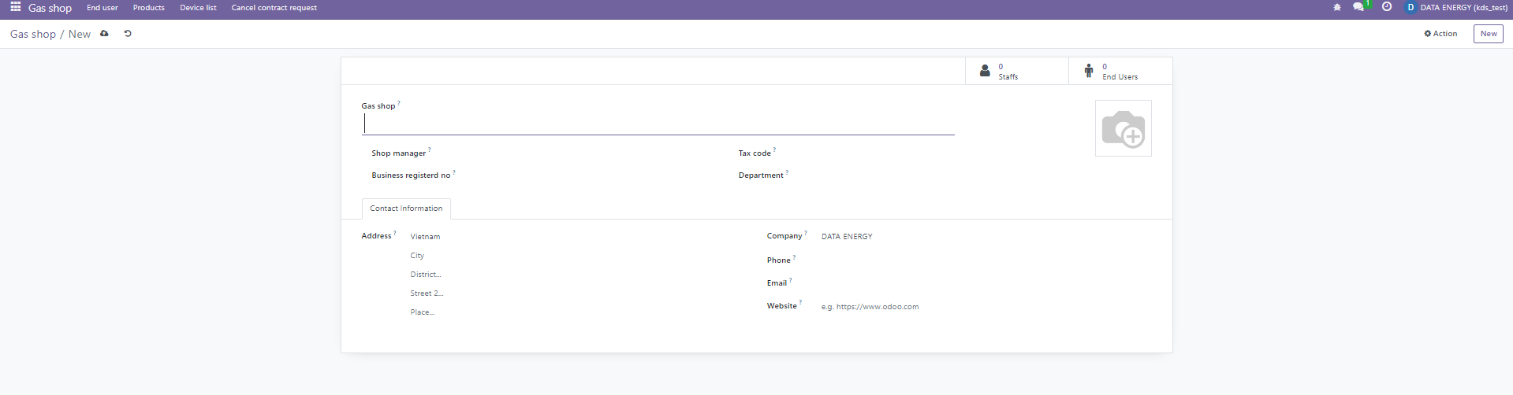

1. **Gas shop creation and product creation**

Each gas shop will have access to a separate system and will manage its own gas shop operations on this system.

**3.1 Appoint gas shop manager**

After creating each gas shop in the system, the system administrator will appoint a gas shop manager, set the system login and password, and send it to each gas shop manager's email address.

Each gas shop manager will set a new login and password after logging into the system with the login and password received by email. Gas shop manager when logging into the system:

- Login address: <http://14.225.192.41:8029/>

- User name: shop_manager

- Password:123

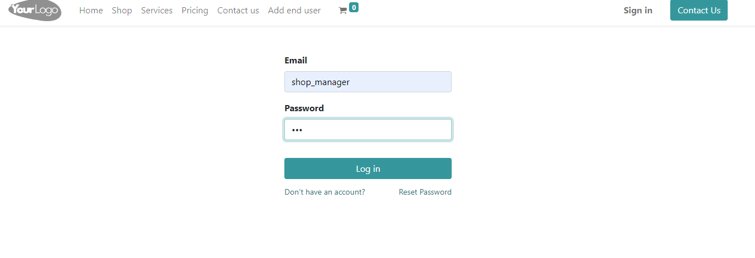

Gas shop manager registers company details in the system.

The following fields must be filled in.

- Gas shop department and position

- Staffs

- End-users

- Products

**3.2 Create a department**

The manager of the gas shop creates a company department in the system.

Click the HR > Department > New button from the main menu to create a new department.

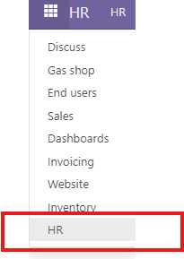

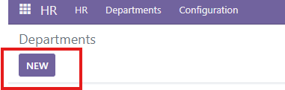

Fill in the following fields when creating gas shop and company department in the system.

* Department name:
* Manager name
* Parent department:

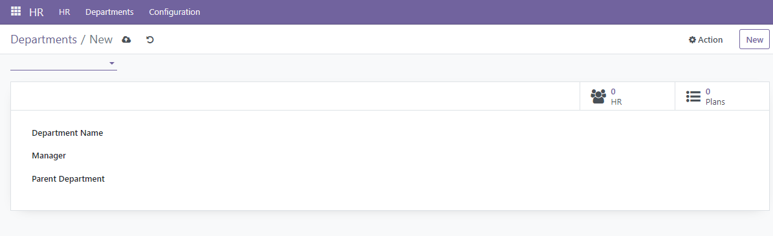

An example of registering a branch unit in the system /Kanban view/

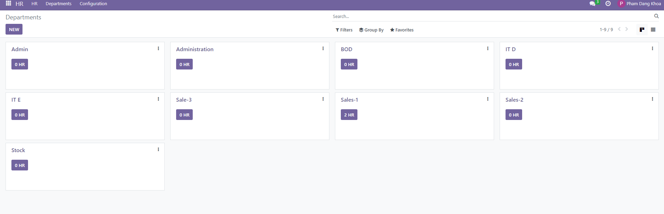

Example of registered branch unit in the system /List view/

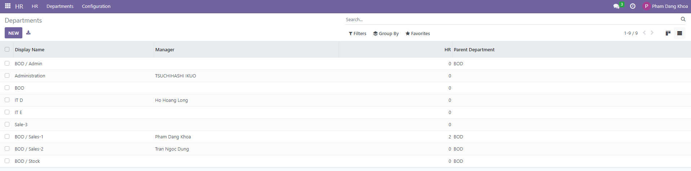

**3.3 Register gas shop staff**

Before registering a gas shop staff in the system, create a job position.

**Job position:**

**HR > Configuration >Job positions > Click the New button.**

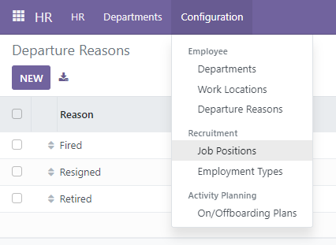

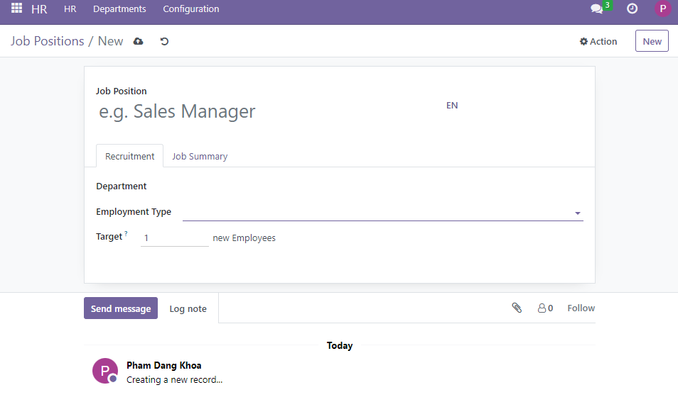

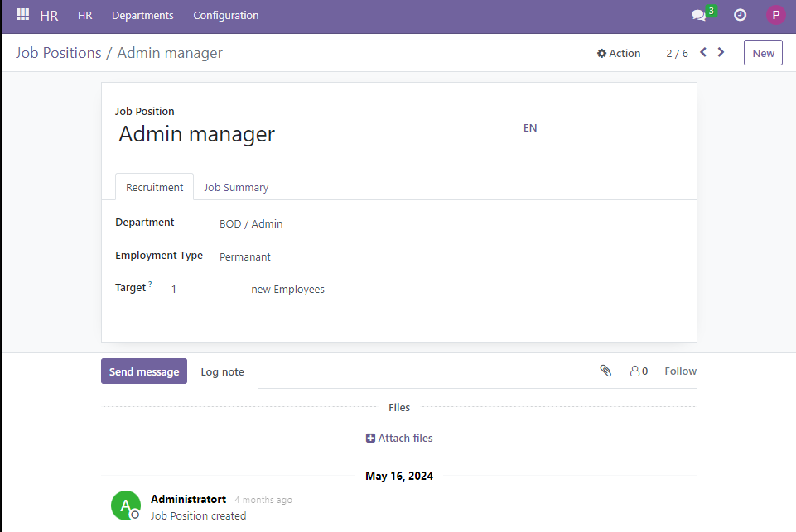

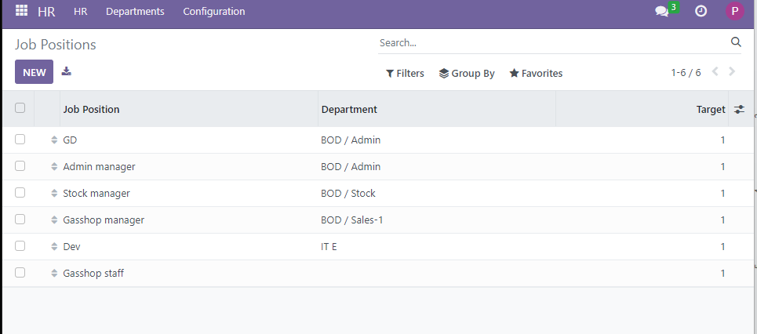

**Registration of gas shop staff**

Select the Main Menu > HR > New button to register a new employee in the system.

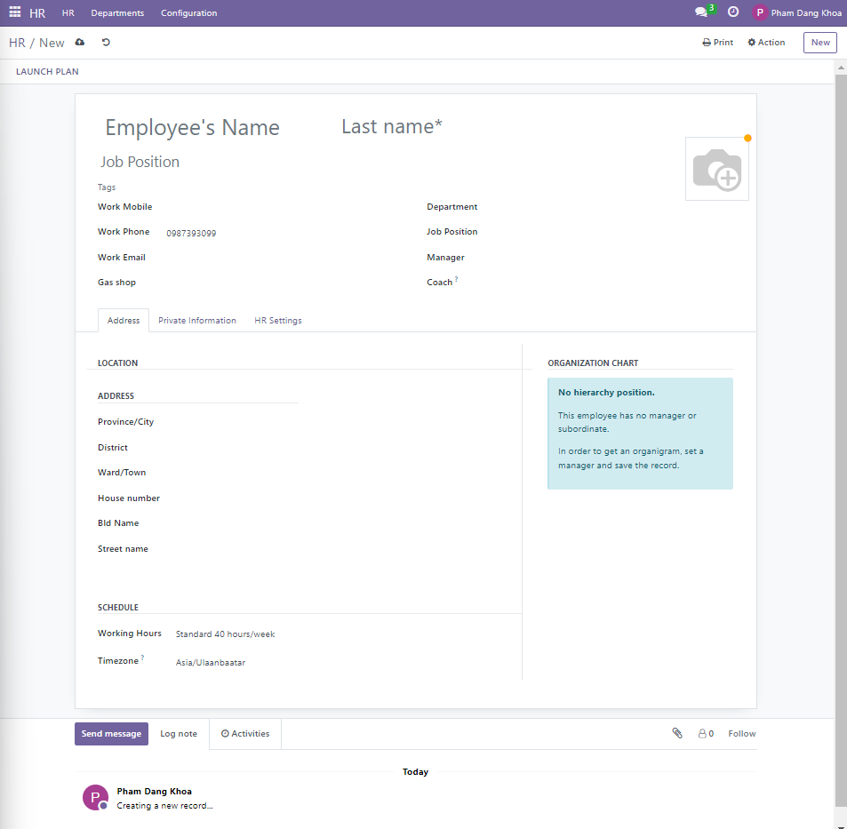

To create a new employee in the system, the following fields must be filled.

- Staff name: Register the name of the staff

- Last name: Register the last name of the staff

- Work mobile: Register a work mobile number

- Work Phone number: Register a phone number

- Work Email: Register staff an email

- Gas shop: Choose which gas shop (branch) the staff will work from the system register

- Department: Select the department in which the staff will work from the system register

- Job position: Choose the job position сонгох

- Manager: Select the manager responsible for the employee

- Coach: Select the coach responsible for the staff

To register the employee's home address, fill in the following fields.

- Province/ City: Select the city from the system register

- District: Select the district from the system register

- Ward/Town: Choose the ward/town that depends on the district

- House number: Register the house name and number

- Bld name: Register the name of the building

- Steet name: Registration of street names

Setting the staff's working hours (schedule) in the system.

- Working Hours: Setting the system for how many hours the staff will work in a week

- Timezone: Select the time zone where the staff will work

The staff's private information is registered in the registration tab.

Private contact information:

- Email: Registration of the staff's personal email

- Phone number: Registration of the staff's personal phone number

- Bank account number: Register the staff's bank account number and fill in the other fields.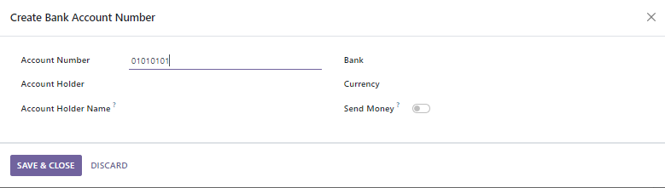

- Language: Select from system registry

- Home work distance: Registration the employee's distance from home to work

Record information about the staff's education.

**-** Certificate: Select from system registry

- Field of Study: Registration field of Study

- School: Register the staff's completed school

Registration of work permits.

**-** Visa no: If the staff is a foreigner, register the visa number

- Work permit no: If the staff is a foreign worker, register the work permit number

- Visa Expiration date: Registration of visa expiration date

- Work permit:Attach a copy of the work permit to the system

Registration of the employee's marital status

- Marital status: Select from system registry

- Number of dependent children: Register the number of children of staffs

Register emergency contact numbers.

**-** Contact name: Register the name of an emergency contact person

- Contact phone: Register emergency contact phone numbers

Registration of citizenship of employees.

**-** Country: Select from system registry

- Nationality ID: Registration of Nationality ID

- Identification Number: Registration of Identification Number

- Passport No: Registration of Passport Number

- Gender: Select from system registry

- Date of birth: Select from system registry

- Place of birth: Select from system registry

- Country of birth: Select from system registry

A new staff will be created in the system after filling in all the fields for registering the new staff's information and pressing the save button.

The list of workers registered in the gas workshop can be seen as follows.

View employees registered in a gas shop (kanban view).

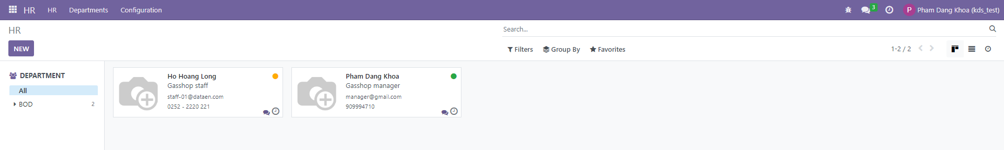

You can also view employee information in detail.

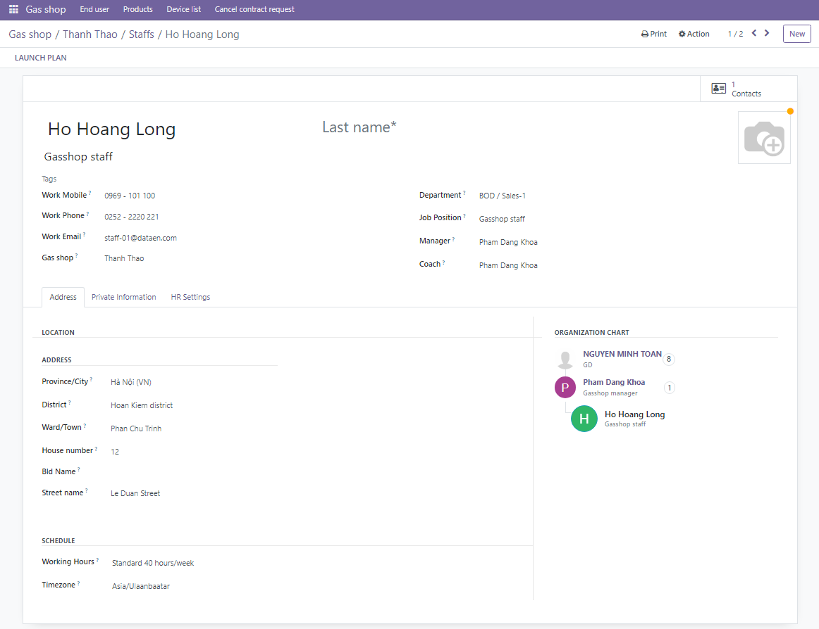

**3.4 Create gas shop products**

When registering gas shop products in the system:

Click Inventory > Products > New button to open the new product creation field and fill out the form to fill in the details about the new product.

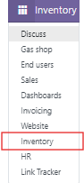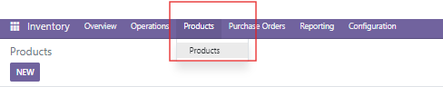

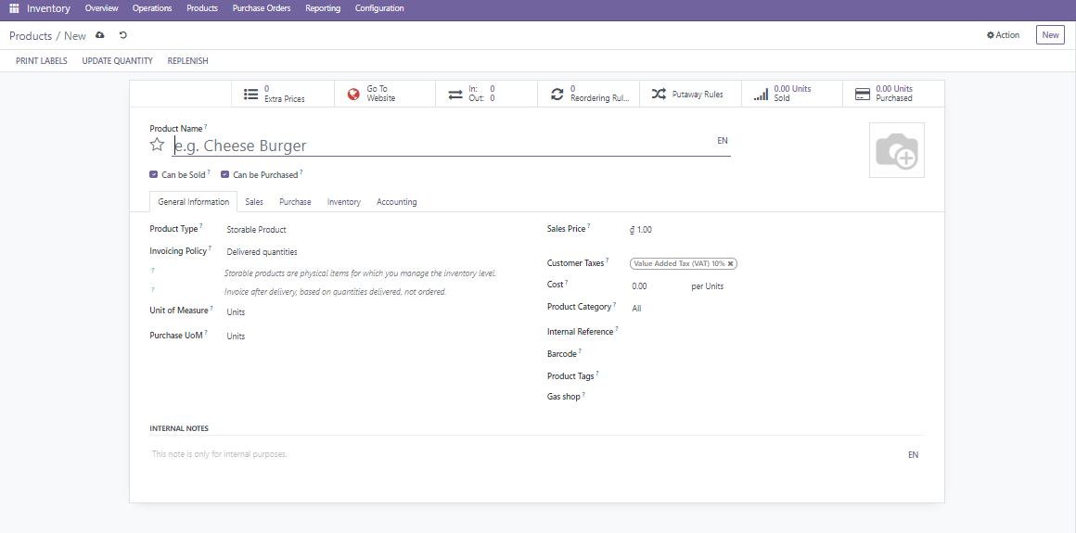

**Product Name:** Enter the name of the product.

**Can be sold:** This option indicates that the product is available for sale to your customers.

If this box is checked, the product will be available in the Sales module and can be added to sales orders.

**Can be purchased**:This option indicates that the product can be purchased from suppliers.

If this box is checked, the product will be available in the Purchase module and can be added to purchase orders.

**Product Type:** Choose from

**Consumable:** Consumables are physical products for which you don't manage the inventory level: they are always available.

**Stockable Product:** Storable products are physical items for which you manage the inventory level.

**Service:** Non-physical products or services.

**Sales Price:** The price at which the product will be sold.

**Cost:** The cost of the product.

**Product Category:** Assign the product to a specific category.

**Internal Reference:** An internal code for the product.

**Barcode:** If the product has a barcode, you can enter it here.

**Unit of Measure:** Specify the unit of measure for the product.

**Vendor:** If applicable, specify the vendor(s) from which you purchase this product.

**Gas shop:** Choose a gas company to sell the product

After completing the new product form, click the save button and the new product will be created in the system.

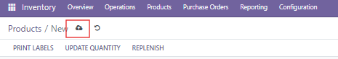

**3.5 Control goods registered in gas shop**

All products registered in the system can be viewed.

Information such as inventory of products in the warehouse, history of products purchased, quantity of products sold, and price of products can be viewed in a unified way on the system.

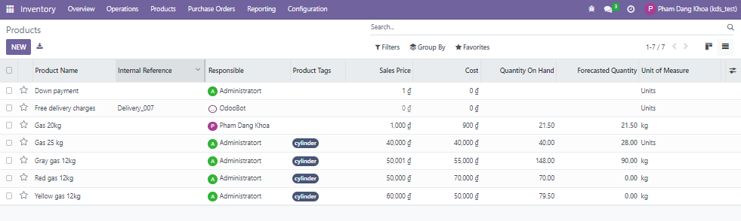

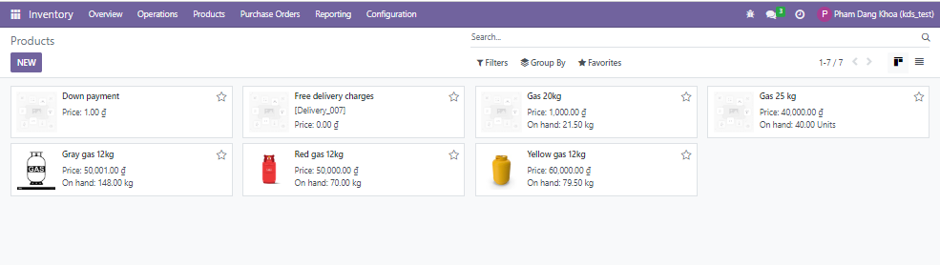

Select a product to view product details.

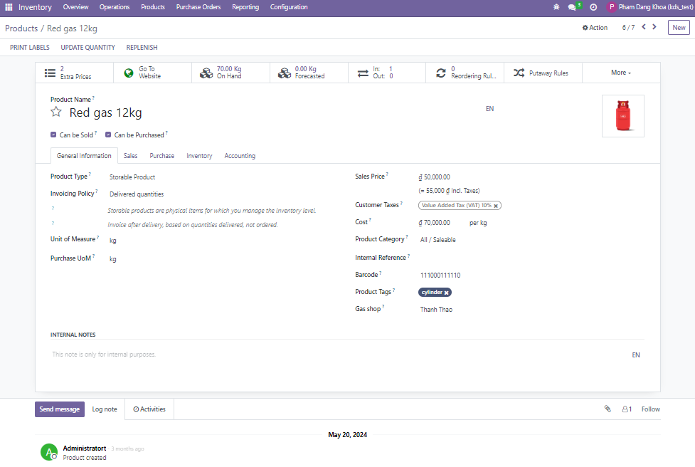

**Smart button**

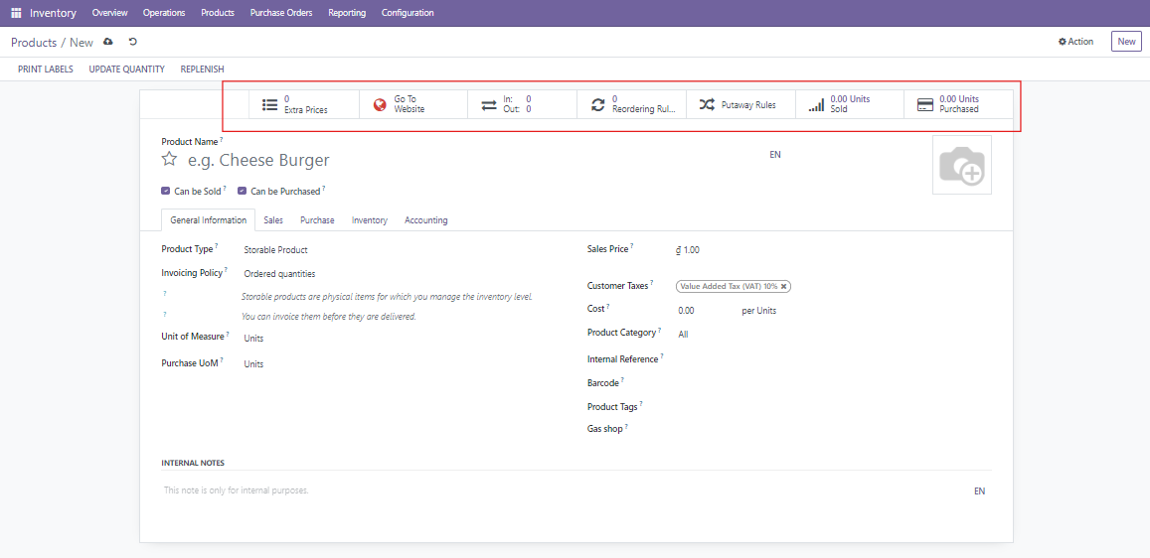

A smart button is a dynamic button that appears at the top of a product form view in the Inventory or Sales module. These buttons provide quick access to related records and actions that are relevant to the product you are viewing. Smart buttons are context-sensitive and update in real-time to reflect the current status of related operations.

Quick Access: Smart buttons allow you to quickly navigate to related records, such as sales orders, purchase orders, inventory adjustments, bills of materials (BoMs), and more.

Real-Time Information: The buttons display real-time counts or statuses, such as the number of sales orders or the current stock level for the product.

**On Hand:**

Purpose: Shows the current quantity of the product available in stock.

Action: Clicking this button allows you to view the detailed stock level, including which warehouses or locations hold the product.

**Forecasted:**

Purpose: Displays the forecasted stock level, taking into account incoming shipments, outgoing sales, and other planned inventory movements.

Action: Click to see how the stock level is expected to change over time.

**Sales:**

Purpose: Indicates the number of open sales orders that include this product.

Action: Clicking this button lets you view all sales orders that contain the product.

**Purchase**:

Purpose: Shows the number of open purchase orders for the product.

Action: Clicking it allows you to access the related purchase orders.

**Reordering Rules:**

Purpose: Indicates the number of reordering rules set up for the product.

Action: Clicking this allows you to view or create new reordering rules.

**Deletion and archiving of goods**

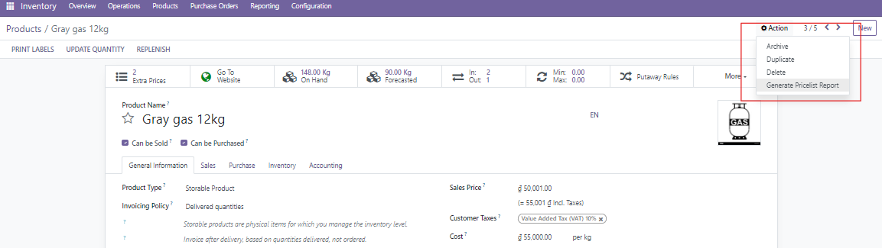

Delete: Permanently removes the product from the system.

Archive: Hides the product from active views but retains it in the system for potential future use or reference.

If you need to manage your products effectively, deciding whether to delete or archive will depend on whether you want to permanently remove the product or simply make it inactive while preserving its data.

**- Product Deletion**

Purpose: To completely remove a product from the system.

How to Delete a Product:

Navigate to Products:

Go to the Inventory or Sales module.

Click on Products > Products to access the product list view.

Select the Product:

Find the product you want to delete.

Click on the product to open its detailed view.

Delete the Product:

Click the Action button (or the three dots menu) in the top-right corner of the product form.

Select Delete from the dropdown menu.

Confirm the deletion when prompted.

Note: Deleting a product removes it permanently from the system. This action cannot be undone, so ensure that you really want to remove the product before proceeding.

**- Product Archiving**

Purpose: To remove a product from active lists without permanently deleting it, allowing for possible future use or reference.

How to Archive a Product:

Navigate to Products:

Go to the Inventory or Sales module.

Click on Products > Products to access the product list view.

Select the Product:

Find the product you want to archive.

Click on the product to open its detailed view.

Archive the Product:

Click the Action button (or the three dots menu) in the top-right corner of the product form.

Select Archive from the dropdown menu.

To View Archived Products:

Use the Filters option in the product list view.

Apply a filter for Archived to view products that have been archived.

Benefits of Archiving:

Data Preservation: Keeps historical data for reference without cluttering active lists.

Reusability: Archived products can be reactivated if needed.

**3.6 Create a end-user on the gas shop**

There are several options for creating a gas shop end user.

- Submit a request to become a user through the website

- Gas shop staff to create a new user on the app

- The gas shop manager has options to create a new user in the system.

In any case, when creating a new user (new user request), a request will appear in the field, which, if confirmed by the manager, will be approved by the system as a user.

When the gas shop manager receives a request from a new customer:

Gas shop > End user > New end user requests check new end user requests.

Name: Customer name

Status: Draft

User type: Master end user and Sub user

Created on: Date of application

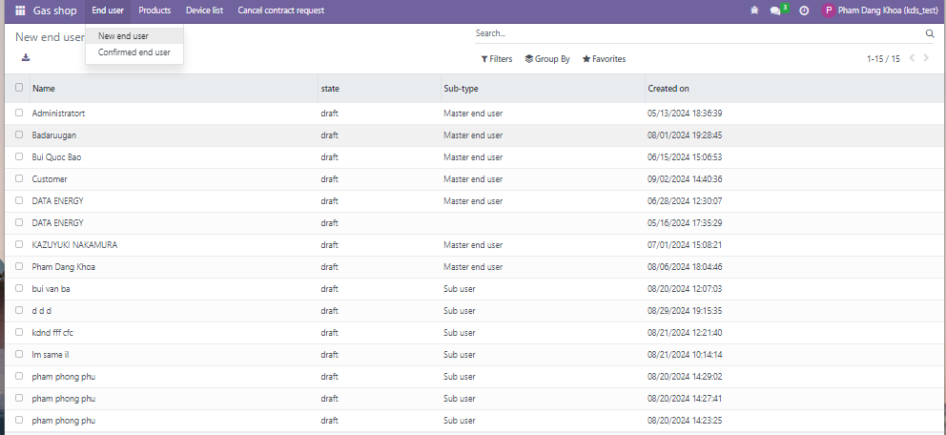

Click on the user's name to view detailed information about the user who wants to become a new user.

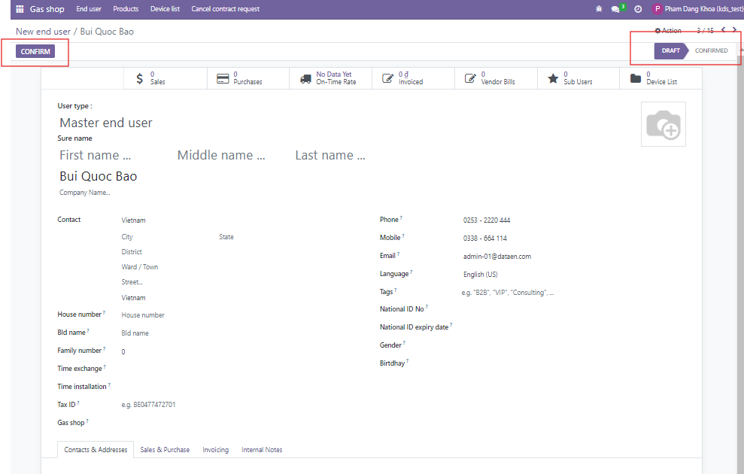

Before being allowed to become a user, the user is in draft status. If the manager checks the information and clicks the confirm button, the status will be confirmed and he will become a gas shop user.

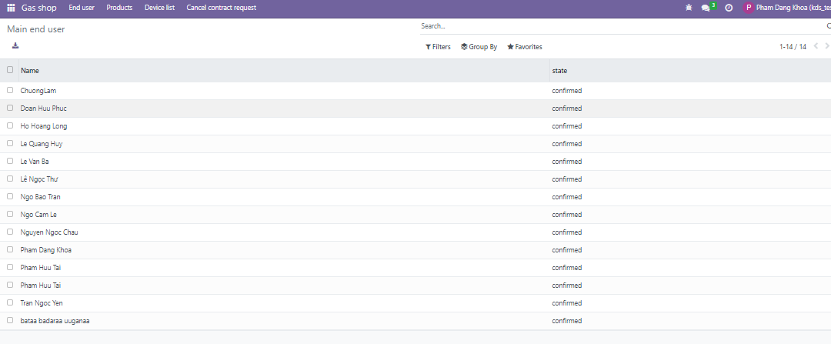

When a User self-submits a request to become a User through the Website:Go to the gas shop web address, click the Add end user button and fill out the form to become a new user.

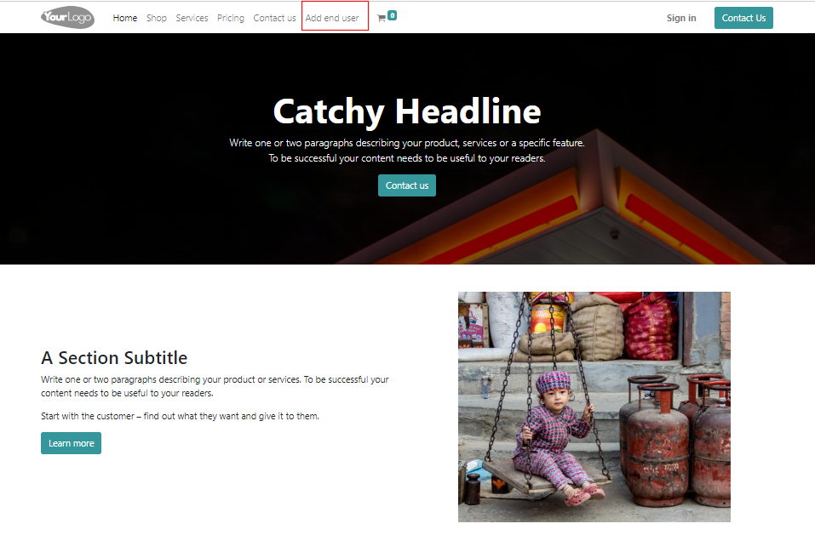

Fill out the new user request form completely and press the submit button, and the gas shop system will accept the request.

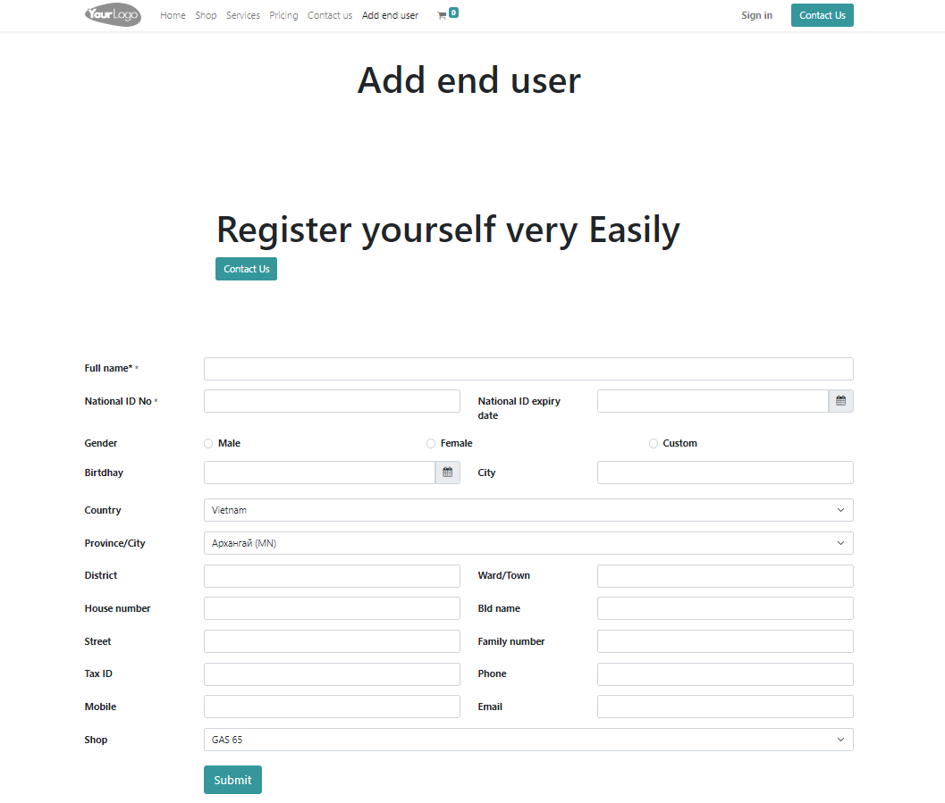

When creating a new customer, the gas shop manager:

Click the End user > New button in the system and fill in all the fields in the new user creation section. After registering the user information, click the save button to create a user request. After that, click the Confirm button to confirm the user.

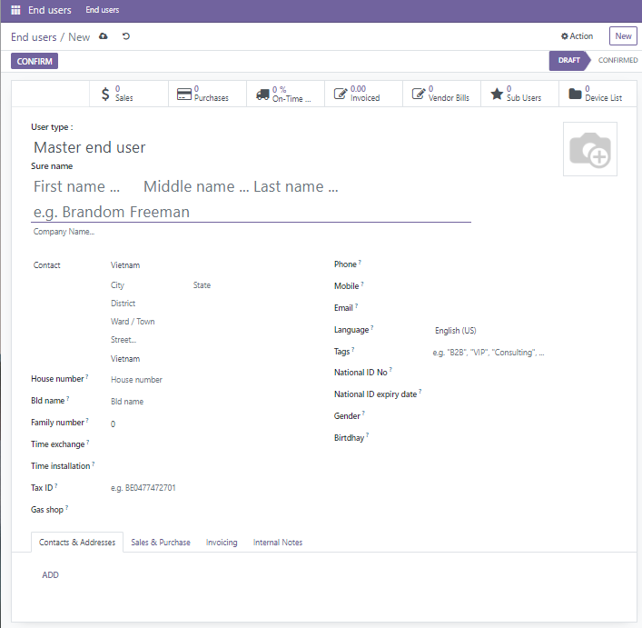

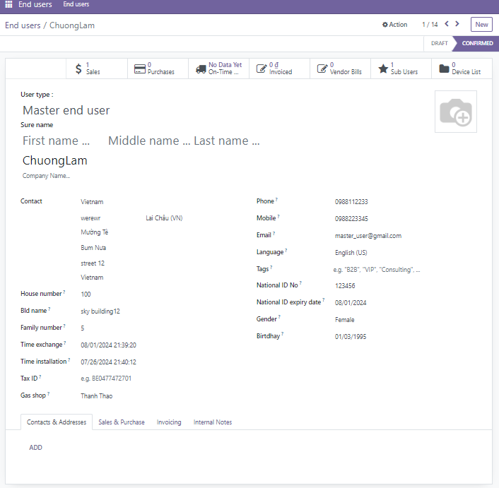

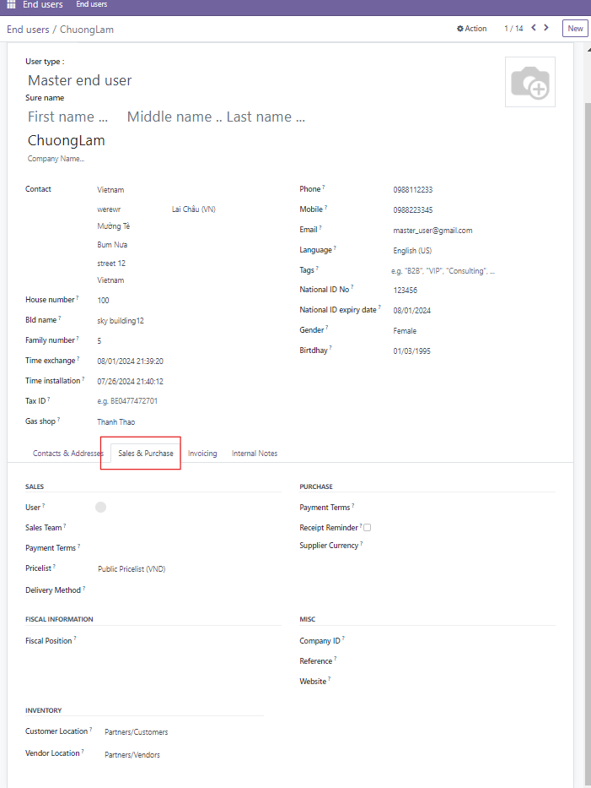

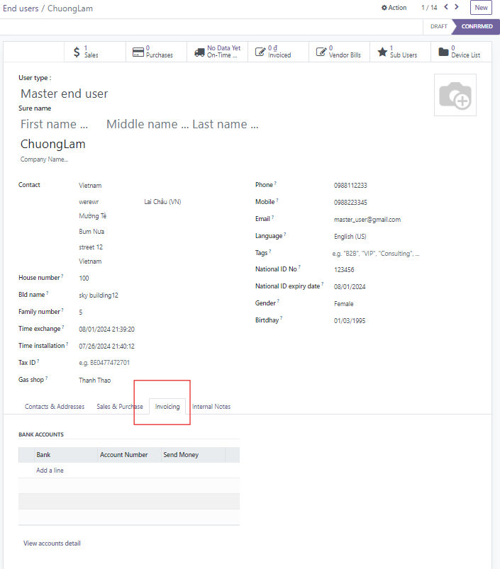

1. **Sales and Purchase**

**4.1 Create a purchase**

The gas shop registers its supplier in the system before making a purchase.

When placing a purchase order, click **Inventory > Purchase orders > New** to create a new purchase order.

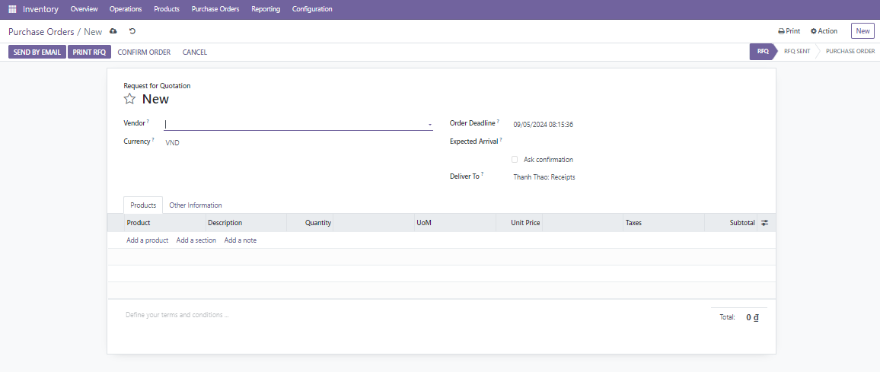

**Vendor:** Select the supplier organization from the system register

**Currency:** Select the currency for purchasing products from the system register.

**Order deadline:** Select the deadline for confirming the order of products from the system.

**Expected arrival:** The Expected Arrival Date for a Purchase Order indicates when the purchased products are expected to be delivered by the supplier. Setting an expected arrival date helps plan your inventory and manage your supply chain efficiently.

Use Cases for the "Ask for Confirmation" Checkbox:

**Check box Ask confirmation:** Large or Critical Orders: You can use this feature to ensure that large or critical purchase orders are reviewed and approved by senior staff before proceeding.

**Deliver to**: Select the warehouse to receive the products.

**Product tab**

**Product:** This is the product or service you are ordering from the vendor.

You can either select a product from the dropdown list (based on your product catalog) or create a new product directly from the purchase order.

If you select a product already configured in System, it will automatically pull in details like the description, price, and unit of measure.

**Description:** The product description provides additional details about the product.

It may be auto-filled when you select the product, but you can also edit it to add more specific information for the vendor.

**Quantity**: This field specifies how many units of the product you are ordering.

If the product is measured in a specific unit (e.g., kilograms, liters, units), the relevant unit of measure will appear here.

**Unit of Measure (UoM):** Specifies the unit in which the product is measured (e.g., units, kilograms, meters, etc.).

System uses UoMs for inventory tracking and purchasing purposes, ensuring you order the correct quantities.

You can configure different UoMs for each product (e.g., purchase by the box but sell by the unit).

**Unit Price:** This is the price per unit of the product. System will typically pull the price from the vendor's price list if it’s available.

You can adjust this price manually if needed.

The price is exclusive of taxes by default, but this can be customized..

**Subtotal:** This is a calculated field that shows the total cost for the product line based on the quantity and unit price. The formula is:

Subtotal = Quantity x Unit Price

The subtotal does not include taxes.

**Delivery Date (Scheduled Date):** This is the date when the product is expected to be delivered by the vendor.It’s an important field for managing supply chain operations and planning inventory. Each product line can have a different delivery date if needed.

**Discount**: If any discount is offered by the vendor, you can apply it to the product line. This will adjust the final cost accordingly.

**Procurement/Shipping Rules:** System manages how the products will be received based on the procurement method. For example, the product might be drop-shipped directly to a customer or received in a warehouse. Depending on how your business operates, this field ensures proper tracking of the product.

**Total:** The total amount for the purchase order line, including taxes, is displayed here.

This is calculated automatically based on the subtotal and applicable taxes or discounts.

**Other information tab**

**Buyer:** The Buyer or Purchase Representative is the person within your organization responsible for managing a specific Purchase Order (PO). This field ensures accountability and helps track who is overseeing the purchase process, including communication with the vendor, following up on deliveries, and managing any issues related to the order.

**Gas shop:**  Information about the gas shop where products are purchased is displayed in this section.

**Payment terms:**The Payment Terms field specifies how and when the vendor will be paid for the goods.Options may include immediate payment, 30-day terms, or customized terms agreed upon with the vendor.These terms will appear on the Purchase Order and vendor bill to ensure clarity on the payment schedule.

**Fiscal position:**Fiscal Position helps in configuring the tax-related rules for a Purchase Order.

It allows you to automatically apply specific taxes or account settings based on the location of the vendor or other rules. You can define a fiscal position in this field to adapt tax rules for local or international suppliers.

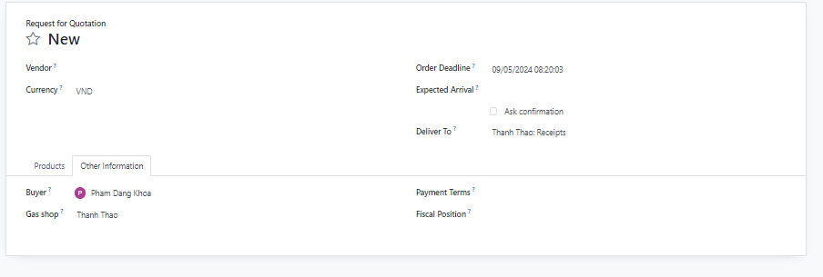

You can see the list of purchase orders in the Purchase order section.

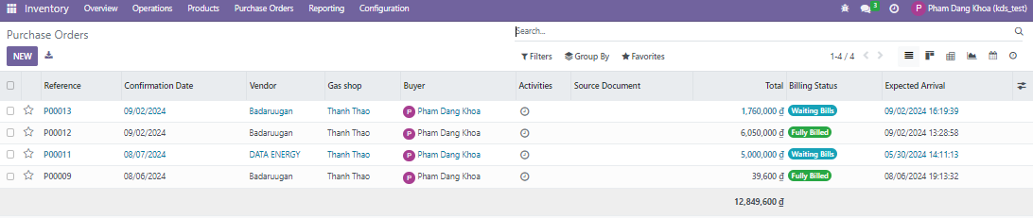

**Reference:** The unique identifier for the Purchase Order. It’s typically generated automatically by System, but you can configure it based on your naming conventions.

**Confirmation date:**The date when the Purchase Order was created or confirmed.

This field helps in tracking the timeline of procurement and can be used to monitor pending orders.

**Vendor:** The supplier or vendor from whom you are purchasing the goods or services.

**Gas shop:** Information about the gas shop where the order was placed

**Buyer:** The employee responsible for handling the Purchase Order. This field is useful for assigning and tracking who is managing the order within your team.

**Total:** The total amount of the Purchase Order, including taxes.

**Status:** The current status of the Purchase Order. The status helps track the progress of the order through various stages.

RFQ: Request for Quotation sent to vendor.

Purchase Order: Order confirmed.

Locked: Order is finalized and can’t be modified.

Done: Order fully processed.

Canceled: Order canceled.

**Receipt Status:** Shows the status of product receipt.

Nothing to Receive: No products have been received yet.

Partially Received: Some of the products have been received.

Fully Received: All products have been received.

**Expected arrival:**

**Received status:**Shows the status of product receipt.

Nothing to Receive: No products have been received yet.

Partially Received: Some of the products have been received.

Fully Received: All products have been received.

By receiving the ordered goods in the warehouse and confirming them in the system, the quantity of goods that can be sold will increase accordingly.

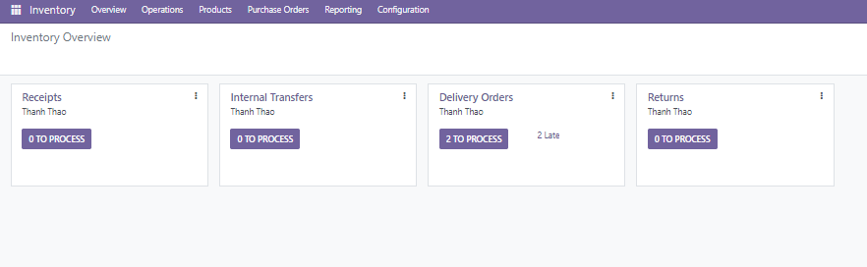

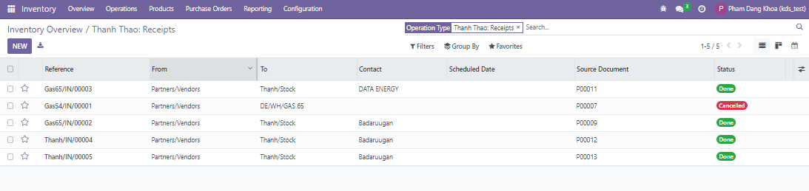

When viewing the product balance in the system, you can see the current product balance in the (On hand) section.

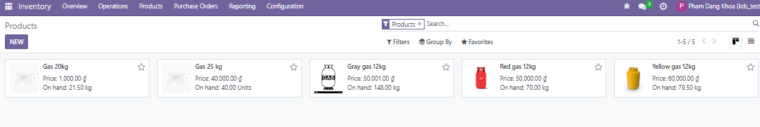

**4.2 Create a sales order**

The Sales module is used to manage all aspects of a company’s sales process, from generating quotations to invoicing customers. This module integrates with other System apps like Inventory, Accounting, and CRM to create a seamless flow of information and streamline the sales pipeline.

Key Features and Workflow of the Sales Module:

**Quotations:**

A quotation is a document sent to a customer to propose a sale. It outlines the products or services, quantities, pricing, and payment terms.

In System, quotations are the first step in the sales process. Once accepted by the customer, the quotation can be converted into a Sales Order.

Quotations can include:

- Customer details

- Products or services

- Payment terms and conditions

- Delivery terms

- Taxes

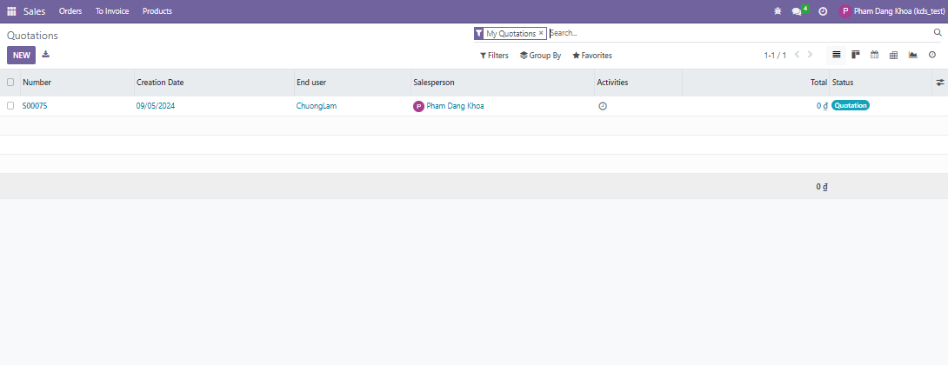

**4.3 Approve sales orders:**

After a customer accepts a quotation, it is confirmed and converted into a Sales Order (SO).

Sales Orders serve as the contract between the company and the customer.

They outline what needs to be delivered, when, and at what price.

Sales Orders trigger various actions such as:

- Stock reservation: System automatically reserves stock for the order.

- Delivery orders: Sent to the warehouse to fulfill the order.

- Invoicing: When the order is fulfilled, an invoice can be generated.

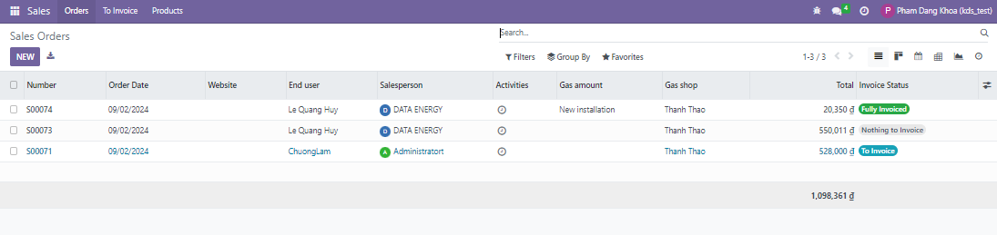

**Products and Price Lists:**

* System allows you to manage both **products** (physical goods) and **services** (intangible goods).
* **Pricelists** can be set up to apply different prices for specific customers, regions, or quantities. These can be fixed or dynamic based on conditions like the date of the sale or customer tier.
* You can also define discount policies and promotional pricing.

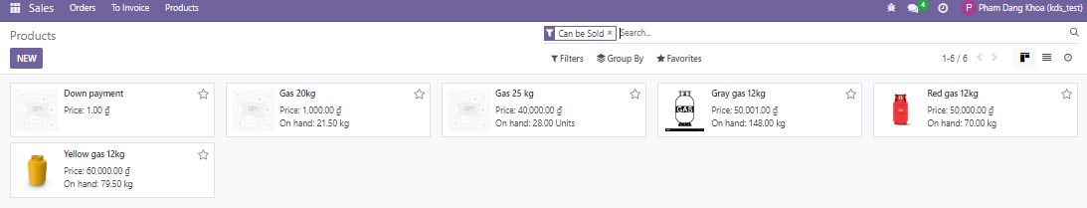

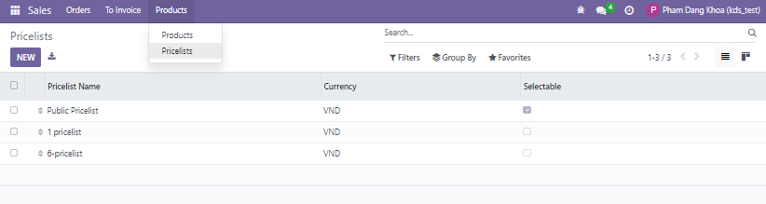

**4.4 Sales delivery**

* System handles delivery management by linking sales with inventory. Once a Sales Order is confirmed, a **delivery order** is automatically created and sent to the warehouse team.
* The delivery order ensures that the right products are picked, packed, and shipped to the customer.
* You can track the status of deliveries, assign specific carriers, and calculate shipping costs.

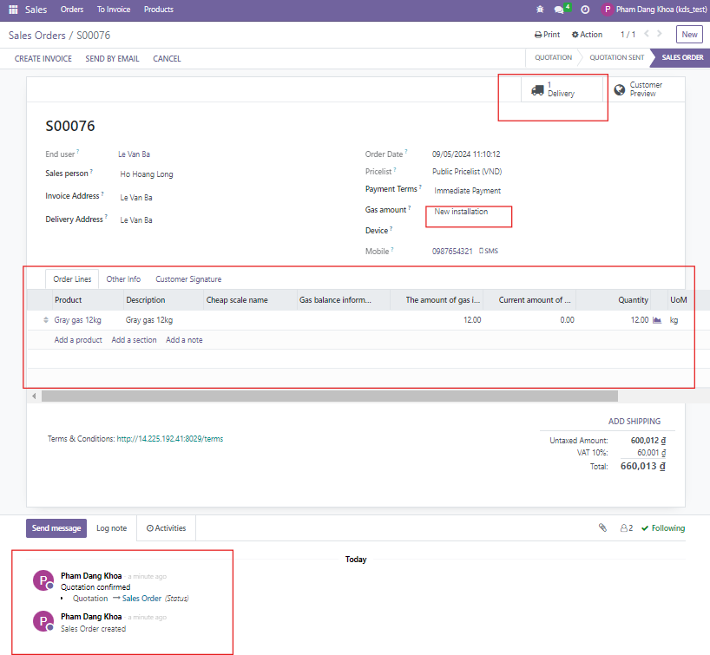

Click on the Delivery button and confirm the delivery by clicking on the Validate button, then the item will be removed from the warehouse. And by confirming the delivery, customers will create a claim.

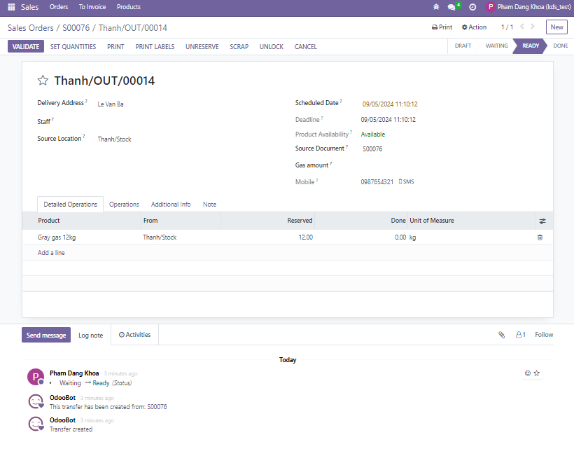

**4.5 Invoice**

Invoicing in system can be done based on different triggers:

* **On Sales Order Confirmation:** Generate an invoice as soon as the Sales Order is confirmed.
* **On Delivery:** Create an invoice after the products have been delivered.
* **Milestone-based invoicing** for services.
* System supports various payment terms, allowing customers to pay immediately, after delivery, or on a credit basis (NET 30, NET 60, etc.).
* Integration with the **Accounting module** ensures invoices are tracked, payments are recorded, and accounts receivable are updated in real-time.

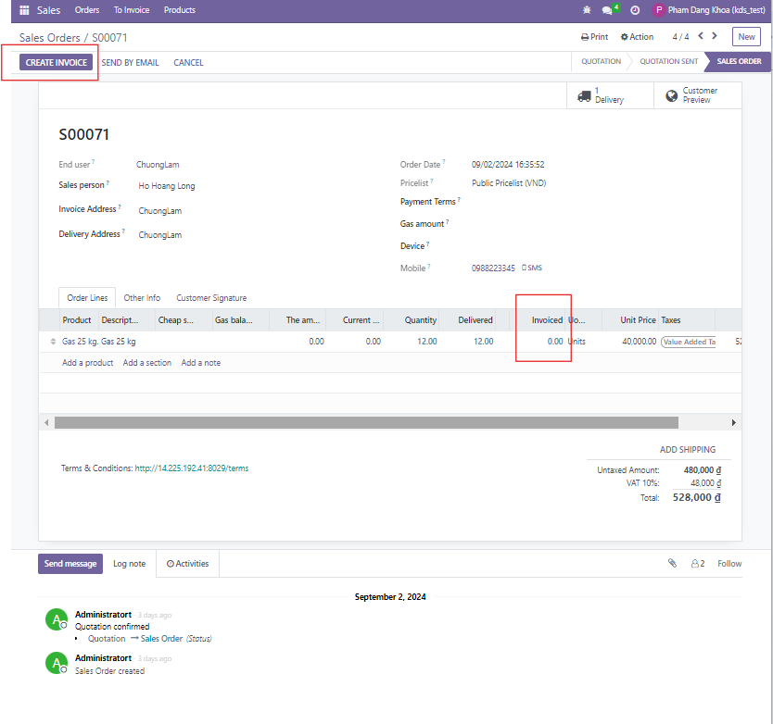

Create invoice by clicking Create invoice button.

Before approving the resulting claim, the amount related information will be checked. At this time, the claim is in Draft status.

After confirming, the status will be changed to Posted. It will also be sent to the user's e-mail address and registered social address.

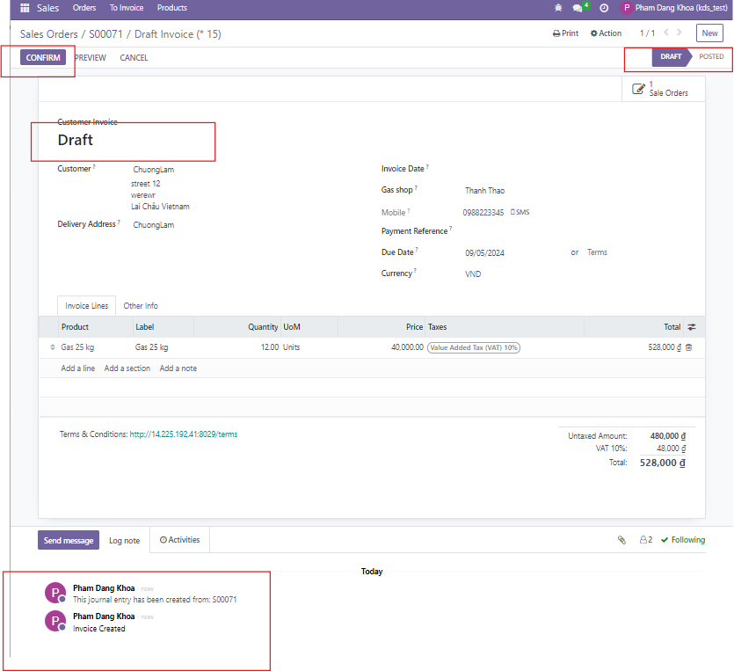

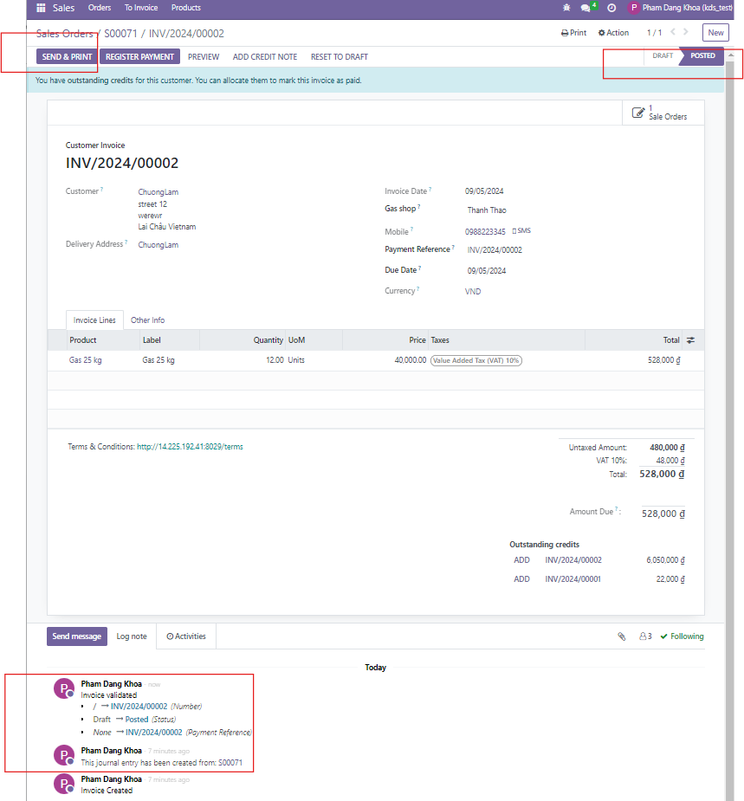

**4.6 Payment**

The payment terms specified in the customer contract are recorded in the system.

After the claim is created, a button will appear to make a payment, click on the button to start the payment process.

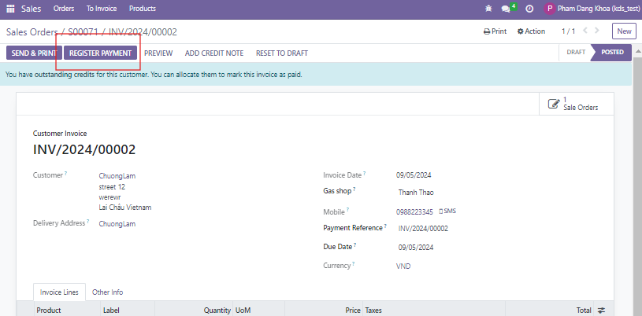

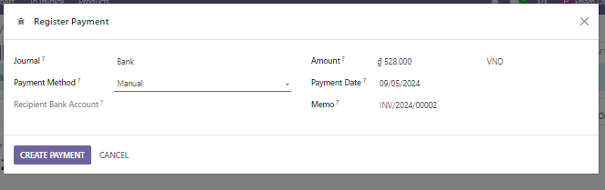

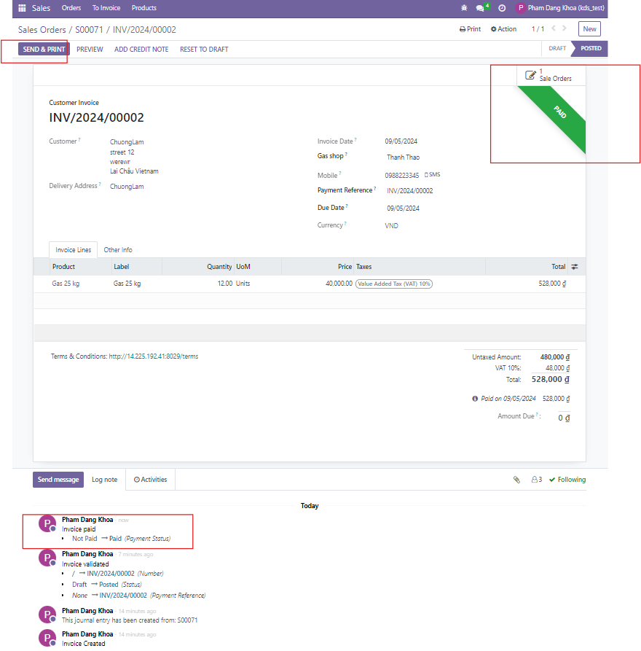

**Customer Management:**

* System’s Sales module includes detailed customer management features, including:
  + **Customer information:** Store contact details, delivery addresses, and payment terms.
  + **Sales history:** View the customer’s past orders, invoices, and payments.
  + **Customer-specific pricing:** Apply specific price lists, discounts, and taxes.

**Reporting and Analytics:**

* The Sales module includes robust reporting tools that allow you to analyze key performance indicators (KPIs) such as:
  + **Sales volume by product, region, or salesperson.**
  + **Profit margins and discounts applied.**
  + **Customer purchasing behavior.**
  + **Sales pipeline performance** through the integration with CRM.
* Reports can be customized to focus on various metrics, such as **monthly sales**, **sales forecasts**, or **sales performance by product category**.