**PHOTOGRAPHIC ESSAY**

**By: Phanuel Iyaya Makhakha**

**Reg: C025-01-0962/2015**

# TOPIC: Rescuing youths from drug use on Kenya's Indian Ocean coast

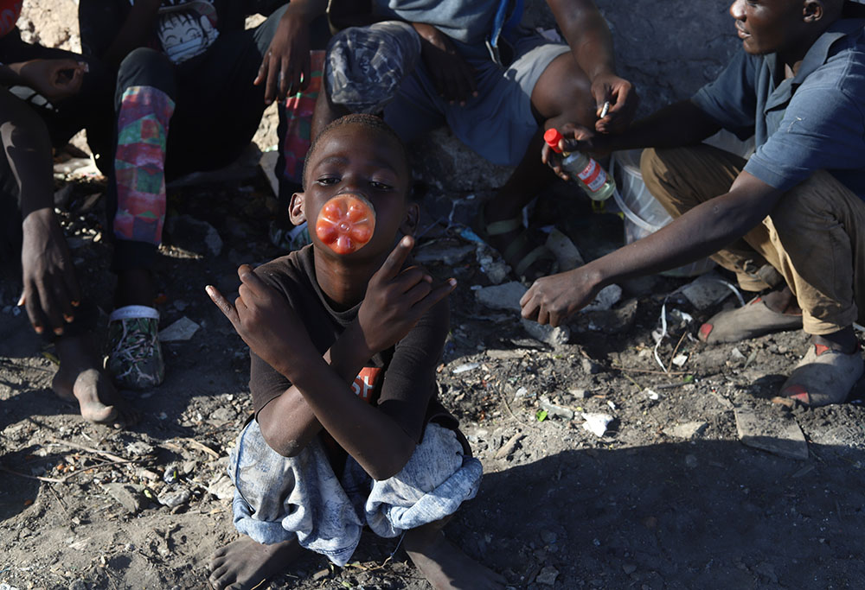

A child sniffs toxic glue from a plastic bottle on the streets of Mombasa, a coastal city in southeastern Kenya on the Indian Ocean. The high rate of youths using drugs has visibly affected their lives and the safety of the region. (GSR photo/Doreen Ajiambo)

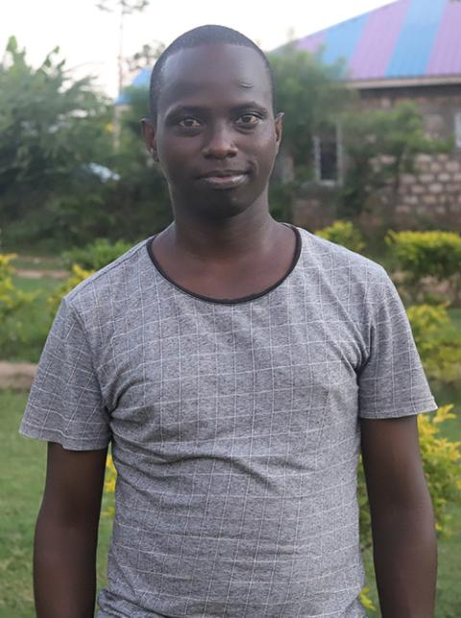

Caleb Kanja, 27, now pursuing a degree in economics at a local university in Kenya, is a beneficiary of the Grandsons of Abraham Rescue Centre in Mombasa. (GSR photo/Doreen Ajiambo)

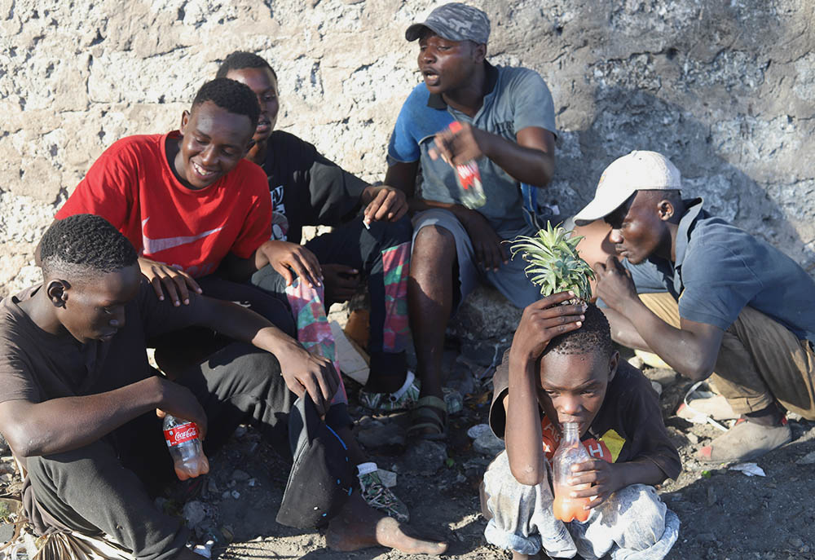

Youths meet for their daily dose of heroin, cocaine and other drug substances in Kenya's coastal region on the Indian Ocean. Addiction has become rife and is visibly affecting the lives of youths in the tourist region. However, the Sisters of St. Joseph of Mombasa are rescuing some youths from the streets, rehabilitating them before reuniting them with their families. (GSR photo/Doreen Ajiambo)



St. Joseph Sr. Veronica Wanjiru is a medical director at Mother Amadea Mission Hospital in Mombasa, Kenya. Wanjiru treats patients who struggle with substance abuse once they reach the Grandsons of Abraham Rescue Centre. (GSR photo/Doreen Ajiambo)

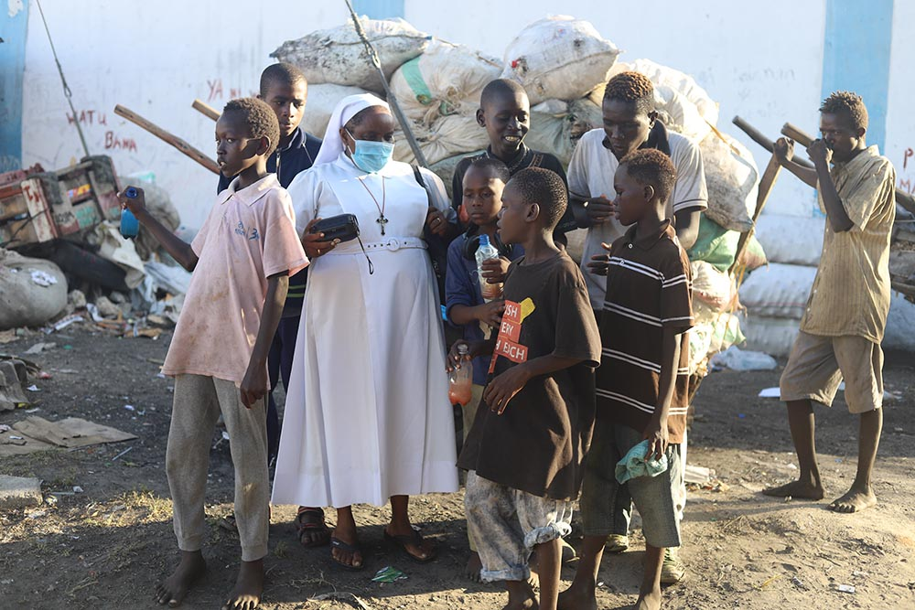

Sr. Jane Frances Kamanthe Malika puts on music from her radio to entertain children from the streets and encourage them to come to the Grandsons of Abraham Rescue Centre. The Sisters of St. Joseph of Mombasa are rescuing youths addicted to drugs from the streets, then rehabilitate them before remitting them back to their families or relatives. (GSR photo/Doreen Ajiambo)

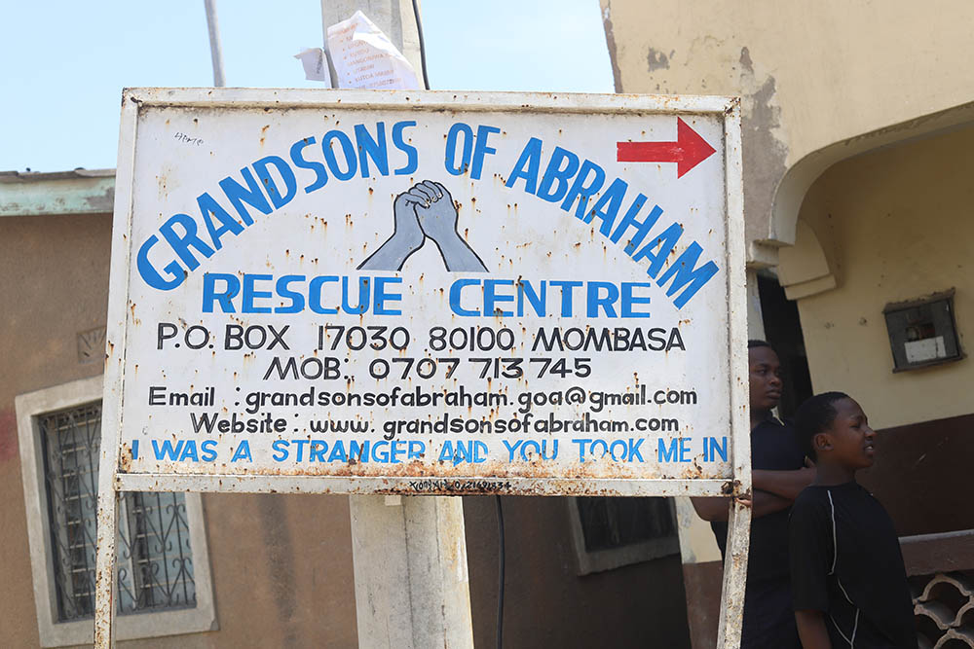

A signpost marks the Grandsons of Abraham Rescue Centre in Mombasa, a coastal city in southeastern Kenya along the Indian Ocean. The center works with the community to rescue drug-addicted street children and rehabilitate and reunite them with their families. (GSR photo/Doreen Ajiambo)