

Interaction design

Final project



Team members:

Nguyễn Quốc Thắng

Nguyễn Quang Khải

Phan Việt Thuần

# TABLE OF CONTENTS

TABLE OF CONTENTS 1

1. Personas and scenarios: 2

1.1 User class 1 2

1.2 User class 2 2

1.3. User class 3 2

2. Scenario 3

2.1. Scenario 1: 3

2.2. Scenario 2: 3

2.3. Scenario 3: 4

3. Create a flow diagram for each scenario: 5

3.1 Flow diagram 1 : 5

3.2 Flow diagram 2: 6

3.3 Flow diagram 3: 7

4. Create a sitemap 8

5. Sketches of all screens 9

6. Design pattern 16

7. Build a wireframe 21

8. High-Fidelity clickable prototype 22

# Personas and scenarios:

## 1.1 User class 1

*Clark Andrews (*Software Developer*)*

**Age:** 29 **Gender:** Male

Clark is a software engineer who has worked for Microsoft Corporation for six years. He devotes all of his time to the firm. Except for leisure and self-care, he works from 10 to 12 hours every day. He doesn't have time to clean and tidy the house since he spends all of his time at work. He wants to discover a service that would assist him clean the house while he is at work.

## 1.2 User class 2

*Susan Johnson (*Marketing consultant*)*

**Age:** 46 **Gender:** Female

Susan is a successful businesswoman in Sydney during 20 years of hard work. She doesn't have time for herself because she has so much to accomplish. So, while on a business trip, she fainted after falling down the stairs owing to physical weakness. When she got to the hospital, the doctor informed her that she had broken her leg and would need 6 months to recuperate.

As a result, she can't take care of herself like she used to. Looking for someone to take care of the food and clean the house.

## User class 3

*Andrew Tate (*Freelance*)*

**Age:** 35 **Gender:** Male



Andrew is a successful businessman in Romania during 10 years of hard work. He doesn't have time for himself because he has so much to accomplish. He used to have a boxing career before become an entrepreneur, he’s now successful and looking for a maid/butler/assistant to help him maintain his house.

# Scenario



## Scenario 1:

Clark devotes full time to the company. He doesn't have time to clean and tidy the house because he spends all his time at work. He wanted to find a service that could help him clean the house while he was at work. App Homemaid helps him hire a maid when he goes to work, so he goes to the app and selects the function "Cleaning the house" then chooses to fill in the information related to the house, the app will schedule a time to help him.

## Scenario 2:

Susan is a successful businesswoman and she always works hard but unfortunately, she has an accident so she needs a housekeeper. So, she researched and signed up for an app to hire someone to do the housework for her when she had an accident.

## Scenario 3:

Andrew is a boxer so when he competes, he needs a maid to clean up for him. So, he used the app and choose the "one-time clean" option for each commute.

# Create a flow diagram for each scenario:



## Flow diagram 1 :

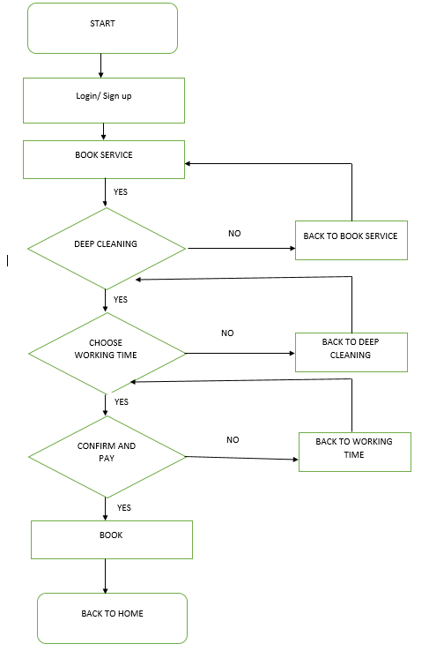

## Flow diagram 2:

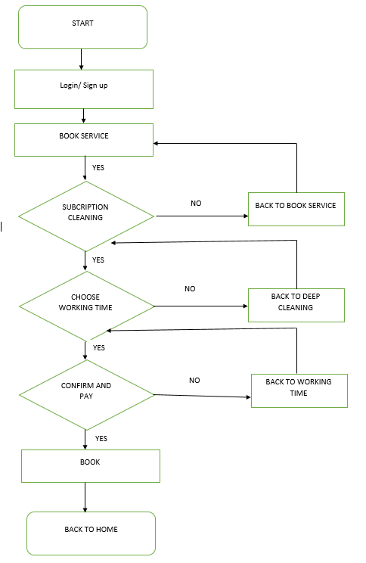

## Flow diagram 3:

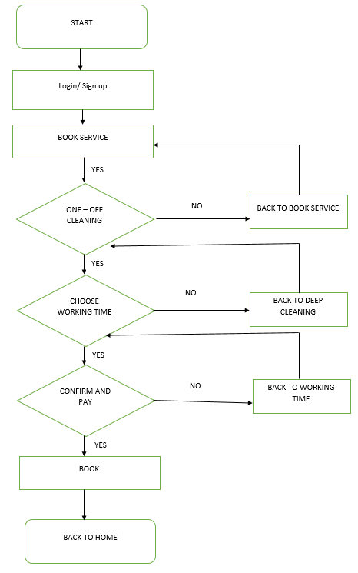

# Create a sitemap

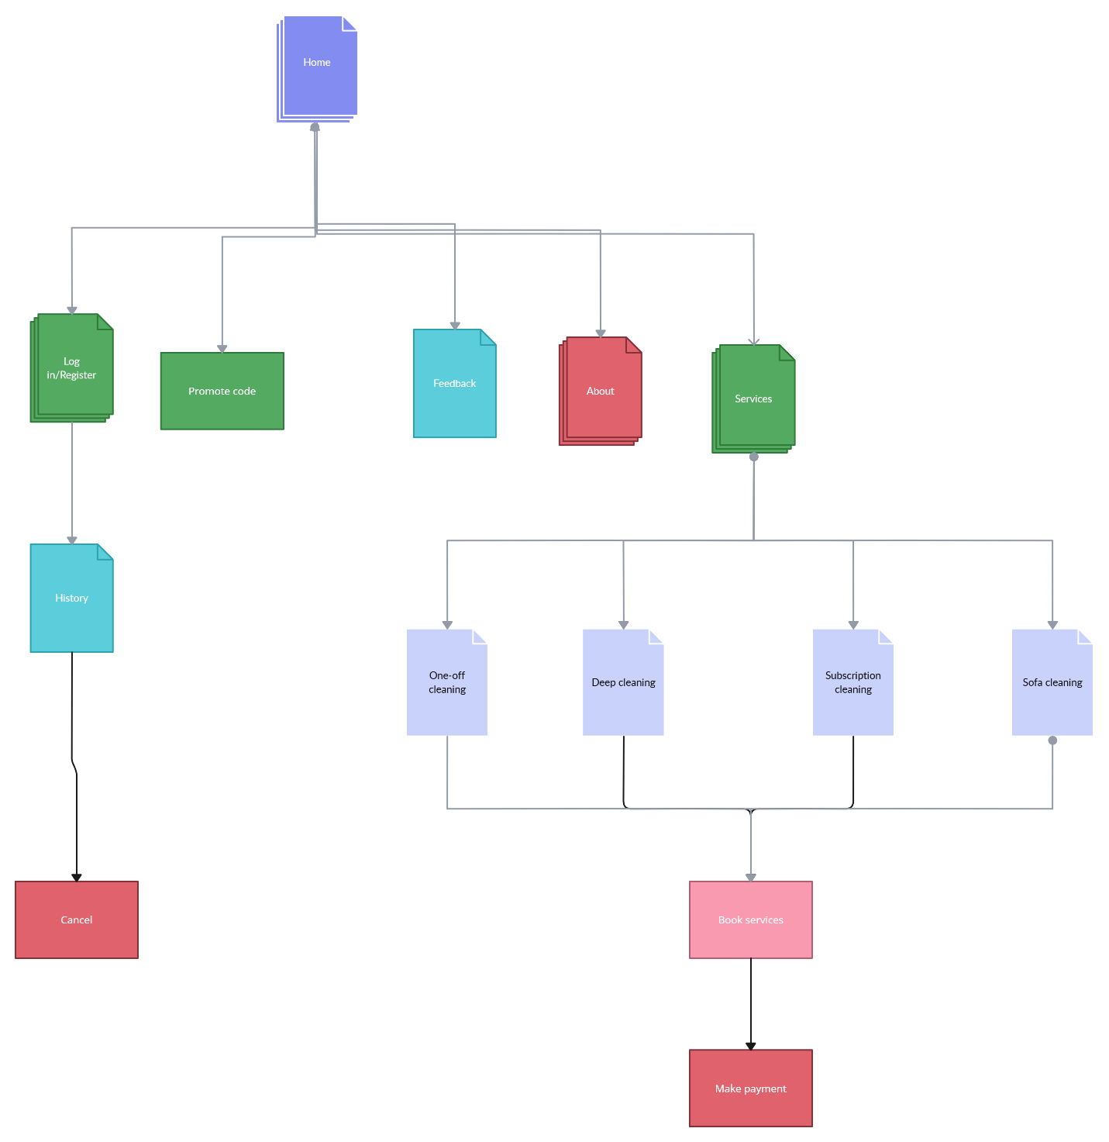

# Sketches of all screens

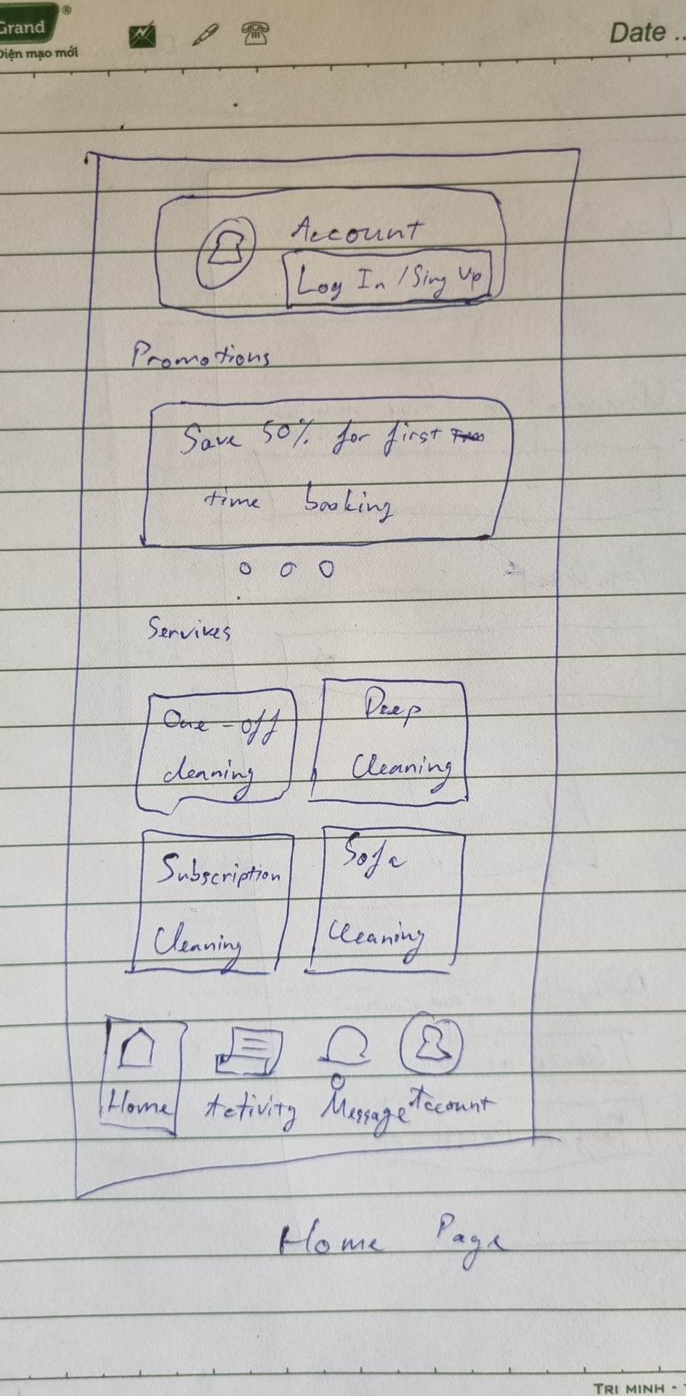

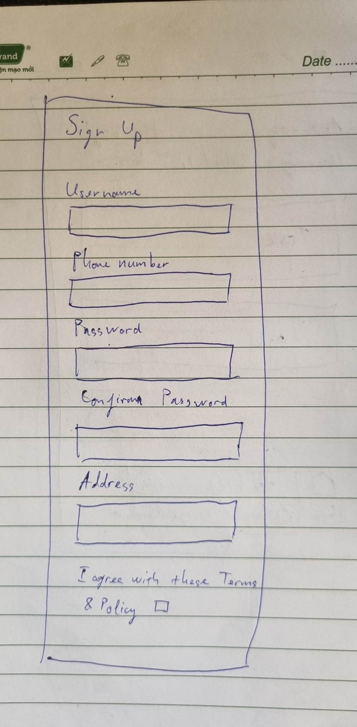

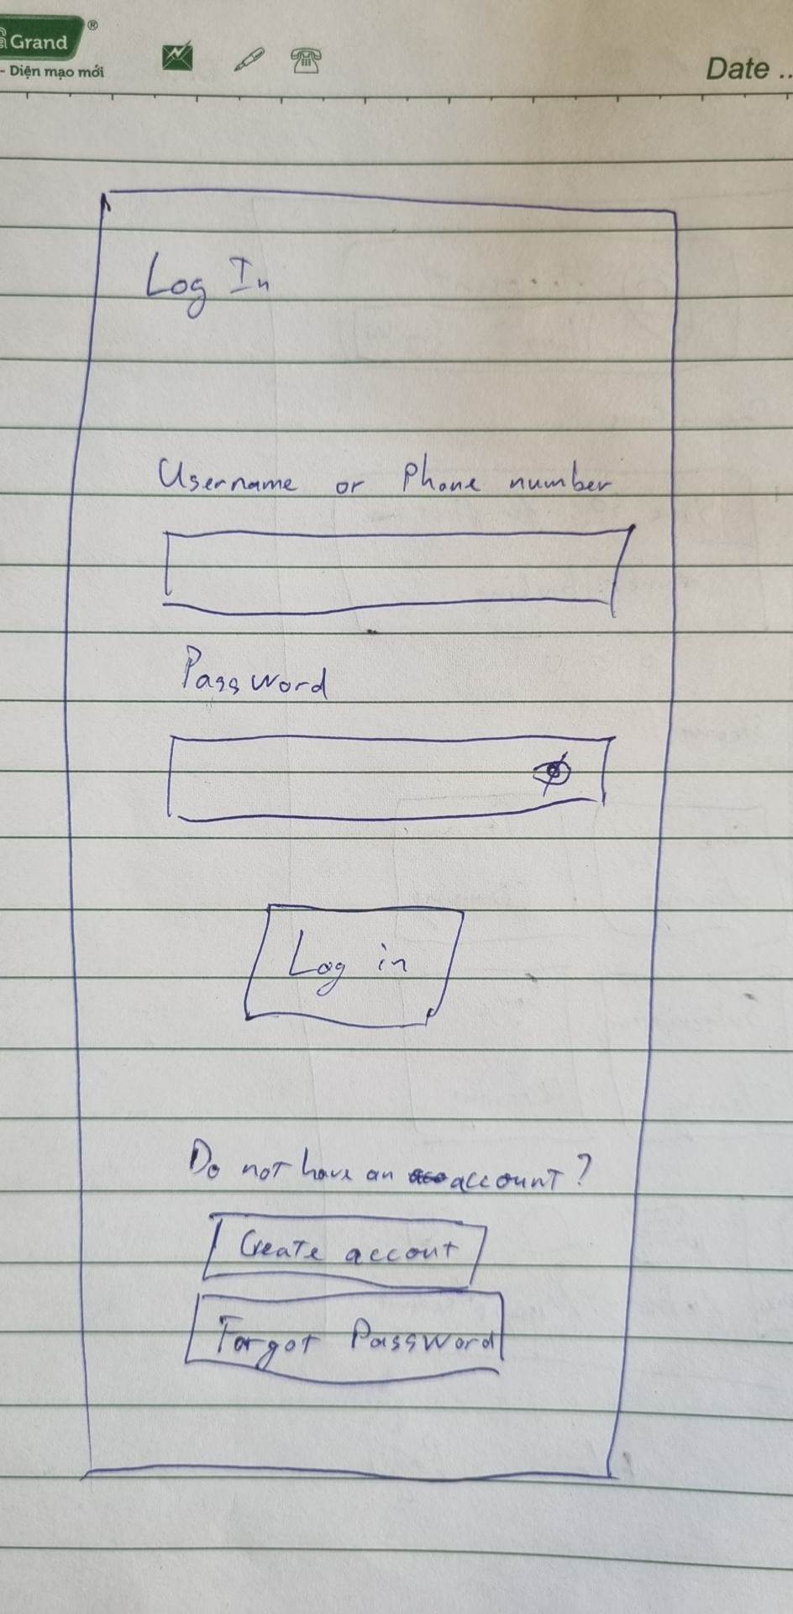

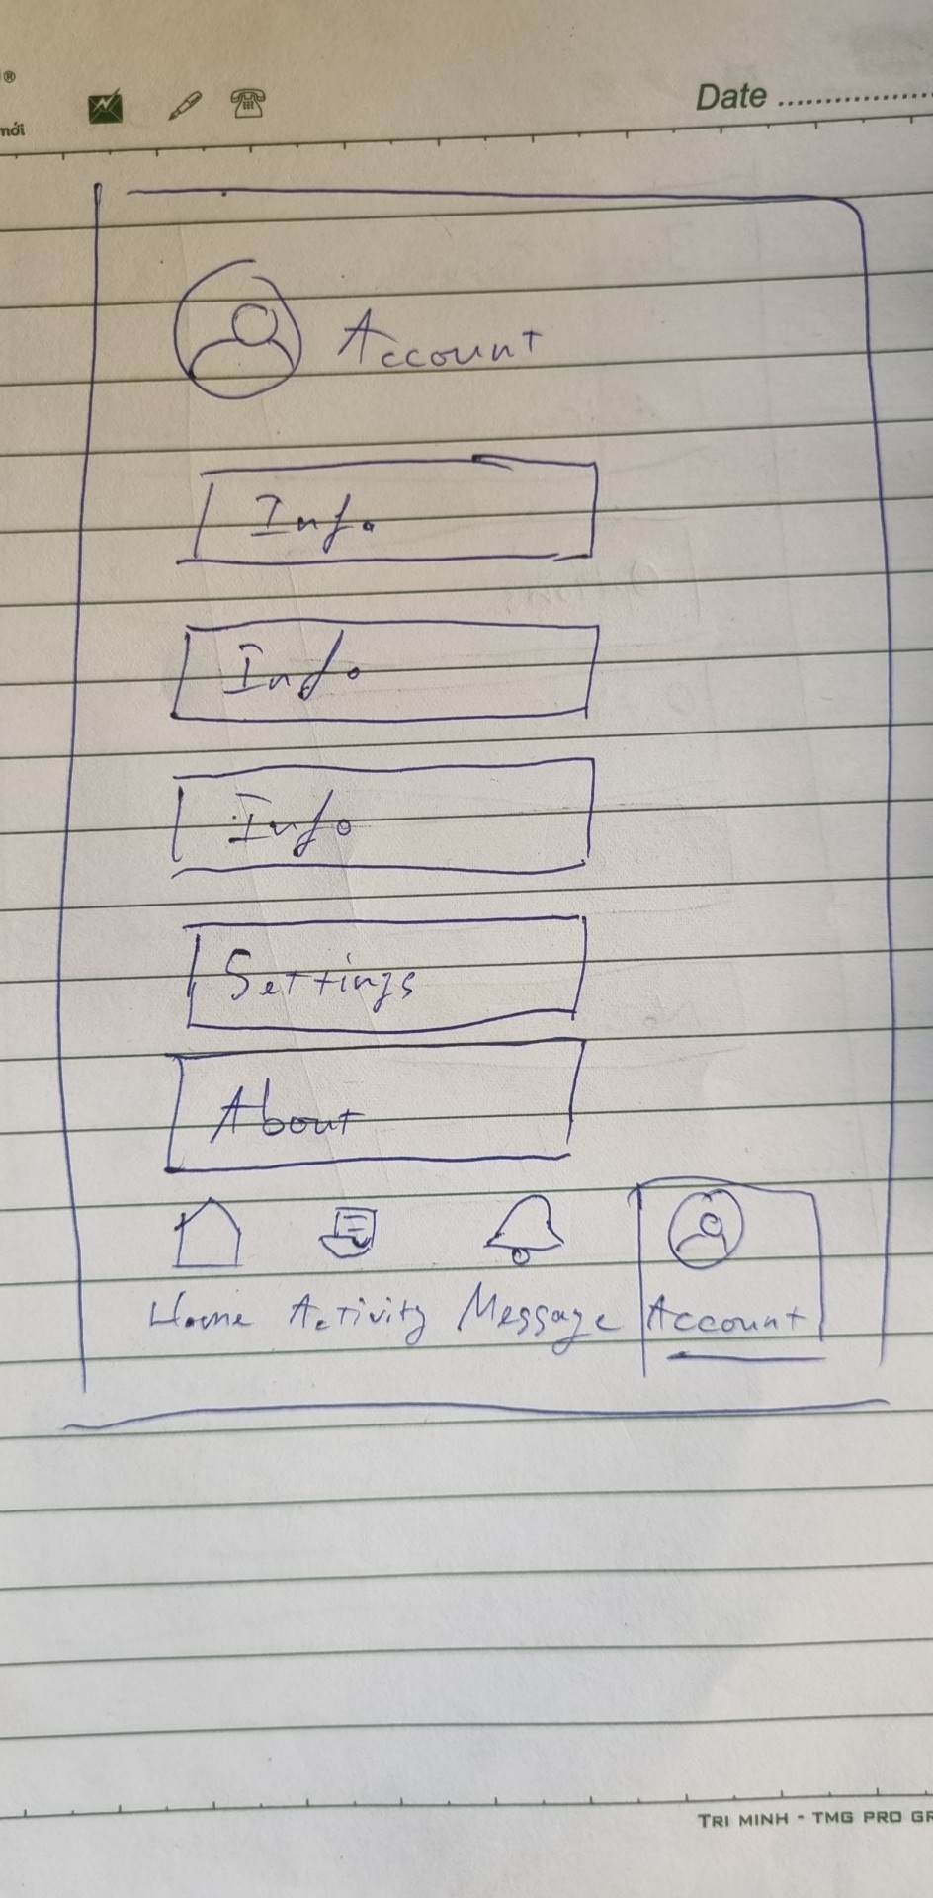

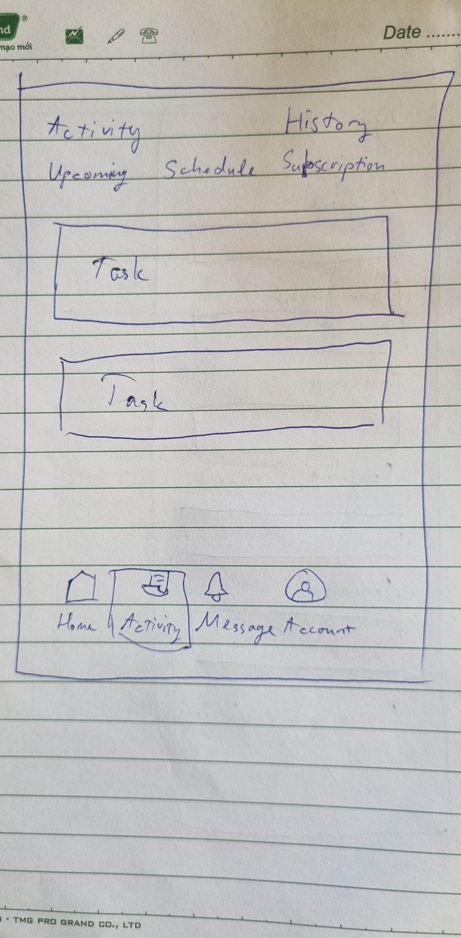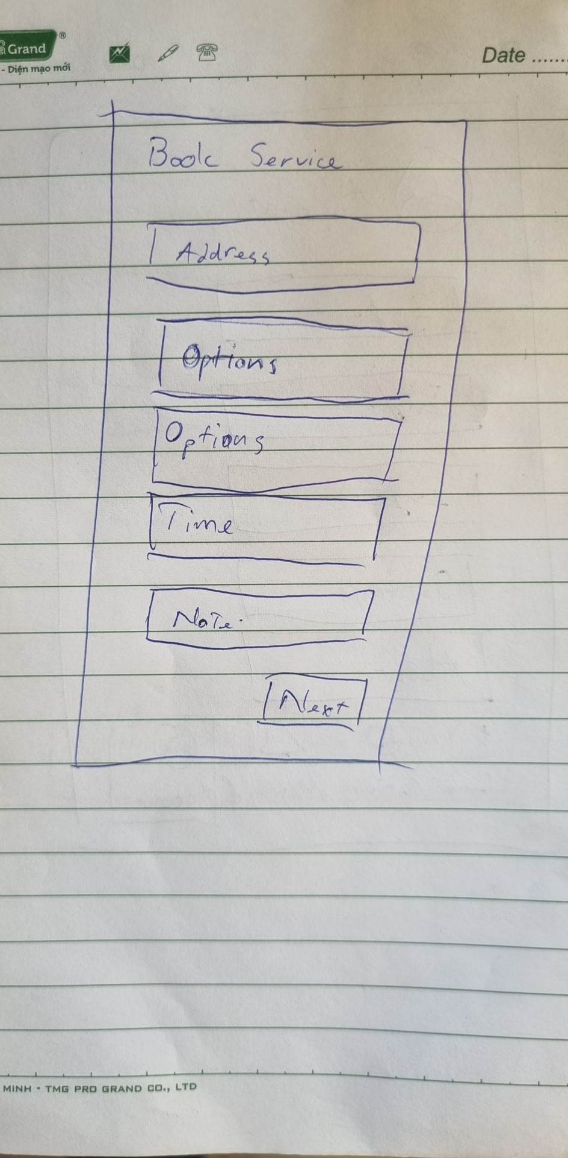

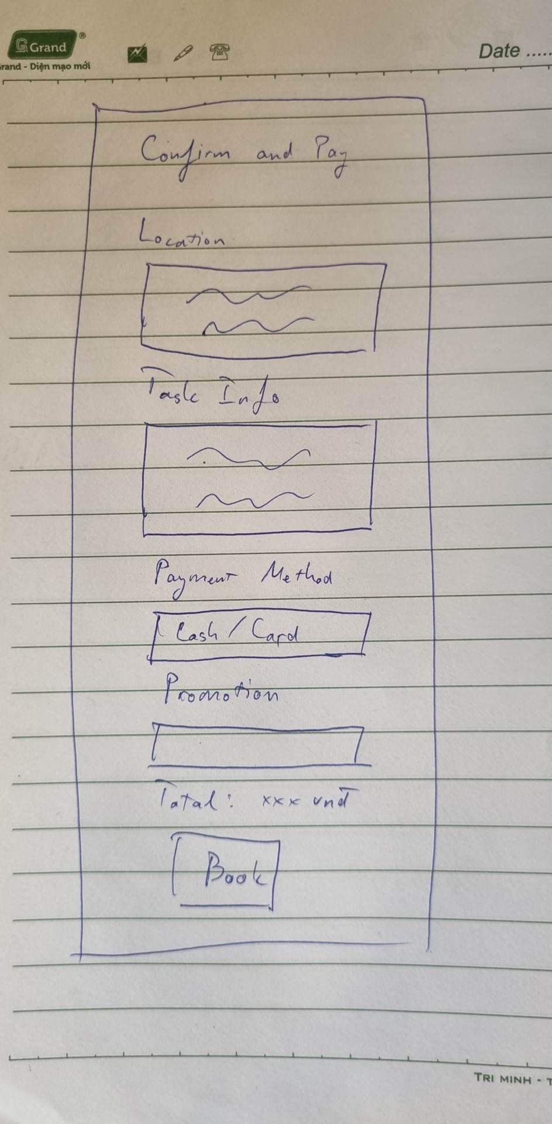

# Design pattern

·         One for navigation

“Flat navigation”

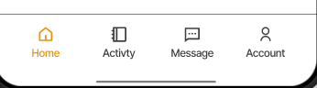

What is it? How it works?

The flat navigation gives a clear indication of current location and can be easily separate for the use to see and use without difficulties.

When to use it?

We use it to in order to make it easy for the user to use when they are first time user that are don’t know where to look for.

Why it works?

It fixed to the bottom of the main screen when people open the apps, so they can either choose to see the section they want fast.

When does it break down?

There is a possibility it breaks down then the user touch the navigate button so fast that make a slightly delay between the transition.

·         One for an animation/transition

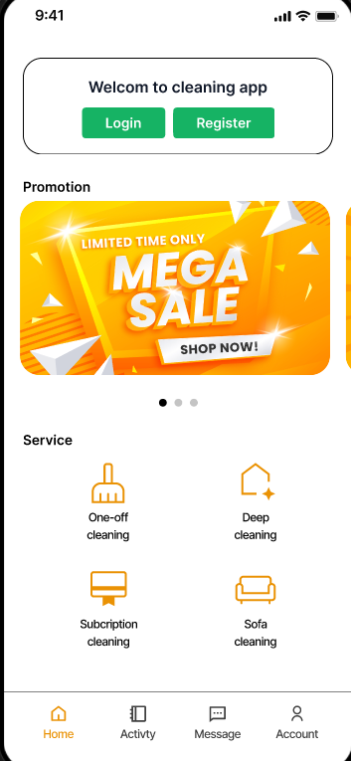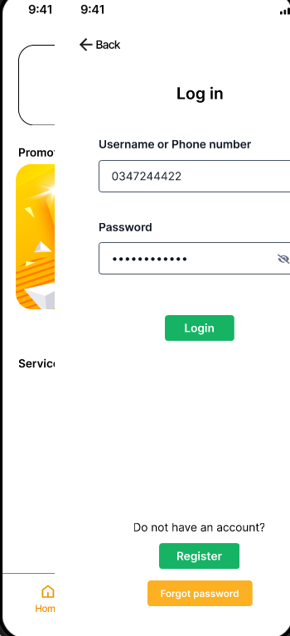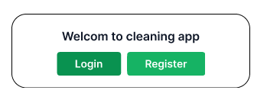

“The sibling transitions”

What is it? How it works?

The sibling transitions will move the screens to the pages where we’re clicked on them like when we forward with the pages when reading books

When to use it?

We use it to make it more appealing to the users, if we don’t make a animation when transitioning the app will not look good.

Why it works?

Because of the attraction that the animation can make to get the attention of the users when they are using the apps, which can make them more enthusing when browsing.

When does it break down?

When they press the pages to fast that it can make the screen goes delay or having a white screen and cannot see the information inside them.

·         One for layout and placement

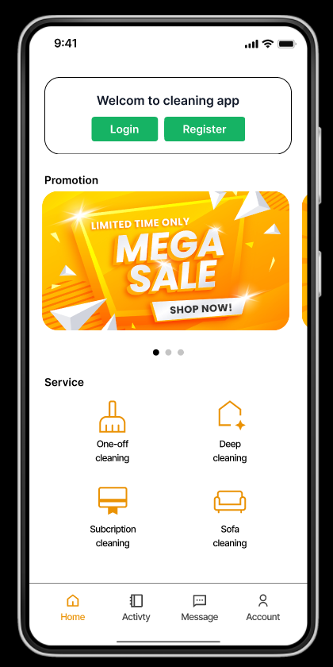

“Grid list”

What is it? How it works?

The grid list is consisting of a repeated component of the services that the app show.

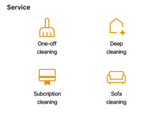

We will use implicit containment to give more space around the element when putting them in place. And by putting the element together, it will become a specific block that contains all the similar services in one place.

When to use it?

The app has so many services but it cannot be put all in one place but have to separate into pages so we use grid list to show 4 of the services at a time.

Why it works?

The grid that contains services in them make the user easy to find and search for the services they need at ease.

When does it break down?

When the user moves it fast or when they hold between the pages in the grid that can make them delay or break down.

·         One for interactive controls (buttons, sliders, clickable areas, etc.)

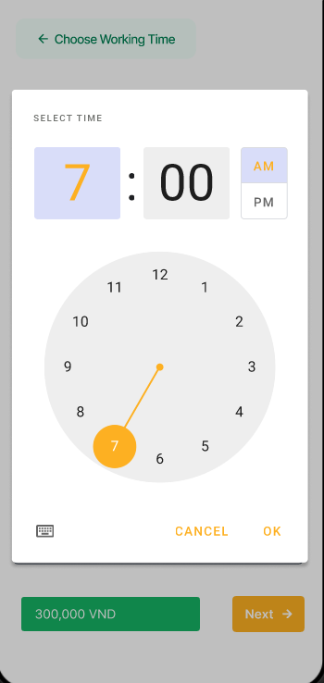

“Pickers”

What is it? How it works?

Picker uses a dialog to select a single time (in the hours: minutes format) on mobile. They adjust to a user’s preferred time setting.

When to use it?

It best suited for display as a confirmation dialog when the user wants to pick a time and confirm it.

Why it works?

We design as it is to make easy for users to pick a specific time that they want when they are booking a service.

When does it break down?

There may be a possibility it can cause delay when users touch the time and rotate it so fast that the time on display cannot followed them.

·         One for something that you think is interesting or innovative

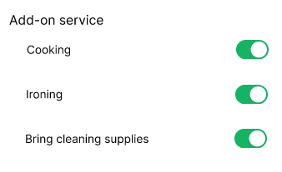

“Toggle switch”

What is it? How it works?

Toggle switch is a on-off switch with two states, you can use it when you need to turn on something or off. The user can choose 1 state at a time

When to use it?

We use it when our users need to change or update the preferences and choices, they want such as when using the add-on services

Why it works?

The add-on services that make it more interesting by giving you additional choices when you are booking the service such as ironing your clothes, bringing our own cleaning supplies if you don’t have or the one that you have at home is broken, etc.

When does it break down?

It does not break down because the users can only choose 1 state at a time so no matter what they do it just turn to the side that they choose.

# Build a wireframe

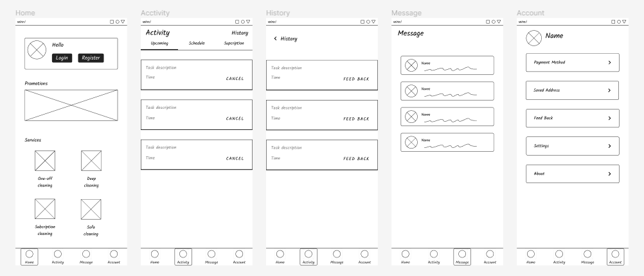

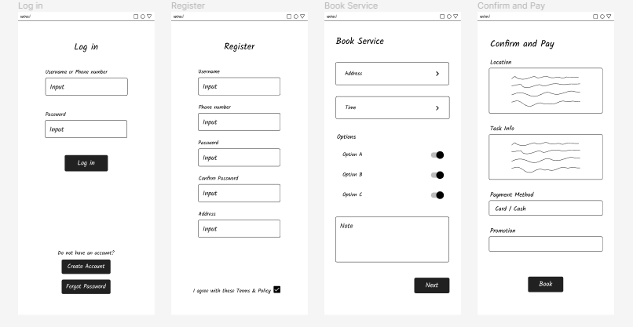

# High-Fidelity clickable prototype

<https://www.figma.com/proto/0wNhsx65JekpBUQsL1h5AA/Prototype?node-id=3%3A2&scaling=scale-down&page-id=0%3A1&starting-point-node-id=3%3A2>