1. Regarding to the ERD
   1. Nghanh kinh doanh?
      1. Which attribute, table?
      2. How many results pop up?
2. Regarding to the Interface
   1. What about the Real-estate search box?

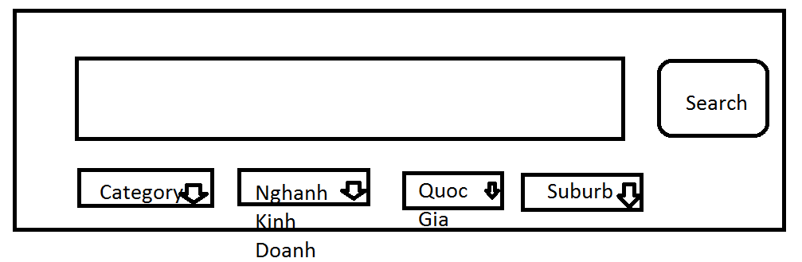

1. Regarding to Function “Loading combobox, countries….”
2. Regarding to the Family stuff
3. Regarding to the driving licence